# Chapter 3 Node Description

ECMiner™ includes Input Node, Preprocessing Node, Chart Node, Modeling Node, Output Node, and Model Evaluation Node.

|  |  |  |
| --- | --- | --- |
| Node Classification | Description | Supported Nodes |
| Input | Load data | ODBC Reader, OLEDB Reader, Access Reader, Excel Reader, Oracle Reader, Oracle Read/Write, File Reader, File Reader2, File Read/Write, Add Input, Copy&Paste Input, Hancell Reader, Image Reader |
| Preprocessing | Define data type, transform, and format.  Filtering and subsetting data | Missing Value, Group By, Multiple Derived Column, Column Reorder, Merge, Standardize, Split, Row Select, Column Combiner, Sort, Fill, Add, Pivot, Derived Column, Sampling, Column Filter, Type Change, COUNTER, RANKING, Group Statistics, Row Select2, Binning |
| Chart | Data visualization with various chart options | 3D Chart, Bar Chart, Contour Chart, Control Chart, Histogram, Matrix Chart, Pareto Chart, Pie Chart, Trend Chart, Statistic Chart, SPC Chart, Box plot, MSPC Chart, Process Contribution Chart, Word Cloud, Radar Chart Matrix, GL Chart, Multi Chart, Correlation Chart, Parallel Coordinates GL Chart, Heat Map GL |
| Modeling | All algorithm nodes for statistical analysis and AI. As a result, Model Node is generated. ECMiner™ supports a total of 41 algorithms. | Adaptive NN, Association Rule, Autoencoder, CART, CCA, CNN, DeepNN, ElmanNet, Factor Analysis, Hierarchical, K-Means, K-NN, LDA, LOF, Logistic, MLR, NaiveBayes, PCA, PCR, PLS, QDA, RBF, RBF DDA, Regularized Regression, RF, RL (AC\_RL, DDPG\_RL, DQN\_RL, PG\_RL, SAC\_RL, TD3\_RL), ScoreCard, SimpleRNN, SOM, SVM, SVR, t-SNE |
| Output | Results. Save as a file or display on the screen | ODBC Writer, OLEDB Writer, Result Pivoting, Oracle DB Writer, Statistics, File Writer, Display, Separated Save |
| Model Evaluation | Compare model performance | Model Evaluation, ROC Chart, Profit Chart |

All nodes in ECMiner™ have properties essential for performing their tasks. Properties are fundamentally composed of a property name and a property value. For example, the File Reader Node requires a property that specifies which file to read, represented by the property name (File Path) and the property value.

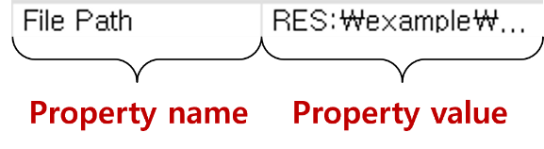

Common Properties

|  |  |  |
| --- | --- | --- |
| Property group | Property Name | Description |
| General Info. | Name | Name of the node |
| Description | Brief comment about the node. |

Additional Information Nodes are

* Variable Type Icon
* Editing Variable Information
* Variable Conditional Selection
* Variable Selection Property Control

Variable Type Icon

The table explains the various roles of the icons.

|  |  |  |
| --- | --- | --- |
| ICON | Type | Description |
|  | Data Type I | Date of data |
|  | String data |
|  | Integer data |
|  | Real number data |
|  | Variable Type | Independent variable in model |
|  | Dependent variable in model |
|  | Data Type II | Discrete data |
|  | Continuous data |

Editing Variable Information

This section explains how to edit variable information (variable names, data types).

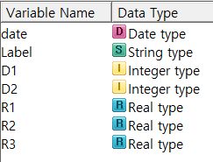

Modification of variable type can be done in the File Reader Node and the Excel Reader Node.

* Change the variable name

Click the variable name to enter the desired variable name.  
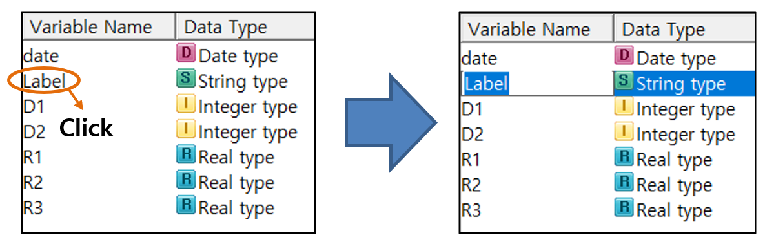

* Change the data type

Select the data type of the variable, and choose the desired type.

Variable Conditional Selection  
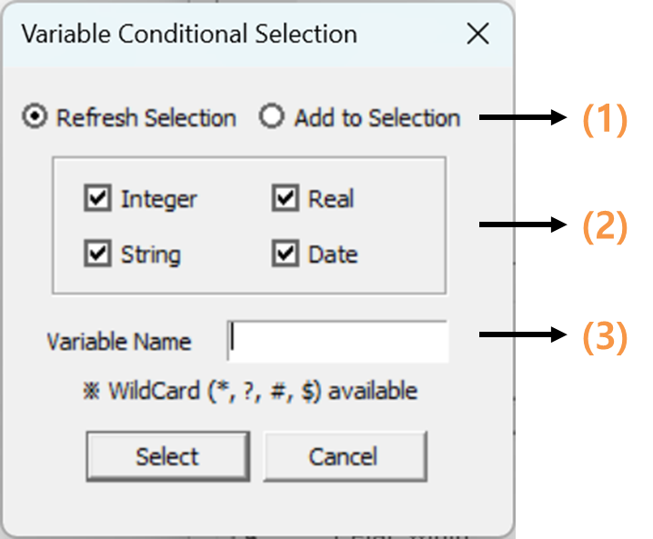

(1) Define whether to retain the previously selected variables or to reset and choose new ones.  
(2) Specify the data type of the variable  
(3) Use a wildcard to specify the conditions of the variable name.

\* Wild Card

* The meanings of the four wildcards are defined as follows:

|  |  |
| --- | --- |
| wildcard | Description |
| \* | The asterisk (\*) represents any string.  For example, "A\*" denotes all variable names starting with A, and "\*B" denotes all variable names ending with B. |
| ? | The question mark (?) represents any single character.  For example, "A??B" denotes a four-character variable name that starts with A and ends with B. |
| # | The pound sign (#) represents any single digit.  For example, "A##B" denotes a variable name that starts with A, has two digits (0-9) in between, and ends with B. |
| $ | The dollar sign ($) represents any single character that is not a digit.  For example, "A$$B" denotes a variable name that starts with A, has two non-digit characters in between, and ends with B. |
| NOTE: Precautions for using wild cards.   * Entering "\*" in the variable name condition represents all variable names. * To select variables that include "ABC" in their names, enter "\*ABC\*". Entering "ABC" without asterisks will select variables named exactly "ABC". * Spaces are treated as characters. Entering "\* ABC \*" will find variable names that include " ABC ", not just "ABC". | |

Variable Selection Property Control

This is a property control for selecting multiple variables. It is only included in nodes that require the selection of multiple variables and is not present in all nodes.

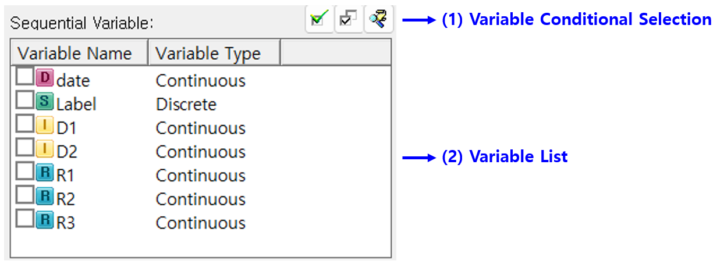

* (1) Function button for selecting variables.

|  |  |
| --- | --- |
| ICON | Function Description |
|  | Upon selecting one or more variables and clicking the designated button, the selected variables will be marked as checked. |
|  | Toggle the checked state. |
|  | You can set conditions to select only the variables that satisfy the requirements. For more details, please refer to the Variable Conditional Selection dialog. |

* (2) Variable list for selecting and checking variables.

The variable list displays only the variables that can be designated according to the node's function. You can use a variable by checking the checkbox next to it.

In this chapter, we will explore the properties and Usage of the nodes mentioned above.

* Input Node
* Preprocessing Node
* Chart Node
* Modeling Node
* Output Node
* Model Evaluation Node

## 3.1 Input Node

ECMiner™ handles various types of data source.



* [ODBC Reader Node](#_3.1.1_ODBC_Reader)   
  Retrieve data from a database using ODBC technology.
* [OLEDB Reader Node](#_3.1.2_OLEDB_Reader)   
  Retrieve data from a database using OLEDB technology.
* [Access Reader Node](#_3.1.3_Access_Reader_1)   
  Retrieve data from MDB files by selecting a table or entering a query.
* [Excel Reader Node](#_3.1.4_Excel_Reader)   
  Retrieve data from an Excel file by selecting the file.
* [Oracle Reader Node](#_3.1.5_Oracle_Reader)   
  Retrieve data from an Oracle database by entering connection details and a query.
* [Oracle Read/Write Node](#_3.1.6_Oracle_Reade/Write)   
  Read and concatenate multiple files, then save for future use.
* [File Reader Node](#_3.1.7_File_Reader)   
  Retrieve data from various file formats (txt, csv, dat, etc.) by specifying the file path.
* [File Reader2 Node](#_3.1.8_File_Reader2)   
  Merge and concatenate multiple files of the same format to create a new file.
* [File Read/Write Node](#_3.1.9_File_Read/Write)   
  Concatenate multiple ECL files and save them in a new ECL file.
* [Add Input Node](#_3.1.10_Add_Input)   
  Combine multiple ECL files row-wise to create a unified dataset.
* [Copy&Paste Input Node](#_3.1.11_Copy&Paste_Input)   
  Manually enter or paste data into the node.
* [Hancell Reader Node](#_3.1.12_Hancell_Reader)

Retrieve data from Hancom Hancell files.

* [Image Reader Node](#_3.1.13_Image_Reader)

Retrieve data from image files or a folder of images.

Common Properties of the Input Node

All Input Nodes have the following common properties.

|  |  |  |
| --- | --- | --- |
| Property group | Property Name | Description |
| Partial Read | Partial Read Method | Three options: "Read All," "From the beginning," and "Random Sampling."   * Read All   Reads all data from the specified Data Source   * From the beginning   Reads only data specified in the "Partial Read Arguments"   * Randosm Sampling   Selects random records specified in the "Partial Read Arguments" |
| Partial Read Arguments | With **From the beginning**, the argument is the number of observations. With **Random Sampling**, it is the percentage of observations. |

### 3.1.1 ODBC Reader Node

|  |  |
| --- | --- |
|  | **ODBC Reader Node** uses ODBC (Open Database Connectivity) technology to retrieve data from a database. You can either select a table or view data name to retrieve data directly, or you can input a query to fetch the data. |

Usage

|  |  |
| --- | --- |
|  |  |

▪ Click the ‘**ODBC Editing’** button to add a new DSN (Data Source Name) to data source.

▪ Enter user name and password to connect selected database

▪ After clicking the ‘**Fetch DB Information**’ button, specify the table or enter a query

Optional:

▪ Specify partial read method

▪ Filter the desired table type or schema

▪ Edit query

Node Properties

|  |  |  |  |  |
| --- | --- | --- | --- | --- |
| Property group | Property Name | Description | Misc. | Note |
| DB Connection | ODBC Editing | Add a new DSN (Data Source Name) for ODBC connections. | button |  |
| Data Source | Displays a list of registered ODBC DSNs on the current PC for selection. | Required |  |
| User Name | Enter the **username** to access the database. |  |
| Password | Enter the user **password** to access the database. |  |
| Partial Read | Partial Read Method | Specifies the method for partially reading the database. | Required | Read All, From the beginning, Random Sampling |
| Partial Read Arguments | With 'From the beginning', the argument is the number of observations. With 'Random Sampling', it is the percentage of observations. |  |  |
| Table | Fetch DB Information | Retrieve information about the database’s schema, tables, views, and other elements from the accessed database. | button |  |
| Use Query | Specify whether to fetch data using a query. |  | Yes, No |
| Table Type | Select the database schema to display in the table attribute. It supports both tables and views. |  | All, Table, View |
| Schema | Display list of table spaces or owners. |  |  |
| Table | Specifies the table from which to import the data. |  |  |
| Query | Edit Query | Activated when the ‘**Use Query’** attribute is set to **'Yes'**. Popping up the query editor, edit, load, and save the query. | button |  |
| Check Query | Check current inputted query. Click the ‘Edit Query’ button to modify it. |  |  |
| Variable Information | Variable Information | Displays the variable name and data type |  |  |

### 3.1.2 OLEDB Reader Node

|  |  |
| --- | --- |
|  | **OLEDB Reader Node** uses OLEDB technology to retrieve data from a database. You can either select a table or view data name to retrieve data directly, or you can input a query to fetch the data. if the database supports both ODBC and OLEDB, it is recommended to use OLEDB. |

Usage

|  |
| --- |
|  |

▪ Select the appropriate driver for the type of database you want to connect to.

▪ Enter the **DB Server Connection Information, User Name, and Password** to connect the database.

▪ After clicking the ‘Fetch DB Information’ button, specify the table or enter a query

Optional:

▪ Specify partial read method

▪ Filter the desired table type or schema

▪ Edit query

Node Properties

|  |  |  |  |  |
| --- | --- | --- | --- | --- |
| Property group | Property Name | Description | Misc. | Note |
| DB Connection | Select the driver | Specifies the appropriate **OLEDB driver** for the type of database you want to connect to. | Required |  |
| DB Server Connection Information | Enter appropriate information to identify the database. For SQL server, enter the IP address of the database server. For Oracle, enter the TNS name. |  |
| User Name | Enter the **username** to access the database. |  |
| Password | Enter the **password** to access the database. |  |
| Partial Read | Partial Read Method | Specifies the method for partially reading the database. | Required | Read All, From the beginning, Random Sampling |
| Partial Read Arguments | With 'From the beginning', the argument is the number of observations. With 'Random Sampling', it is the percentage of observations. |  |  |
| Table | Fetch DB Information | Retrieve information about the database’s schema, tables, views, and other elements from the connected database. | button |  |
| Use Query | Specify whether to fetch data using a query. |  | Yes, No |
| Table Type | Select the database schema to be listed in the table attribute. It supports tables and views. |  | All, Table, View |
| Schema | Display list of table spaces or owners. |  |  |
| Table | Specifies the table from which to import the data. |  |  |
| Query | Edit Query | Activated when the ‘**Use Query’** attribute is set to **'Yes'**. Popping up the query editor, edit, load, and save the query. | button |  |
| Check Query | Check current inputted query. Click the ‘Edit Query’ button to modify it. |  |  |
| Variable Information | Variable Information | Displays the variable name and data type |  |  |

### 3.1.3 Access Reader Node

|  |  |
| --- | --- |
|  | **Access Reader Node** retrieves data stored in MDB format. You can either select a table to fetch the corresponding data directly or enter a query to retrieve the data. |

Usage

|  |
| --- |
|  |

▪ Enter the file path and user **password** to access the MDB file.

▪ After clicking the ‘**Fetch DB Information’** button, specify the table or enter a query

Optional:

▪ Specify partial read method

▪ Edit query

Node Properties

|  |  |  |  |  |
| --- | --- | --- | --- | --- |
| Property group | Property Name | Description | Misc. | Note |
| Connect to DB | File Path | Specifies the path to the MDB file. | button |  |
| Password | Enter the **password** to access the MDB. | Required |  |
| Partial Read | Partial Read Method | Specifies the method for partially reading the database. | Required | Read All, From the beginning, Random Sampling |
| Partial Read Arguments | With 'From the beginning', the argument is the number of observations. With 'Random Sampling', it is the percentage of observations. |  |  |
| Table | Fetch DB Information | Retrieve information about the database’s schema, tables, views, and other elements from the connected database. | button |  |
| Use Query | Specify whether to fetch data using a query. |  | Yes, no |
| Table | Specifies the table from which to import the data. |  |  |
| Query | Edit Query | Activated when the ‘**Use Query’** attribute is set to **'Yes'**. Popping up the query editor, edit, load, and save the query. | button |  |
| Check Query | Check current inputted query. Click the ‘Edit Query’ button to modify it. |  |  |
| Variable Information | Variable Information | Displays the variable name and data type |  |  |

### 3.1.4 Excel Reader Node

|  |  |
| --- | --- |
|  | **Excel Reader Node** retrieves data stored in Excel file. You can directly select the file to fetch the corresponding data. |

Usage

|  |
| --- |
|  |

▪ Specifies the path of the Excel File.

▪ Select the Worksheet

Optional:

▪ Specify the file **Partial Read Method**.

▪ Specify the First row is Variable names

▪ Specify the Processing string types for all fields

Node Properties

|  |  |  |  |  |
| --- | --- | --- | --- | --- |
| Property group | Property Name | Description | Misc. | Note |
| Excel File | File Path | Specifies the path to the Excel File. | button |  |
| Reload Files | Re-import the data if the file was not read properly or you modified the file. |  |
| Partial Read | Partial Read Method | Specifies the method for partially reading the database. | Required | Read All, From the beginning, Random Sampling |
| Partial Read Arguments | With 'From the beginning', the argument is the number of observations. With 'Random Sampling', it is the percentage of observations. |  |  |
| Selection options | Worksheet | Reads the data from the selected worksheet. | Required |  |
| First row is Variable names | Set to **'Yes’,** if the first row is ‘Variable name’. If set to **'No'** even whenthefirst row contains variable names, all variable types may be set as strings. | Auto. | Yes, No |
| Processing string types for all fields | Reads all input data as strings. |  | Yes, No |
| Variable Information | Variable Information | Displays the variable name and data type |  |  |

### 3.1.5 Oracle Reader Node

|  |  |
| --- | --- |
|  | The **Oracle Reader Node** retrieves data from an Oracle database. |

Usage

|  |
| --- |
|  |
|  |

▪ Enter **TNS Name, Connection account and Account Password** to access the database.

▪ After clicking the ‘**Fetch DB Information’** button, specify the table or enter a query

Optional:

▪ Specify partial read method

▪ Edit variable list

▪ Edit query

Node Properties

|  |  |  |  |  |
| --- | --- | --- | --- | --- |
| Property group | Property Name | Description | Misc. | Note |
| Oracle Connection Information | TNS Name | Enter the TNS name of the Oracle database you want to access to. | button |  |
| Connection account | Enter the name of the database accessed account. | Required |  |
| Account Password | Enter the password for the database accessed account. |  |
| Partial Read | Partial Read Method | Specifies the method for partially reading the database. | Required | Read All, From the beginning, Random Sampling |
| Partial Read Arguments | With 'From the beginning', the argument is the number of observations. With 'Random Sampling', it is the percentage of observations. |  |  |
| Edit Variable Information | User Input for Variable List | Set to 'Yes' to manually type the list of variables. If set to 'No', the column information returned from the database is used. |  |  |
| Edit Variable List | Activate when the **User Input for Variable List** attribute is set to **'Yes'.** And edit the list of variables. | button |  |
| Specify the query method | Use Query | Specify whether to fetch data using a query. |  |  |
| Table | Select the Table. |  |  |
| Query | Edit Query | Activated when the ‘**Use Query’** attribute is set to **'Yes'**. Popping up the query editor, edit, load, and save the query. | button |  |
| Variable Information | Variable Information | Displays the variable name and data type |  |  |

### 3.1.6 Oracle Read/Write Node

|  |  |
| --- | --- |
|  | **Oracle Read/Write Node** read multiple files with the same format, concatenate them vertically to create data for analysis, and provides a function to save it for future use. |

Usage

|  |
| --- |
|  |

▪ Enter the **TNS Name, Connection account and Account Password** to access the database.

▪ After clicking the ‘Fetch DB Information’ button, specify the table or enter a query

▪ Specify the **File Path** and Reference **Variable** to save.

Optional:

▪ Specify partial read method

▪ Edits variable list

▪ Edits query

Node Properties

|  |  |  |  |  |
| --- | --- | --- | --- | --- |
| Property group | Property Name | Description | Misc. | Note |
| Oracle Connection Information | TNS Name | Enter the TNS name of the Oracle database you want to access to. | button |  |
| Connection account | Enter the name of the database accessed account. | Required |  |
| Account Password | Enter the password for the database accessed account. |  |
| Edit Variable Information | User Input for Variable List | Set to 'Yes' if you want to manually enter the list of variables. If set to 'No', the column information returned from the database is used. | button |  |
| Edit Variable List | Activate when the **User Input for Variable List** attribute is set to **'Yes'.** The variable editor will pop up, allowing you to edit the list of variables. |  |
| Storage options | File Path | Specify the path for the file to be saved. |  |  |
| Reference Variable | Specify the reference variable. |  |  |
| Number of Data Splits | Specify the number of data splits. |  |  |
| Specify the query method | Use Query | Specify whether to fetch data using a query. | button |  |
| Table | Select the Table. |  |  |
| Query | Edit Query | Activated when the ‘**Use Query’** attribute is set to **'Yes'**. Popping up the query editor, edit, load, and save the query. | button |  |
| Variable Information | Variable Information | Displays the variable name and data type to be read |  |  |

### 3.1.7 File Reader Node

|  |  |
| --- | --- |
|  | **File Reader Node** retrieves data from files with extensions such as txt, csv, dat, tab, and ecl. |

Usage

|  |
| --- |
|  |

▪ Specifies the path for the file

▪ **Selection options** will be updated automatically, and you will be able to edit them

Optional:

▪ If not read correctly, click the ‘**Reload** **Files’** button

▪ Specify partial read method

▪ Edits variable name and variable type from Variable Information

Node Properties

|  |  |  |  |  |
| --- | --- | --- | --- | --- |
| Property group | Property Name | Description | Misc. | Note |
| File | File Path | Specifies the path for the file. | Required |  |
| Reload Files | Re-import the data if the file was not read properly or you modified the file. | button |  |
| Preview | View a portion of the specified file. |  |  |
| Partial Read | Partial Read Method | Specifies the method for partially reading the database. | Required | Read All, From the beginning, Random Sampling |
| Partial Read Arguments | With 'From the beginning', the argument is the number of observations. With 'Random Sampling', it is the percentage of observations. |  |  |
| Selection options | Is first row Variable names | Set to **'Yes’,** if the first row is ‘Variable name’. If set to **'No'** even whenthefirst row contains variable names, all variable types may be set as strings. | Auto. | Yes, No |
| Delimiter | Select the type of delimiter. Supported delimiters are tab, space, bar, comma, semicolon, and colon. To use a different delimiter, select the 'Other' option. | Required | (tab), '|', (Space), ',', ';', ':', (Other) |
| Other Delimiter | Set other delimiters in case the property of a delimiter is (Other). |  |  |
| Test has grouping symbols | Specify whether to remove quotation marks from string data that contains them. | Ex: “ABC"🡺 ABC | Yes, No |
| Variable Information | Variable Information | Displays the variable name and data type |  |  |

### 3.1.8 File Reader2 Node

|  |  |
| --- | --- |
|  | **File Reader2 Node** merges multiple files of the same format by vertically concatenating them to generate a new file. |

Usage

|  |  |  |
| --- | --- | --- |
|  |  |  |

▪ Click ‘**Edit Variable List’** to view or modify the list of variables.

Manage variables by adding, deleting, and deleting all variables

Import and export the variable names in data formatted with line breaks for variable parsing

▪ Click ‘**Edit File List**’ to specify folder to load data with a specific extension

▪ The order of variables of the newly added files is in the same order as the previous files.

Optional:

▪ Specifies delimiter

▪ Specifies FTP

Node Properties

|  |  |  |  |  |
| --- | --- | --- | --- | --- |
| Property group | Property Name | Description | Misc. | Note |
| Selection options | Edit Variable | Edit the list of variables. If a variable does not exist, you can set it manually | Required |  |
| Edit File | Select the data to be imported. |  |
| First row is Variable names | Set to **'Yes’,** if the first row is ‘Variable name’. If set to **'No'** even whenthefirst row contains variable names, all variable types may be set as strings. | Yes  No |
| Use FTP | Set whether to use FTP. | Yes  No |
| Delimiter | Select the type of delimiter. Supported delimiters are tab, space, bar, comma, semicolon, and colon. To use a different delimiter, select the 'Other' option. | (tab), '|', (Space), ',', ';', ':', (Other) |
| Other Delimiters | Set other delimiters in case the property of a delimiter is (Other). |  |  |
| Connect to FTP | FTP Server | Set the FTP server where the file is located. | Required when using FTP |  |
| FTP User | Enter the FTP user ID. |  |
| FTP Password | Enter the FTP password. |  |
| Variable Information | Variable Information | Displays the variable name and data type. |  |  |

### 3.1.9 File Read/Write Node

|  |  |
| --- | --- |
|  | Using the **File Read/Write Node**, vertically concatenate multiple \*.ecl files of the same format to create a new ECL dataset and save it in a \*.ecl file. |

It is configured to execute both the **File Reader node** and the **File Writer node** simultaneously.



Usage

|  |  |  |
| --- | --- | --- |
|  |  |  |

▪ Clicking ‘**Edit Variable List’** to view or modify the list of variables.

▪ Manage variables by adding, deleting variables.

▪ Import and export the variable names in data

▪ Clicking ‘**Edit File List**’, specify folder to load data

▪ Ensure the order of variables is the same to generate the desired data.

▪ Specify the path and name of the file to be saved.

**Optional:**

▪ Specifies delimiter

▪ Specifies FTP

▪ Select whether to save the data separately.

Node Properties

|  |  |  |  |  |
| --- | --- | --- | --- | --- |
| Property group | Property Name | Description | Misc. | Note |
| Selection options | Edit Variable | Edit the list of variables. If a variable does not exist, you can set it manually | Required |  |
| Edit File | Select the data to be imported. |  |
| First row is Variable names | Set to **'Yes’,** if the first row is ‘Variable name’. If set to **'No'** even whenthefirst row contains variable names, all variable types may be set as strings. | Yes  No |
| Use FTP | Set whether to use FTP. | Yes  No |
| Delimiter | Select the type of delimiter. Supported delimiters are tab, space, bar, comma, semicolon, and colon. To use a different delimiter, select the 'Other' option. | (tab), '|', (Space), ',', ';', ':', (Other) |
| Other Delimiters | Set other delimiters in case the property of a delimiter is (Other). |  |  |
| Connect to FTP | FTP Server | Set the FTP server where the file is located. | Required when using FTP |  |
| FTP User | Enter the FTP user ID. |  |
| FTP Password | Enter the FTP password. |  |
| Storage Options | File Path | Specify the path and name of the file to be saved. | Required |  |
| Reference Variable | Select the variable to use as a criterion when dividing the data for storage. | Select 'None' as an option. |
| Number of Data Splits | Set how many pieces of data to use as a basis for division. |  |
| Variable Information | Variable Information | Displays the variable name and data type to be read. |  |  |

### 3.1.10 Add Input Node

|  |  |
| --- | --- |
|  | **Add Input Node** combines multiple ECL files with the same data structure by concatenating them row-wise to create a unified dataset. |

Usage

|  |
| --- |
|  |

▪ Set the path to the folder containing ecl files of the same format.

▪ Select the **Variable Matching Method**

▪ Use an asterisk (\*) as a prefix or suffix to distinguish file names and specify the **File type**.

▪ Click the **Reload Files** button.

Node Properties

|  |  |  |  |  |
| --- | --- | --- | --- | --- |
| Property group | Property Name | Description | Misc. | Note |
| File | Variable Matching Method | Two options: " Variable Order", " Variable Name".   * Variable Order   Consider variables with the same order as identical.   * Variable Name   Consider variables with the same name as identical. | Required | Variable Order  Variable Name |
| File Path | Specifies the path for the file. |  |
| File type | Use an asterisk (\*) as a prefix or suffix to specify and distinguish the file type.  If the data files are named "test1, test2, ..." enter "test\*". For files named "1test, 2test, ..." enter "\*test". |  |
| Variable Information | Variable Information | Displays the variable name and data type to be read. |  |  |
| NOTE: In the 'Variable Matching Method', if the 'Variable Name' option is selected and the variables in the input datasets do not match, the unmatched datasets will be filled with blank spaces. | | | | |

### 3.1.11 Copy&Paste Input Node

|  |  |
| --- | --- |
|  | Using **Copy&Paste Input Node**, enter or paste the data you want. |

Usage

|  |
| --- |
|  |

▪ Click **Paste** button to enter data directly or paste it.

Optional:

▪ Specify the Partial Read Method

▪ Specify whether variable names are on the first line

▪ Specify whether to use text delimiters

▪ Modify variable names and types.

Node Properties

|  |  |  |  |  |
| --- | --- | --- | --- | --- |
| Property group | Property Name | Description | Misc. | Note |
| Copy& Paste | Paste | Activate a dialog box where you can enter or paste data. | Required | button |
| Partial Read | Partial Read Method | Specifies the method for partially reading the database. | Required | Read All, From the beginning, Random Sampling |
| Partial Read Arguments | With 'From the beginning', the argument is the number of observations. With 'Random Sampling', it is the percentage of observations. |  |  |
| Selection options | Is first row Variable names | Set to **'Yes’,** if the first row is ‘Variable name’. If set to **'No'** even whenthefirst row contains variable names, all variable types may be set as strings. | Auto. | Yes, No |
| Delimiter | Select the type of delimiter. Supported delimiters are tab, space, bar, comma, semicolon, and colon. To use a different delimiter, select the 'Other' option. | Required | (tab), '|', (Space), ',', ';', ':', (Other) |
| Other Delimiters | Set other delimiters in case the property of a delimiter is (Other). |  |  |
| Text has grouping symbols | Specify whether to remove quotation marks from string data that contains them. | ex: “ABC"🡺 ABC | Yes, No |
| Variable Information | Variable Information | Displays the variable name and data type |  |  |

### 3.1.12 Hancell Reader Node

|  |  |
| --- | --- |
|  | Using **Hancell Reader Node**, retrieves data stored in Hancom Hancell file. |

Usage

|  |
| --- |
|  |

▪ Specifies the path to the Hancom/Hancell file and select the worksheet.

Optional:

▪ Specify the Partial Read method for the file.

Node Properties

|  |  |  |  |  |
| --- | --- | --- | --- | --- |
| Property group | **Property Name** | **Description** | **Misc.** | **Note** |
| Excel File | File Path | Specifies the path to the Hancom Hancell File. | button |  |
| Reload Files | Re-import the data if the file was not read properly or you modified the file. | Reload Files |
| Partial Read | Partial Read Method | Specifies the method for partially reading the database. | Required | Read All, From the beginning, Random Sampling |
| Partial Read Arguments | With 'From the beginning', the argument is the number of observations. With 'Random Sampling', it is the percentage of observations. |  |  |
| Selection options | Worksheet | Reads the data from the selected worksheet. | Required |  |
| First row is Variable names | Set to **'Yes’,** if the first row is ‘Variable name’. If set to **'No'** even whenthefirst row contains variable names, all variable types may be set as strings. | Auto. | Yes, No |
| Processing string types | Reads all input data as strings. |  | Yes, No |
| Variable Information | Variable Information | Displays the variable name and data type |  |  |

### 3.1.13 Image Reader Node

|  |  |
| --- | --- |
|  | Using **Image Reader Node,** retrieve data from image files or a folder containing multiple images. |

Usage

|  |  |
| --- | --- |
|  |  |

▪ Click **Edit File** button to add or modify the image file path.

Node Properties

|  |  |  |  |  |
| --- | --- | --- | --- | --- |
| Property group | Property Name | Description | Misc. | Note |
| Image Selection | Edit File | Use the **Edit File** button to specify the path of the image file. You can select the image list using 'Add File' and 'Add Folder'. | button |  |
| Image Metadata | Image Metadata | Displays the variable name and data type. |  |  |

## 3.2 Preprocessing Node

Data preprocessing is essential step in data analysis. **ECMiner™** provides **Preprocessing Nodes** for data cleaning to handle missing values, remove noise, correcting errors. Normalization, Standardization, Grouping, and Binning is also available.

* [Missing Value](#_3.2.1_Missing_Value_1)  
  For missing values, you may use imputation values (mean, median, or other specified techniques)
* [Group By](#_3.2.2_Group_By)  
  Groups data based on the values of specified variables to create a new dataset.
* [Multiple Derived Variables](#_3.2.3_Multiple_Derived)  
  Applies the same rule to specified variables to create new variables.
* [Column Reorder](#_3.2.4_Column_Reorder)  
  Changes data order
* [Standardize](#_3.2.5_Standardize_Node)  
  Transform data to have a mean of zero and a standard deviation of one or specified value.
* [Merge](#_3.2.6_Merge_Node)  
  Combine two or more data set by key value.
* [Split](#_3.2.7_Split_Node)  
  Divides the data for modeling and evaluation purposes (For example, Train set and Test set).
* [Row Select](#_3.2.8_Row_Select)  
  Selects only the rows where a specified condition is true.
* [Row Select2](#_3.2.9_Row_Select2)  
  A node that groups based on specified key variables and then selects values that meet the condition.
* [Column Combiner](#_3.2.10_Column_Combiner)  
  Combine the multiple results of modeling/model into one.
* [Image Processing Node](#_3.2.11_Image_Processing)

Performs various processing tasks for the images such as detection, extraction, distortion and etc.

* [Image Statistics Node](#_3.2.12_Image_Statistics)

Extracts statistical information of image pixels.

* [Sort](#_3.2.13_Sort_Node)  
  Sort data by a specified variable.
* [Fill](#_3.2.14_Fill_Node)  
  Fill with a specified value if a specified condition is true.
* [Add](#_3.2.15_Add_Node)  
  Combine input data sources into one.
* [Derived Variable](#_3.2.16_Derived_Column)  
  Create a new derived variable
* [Sampling](#_3.2.17_Sampling_Node)  
  Randomly select a specified portion from the entire dataset.
* [Pivot](#_3.2.18_Pivot_Node)  
  Transform data from a detailed, long format into a summary, wide format.
* [Column Filter](#_3.2.19_Column_Filter)  
  Select a subset of data based on specific criteria
* [Type Change](#_3.2.20_Type_Change)  
  Change the type of variable
* [Counter](#_3.2.21_Counter_Node)  
  Add the result of counting by group according to specified variable.
* [Group Statistics](#_3.2.22_Group_Statistics)  
  Compute statistics for different groups or categories within a dataset
* [RANKING](#_3.2.23_RANKING_Node)  
  Calculate ranking for a specified variable
* [Binning](#_3.2.24_Binning_Node)  
  Divide grouping continuous data into discrete intervals
* [Transpose](#_3.2.25_Transpose_Node_1)  
  Swap the rows and columns of data
* [Tagging](#_3.2.26_Tagging_Node)  
  Perform morphological analysis.
* [Import R](#_3.2.25_Transpose_Node_1)  
  Runs user-defined R code using the connected data
* [Import Python](#_3.2.26_Tagging_Node)  
  Runs user-defined Python code using the connected data

### 3.2.1 Missing Value Node

|  |  |
| --- | --- |
|  | **Missing Value Node** imputes the missing values |

Usage

Replace the missing values for All variables or Continuous variables or Discrete Variables

Node Properties

|  |  |  |  |  |
| --- | --- | --- | --- | --- |
| Property group | Property Name | Description | Misc. | Note |
| Options | Target variable | Choose which one to replace the missing value |  | All variables, Discrete Variables Only, Continuous Variables Only |
| Continuous Variable | Option for **continuous** variable |  | Average, Median, Previous Value, Subsequent Value, Interval Mean, Linear interpolation, Spline Interpolation, User-defined (default 0) |
| Discrete Variable | Options for **Discrete** variable |  | Maximum Iteration, Minimum Iteration, Previous Value, Subsequent Value |

Methods for Replacing Missing Values

|  |  |  |
| --- | --- | --- |
| Type | Value | Description |
| Continuous | Average | Mean value of the variable |
| Median | Median value of the variable |
| Previous Value | Previous value of the continuous variable |
| Subsequent Value | Subsequent value of the continuous variable |
| Interval Mean | (Previous value + subsequent value) / 2 |
| User-defined (default 0) | User-defined value, default is 0 |
| Discrete | Value corresponding to the maximum count, | The most frequent value |
| Value corresponding to the minimum count | The least frequent value |
| Previous Value | Previous value of the discrete variable |
| Subsequent Value | Subsequent value of the discrete variable |

### 3.2.2 Group By Node

|  |  |
| --- | --- |
|  | **Group By Node** specifies the grouping variable and select the variable you want to calculate statistical measure. |

Usage

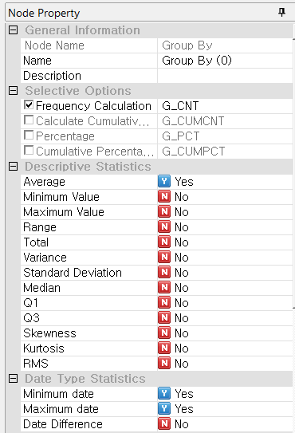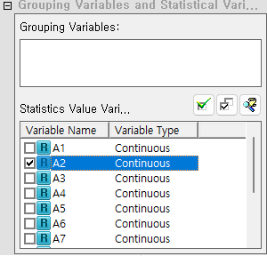

Node Properties

|  |  |  |  |  |
| --- | --- | --- | --- | --- |
| Property group | Property Name | Description | Misc. | Note |
| Options | - | Generate derived variables for the values of selected variable. | Required (Select at least one) | Frequency Calculation,  Calculate Cumulative Frequency,  Percentage,  Cumulative Percentage |
| Statistics | Descriptive Statistics | mean, minimum, maximum, total sum, variance, standard deviation, median, Q1, and Q3 to create derived variables. |  |  |
| Date Type Statistics | minimum date, maximum date, and date difference to create derived variables. |  |  |
| Grouping Variables and Variables | Grouping Variables | Select the grouping variable. The grouping variable should be discrete. | Required |  |
| Selected continuous Variables | Select the variable for which you want to calculate descriptive statistics by the grouping variable. | Optional |  |

### 3.2.3 Multiple Derived Column Node

|  |  |
| --- | --- |
|  | **Multiple Derived Column Node** applies a common transformation rule to several existing fields to create new fields. During this process, each field is substituted into a common formula, so the data types of the existing fields must match. |

Usage

|  |  |  |  |  |  |  |  |  |  |  |  |
| --- | --- | --- | --- | --- | --- | --- | --- | --- | --- | --- | --- |
|  | |  |  |  | | --- | --- | --- | | bin_select | the selected variable | | | bin_reverse | Invert the selected variables and the unselected variables | | | btn_condition | Variable Conditional Selection |  | | * Set the prefix and suffix for the new derived columns. * Select the variables to be applied the common transformation rules * Define the common transformation rules using the formula editor. |

Node Properties

|  |  |  |  |  |
| --- | --- | --- | --- | --- |
| Property group | Property Name | Description | Misc. | Note |
| Selection Options | Prefix | Prefix of derived variables | Conditionally Required | Enter at least one of the following : prefix, suffix. |
| Suffix | Suffix of derived variables |
| Variable Selection | Variable Selection | List the names and types of variables. It Select the variable for a new derived variable | Other UI | Refer to the Usage |
| Edit Formula | Formula | Define the variable transformation rules | Refer to the formula editor. |

### 3.2.4 Column Reorder Node

|  |  |
| --- | --- |
|  | **Column Reorder Node** changes the variable order. |

Usage

|  |  |  |  |  |  |  |  |  |  |  |  |  |  |
| --- | --- | --- | --- | --- | --- | --- | --- | --- | --- | --- | --- | --- | --- |
|  | |  |  | | --- | --- | | btn_up | move the variable up in order | | btn_down | move the variable down in order | |  | Move the variable to the first line | |  | Move the variable to the first line | | btn_reorder | Sort the variable names in ascending order. | | btn_reset | Reset the variable order | |

Node Properties

|  |  |  |  |  |
| --- | --- | --- | --- | --- |
| Property group | Property Name | Description | Misc. | Note |
| Variable Order | Variable Order | Rearrange the variables according to do user’s preference. |  |  |

### 3.2.5 Standardize Node

|  |  |
| --- | --- |
|  | **Standardize Node** standardizes the selected variables. |

Usage

|  |  |  |  |  |  |  |  |  |  |  |  |
| --- | --- | --- | --- | --- | --- | --- | --- | --- | --- | --- | --- |
|  | |  |  |  | | --- | --- | --- | | bin_select | the selected variable | | | bin_reverse | Invert the selection of the selected variables and unselected variables. | | | btn_condition |  | Select variables based on conditions such as variable type or variable name. | |  |
|  |  |
| * Specify the reference variable and select the variables to transform. |  |

Node Properties

|  |  |  |  |  |
| --- | --- | --- | --- | --- |
| Property group | Property Name | Description | Misc. | Note |
| Standardized variables | Status | Choose whether to create a standardized variable |  | To create a new variable for the standardized, select 'Yes' |
| Suffix | Specify the suffix string for a derived standardized variable |  |
| Standardization Mean | Specify the mean value for the standardized variable |  |
| Standardization Standard Deviation | Specify the standard deviation for the standardized variable |  |
| Maximum correction | Select this option if you want the maximum value of the generated standardized variables |  |
| Relative ratio variable | Creation status | Specify whether to create relative ratio variables. | Conditionally Required |
| Suffix | Specify the string to append to the generated relative ratio variables. |  |
| Select Reference Variable | Reference Variable | If no variable is specified, calculations are performed for each record. If a variable is specified, calculations are performed for each category of the specified reference variable. The reference variable must be categorical. | Optional | Refer to the Usage. |
| Variables to Transform | Variable to Transform | Select the variables to transform, which must be continuous. | Required | Refer to the Usage. |

*Note: Relative ratio variables store the value of each row divided by the calculated total sum of the specified variable.*

### 3.2.6 Merge Node

|  |  |
| --- | --- |
|  | **Merge Node** combines two or more data. |

Various merging methods are provided, including **Inner Join, Outer Join, Partial Outer Join, Anti-Join**, depending on the purpose for new data.

Usage

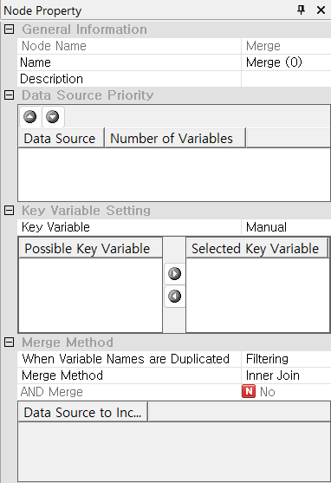

The **Data Source** interface displays data sets. Select a data set with the highest priority for merging. When merging two datasets, the data source with the highest priority serves as the primary base.

|  |  |  |
| --- | --- | --- |
|  | ICON | Function |
| btn_up | Change the order of data set to the top priority. |
| btn_down | Change the order of data set to the next priority |

To set the key field for merging, select the variable in the list of **Possible Key Fields** and then it goes to **Selected Key Fields**. Use the buttons in the center to select or deselect key fields

|  |  |  |
| --- | --- | --- |
|  | ICON | Function |
| btn_right | Adds a key variable. |
| btn_left | Deletes a key variable |

**Data Source to Include** is activated when **Merge Method** is set to **Partial Outer Join**, which returns only the selected data sources.

|  |
| --- |
|  |
|
|

Node Properties

|  |  |  |  |  |
| --- | --- | --- | --- | --- |
| Property group | Property Name | Description | Misc. | Note |
| Data Source  Priority | Data Source | A list of data sets. Set their priority of data sets | Other UI | Refer to the Usage. |
| Key Variable Setting | Key variable | Specifies a key variable. If **Manual** is selected, choose the key variable. | Required | Automatic, Manual |
| Select Key variable | Select or delete key variable using icon btn_rightbtn_left | Other UI | Refer to the Usage. |
| Merge Method | When Variable Names are Duplicated | Select the method for handling duplicate variable names | Required | Filtering, Assign Index, Error Occurred |
| Merge Method | Select the merge method. | Inner Join, Outer Join, Partial Outer Join, Anti-Join |
| Data Source to Include | When **Merge Method** is set to **Partial Outer Join,** you can directly select or deselect data sources checking boxes. | Other UI | Refer to the Usage. |

**Reference: Merge Method**

ECMiner™ provides the following Merge Methods.

|  |  |  |
| --- | --- | --- |
| Merge Method | Description | Note |
| Inner Join | Keeps only rows where ‘key variable’ matches in both data sets |  |
| Outer Join | Keeps all rows from both datasets, adding NaN or nulls where no match is found. |  |
| Partial Outer Join | Keep all rows from the data set with the highest priority and add matched rows from the second data set. | You must specify the data sources to include. |
| Anti-Join | Adds rows with non-matching key value from the data sources to the new data source |  |

**Example**

Assume there are data sources A and B as follows:

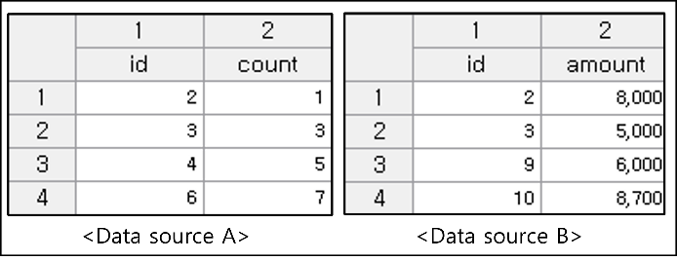

The key variable is set to 'id', and the merging methods performs as the following

**(1) Inner Join**

Merge only the rows with matching key values, specifically 'id' 2 and 3, from the two data sets. The result is as follows:

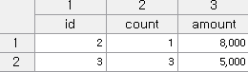

**(2) Outer Join**

For the key field 'id', Data A has key values 2, 3, 4, 6, while Data B has key values 2, 3, 9, 10. Outer Join keeps all rows from both data sets. In this case, <NULL> values are assigned to variables where no data is available.

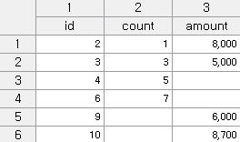

**(3) Partial Outer Join (or Left Join)**

Perform an outer join merge on all key values from the two data sources, and then return only the values from the selected data. For example, a partial outer join is with Data A, then the new data is only ‘id’ 2, 3, 4, and 6.

|  |  |  |
| --- | --- | --- |
| By selecting only Data A,  Partial Outer Join |  | By selecting only Data B,  Partial Outer Join |
|  |  |  |

**(4) Anti-Join**

When the primary data is A, remove the rows in Data B that have duplicate key values. In other words, among the key values 2, 3, 4, 6 in A, the duplicates 2 and 3 that are also present in B are removed, resulting in the following outcome

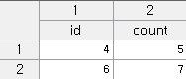

### 3.2.7 Split Node

|  |  |
| --- | --- |
|  | **Split Node** divides data into either analysis or evaluation sets. |

Usage

|  |  |
| --- | --- |
|  | * Select the Partition Method. (Currently, only Random Extraction is available.) * Specifies whether the extracted sample is to be used for analysis or evaluation in the Analysis / Evaluation attribute. * Specifies the method to determine the Partition Size. * Specifies the Percentage or the Count according to the Partition Size Specification Method. |

Node Properties

|  |  |  |  |  |
| --- | --- | --- | --- | --- |
| Property group | **Property Name** | **Description** | **Misc.** | **Note** |
| Selection options | Partition Method | Specify how the data is partitioned for analysis/evaluation. Random Extraction is available. | Required | Random Extraction |
| Analysis / Evaluation | Specify whether some of the extracted data will be used for analysis or evaluation. | For analysis, Evaluation |
| Partition Size Method | Specify the method to determine the partition size. | Percentage, Count |
| Partition Size | Partition Size (Percentage) | Activates when the **Partition Size Method** is set to **Percentage** |  | 0<real numbers<100 |
| Partition Size (Count) | Activates when the **Partition Size Specification Methods** set to **Count.** Enters desired data size as an integer. |  | integer |

### 3.2.8 Row Select Node

|  |  |
| --- | --- |
|  | **Row Select Node** filters rows based on a specified condition. |

Usage

|  |  |
| --- | --- |
|  | * Choose User Input to define a custom selection. Select Remove Rows with Missing Values if you want to remove only the rows with missing values. * When Condition format is set to User input, specify the Selection condition. Click the ‘Edit’ to enter the formula corresponding to the condition in the expression editor. |

Node Properties

|  |  |  |  |  |
| --- | --- | --- | --- | --- |
| Property group | Property Name | Description | Misc. | Note |
| Selection options | Condition format | Select ‘**User input’** to specify specific conditions, or ‘**Remove Rows with Missing Values’** to remove only missing values. | Required | User input,  Remove Rows with Missing Values |
| Selection condition | When the Condition format is set to ‘**User Input’**. Clicking ‘**Edit**’, the editor window pops up allowing you to enter the criteria to select the desired row from the data. | button | Refer to the **Expression editor**. |
| Conditions Reading Window | Displays the currently entered criteria formula. |  |  |

### 3.2.9 Row Select2 Node

|  |  |
| --- | --- |
|  | **Row Select2** **Node** groups data based on the specified key variables and retrieves information that matches the selected variable values. |

Usage

|  |  |
| --- | --- |
|  | * After specifying Grouping Variable, select the Data Variables to analyze. * Select the value of Variable (Maximum value, Minimum Value, Maximum / Minimum outlier, Maximum / Minimum value, Remove Duplicates, Remove Duplicates & Eliminate All Zeros) to see the results. |

Node Properties

|  |  |  |  |  |
| --- | --- | --- | --- | --- |
| Property group | Property Name | Description | Misc. | Note |
| Selection options | Grouping Variable | Group using specific variables. | Required |  |
| Data Variables | Specifies the data variables to be analyzed by the grouped variables. |  |
| Variable Processing | Specifies how the variable is processed.   * Maximum value: The maximum value for each group. * Minimum Value: The minimum value for each group. * Maximum/Minimum outlier: The values excluding the maximum and minimum for each group in a data variable. * Maximum / Minimum value: The maximum and minimum values for each group in the data variable * Remove Duplicates: The deduplicated values for each group in the data variable. * Remove Duplicates & Eliminate All Zeros: The values that are deduplicated and exclude zeros for each group in the data variable |  |

### 3.2.10 Column Combiner Node

|  |  |
| --- | --- |
|  | **Column Combiner Node** combines the multiple results of modeling/model into one. It has the following limitations: |

Limitations

* The model or modeling nodes you connect must use the same source data.
* You can only connect to Model or Modeling nodes; connections to other types of nodes are not allowed.

Usage

|  |  |
| --- | --- |
|  | * Set the stream for the model or modeling task * Connect the model or modeling nodes within the stream, whose results you want to bundle together, to the Column Combiner Node * Analyzes the variables of the connected nodes and automatically lists the variables to be used in the Column Combiner Node. * Add index numbers if duplicate variable names exist. |

Node Properties

|  |  |  |  |  |
| --- | --- | --- | --- | --- |
| Property group | Property Name | Description | Misc. | Note |
| Variable information | Variable information | Displays information about the variables that are currently combined. |  |  |

### 3.2.11 Image Processing Node

|  |  |
| --- | --- |
|  | **Image Processing Node** performs various processing tasks for the input images such as **transformation, classification, detection, recognition, extraction, distortion, modification, enhancement, restoration, compression, filtering**, and more. |

Usage

|  |  |
| --- | --- |
|  | * Read in the image data in Image Reader node. * Set the Input Image Path and click the Edit button to apply various filters to the images.   Optional:   * Specify Save Path |

An example of an **Image Processing Node** is as follows:

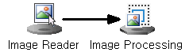

Node Properties

|  |  |  |  |  |
| --- | --- | --- | --- | --- |
| Property group | Property Name | Description | Misc. | Note |
| Enter Image | Input Image Path | Select a valid field that contains the image path information | Required |  |
| Image Processing | Image Processing Edit | Apply various filters to the images. | button | Image Process Tool |
| Image Output | Specify Save Path | Specify the path for the file to be saved. | Optional | Yes, No |
| Storage Path | Displays information about the save path. |  |  |

Image Process Tool

Screen

The image processing node's user interface is composed of several key areas: **Image List, Output, Filter, and Filter Properties**, all organized around a central **main screen**.

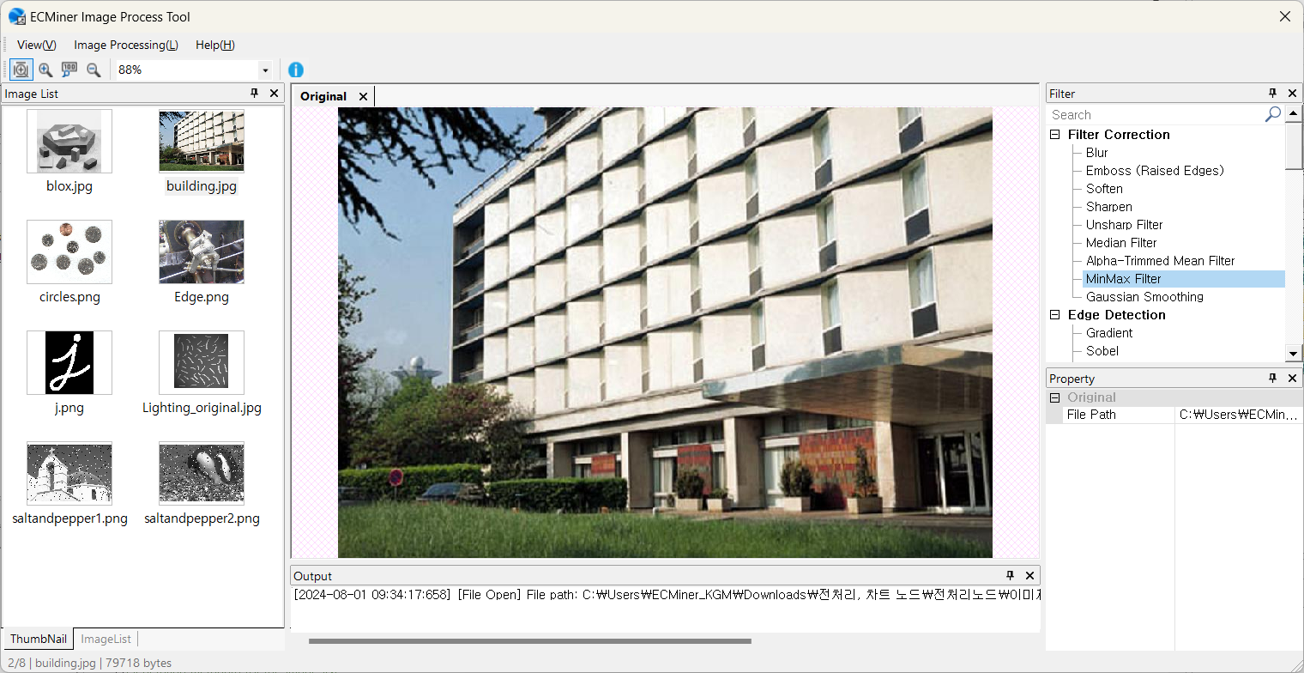

Filter

The filters in the Image Process Tool are categorized into eight main types as follows:

* **Filter Correction**: A collection of filters that perform basic image processing.
* **Edge Detection:** A collection of filters that detect boundaries and outline.
* **Corner Detection**: A collection of filters that detect intersections and corners.
* **Morphology**: Predefined shape-based filters used to transform and describe the structure of objects within an image, applicable to both binary and grayscale images.
* **Geometric Transformation**: A collection of filters that perform geometric transformations.
* **Pyramids**: A method that generates a multi-level image set, with each level having progressively lower resolution, starting from the original high-resolution image.
* **Arithmetic Transformation**: A collection of filters that perform arithmetic operations.
* **Miscellaneous**

Operation Principle of Filters

|  |  |  |  |  |
| --- | --- | --- | --- | --- |
| Category | Filter | | Property | |
| **Name** | **Description** | **Name** | **Description** |
| Filter Correction | Blur | Blur the input image. | Filter Size | Choose from 3x3, 5x5, 7x7, 9x9, 11x11, 13x13 |
| Emboss | Apply an embossing effect to the image to accentuate its edges and create the appearance of a raised surface. | Filter Type | Choose from 135, 90, 45, North, West, South, East, Northeast |
| Soften | Transform the input image to a soft or smooth version. | Filter Type | Choose from Smoothly1,2,3 etc. |
| Sharpen | Enhance the clarity of the input image. | Mask type: | Choose from Sh |
| Unsharp Filter | Removes low-detail elements from the original image and then reapplies them to enhance the sharpness and clarity of edges and details. | Mask Size | Choose from 3x3, 5x5, 7x7, 9x9 |
| Blur Reduction Rate (%) | (Default value: 10.0) |
| Median Filter | Calculates the median value around each pixel in the image, then replaces that pixel value to preserve edges, reduce noise, and improve image smoothness. | Mask Size | Choose from 3x3, 5x5, 7x7, 9x9, 11x11, 13x13 |
| Alpha-Trimmed Mean Filter | Pixels are eliminated according to the designated alpha value in the image, and the average of the remaining values is calculated, thereby effectively mitigating noise and preserving essential image details. | Mask Size | Choose from 3x3, 5x5, 7x7, 9x9, 11x11, 13x13 |
| Alpha Value |  |
| MinMax Filter | Used to remove extreme impulse noise or to highlight features based on brightness differences.  \*Impulse noise: A condition characterized by random scattering of black and white dots. | Mask Size | Choose from 3x3, 5x5, 7x7, 9x9, 11x11, 13x13 |
| Maximum value | Max: Removes dark impulse values to brighten. Min: Removes bright impulse values to darken. |
| Gaussian Smoothing | Replaces the current pixel value in the input image with a weighted average of itself and its neighboring pixel values. | Mask Size | Sigma: (Default value: 1.0) |
| Edge Detection | Gradient | Detects edges in the input image by calculating gradient (derivative) values. | Mask Direction | Choose from x-direction, y-direction, x, y directions |
| Sobel | Detects edges in all directions in the input image, but is more sensitive to edges in diagonal directions and is robust against noise. | Mask Direction | Choose from x-direction, y-direction, x, y directions |
| Mask Size | Choose from 3x3, 5x5, 7x7 |
| Scharr | Enhances the directional accuracy of the Sobel filter, compensating for its limitations. | Mask Direction | Choose from x-direction, y-direction, x, y directions |
| Prewitt | Detects vertical and horizontal edges in the input image. It is fast, but its performance might be lower compared to other methods. | Mask Direction | Choose from x-direction, y-direction, x, y directions |
| Frei-Chen | Equalizes gradients at horizontal, vertical, and diagonal edges. Easily extracts subtle edge details and produces thinner lines, but may incorrectly detect noise as edges. |  |  |
| Roberts | Detects only well-defined edges at a very fast speed. | Mask Direction | Choose from x-direction, y-direction, x, y directions |
| Laplacian | Removes low-frequency (minimal change) and emphasizes high-frequency (significant change) to detect sharp edges in all directions of the input image. | Mask Size | Choose from 3x3, 5x5, 7x7 |
| Canny | Detects edges as a single line by setting upper and lower threshold values. | Mask Size | Choose from 3x3, 5x5, 7x7 |
| Threshold1 | (Default value: 0.2) |
| Threshold2 | (Default value: 0.8) |
| Corner Detection | Minimum Eigenvalue | A corner detection technique that utilizes the minimum eigenvalue in its calculations. | Result Image Format | Choose from Visualize feature points on the original image, View Feature Point Data |
| Mask Size | Choose from 3x3, 5x5, 7x7 |
| Block Size | (Default value: 2) |
| Minimum Detection Value Ratio | (Default value: 0.1) |
| Harris | A technique that detects corners by moving a small window within the object in the image up, down, left, and right, identifying points where there is a significant change in pixel values within the window. | Result Image Format | Choose from Visualize feature points on the original image, View Feature Point Data |
| Mask Size | Choose from 3x3, 5x5, 7x7 |
| Block Size | (Default value: 2) |
| k | (Default value: 0.04) |
| Minimum Detection Value Ratio | (Default value: 0.1) |
| GFTT (Good Features to Track) | A feature detection technique that considers affine transformations for easier tracking. | Result Image Format | Choose from Visualize feature points on the original image, View Feature Point Data |
| Block Size | (Default value: 3) |
| Detection Limit Ratio | (Default value: 0.01) |
| Detection Count Limit | (Default value: 25) |
| Minimum Distance Between Detections | (Default value: 3) |
| FAST | A feature extraction technique designed for extreme speed. | Result Image Format | Choose from Visualize feature points on the original image, View Feature Point Data |
| Threshold | (Default value: 10) |
| Non-Maximum partition suppression | Choose from Use, Not Used |
| Morphology | Erosion | Removes small objects and reduces boundaries in the input image to eliminate unwanted small noise | Kernel Shape | Choose from RECT, CROSS, ELLIPSE |
| Kernel Size | (Default value: 3) |
| Dilation | Expands small objects and enlarges boundaries in the input image to enhance structural features and close small holes. | Kernel Shape | Choose from RECT, CROSS, ELLIPSE |
| Kernel Size | (Default value: 3) |
| Opening | Apply erosion followed by dilation to remove small white noise. | Kernel Shape | Choose from RECT, CROSS, ELLIPSE |
| Kernel Size | (Default value: 3) |
| Closing | Apply dilation followed by erosion to fill or remove small black holes in white objects. | Kernel Shape | Choose from RECT, CROSS, ELLIPSE |
| Kernel Size | (Default value: 3) |
| Binary Threshold | (Default value: 100) |
| Draw Borders | Choose from Yes, No |
| Border Thickness | (Default value: 3.0) |
| R Upper Limit | (Default value: 255) |
| G Upper Limit | (Default value: 255) |
| B Upper Limit | (Default value: 255) |
| Top Hat | Extract small elements and details in the input image, and increase the brightness of objects against a dark background. | Kernel Shape | Choose from RECT, CROSS, ELLIPSE |
| Kernel Size | (Default value: 3) |
| TOP HAT Type | Choose from WHITE, BLACK |
| Gradient | Leaves only the outlines of binary image regions.  The Gradient = Dilate(src) - Erode(src) is identical to subtracting Erode from Dilate. | Kernel Shape | Choose from RECT, CROSS, ELLIPSE |
| Kernel Size | (Default value: 3) |
| Smoothing | This method is primarily used to mitigate noise or damage in an input image or video | Kernel Shape | Choose from RECT, CROSS, ELLIPSE |
| Kernel Size | (Default value: 3) |
| Geometry | Rotation | Rotate the image counterclockwise. | Rotation angle | 0~360 degrees |
| Scaling | Converts the size of the input image to a user-specified size. | Interpolation Method | Choose from Nearest, Linear, Area, Cubic, Lanczos4 |
| Scaling Size | (Default value: 1.0) |
| Super Resolution | Converts a low-resolution input image into a corrected high-resolution image. | Super Resolution Method | Choose from ESPCN, FSRCNN, or LAPSRN. |
| Scaling Size | Choose from x2, x3, or x4. |
| Crop | Cuts the input image to a user-specified size. | Select Area | Crop button |
| Method for Handling Exceptions | Choose from Zero padding, Original Version Only |
| Start of Crop X-value | (Default value: 0) |
| Start of Crop Y-value | (Default value: 0) |
| End of Crop X-value | (Default value: 256) |
| End of Crop Y-value | (Default value: 256) |
| Perspective Transform | Transforms the perspective of the image to a user-selected area. | Select Area | Perspective Transformation button |
| Top Left X-value | (Default value: 0) |
| Top Left Y-value | (Default value: 0) |
| Top Right X-value | (Default value: 256) |
| Top Right Y-value | (Default value: 0) |
| Bottom Left X-value | (Default value: 0) |
| Bottom Left Y-value | (Default value:256) |
| Bottom Right X-value | (Default value:256) |
| Bottom Right Y-value | (Default value:256) |
| Affine Transform | Transforms the input image while preserving the linearity, distance ratio, and parallelism of the image. It supports translations, scaling, rotation, and even shearing and reflection transformations. | Select Area | Affine Transformation button |
| Top Left X-value | (Default value: 25) |
| Top Left Y-value | (Default value: 25) |
| Top Right X-value | (Default value: 204) |
| Top Right Y-value | (Default value: 25) |
| Bottom Left X-value | (Default value: 128) |
| Bottom Left Y-value | (Default value:204) |
| Flip | Flip the input image. | Direction | Choose from X-axis, Y-axis, XY-axis. |
| Translation | Translates the input image. | X-axis | (Default value: 10) |
| Y-axis | (Default value: 10) |
| Log Polar Transformation | Converts from Cartesian to polar coordinates to consistently recognize objects despite changes in rotation or scale. | Direction Method | Choose from Forward, Inverse |
| M | (Default value: 80.0) |
| Pyramids | Up/Down | Applying Gaussian filtering to an image, the pyramid technique adjusts the image size. ‘pyrUp’: x2, ‘pyrDown’: x1/2. | Method | Choose from Up, Down |
| Mean Shift | Mean shift segmentation using image pyramids on the input image. It involves creating an image pyramid at specified levels, and setting the final values using the average spatial values and average color vectors through the spatial window radius and color window radius. However, due to its high computational demand, effective results require using appropriate image sizes and parameter values. | Space Radius | (Default value: 2.0) |
| Color Radius | (Default value: 40.0) |
| Maximum Pyramid Level | (Default value: 3) |
| Arithmetic Operations | Multiply /Divide | Multiplies or divides the input image by a constant value to increase or decrease brightness. | Calculation Method | Choose from Multiplication Operation, Division Operation |
| Calculation Value | (Default value: 1.0) |
| Misc. | Noise Generation | Generates various noises for the restoration of the input image. | Noise type | Choose from Gaussian, Exponential, Poisson, Uniform, Impulse, Salt and Pepper, Multi Gaussian, Laplacian |
| Mean Value | (Default value: 0.0) |
| Standard Deviation | (Default value: 100) |
| Length | (Default value: 1000) |
| Range | (Default value: 0.3) |
| Coefficient | (Default value: -20) |
| Edge Padding | Fills the edges of the image using padding methods. | Padding generation method | Choose from Fill with 0, Edge Value Replication, Mirror, Iteration, Edge Value Exclusion, |
| Padding width | (Default value: 1) |
| Thresholding | Convert pixels brighter than a given threshold to white, and all others to black for binary conversion. | Range Restriction Method | Choose from Binarization, Binarization Color, Inversion, Crop, Zero-Pointing, Zero-Point Color, nversion, OTSU, TRIANGLE |
| Threshold value | (Default value: 90) |
| Specified Value | (Default value: 255) |
| Adaptive Thresholding | Each pixel is compared to the average value of surrounding pixels; if the difference is large, the pixel is treated as an outlier and thresholded accordingly.  Pixels brighter than the adapted threshold are converted to white, and all others to black for binary conversion. | Threshold Method | Choose from Binarization, Binarization Color, Inversion, Crop, Zero-Pointing, Zero-Point Color, nversion, OTSU, TRIANGLE |
| Adaptive Thresh Method | Choose from Average, Gaussian |
| Mask Size | Choose from 3x3, 5x5, 7x7 |
| Maximum value | (Default value: 255) |
| Parameter | (Default value: 5) |
| Hough Line Detection | detect straight lines in an input image. | Canny: Usage Status | Choose from Use, Not Use |
| Canny: Mask size | Choose from 3x3, 5x5, 7x7 |
| Canny: Threshold 1 | (Default value: 0.2) |
| Canny: Threshold 2 | (Default value: 0.8) |
| Hough: Type | Choose from Standard, Probabilistic, Multi-scale |
| Hough: Rho | (Default value: 1) |
| Hough: Theta | (Default value: 180) |
| Hough: Threshold Value | (Default value: 150) |
| Hough: Raw Improvement Value(srn) | (Default value: 0) |
| Hough: Theta Improvement Value(stn) | (Default value: 0) |
| Hough: Minimum Line Length Value | (Default value: 0) |
| Hough: Maximum Line Gap Value | (Default value: 0) |
| Hough Circle Detection | Detect circles in an input image. | DP Value | (Default value: 2) |
| Minimum Distance Value | (Default value: 100) |
| PARAM1 value | (Default value: 200) |
| PARAM2 value | (Default value: 100) |
| Minimum radius value | (Default value: 10) |
| Maximum radius value | (Default value: 0) |
| Use of blur | Choose from Use, Not Use |
| Mask size | Choose from 3x3, 5x5, 7x7, 9x9, 11x11, 13x13 |
| Grayscale | Converts the input color image to a grayscale image. |  |  |
| Color Extraction | Extracts the values corresponding to Red, Blue, and Green from the input image and displays them on the screen. | Color type | Choose from Red, Green, Blue |
| Contours Detection | Finds the contours of an image by identifying boundaries that have the same color or intensity. | Use of Threshold | Choose from Use, Not Use |
| Threshold | (Default value: 127) |
| Contour Detection Mode | Choose from External, List, Ccomp, Tree |
| Contour Approximation Method | Choose from None, Simple, TC89\_L1, TC89\_KCOS |
| Output Method | Choose from Origin, |
| Flood Fill | If adjacent pixels are similar to the reference color, fill the entire area with a single color. | Staring X | (Default value: 0) |
| Staring Y | (Default value: 0) |
| Low Diff | (Default value: 5) |
| High Diff | (Default value: 5) |
| Color | Choose one of 13 colors. |
| Histogram Equalization | Calculate the cumulative sum of the image histogram and normalize it by dividing by the total number of pixels. | Histogram Method | Choosing from Smoothing, Stretching, Sliding |
| Sliding Value | (Default value: 0) |
| Fourier Transform | The Fast Fourier Transform (FFT) is an efficient algorithm that quickly performs the Discrete Fourier Transform and its inverse. It is used in many fields, from digital signal processing to algorithms for solving partial differential equations. | Transformation Method | Choose from Affine transformation, Inverse transformation |
| Change Detection | Compares a pair of selected images pixel by pixel to detect differences. | Comparison File Selection Method | Choose from Next File, Previous File, User-defined |
| Comparison File | Choose from Image List File |
| Threshold | (Default value: 50) |
| Noise Removal Filter | Choose from 1x1, 2x2, 3x3, 4x4, 5x5 |
| View Changes Only | Choose from true, false |
| Change Detection (CNN) | Divides a pair of selected images into patches at the same locations and compares them to detect changes. | Comparison File Selection Method | Choose from Next File, Previous File, User-defined |
| Comparison File | Choose from Image List File |
| Patch size | (Default value: 5) |
| Threshold | (Default value: 50) |
| View Changes Only | Choose from true, false |

### 3.2.12 Image Statistics Node

|  |  |
| --- | --- |
|  | **Image Statistics Node** extracts statistical information about the pixels of image. |

**Overview**

* The **Image Statistics Node** performs grayscale preprocessing on digital images.
* After preprocessing, it extracts statistics (**mean, maximum, minimum, median, variance, and standard deviation**) for each pixel's grayscale values (integers from 0 to 255) in the grayscale image.
* The extracted statistics can be visualized using an output node or chart node.

Usage

|  |  |
| --- | --- |
|  | * Connect to an **Image Reader Node**. * Specify the **Input Image Path**. |

When used with **the Image Processing Node**, connect **Image Reader - Image Processing - Image Statistics**.

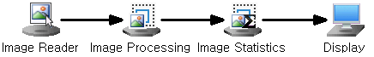

Node Properties

|  |  |  |  |  |
| --- | --- | --- | --- | --- |
| Property group | Property Name | Description | Misc. | Note |
| Enter Image | Input Image Path | Select a valid field that contains the image path information | Required |  |

Result

[Information on the results of image statistics extraction]

In the Display Node, you can view the information of the original data points and the coordinate information of the map points on the reduced dimension.

**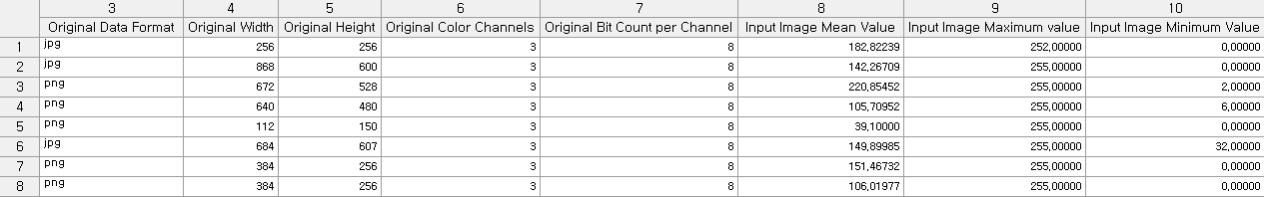**

### 3.2.13 Sort Node

|  |  |
| --- | --- |
|  | **Sort Node** sorts data based on a specified variable. |

Usage

|  |  |
| --- | --- |
|  | * Press **button** to add a list of sorting variables * Specify the sorting criterion variable. * Determine the sorting order. * Use **buttons** to change the order of the criterion variables. |

Node Properties

|  |  |  |  |  |
| --- | --- | --- | --- | --- |
| Property group | Property Name | Description | Misc. | Note |
| Sort | Sorting Variables | Specify the variable to sort, the order of sorting, and the sorting direction. | User interface | Ascend, Descend |

### 3.2.14 Fill Node

|  |  |
| --- | --- |
|  | **Fill Node** replaces values in the data of a specified variable based on conditions. |

Usage

|  |  |
| --- | --- |
|  | * Specify the variable to add the filler. * Click the **Edit Filler** button. * Specify the condition of the data to fill. * Enter the value to be filled.   Optional:   * Edit Filler, delete last filler * Use the User-defined condition |

Node Properties

|  |  |  |  |  |
| --- | --- | --- | --- | --- |
| Property group | Property Name | Description | Misc. | Note |
| Add / Remove Filler | Add Filler | Select the variable name to which you want to add fillers. |  | List of available variables. |
| Delete last filler | Deletes the last filler that is currently added. | button |  |
| Edit Filler | Select the variable you want to add filler to at once. |  |
| Filler Info. | Filler | Choose whether to set the fill condition as missing values or to create a user-defined condition. If you select **User-defined**, you must provide a conditional statement. |  | User-defined, Missing Values |
| Condition Edit | Edit the fill condition using the expression editor. | button | Refer to the **Expression editor.** |
| Value Edit | Specify the value to be filled when the fill condition is met. |

Note: When a user-defined condition is specified, the fill operation is executed as long as the result is true, regardless of the form of the entered expression. This means that whether it's a simple conditional statement (e.g., {A} < 1) or an IF ~ ENDIF structure, as long as the outcome is true, the fill will be performed.

### 3.2.15 Add Node

|  |  |
| --- | --- |
|  | **Add Node** combines multiple datasets into a single dataset. There is no limit to the number of datasets, and you can combine the input data sources together as long as memory allows. |

Usage

When data files are connected to the **Add Node**, their names are displayed in the **Data Source Priority**. There is no limit to the number of data sets that can be added.

|  |  |
| --- | --- |
|  |  |

In **Data Source Priority**, the top data set serves as the **main source**, to which all other data sets are added. Use **the** **,****buttons** to change the rank of a data source.

|  |
| --- |
|  |

The "Fields" column lists the variables that will be added when the node is executed. As shown in the image, variables from "data source A~C" are mapped to the "Fields" variables.

Optional:

* Variable Matching Method
* Variables to Include Main Source Only or All sources
* Decide whether or not to add a source index

Node Properties

|  |  |  |  |  |
| --- | --- | --- | --- | --- |
| Property group | Property Name | Description | Misc. | Note |
| Data Source Priority | Data Source | Specify **the main source**, which serves as the basis for the combine operation in the data sources, to the top position. | Other UI | Refer to the Usage. |
| Selection options | Variable Matching Method | When combining data, choose whether to base for merging on **Variable Name** or **Variable Position**. |  | Variable Name, Variable Position |
| Variables to Include | Specify Variables to Include in the results. | Required | Main Source Only, All sources |
| Add data source index | A column is added for which data source comes from. Data source index is added in each row of data. The default name of the created column is "Data Source", which can be modified. | check-box |  |

### 3.2.16 Derived Column Node

|  |  |
| --- | --- |
|  | **Derived Column Node** creates new variables. |

Usage

**Derived Variables** is to create a new variable from original variable.

|  |  |
| --- | --- |
|  | * Click (1) to enter the new name for the derived variable. * Click (2) button to open the Expression Editor window. Use the Expression Editor to enter the formula for the derived variable. * Check the entered formula through (3). |

Node Properties

|  |  |  |  |  |
| --- | --- | --- | --- | --- |
| Property group | Property Name | Description | Misc. | Note |
| Add / Remove Derived Variables | Add Derived Variable | Creates additional Derived Variables. | button |  |
| Delete the last derived Variable | Deletes the most recently added derived variable, but it will not be deleted if it is the only one remaining |  |
| Edit Derived Variables | Delete any unselected derived variable. |  |
| Added Derived Variable | Derived Variable #00 | A list of derived variables that you want to add. |  | Variable name default: D\_FIELD00 (00 is index) |
| Edit | Edit the expressions of derived variables in the editor window. | button | Refer to the Expression editor. |
| Expression Window | View the formulas defined for that derived variable. |  |  |

### 3.2.17 Sampling Node

|  |  |
| --- | --- |
|  | **Sampling Node** extracts samples from data. |

Usage

|  |  |
| --- | --- |
|  | * Specify the Sampling method. * Specify whether to use the extracted sample or not. * Specify how you want to determine the sample size. * Enter either Percentage or Count based on the selected Sample Size Method. |

Node Properties

|  |  |  |  |  |
| --- | --- | --- | --- | --- |
| Property group | Property Name | Description | Misc. | Note |
| Selection options | Sampling method | Select sampling method. | Required | Random Sampling, Systematic Sampling, Stratified Sampling, From the beginning, Stratified Sampling (Equal Partition) |
| Selection status | Specify whether you want to use or exclude the extracted data. | Select, Exclusion |
| Discrete Variable | Select the discrete variable to be used as the basis for stratified sampling. |  |  |
| Sample size | Sample size method | Specify the method for determining the sample size. | Required | Percentage, Count. |
| Sample size  (percentage) | Set the **Percentage** of samples for sampling. If the calculated sample count is not an integer, it is roundest to integer |  | real numbers from 0 to 100 |
| Sample size (Count) | Set the number(count) of samples for sampling |  | integer |
| NOTE: Description of the sampling method.   * Random Extraction: Extract data randomly using tools such as random number tables. * Hierarchy Extraction: Order every member of the population, extract one sample randomly, and then extract subsequent samples at fixed intervals. (Note: Only up to 50% of the total data can be sampled. Additionally, if the calculated sampling interval is not an integer, it is rounded to the nearest integer.) * Stratified Sampling: Dividing the population into homogeneous subgroups and then randomly sampling from these subgroups based on their sizes. | | | | |

### 3.2.18 Pivot Node

|  |  |
| --- | --- |
|  | **Pivot Node** transforms data by grouping specified variables into columns and rows, and then displays the values of the desired variables based on the specified criteria, excluding the grouped columns and rows. |

Usage

When you click the Configure Pivoting Information button in the properties window, the following window will pop up.

|  |  |
| --- | --- |
|  | * Specify the file path that will be used as the data source. |
|  | * Identify the data format and set the data reading options. |
|  | * Specify the Variable Type. * Note: Variable name and Type cannot be change in ecl file. |
|  | * Specify the data variables with the row and column variables (categorical variables) that will be used for pivoting. |
|  | * Review the list of variables generated after pivoting |

The pivot information interface in the properties window is as follows:

* Click Configure Pivoting Information button to set the properties.

Node Properties

|  |  |  |  |  |
| --- | --- | --- | --- | --- |
| Property group | Property Name | Description | Misc. | Note |
| Selection options | Configure Pivoting Information | Configure pivoting information through the properties window | button |  |

### 3.2.19 Column Filter Node

|  |  |
| --- | --- |
|  | **Column Filter Node** filters out unused variables or renames them. You can select multiple variables for filtering at once by using the Shift and Ctrl keys |

Usage

Column Filter Node has the following **property configuration**

|  |
| --- |
|  |

Column Filter Node's interface is divided into two sections: a functional button section for changing properties, and a Variable Information section for viewing the current status of variables. In the Variable Information section, you can also change variable names and attributes

* (1) function button

|  |  |  |
| --- | --- | --- |
| **button** | **Function** | |
| **btn_normal** | Set to use the selected variables. | |
| **btn_filtered** | Set to not use the selected variables. | |
| **btn_skip** | Set to exclude the selected variables during modeling only. | |
| **btn_condition** |  | Allows you to select variables based on conditions such as variable type or variable name. |

* (2) variable information

|  |  |
| --- | --- |
| **Column** | **Description** |
| **Variable Name**  **(before)** | Displays the variable's status, including data type, whether it is independent or dependent, and whether it is discrete or continuous. |
| **Variable Filter** | Displays attributes like 'use,' 'do not use,' or 'exclude' during algorithm execution. Double-click the left mouse button to change the status. |
| **Variable Name (after)** | Click variable name and rename it. |

Select the variable you want to modify in the Variable Information window.

Use the functional button to change the variable type, or double-click to make the change

Node Properties

|  |  |  |  |  |
| --- | --- | --- | --- | --- |
| Property group | Property Name | Description | Misc. | Note |
| Variable Filter | Variable Filter | Allows to modify Usage status of variables. | Other UI | Refer to the Usage. |

### 3.2.20 Type Change Node

|  |  |
| --- | --- |
|  | **Type Change Nde** modifies the type of a variable, defining independent or dependent variables, and continuous or discrete types. Multiple variables can be selected and changed simultaneously, and multiple selections can be made using the Shift key and Ctrl key. |

Usage

**Type Change Node** has the following property configuration interface.

|  |
| --- |
|  |

The interface has two parts: a functional button for changing properties, and a Variable Information section for displaying the current status of variables

* (1) function button

|  |  |  |
| --- | --- | --- |
| **button** | **Function** | |
|  | Change the type of the selected variable to **Independent Variable**. | |
|  | Change the type of the selected variable to **Dependent Variable**. | |
|  | Change the statistical type of the selected variable to **Continuous** | |
|  | Change the statistical type of the selected variable to **Discrete.** | |
|  | Initializes the type of the variable. | |
| **btn_condition** |  | Allows you to select variables based on conditions such as variable type or variable name. |

* (2) variable information

|  |  |
| --- | --- |
| **Column** | **Description** |
| **Variable Name** | Displays variable names and data types. You cannot change the data type. |
| **Variable Type** | Change the variable type as Independent and Dependent in modeling. Double-click the left mouse button to change it |
| **Data Type** | Displays the statistical types of the variable. Red-marked areas cannot be changed. For other areas, double-click the left mouse button to modify. |

Select the variable you want to modify in the Variable Information window.

Use the functional button to change the variable type, or double-click to make the change.

Node Properties

|  |  |  |  |  |
| --- | --- | --- | --- | --- |
| Property group | Property Name | Description | Misc. | Note |
| Data Type | Data Type | Allows to change the type of a variable. | Other UI | Refer to the Usage. |

### 3.2.21 Counter Node

|  |  |
| --- | --- |
|  | **Counter Node** adds the count results for each group as derived variables according to the specified grouping conditions |

Usage

|  |  |
| --- | --- |
|  | ▪ Specify the grouping variable for counting  ▪ A derived variable will be added based on the selected option. |

Node Properties

|  |  |  |  |  |
| --- | --- | --- | --- | --- |
| Property group | Property Name | Description | Misc. | Note |
| Selection options | Selection options | Adds a derived variable based on the selected value |  | Frequency Calculation, Calculation Cumulative Frequency, Percentage, Cumulative Percentage, Element numbers within the group |
| Grouping Variables and Sequential Variable | Grouping Variables | Specify the grouping variable; it must be discrete | Required |  |
| Sequential Variable | Selecting ‘Element numbers within the group’, assign the element number in the order of the value of the Sequential Variable. | Optional |  |

### 3.2.22 Group Statistics Node

|  |  |
| --- | --- |
|  | **Group Statistics Node** adds a new derived variable based on the selected statistics of the chosen variable according to the specified grouping conditions. |

Usage

|  |  |
| --- | --- |
|  | ▪ Specify the grouping variable for counting  ▪ A derived variable will be added based on the selected option. |

Node Properties

|  |  |  |  |  |
| --- | --- | --- | --- | --- |
| Property group | Property Name | Description | Misc. | Note |
| Selection options | Selection options | Adds a derived variable based on the selected value |  | Frequency Calculation, Calculation Cumulative Frequency, Percentage, Cumulative Percentage |
| Statistics | Continuous Statistics | Specify which continuous statistical information you want to use to add the derived variable. | Required | At least one selection required,  Average, Minimum Value, Maximum value, Range, Total, Variance, Standard Deviation, Median, Q1, Q3, Skewness, Kurtosis, RMS |
| Date Type Statistics | Specify which date-related statistical information you want to use to add the derived variable. | Optional | Minimum date, Maximum date, Date Difference |
| Grouping Variables and Statistical Variables | Grouping Variables | Specify the grouping variable; it must be discrete. | Required |  |
| Statistical Variables | Select the variable for which you want to check statistical values based on the grouping variable. The statistical value variable must be continuous. | Required |  |

### 3.2.23 RANKING Node

|  |  |
| --- | --- |
|  | **Ranking Node** calculates rankings and adds them as a derived variable. |

Usage

|  |  |
| --- | --- |
|  | * Specify the variable and sorting direction to perform the RANKING. * A new RANKED variable will be added. |

Node Properties

|  |  |  |  |  |
| --- | --- | --- | --- | --- |
| Property group | Property Name | Description | Misc. | Note |
| Selection options | Rank Criteria | Specify the variables to be ranked and the ranking direction. | Required | Ascending /Descending |
| Rank Variable Name | Enter the name for the new derived variable created after ranking. |  |
| Save as String | Specify whether to add the ranking variable as a string type. | Optional |  |
| Rank Count | Specify the number of ranks. If the entered value is less than 2, the rank count will be set to the total number of data entries. | Required |  |

### 3.2.24 Binning Node

|  |  |
| --- | --- |
|  | **Binning Node** segment an independent variable into several intervals. It is used for converting numerical variables into categorical ones or for redefining the categories of discrete variables. |

Usage

Using **Binning Node**, two datasets are required: bass data to determine the binning criteria and another data to apply the binning. The bass data must have a **discrete dependent variable**, requiring an initial step of saving the data in an ECL file.

|  |  |
| --- | --- |
|  |  |

|  |
| --- |
| Clicking "**Edit Binning**" button, you will see the following interface. |
|  |
| Load the previously saved ECL file as bass data and Specify the Dependent Variable.  Add the Independent Variables and execute binning on each of the variables  <Note> Interval and Interval Number are only for continuous variables. |
|  |
| Adjust the intervals based on the charts and statistics. |

Node Properties

|  |  |  |  |  |  |
| --- | --- | --- | --- | --- | --- |
| Property group | Property Name | function | Description | Misc. | Note |
| Selection options | Edit Segmentation | Base Date | Load the ECL file. |  |  |
| Dependent Variable | Select dependent variable values considered as an Event. |  |  |
| Independent Variable | Select independent variable.  -Continuous data splits according to interval conditions such as **Buckets/Quantile** and **Interval Number**.  -Discrete data splits all attributes into separate groups. |  |  |
| Binning Variable | Display the added variable for binning. |  |  |
| Binning Results | Display statistical information for each interval.  Right-click to perform modifications, such as merging or splitting intervals. |  |  |
| Interval | Modify the interval criteria for continuous data. | Right click, drag |  |
| Chart | Display the information for each group. |  |  |

### 3.2.25 Transpose Node

|  |  |
| --- | --- |
|  | **Transpose Node switches** the rows and columns of the data. |

Usage

|  |  |
| --- | --- |
|  | * Click the **Get variable information** button to retrieve the data.   Optional:   * Column of original variable name * Add variable name. |

Node Properties

|  |  |  |  |  |
| --- | --- | --- | --- | --- |
| Property group | Property Name | Description | Misc. | Note |
| Selection options | Option to create var\_name column | Decide whether to add the original data's column names as new variables. | Optional | Yes, No |
| Whether variable name is specified | Decide whether to use specific variable values from the original data as column names for the new data. | Yes, No |
| Variable Selection | Specify the variables to be used as column names. | When specifying column names |  |
| When Variable Names are Duplicated | Specify the handling method in case of duplicate variable names. | When specifying column names | Assign Index, Error Occurred |
| Get variable information | After setting the properties, you must click the **Get variable information** button to retrieve the data. It is necessary to click this button each time the properties are changed. | Required, button |  |

**Example**

You can transpose rows and columns, using a specific variable as the column name for the new data, and adding the original column names as a new variable.

|  |  |
| --- | --- |
| <Original Data> | <Transpose Data> |
|  |  |

### 3.2.26 Tagging Node

|  |  |
| --- | --- |
|  | **Tagging Node** performs morphological analysis by segmenting morphemes and assigning parts of speech |

Usage

|  |  |
| --- | --- |
|  | * ECMiner™ can perform morphological analysis using its built-in dictionary without any additional configuration options.   Optional:   * Use the User Dictionary File. * Specify Variable Name of Result column. |

|  |
| --- |
| When you click the "User Dictionary Registration" button, you will see the following interface. |
|  |
| Click the **dictionary registration** button to access the **User-defined Dictionary** and add words that are not in the default dictionary. |
| **NOTE: If no file path is specified, the User Dictionary File defaults to the 'userdic.txt' file located in the KmatRsc folder within the ECMiner™ installation directory.** |

**The format of the dictionary**

**(1) Lemma Notation**

Enter the **lemma** and **part of speech**, separated by a tab. You can use standard parts of speech or user-defined parts of speech.

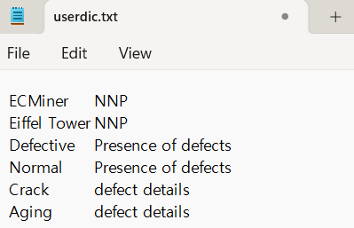

**(2) Regular Expression**

Enter the “**Regular Expression”**, **part of speech**, and the **regular expression** separated by tabs. You can use standard parts of speech or user-defined parts of speech.

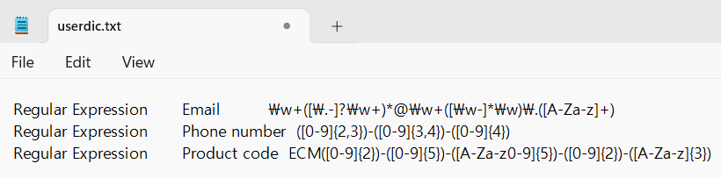

Node Properties

|  |  |  |  |  |
| --- | --- | --- | --- | --- |
| Property group | Property Name | Description | Misc. | Note |
| User Dictionary | User Dictionary File | Specify the dictionary file path as needed. | button | Refer to the Usage. |
| User Dictionary Registration | Register morphemes in the dictionary to add new words or specify phrases as morphemes. |
| Specify Variable Names | Variable Name for Morphological Analysis Result | Specify the default names for newly created morpheme and part-of-speech variables. |  |  |

**Results**

Tagging Nodes accepts a string-type variable as input and produces five output columns.

* **Input sentence**: Input data for morphological analysis.
* **Text\_Result (Morpheme)**: Morphemes extracted from the input sentence
* **Text\_Result (Part of Speech)**: Parts of speech of the morphemes
* **English POS of Words**: English part of speech of the morpheme within the phrase
* **Sentence English POS (Part of Speech)**: English part of speech of the morpheme within the sentence

**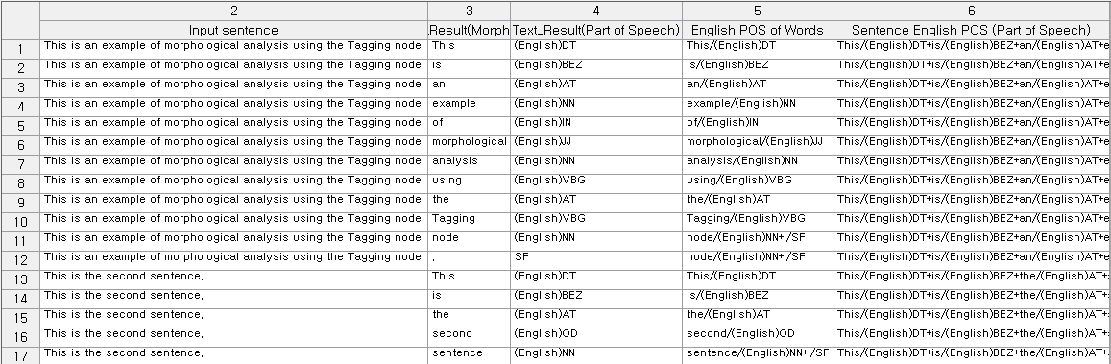**

*\* When there are two or more character-type variables*

Assume there is data composed of two character-type variables as follows.

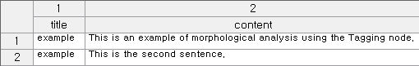

You can see that combining two character-type variables from the input data forms the input sentence.

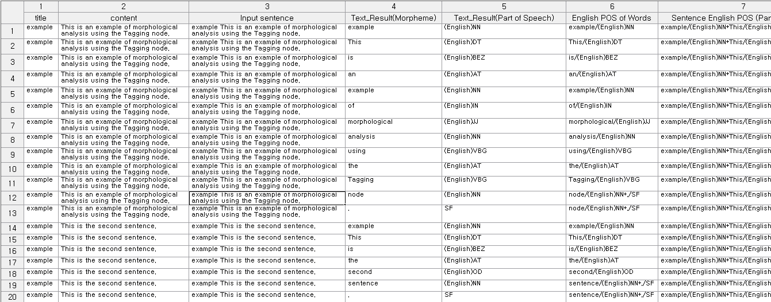

### 3.2.27 Import R Node

|  |  |
| --- | --- |
|  | **Import R Node** executes R scripts using the input data within ECMiner™.The input data are automatically converted into an R DataFrame named 'ecmData’, and the results are returned to ECMiner™ as output data. |

Usage

|  |  |
| --- | --- |
|  | * Select R environment in the **Information**. * Click the **Edit** button to write of import the R script. |

Node Properties

|  |  |  |  |  |
| --- | --- | --- | --- | --- |
| Property group | Property Name | Description | Misc. | Note |
| Script | Edit | Opens the R script editor to write or import code. | Required, button |  |
| Information | Information | Select the R version to use. When selected, the R version, Environment Location, and R execute file path are displayed. | Required, button |  |

### 3.2.28 Import Python Node

|  |  |
| --- | --- |
|  | **Import Python Node** executes Python scripts using the input data within **ECMiner™**. The input data are automatically converted into a Python **DataFrame** named ‘ecmData’, and the results are returned to **ECMiner™** as output data. |

Usage

|  |  |
| --- | --- |
|  | * Select Python environment in the **Information**. * Click the **Edit** button to write of import the Python script. |

Node Properties

|  |  |  |  |  |
| --- | --- | --- | --- | --- |
| Property group | Property Name | Description | Misc. | Note |
| Script | Edit | Opens the Python script editor to write or import code. | Required, button |  |
| Information | Information | Select the Python version to use. When selected, the Python version, Environment Location, and Python execute file path are displayed. | Required, button |  |

|  |  |  |  |  |  |  |  |  |  |  |  |  |  |  |  |  |  |  |  |  |  |  |  |  |  |  |  |  |  |  |  |  |  |  |  |  |  |  |  |  |  |  |  |  |  |  |  |  |  |  |  |  |  |  |  |  |  |  |  |  |  |  |  |  |  |  |  |  |  |  |  |  |  |  |  |  |  |  |  |  |  |  |  |  |  |  |  |  |  |  |  |  |  |  |  |  |  |  |  |  |  |  |  |  |  |  |  |  |  |  |  |  |  |  |  |  |  |  |  |  |  |  |  |  |  |  |  |  |  |  |  |  |  |  |  |  |  |  |
| --- | --- | --- | --- | --- | --- | --- | --- | --- | --- | --- | --- | --- | --- | --- | --- | --- | --- | --- | --- | --- | --- | --- | --- | --- | --- | --- | --- | --- | --- | --- | --- | --- | --- | --- | --- | --- | --- | --- | --- | --- | --- | --- | --- | --- | --- | --- | --- | --- | --- | --- | --- | --- | --- | --- | --- | --- | --- | --- | --- | --- | --- | --- | --- | --- | --- | --- | --- | --- | --- | --- | --- | --- | --- | --- | --- | --- | --- | --- | --- | --- | --- | --- | --- | --- | --- | --- | --- | --- | --- | --- | --- | --- | --- | --- | --- | --- | --- | --- | --- | --- | --- | --- | --- | --- | --- | --- | --- | --- | --- | --- | --- | --- | --- | --- | --- | --- | --- | --- | --- | --- | --- | --- | --- | --- | --- | --- | --- | --- | --- | --- | --- | --- | --- | --- | --- | --- | --- | --- |
| ***NOTE****: Regular expressions serve as templates to match specific patterns and search terms in data. They are made up of literals (pure letters or numbers), metacharacters (which represent types of characters or character groups), and escape sequences.*   * **Literal**: When only literals are used, without metacharacters and escapes, their representation is identical to the lemma notation. Example) "Regular expression name John Doe" extracts "John Doe" as a morpheme and assigns it the part of speech "name." * Single Character Metacharacters  |  |  |  | | --- | --- | --- | | **Metacharacters** | **Description** | **Examples** | | **\*** | Find at least 0 preceding strings or sub-expressions. | "zo\*" finds "z" and "zoo." | | **+** | Find one or more of the preceding strings or subexpressions. | "zo+" finds "zo" and "zoo" but not "z." | | **?** | Find one or more of the preceding strings or subexpressions.  When a `?` follows other quantifiers like `\*`, `+`, `?`, `{n}`, `{n,}`, or `{n,m}`, the matching pattern becomes non-greedy. Non-greedy patterns seek the smallest possible matching section within the searched string, in contrast to the default greedy patterns, which aim to match as much of the string as possible. | zo? finds "z" and "zo" but not "zoo”.  "o+?" finds one "o" in "oooo," while "o+" finds all the "o"s.  "do(es)?" finds "do" in both "do" and "does." | | **^** | Locates positions at the start of the searched string. When used with the `m` flag for multi-line searching, it also finds positions following `\n` or `\r`.  When used as the first character inside brackets, `^` negates the set of characters. | "^\d{3}" finds three digits at the beginning of the searched string.  "[^abc]" finds any character except for a, b, and c. | | **$** | Locates positions at the end of the searched string. When used with the `m` flag for multi-line searching, it also finds positions before `\n` or `\r`. | "\d{3}$" finds three digits at the end of the searched string. | | **.** | Find all single characters except the newline character `\n`. To find all characters, including `\n`, patterns like `[\s\S]` are used. | "a.c" finds "abc," "a1c," and "a-c." | | **[]** | Square brackets mark the beginning and end of a set, grouping one or more individual characters into a list. | [1-4] finds "1", "2", "3", or "4". [^aAeEiIoOuU] finds any character that is not a vowel. | | **{}** | Quantifiers mark the start and end of an expression and specify the number of times to repeat the sequence when the number of characters cannot be predefined. | a{2,3} finds "aa" and "aaa". | | **()** | Parentheses mark the beginning and end of a subexpression, which can be stored for later use. | A(\d) finds anything from "A0" to "A9", storing the digit for later use. | | **|** | The pipe symbol represents a choice between two or more items. | z|food finds either "z" or "food". (z|f)ood finds "zood" or "food". | | **/** | Slashes mark the beginning and end of a literal regular expression pattern. After the second slash, a single character flag can be added to specify search behavior. | /abc/gi is a literal regular expression that finds "abc". The 'g' flag specifies finding all occurrences of the pattern, and the 'i' flag specifies ignoring case during the search. | | **\** | The following character is indicated as a special character, literal, or octal escape.  To search for a single character meta character, you must escape the character. | \n finds a newline character. \( finds "(". \\ finds "\". \+ finds "+". |  * Composite character-type metacharacters  |  |  |  | | --- | --- | --- | | **Metacharacters** | **Description** | **Example** | | **\b** | Finds word boundaries, which are positions between a word and a space. | "er\b" finds "er" in "never" but not in "verb." | | **\B** | Finds non-word boundaries. | "er\B" finds "er" in "verb" but not in "never." | | **\d** | Finds digits.  Same as [0-9]. | When the searched string is "12 345," "\d{2}" finds "12" and "34." "\d" finds "1," "2," "3," "4," or "5." | | **\D** | Finds non-digit characters.  Same as [^0-9]. | "\D+" finds "abc" and " def" in "abc123 def." | | **\w** | Finds non-digit characters.  Same as [^0-9]. | When the searched string is "The quick brown fox…," "\W+" finds "…" and all spaces. | | **\W** | Finds all characters except A-Z, a-z, 0-9, and underscores.  Same as [^A-Za-z0-9\_]. | When the searched string is "The quick brown fox…," "\W+" finds "…" and all spaces. | | **[xyz]** | It is a character set. Finds any one of the specified characters. | "[abc]" finds "a" in "plain." | | **[^xyz]** | It is a negated character set. Finds any characters not specified. | "[^abc]" finds "p," "l," "i," and "n" in "plain." | | **-a[z]** | It is a character range. Finds characters within a specified range. | "[a-z]" finds lowercase English letters from "a" to "z." | | **[^a-z]** | It is a negated character range. Finds any characters not within the specified range. | "[^a-z]" finds all characters that are not in the range "a" to "z." | | **{n}** | Finds exactly n occurrences, where n is an integer. | "o{2}" does not find the "o" in "Bob" but finds the two "o"s in "food." | | **{n,}** | Finds at least n occurrences, where n is an integer.  "\*" is equivalent to {0,}.  "+" is equivalent to {1,}. | "o{2,}" does not find the "o" in "Bob" but finds all the "o"s in "foooood." | | **{n,m}** | Finds at least n and at most m occurrences, where n and m are integers, and n is less than or equal to m. There should be no space between the comma and the numbers.  "?" is equivalent to {0,1}. | When the searched string is "1234567," "\d{1,3}" finds "123," "456," and "7." | | **(pattern)** | Finds a pattern and stores the matching items.  To find the parenthesis characters ( ), use "\(" or "\)". | "(Chapter|Section) [1-9]" finds "Chapter 5" and stores "Chapter" for later use. | | **(?:pattern)** | Finds a pattern but does not store the matches. That is, the matches are not saved for later use. This is useful when combining parts of the pattern with the "or" character (|). | "industr(?:y|ies)" is the same as industry|industries. | | **(?=pattern)** | It is a positive lookahead. After finding a match, it starts the search for the next match from in front of the matched text. The matches are not stored for later use. | ^(?=.\*\d).{4,8}$ ensures a password is between 4-8 characters and includes at least one digit.  Within the pattern, ".\*\d" finds any number of characters followed by a digit. When the searched string is "abc3qr," it matches "abc3."  ".{4,8}" starts from the front, not the back of the match, finding 4-8 characters. This matches "abc3qr."  "^" and "$" specify positions at the start and end of the searched string. This ensures that if there are characters outside the matched string, it does not count as a match. | | **(?!pattern)** | It is a negative lookahead. It finds search strings that do not match the pattern. After finding a match, it starts the search for the next match from in front of the matched text. The matches are not stored for later use. | "\b(?!th)\w+\b" finds words that do not start with "th."  Within the pattern, "\b" finds word boundaries. When the searched string is " quick," it matches the first space. "(?!th)" finds strings that are not "th," matching "qu."  "\w+" searches for a word from the front of the match. This matches "quick." | | **\cx** | Finds control characters marked with "x". The value of "x" must be within the range of A-Z or a-z. If not, "c" is considered as the literal character "c". | "\cM" finds the Ctrl+M or carriage return character. | | **\xn** | Finds "n", where "n" is a hexadecimal escape value. The hexadecimal escape value must be exactly two digits long. ASCII codes can be used in regex. | "\x41" finds "A". "n" must be exactly two digits, so "\x041" is like writing "\x04" followed by "1". | | **\num** | Finds "n", where "n" is a hexadecimal escape value. The hexadecimal escape value must be exactly two digits long. ASCII codes can be used in regex. | "(.)\1" finds two consecutive identical characters. | | **\n** | Identifies either an octal escape value or a backreference. If there are more than "n" captured subexpressions before "\n", then "n" is a backreference indicating additional repetitions of the subexpression. If "n" is an octal (0-7) and there are not enough preceding captures, then "n" is an octal escape value. | "(\d)\1" finds two consecutive identical digits. | | **\nm** | Identifies either an octal escape value or a backreference. If there are more than "nm" captured subexpressions before "\nm", then "nm" is a backreference. If there are "n" captures before "\nm" and a literal "m" follows, then "n" is a backreference followed by literal "m". If none of these conditions are met, "\nm" finds the octal escape value "nm", assuming "n" and "m" are octal (0-7). | "\11" finds the tab character. | | **\nml** | Finds the octal escape value "nml" where "n" is an octal (0-3) and "m" and "l" are octals (0-7). | "\011" finds the tab character. | | **\un** | Finds "n", where "n" is a Unicode character represented by a four-digit hexadecimal | "\u00A9" finds the copyright symbol (©). |  * Escaping: Unmentioned non-printable characters in metacharacters are also specified by escapes.  |  |  |  | | --- | --- | --- | | **Metacharacters** | **Description** | **Included options** | | **\f** | Form feed character | \x0c and \cL | | **\n** | Line feed character | \x0a and \cJ | | **\r** | Carriage return character | \x0d and \cM | | **\s** | All whitespace characters, including space, tab, and form feed characters. | [ \f\n\r\t\v] | | **\S** | All non-whitespace characters | [^ \f\n\r\t\v] | | **\t** | Tab character | \x09 and \cI | | **\v** | Vertical tab character | \x0b and \cK | |

## 3.3 Chart Node

**Chart Node** is for data visualization. Data visualization is an essential tool, and **ECMiner™** provides various charts option.

* [3D Chart Node (√)](#_3.3.1_3D_Chart)  
  Create dynamic 3D charts using data.
* [Bar Chart](#_3.3.2_Bar_Chart)   
  Draw a bar chart using data.
* [Box plot](#_3.3.3_Box_plot)  
  Visualize data distribution with median, quartiles, range, and outliers.
* [Contour Chart](#_3.3.4_Contour_Chart_1)  
  Draw a contour chart using data.
* [Control Chart (√)](#_3.3.5_Control_Chart)  
  Display a control chart to show data distribution.
* [Histogram](#_3.3.6_Histogram)  
  Draw a histogram to assess the distribution of continuous variables.
* [Matrix Chart (√)](#_3.3.7_Matrix_Chart)  
  Visualize data in a matrix format to show correlations between variables.
* [Matrix GL Chart](#_3.3.8_Matrix_GL)  
  Use GP/GPU to explore variations across variables in a matrix chart.
* [MSPC Chart (√)](#_3.3.9_MSPC_Chart)  
  Analyze multiple interrelated variables to monitor process stability and anomalies.
* [Multi Chart](#_3.3.10_Multi_Chart)  
  Compare features of multiple variables simultaneously.
* [Parallel Coordinates GL Chart](#_3.3.11_Parallel_Coordinates)  
  Connect variables across parallel axes to identify data patterns and relationships.
* [Pareto Chart](#_3.3.12_Pareto_Chart)  
  Draw a Pareto chart to visualize the distribution of discrete variables.
* [Pie Chart](#_3.3.13_Pie_Chart)  
  Draw a pie chart to show the relative ratios of discrete data.
* [Process Contribution Chart](#_3.3.14_Process_Contribution)  
  Visualize model data and contributions using the Process and Model Node.
* [Rader Chart](#_3.3.15_Radar_Chart)   
  Display values of multiple variables along radiating axes for comparison.
* [SPC Chart (√)](#_3.3.16_SPC_Chart)  
  Monitor and analyze data fluctuations for process stability and quality control.
* [Statistic Chart](#_3.3.17_Statistic_Chart)  
  Compare statistics of variables, showing changes in statistics at a glance
* [Scatter plot](#_3.3.18_Scatter_plot)  
  Create scatter plots to display trends between variables.
* [Trend Chart (√)](#_3.3.18_Trend_Chart)  
  Create time series charts to display trends.
* [Word Cloud](#_3.3.19_Word_Cloud)  
  Visualize word frequencies in text data with word size proportional to frequency.

**ECMiner™** provides data slide bar function to the charts marked (√) in above list. The bar function allows you to match the data to the charts which specifies the distribution and area of specific data within the chart.

Chart Toolbar

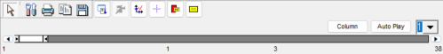

1. Common buttons in Chart Toolbar

1.  **Edit**   
   Edit the chart’s properties. Also, can open ‘Editing’ window on the chart screen by following steps: right click on the chart → Properties(P)
2.  **Print**  
   Print the chart.
3. 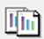 **Copy**   
   Copy the chart.
4.  **Save**   
   Save the chart as an image file.
5.  **Extract Data**   
   Extract data from the displayed points. Generate **Row Select Node** to select displayed points after executing the button.
6.  **Axes Scaling**Adjust the scale of X and Y axes equally.
7.  **Indicator Line**Activates/deactivates vertical and horizontal indicators that follows the position the mouse points to.
8.  **Mark Tip**Activates/deactivates the function that displays a mark of the data point where the mouse points to.
9.  **Mark All**Activates/deactivates the function that displays marks of all the data points showing.
10.  **Auto Play**Select the desired number of data using the slide bar, then run the button. The slide bar moves automatically and shows selected data.  
    Selectable movement interval times: 1, 5, and 10 seconds.
11. Use the slide bar to select the data for the desired section, and highlight the selected data in a series color.

2. Basic Usages in Chart

1. Move the chart by mouse right clicking and dragging.
2. Zoom in/out of the desired part by clicking and dragging the set rectangular area.  
   Zoom feature doesn’t provide in charts below: Radar Chart, Matrix Chart, Box Plot, Word Cloud

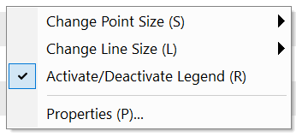

1. Change Point Size  
   Change the size of the points that display data in the chart. Point sizes from 1 to 10.
2. Change Line Size  
   Change the thickness of the line connecting the data points in the chart. Line sizes from 1 to 5.
3. Activate/Deactivate Legend  
   Select whether to display the legend or not. When the legend is activated, it also displays the legend to help understanding the chart. Can check/uncheck to display or hide the data when the data is marked with a checkbox.
4. Properties  
   Open ‘Editing’ window. Same as ‘Edit’ button in toolbar.

**3. 3D chart Toolbar**

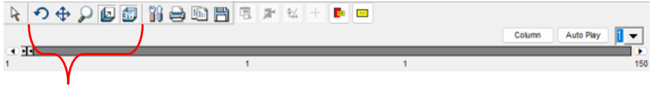

These 5 buttons are used only at 3D chart.

1.  **Rotate**Rotate chart by clicking & dragging.
2.  **Move**Move the chart by clicking & dragging.
3.  **Zoom**  
   Zoom in / out by clicking & dragging. Drag from the top left to the bottom right to zoom in, and reverse to the original.
4.  **Depth**Adjust the depth in 3-dimensions by clicking & dragging.
5.  **3D**Switch chart to 3D or 2D

**4. GL chart Toolbar**



GL chart Toolbar is almost same as basic chart toolbar. Print, Save, Indicator, Mark tip and Auto Play buttons are same function.

1.  **Max Range**Enter the desired range and press the Set button to separate and highlight the data in the range.
2.  **Point**Change the size of the points that display data in the chart. Used in the Matrix GL Chart.  
   Point sizes from 3 to 10.
3.  **Line**Change the thickness of the line connecting the data points in the chart. Used in the Parallel Coordinates GL Chart. Line sizes from 1 to 10.

### 3.3.1 3D Chart

|  |  |
| --- | --- |
|  | **3D Chart** is for 3D dynamic chart using data. |

Usage

|  |  |
| --- | --- |
|  | ▪ For two or more series chart, click Add Series, and define the variables for X-axis, Y-axis, and Z-axis.  ▪ Chart options  Label  Point shape |

Node Properties

|  |  |  |  |  |  |
| --- | --- | --- | --- | --- | --- |
| Property group | Property Name | | Description | Misc. | Note |
| Chart options | Label | | Select the variable to label that separate the data with coloring. |  |  |
| Add | | Used to plot multiple series on a single chart. Adds selected series. | button |  |
| Delete | | Deletes last added series. | button |  |
| Edit | | Removes unselected series. | button |  |
| Series List | Series #00 | X-axis | Select a variable for X-axis | Required |  |
| Y-axis | Select a variable for Y-axis | Required |  |
| Z-axis | Select a variable for Z-axis | Required |  |
| Point shape | Point shape: Rectangle, Circular, Triangle, Inverse Triangle, Cross, X-type, Star-Shape, Diamond, Small Dot |  |  |

### 3.3.2 Bar Chart

|  |  |
| --- | --- |
|  | **Bar Chart** draws a bar chart using data. |

Usage

|  |  |
| --- | --- |
|  | ▪ Specify the variable to be represented in the chart within the variable properties of the Series List properties window.  ▪ Optional  Specify **Label** properties  Specify **Bar Stack** properties  Click the 'Add Series' button as many times as needed to add the required number of series |

Node Properties

|  |  |  |  |  |  |
| --- | --- | --- | --- | --- | --- |
| Property group | Property Name | | Description | Misc. | Note |
| Chart options | Bar Stack | | Specify the type of bar chart. (Disabled when the X-axis type is set to series index due to the nature of the Bar Chart.) | Required | None, Stacked, Stacked 100% |
| X-axis format | | Set X-axis type.  Data Index: Data index values of the specified variables will be used for the X-axis.  Series Index: The chart will be divided by series, which can be identified through the legend | Required | Data Index, Series  Index |
| Add | | Used to plot multiple series on a single chart. Adds selected series. | button |  |
| Delete | | Deletes last added series. | button |  |
| Edit | | Removes unselected series. | button |  |
| Series List | Series #00 | Variable | Specify the variable to be displayed as a bar chart | Required |  |
| Label | Specify the variable to be used as the label. If the type of the specified variable is discrete, this property will be ignored |  |  |
| NOTE: The meaning of a Bar chart varies based on the variable type.   * If the variable is continuous, the x-value represents the data index and the y-value represents the corresponding variable value. * If the variable is discrete (categorical), the x-value represents the category name and the y-value represents the frequency of data in that category. | | | | | |

### 3.3.3 Box plot

|  |  |
| --- | --- |
|  | **Box plot** visualize the distribution of data with information of median, quartiles, range, and outliers by Group variable. |

Usage

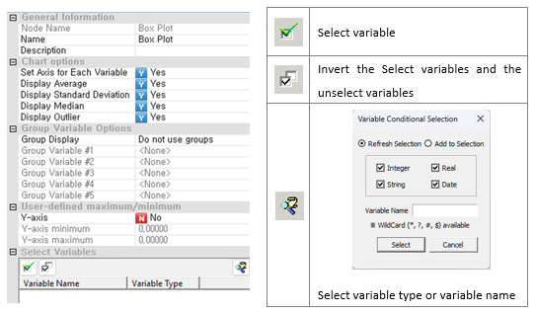

Optional

Chart option:

▪ Specify Set Axis for Each Variable, Display Average, Display Standard Deviation, Display Median, and Display Outlier properties

Group Variable Option:

▪ Specify Group Variable Options properties

User-defined maximum/minimum

Node Properties

|  |  |  |  |  |
| --- | --- | --- | --- | --- |
| Property group | Property Name | Description | Misc. | Note |
| Chart options | Set Axis for Each Variable | Decide whether to set separate axes for each variable and draw the chart accordingly. | Required | Yes, No |
| Display Average | Decide whether to display averages on the chart. | Required | Yes, No |
| Display Standard Deviation | Decide whether to display the standard deviation on the chart. | Required | Yes, No |
| Display Median | Decide whether to display the median on the chart. | Required | Yes, No |
| Outlier Display | Decide whether to display outlier on the chart. | Required | Yes, No |
| Group Variable Options | Group Display | Specify the method for displaying group-related variables in the data if such variables are present. | Required | No grouping or Series separation |
| Group Variable #1 | Select the first group variable. |  |  |
| Group Variable #2 | Select the second group variable. |  |  |
| Group Variable #3 | Select the third group variable |  |  |
| Group Variable #4 | Select the fourth group variable |  |  |
| Group Variable #5 | Select the fifth group variable. |  |  |
| User-defined maximum/minimum | Y-axis | Decide whether to use manually specified Y-axis values. | Required | Yes, No |
| Y-axis minimum | Minimum value of Y-axis |  | Real Number |
| Y-axis maximum | Maximum value of Y-axis |  | Real Number |
| Select Variables | Variable List | Specify the variables to be plotted. | Required |  |

**Box plot**: Divides the data into 10 groups based on the two group variables FIELD1 and FIELD4, and draws 10 box plots accordingly when 'Group Display' is set to 'Series'.

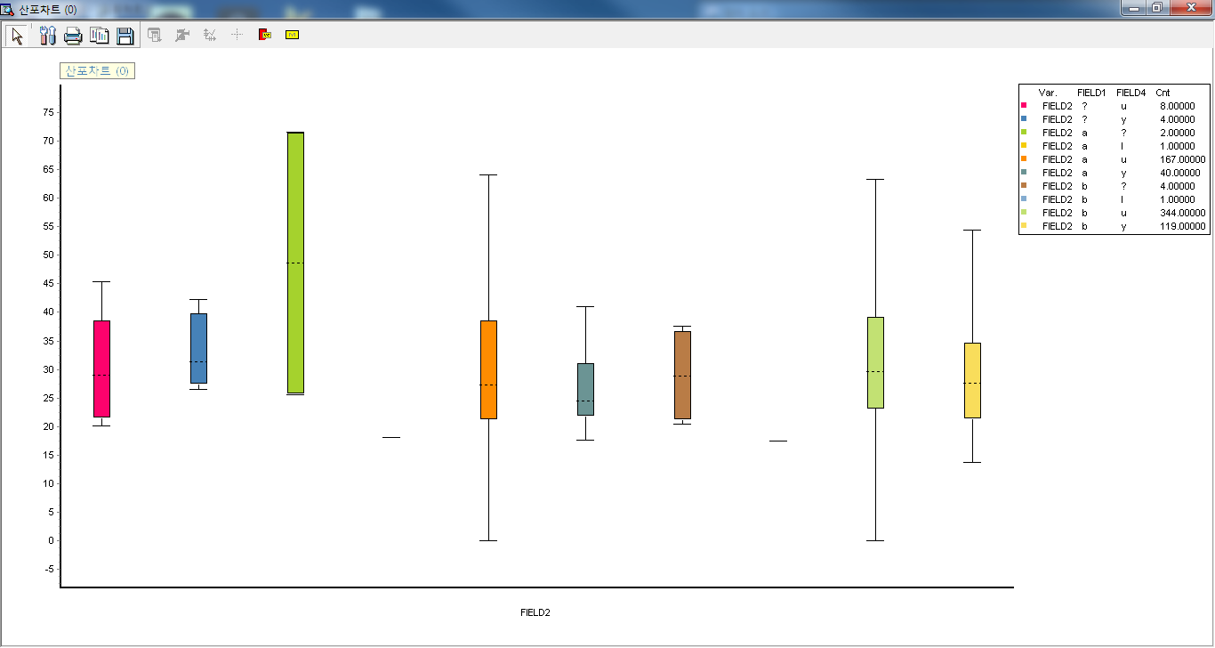

### 3.3.4 Contour Chart

|  |  |
| --- | --- |
|  | **Contour Chart** draws a contour chart using data. |

Usage

|  |  |
| --- | --- |
|  | * Specify the variables to be used for the X1-axis, X2-axis, and Y-axis in the Series List properties window.   Options   * Specify **Color pattern** properties. * Specify **3D Surface** properties. * Click the 'Add Series' button as many times as needed to add the required number of series   ***NOTE***  The X1-axis and X2-axis correspond to the two-dimensional axes for the contour coordinates, while the Y-axis represents the height at each coordinate. |

Node Properties

|  |  |  |  |  |  |
| --- | --- | --- | --- | --- | --- |
| Property group | Property Name | | Description | Misc. | Note |
| Chart options | 3D Surface | | Specify whether to display in 3D or in 2D. | Required | Yes, No |
| Add | | Used to plot multiple series on a single chart. Adds selected series. | button |  |
| Delete | | Deletes last added series. | button |  |
| Edit | | Removes unselected series. | button |  |
| Series List | Series #00 | X1-Axis | Specify the variable for the X1 axis (first position coordinate). | Required |  |
| X2-Axis | Specify the variable for the X2 axis (second position coordinate) | Required |  |
| Y-Axis | Specify the Y-axis variable, which represents the height. | Required |  |
| Color pattern | Specify the color pattern for the contours on the chart. | Required | Strongly, Weaken, Three Colors, Two Colors, Monochrome |

### 3.3.5 Control Chart

|  |  |
| --- | --- |
|  | **Control Chart** displays a control chart Using a control chart, you can see the distribution of data. |

Usage

|  |  |
| --- | --- |
|  | * For two or more series, click **Add Series** and select the variables of X-axis and Y-axis. * Options   Label  Colors by Label  Point shape |

Node Properties

|  |  |  |  |  |  |
| --- | --- | --- | --- | --- | --- |
| Property group | Property Name | | Description | Misc. | Note |
| Chart options | Label | | Select the variable to label that separate the data with coloring. |  |  |
| Colors by Label | | Select whether to color by label or by series. |  | Yes, No |
| Add | | Used to plot multiple series on a single chart. Adds selected series. | button |  |
| Delete | | Deletes last added series. | button |  |
| Edit | | Removes unselected series. | button |  |
| Series List | Series#00 | X-Axis | Select a variable for X-axis | Required |  |
| Y-Axis | Select a variable for Y-axis | Required |  |
| Point shape | Point shape: Rectangle, Circular, Triangle, Inverse Triangle, Cross, X-type, Star-Shape, Diamond, Small Dot | Required |  |

### 3.3.6 Histogram

|  |  |
| --- | --- |
|  | **Histogram** draws a histogram that allows you to assess the distribution of a continuous variable. It is applicable for continuous variables and can simultaneously plot both a normal distribution and a curve. |

Usage

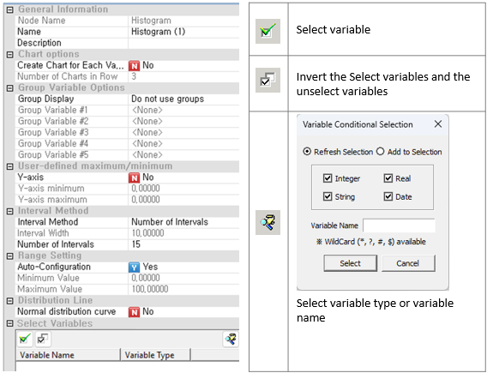

* Specify **Interval Method** as **Interval Width** or **Number of Intervals**.
* Select a continuous variable to draw a histogram.

**Options**

Chart option:

* Specify **Number of Charts in Row** when **Create Chart for Each Variable** is set to **Yes**

Group Variable Options:

* Specify **Group Display**

User-defined maximum/minimum:

* Specify **Y-axis minimum** and **maximum** when **Y-axis** is set to **Yes**

Interval Method:

* Specify **Interval Width** when **Interval Method** is set to **Interval Width**
* Specify **Number of Intervals** when **Interval Method** is set to **Number of Intervals**

Range Setting:

* Range will be defined by the maximum and minimum values of the **Variable Selection** when **Auto-Configuration** is set to **Yes**
* Specify range of **Maximum** and **Minimum Value** of the selected variable when **Auto-Configuration** is set to **No**

Distribution Line

* Specify **Normal distribution curve**

Node Properties

|  |  |  |  |  |
| --- | --- | --- | --- | --- |
| Property group | Property Name | Description | Misc. | Note |
| Chart options | Create Chart for Each Variable | Plots multiple charts, one for each variable. | Required | Yes, No |
| Number of Charts in Row | Specify the number of charts to be placed in each row. |  | Natural Number |
| Group Variable Options | Group Display | Specify the method for displaying group-related variables in the data if such variables are present | Required | No grouping, Series separation, or Chart separation |
| Group Variable #1 | Select the first group variable. |  |  |
| Group Variable #2 | Select the second group variable. |  |  |
| Group Variable #3 | Select the third group variable |  |  |
| Group Variable #4 | Select the fourth group variable. |  |  |
| Group Variable #5 | Select the fifth group variable. |  |  |
| User-defined maximum/minimum | Y-axis | Decide whether to use manually specified Y-axis values. | Required | Yes, No |
| Y-axis minimum | Minimum value of Y-axis |  | Real Number |
| Y-axis maximum | Maximum value of Y-axis |  | Real Number |
| Interval Method | Interval Method | Specify the method for determining the data intervals of the specified continuous variable. | Required | Interval Width, Number of Intervals |
| Interval Width | Enabled when the **Interval method** is set to **interval Width**. Calculates the number of data points within each specified interval and draws a histogram |  | Real Number |
| Number of Intervals | Enabled when the **Interval method** is set to **number of sections**. Divides the entire range into the specified number of intervals, calculates the number of data points within each interval, and draws a histogram |  | Natural Number |
| Range Setting | Auto-Configuration | Determine whether to manually specify the minimum and maximum values for the range of the histogram | Required | Yes, No |
| Minimum Value | Enabled when **Auto-Configuration** is set to **No**. Enter the minimum value for the range in which to draw the histogram. |  | Real Number |
| Maximum Value | Enabled when **Auto-Configuration** is set to **No**. Enter the maximum value for the range in which to draw the histogram. |  | Real Number |
| Distribution Line | Normal distribution curve | Specify whether to include a normal distribution curve | Required | Yes, No |
| Select Variables | Variable list | Specify the variables to be plotted as a chart. | Required |  |

### 3.3.7 Matrix Chart

|  |  |
| --- | --- |
|  | **Matrix Chart** visualizes data in a matrix format. It represents the correlation between multiple variables. |

Usage

|  |  |  |  |  |  |  |  |
| --- | --- | --- | --- | --- | --- | --- | --- |
|  | |  |  | | --- | --- | |  | Select variable | |  | Invert the Select variables and the unselect variables | |  | Select variable type or variable name | |

* Specify the Charting method as Simple Matrix Plot or Matrix of Designated Rows for X, Y.

Chart options:

* Specify Draw Histogram
* Specify Number of Bins

Group Variable Options:

* Specify Group Display

Node Properties

|  |  |  |  |  |
| --- | --- | --- | --- | --- |
| Property group | Property Name | Description | Misc. | Note |
| Chart options | Charting method | **Simple Matrix Plot**: Scatter plot of X and Y  **Matrix of Designated Rows for X, Y**: Draws a scatter plot with the variable selected in **Variable Selection #1** as the X-axis and the variable selected in **Variable Selection #2** as the Y-axis. | Required | Simple Matrix Plot, Matrix of Designated Rows for X, Y |
| Draw Histogram | For **Matrix of Designated Rows for X, Y.** Determine whether to draw a histogram for each variable. | Required | Yes, No |
| Number of Bins | **For Matrix of Designated Rows for X, Y, set** the number of bins. | Required | Real Number |
| Group Options | Group Display | Display group-related variables in color if they are present in the data. |  | Color by category |
| Group Variable #1 | Select the first group variable. |  |  |
| Group Variable #2 | Select the second group variable. |  |  |
| Group Variable #3 | Select the third group variable. |  |  |
| Group Variable #4 | Select the fourth group variable. |  |  |
| Group Variable #5 | Select the fifth group variable. |  |  |
| User-defined maximum/minimum | Y-axis | Decide whether to use manually specified Y-axis values. | Required | Yes, No |
| Y-axis minimum | Minimum value of Y-axis |  | Real Number |
| Y-axis maximum | Maximum value of Y-axis |  | Real Number |
| X-axis | Decide whether to use manual specified X-axis. Maximum and Minimum values. | Required | Yes, No |
| X-axis minimum | Minimum value of X-axis |  | Real Number |
| X-axis maximum | Maximum value of X-axis |  | Real Number |
| Select Variable #1 | Variable list | Specify variables to be drawn as a matrix chart. |  |  |
| Variable Selection #2 | Variable list | For **Matrix of Designated Rows for X, Y, s**pecify the variables to be plotted in the matrix chart. | Required |  |

Results

* **Simple Matrix Plot**: Draw a scatter plot in a matrix format using the specified variables as the X and Y axes.

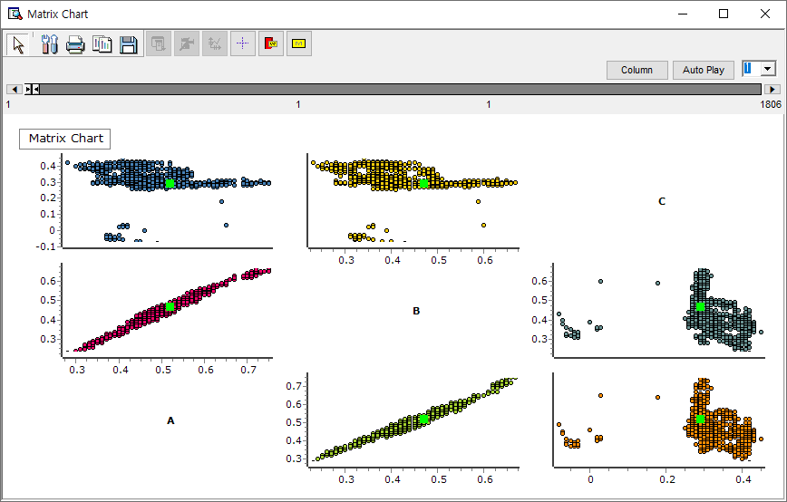

* **Matrix of Designated Rows for X, Y**: Draw a scatter plot in a matrix format using the variable specified in Variable Selection #1 as the X-axis and the variable specified in Variable Selection #2 as the Y-axis.

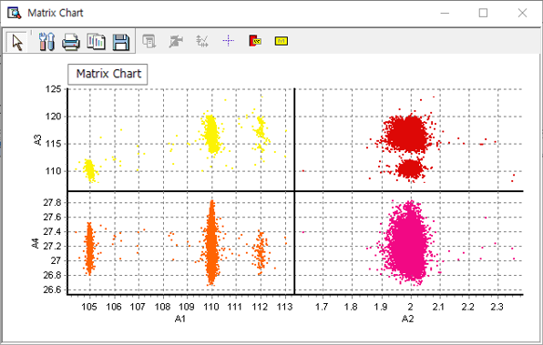

### 3.3.8 Matrix GL Chart

|  |  |
| --- | --- |
|  | **Matrix GL chart** utilizes GP/GPU to explore variations in observed values across variables, offering an enhanced version of the matrix chart. |

Usage

|  |  |  |  |  |  |  |  |
| --- | --- | --- | --- | --- | --- | --- | --- |
|  | |  |  | | --- | --- | |  | the Select variable | |  | Invert the Select variables and the unselect variables | |  | Select variable type or variable name | |

* Set the number of bins in the histogram by entering the Number of Bins option.
* At least 3 variables must be selected in the Select Variables.
* Optional   
  Group Display

Node Properties

|  |  |  |  |  |
| --- | --- | --- | --- | --- |
| Property group | Property Name | Description | Misc. | Note |
| Chart options | Number of Bins | Set the number of sections of the histogram. |  | natural number |
| Group Variable Options | Group Display | Specify whether to disable group display or Color by category. | Optional | Do not use groups, Color by category |
| Group Variable #1 | Select the first group variable. |  |  |
| Group Variable #2 | Select the second group variable. |  |  |
| Group Variable #3 | Select the third group variable. |  |  |
| Group Variable #4 | Select the fourth group variable. |  |  |
| Group Variable #5 | Select the fifth group variable. |  |  |
| Select Variables | Variable List | Specify at least 3 variables to be plotted. | Required |  |

### 3.3.9 MSPC Chart

|  |  |
| --- | --- |
|  | **MSPC Chart** analyzes the impact of multiple interrelated variables on a process, comprehensively monitoring the process's stability, variability, and anomalies. |

Usage

|  |  |  |  |  |  |  |  |
| --- | --- | --- | --- | --- | --- | --- | --- |
|  | |  |  | | --- | --- | |  | Select variable | |  | Invert the Select variables and the unselect variables | |  | Select variable type or variable name | |

* Select Chart form and variables
* Options are based on selected chart form.
* Chart form  
  ▪ T-Square  
  ▪ MEWMA  
  ▪ Generalize Variance  
  ▪ T-Square Generalize Variance

Node Properties

|  |  |  |  |  |
| --- | --- | --- | --- | --- |
| Property group | Property Name | Description | Misc. | Note |
| Selection options | Chart form | Select charting method. | Required | T2, MEWMA, generalized variance, T2-generalized variance). |
| UCL selection | Specify the standard of UCL (Upper Control Limit) if you select T2, T2-Generalized Variance. Phase1 is used when creating a model, and Phase2 is used when monitoring new data. |  | Phase1-for modeling, Phase2-for monitoring |
| MEWMA weight | Specify the weight If you select **MEWMA**. |  | 0~1 |
| Use Subgroup | Usage | Select whether to use subgroups. | Required | Yes, No |
| Subgroup Count | Enter the count of the subgroup if Usage is **Yes** |  | natural number |
| Select Variables | Variable List | Specify the variables to be plotted. | Required |  |

Chart form

(1) T2 Control Chart (T-square Control Chart)

T² control chart (Hotelling T² control chart) monitors the mean of multiple variables and is interpreted similarly to the X-Bar control chart. It assesses the process by considering both the variation of each variable and their correlations. If the T² statistic exceeds control limits, it signals a potential issue in the process.

Usage

* Select T-Square in Chart form.
* Check variables for multivariate process management in Select Variables.
* Select the type of management limit line in UCL selection.
* Optional  
  Enter the number of subgroups.

Results

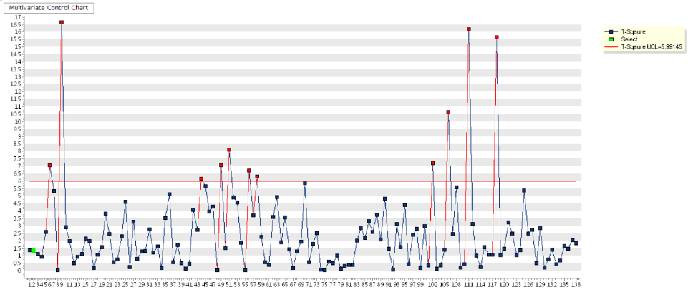

(2) MEWMA Control Chart (Multivariate EWMA Control Chart)

MEWMA is a multivariate control chart that uses exponentially weighted moving averages to detect small changes in the process. By assigning greater weight to more recent measurements, it makes the process more sensitive to changes, allowing for quicker detection of shifts. The smaller the smoothing constant Weight, the faster it can detect shifts in the process mean.

Usage

* Select MEWMA in Chart form.
* Check variables for multivariate process management in Select Variables.
* Enter weights from 0 to 1. (default: 0.1)
* Optional  
  Enter the number of subgroups.

Results

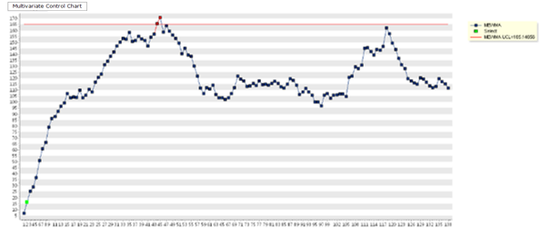

(3) Generalized variance control chart

Generalized Variance Control Chart monitors the variability among multiple correlated variables and is interpreted similarly to the S control chart. It assesses the process by analyzing the covariance matrix.If the generalized variance exceeds control limits, it signals a potential issue in the process.

Usage

* Select generalized distribution in Chart form.
* Check variables for multivariate process management in Select Variables.
* Set the required number of subgroups.

Results

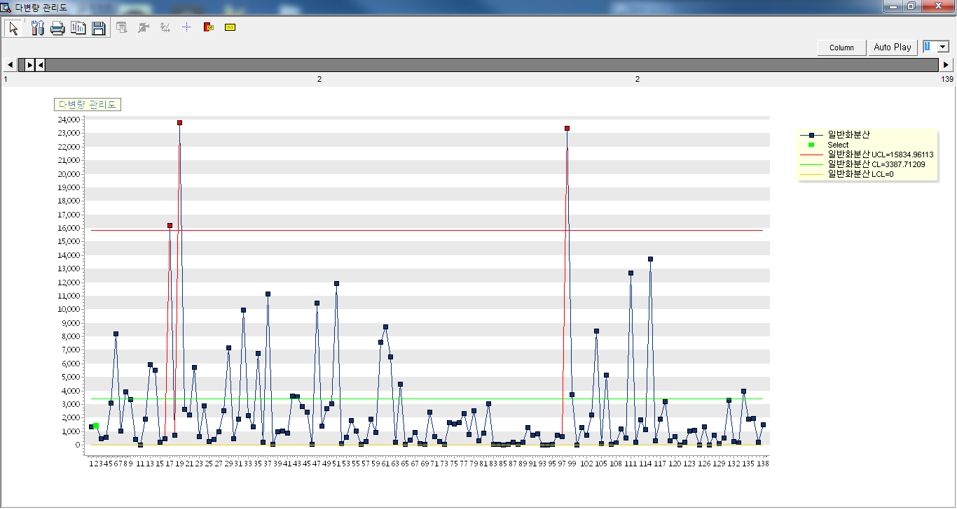

(4) T-Sq Generalized variance control chart

T²-Generalized Variance Control Chart monitors both the process mean and variability among multiple correlated variables and is interpreted similarly to the X-bar and S control charts. It assesses the process by analyzing both the mean vector and the covariance matrix. If the T² statistic or the generalized variance exceeds control limits, it signals a potential issue in the process.

Usage

* Select T-Sq Generalized Variance in Chart form.
* Check variables for multivariate process in Select Variables.
* Set the number of subgroups.

Results

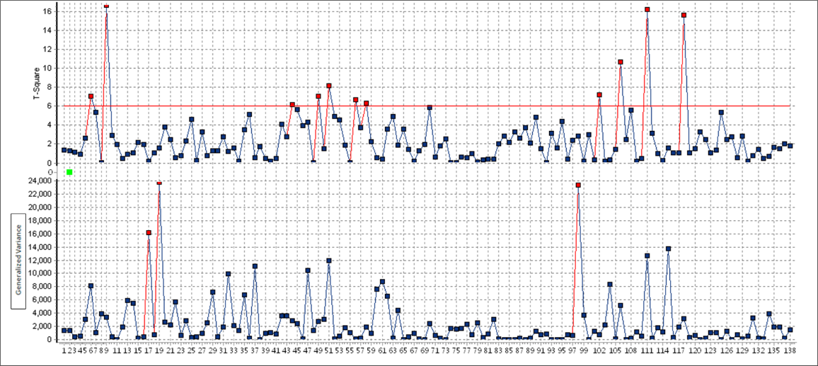

### 3.3.10 Multi Chart

|  |  |
| --- | --- |
|  | **Multi Chart** is ECMiner's unique chart, designed to easily compare the features of multiple variables simultaneously. |

Usage

|  |  |  |  |  |  |  |  |
| --- | --- | --- | --- | --- | --- | --- | --- |
|  | |  |  | | --- | --- | |  | Select variable | |  | Invert the Select variables and the unselect variables | |  | Select variable type or variable name | |

* Select **Chart form** to draw various charts.
* The options used vary based on selected chart type.

Chart form  
▪ Trend: time series data

▪ Data: scatterplot

▪ Box Plot: box plot.

▪ Distribution: normal distribution probability plot.

▪ Correlation: A function that expresses relationships between variables.

* Enter the number of row and Columns for the output screen.

Check the variable for Y-axis and X-axis.

Node Properties

|  |  |  |  |  |  |  |
| --- | --- | --- | --- | --- | --- | --- |
| Property group | Property Name | | Description | | Misc. | Note |
| Chart form | Chart form | | Select a charting method. | |  | Trend,  Data,  Box Plot, Distribution, Correlation |
| Chart options | Display Regression Line | | When the chart form is **Correlation**, select whether or not to display rare lines. | | Yes, No | Simple matrix diagram,  X Y specified matrix diagram |
| Display Basic Statistics | | When the Chart form is **Box Plot**, select whether or not to display basic statistics. | | Yes, No |  |
| Display points/lines | | When the chart form is **Trend** or **Data**, select whether to display dots and lines on the chart. | | Yes, No |  |
| Outlier Display | | When the chart form is **Box Plot**, select whether or not to display outliers. | | Yes, No |  |
| Management Limits | UCL | | When the chart form is **Trend** or **Data**, select the variable to display the upper limit. | | continuous variable |  |
| LCL | | When the chart form is **Trend** or **Data**, select the variable to display the low limit. | | continuous variable |  |
| Output Option | Number of Charts in Row | | Specify the number of charts to be displayed in one row. | | Natural Number | 1~10 |
| Number of Charts within a Column | | Specify the number of charts to be displayed in one column. | | Natural Number | 1~10 |
| X-axis variable | X-axis variable | | When the chart form is **Trend** or **Correlation**, select the variable to use as the X-axis. | | Trend:  Date type, Correlation: Continuous type |  |
| Label | | When the chart form is **Data**, select the variable to use as label. | | discrete variable |  |
| Y-axis variable | Variable List | | Specify the variables to be plotted a chart. | | Required |  |
| Chart division | Variable List | | Specify the variables to be plotted a chart. | | Optional |  |
| Group Variable | Variable List | | Specify the variables to be plotted a chart. | | Optional |  |
|  | |  | |  | | |  |
|  | |  | |  | | |  |

Basic screen

* When the node is executed, the configured property values are displayed on a **Multi Chart screen**.

Options can be modified in the screen and are reflected in the Node Properties.

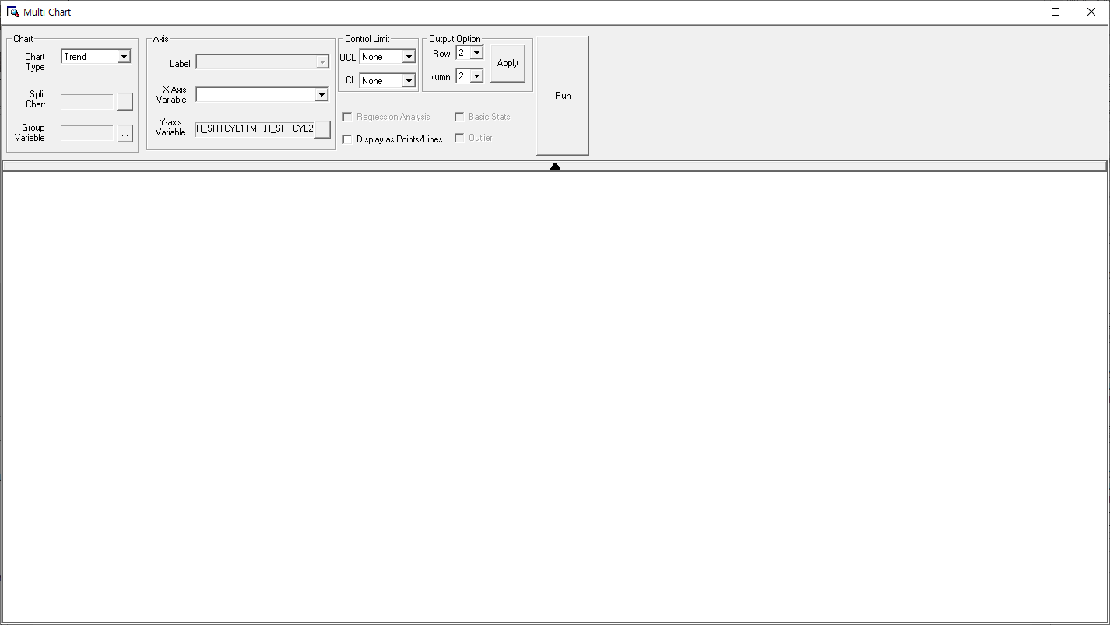

Example Usage

* Screen when using Trend in Chart form

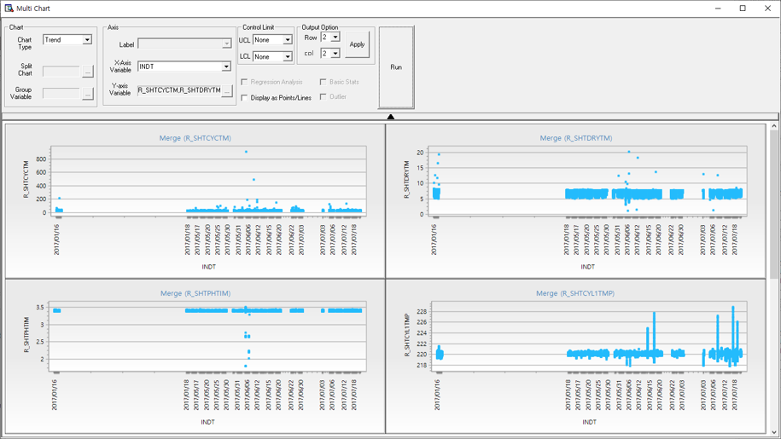

* Screen when using data in Chart form

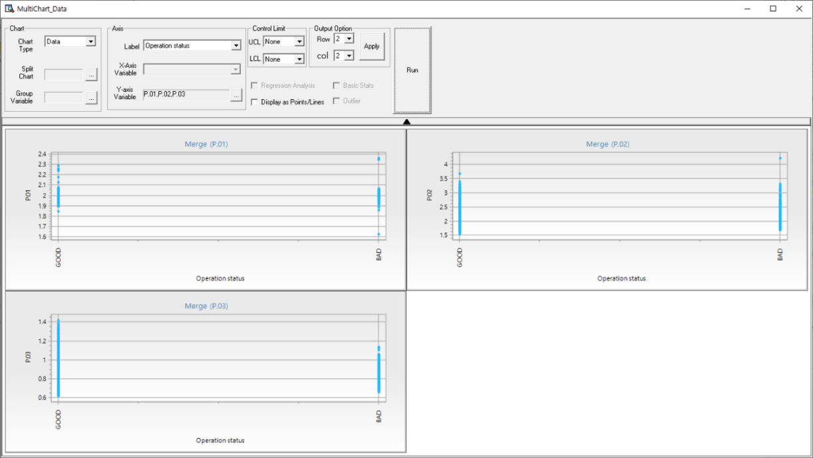

* Screen when using Boxplot as the Chart form

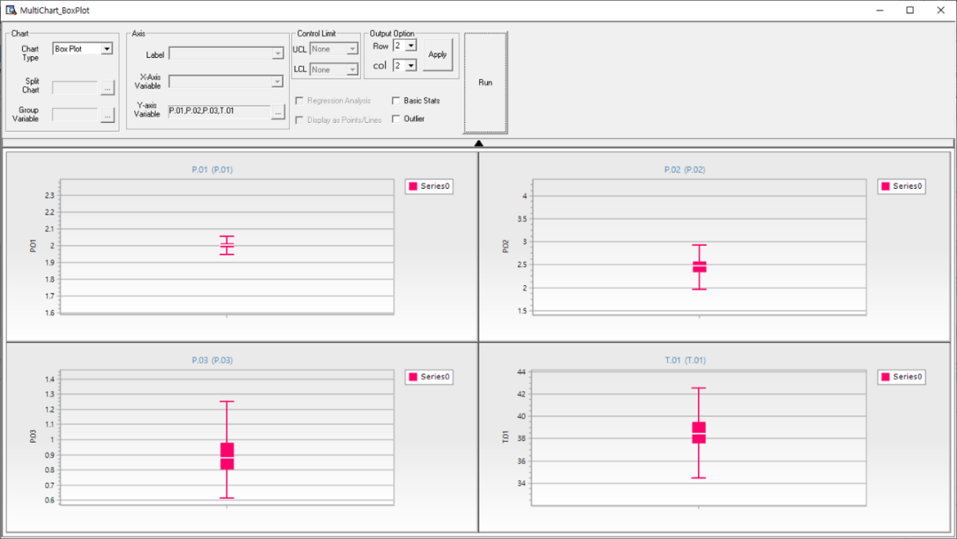

* Screen when Distribution is used as Chart form

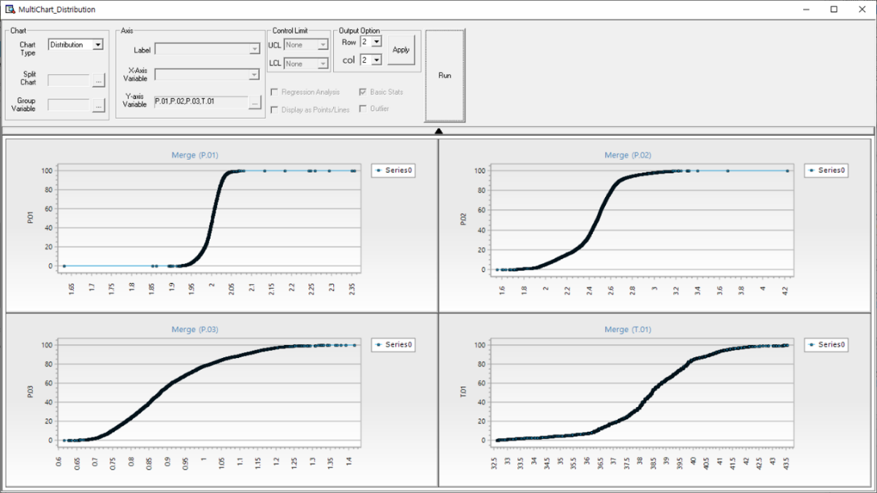

* Screen when Correlation is used as the Chart form

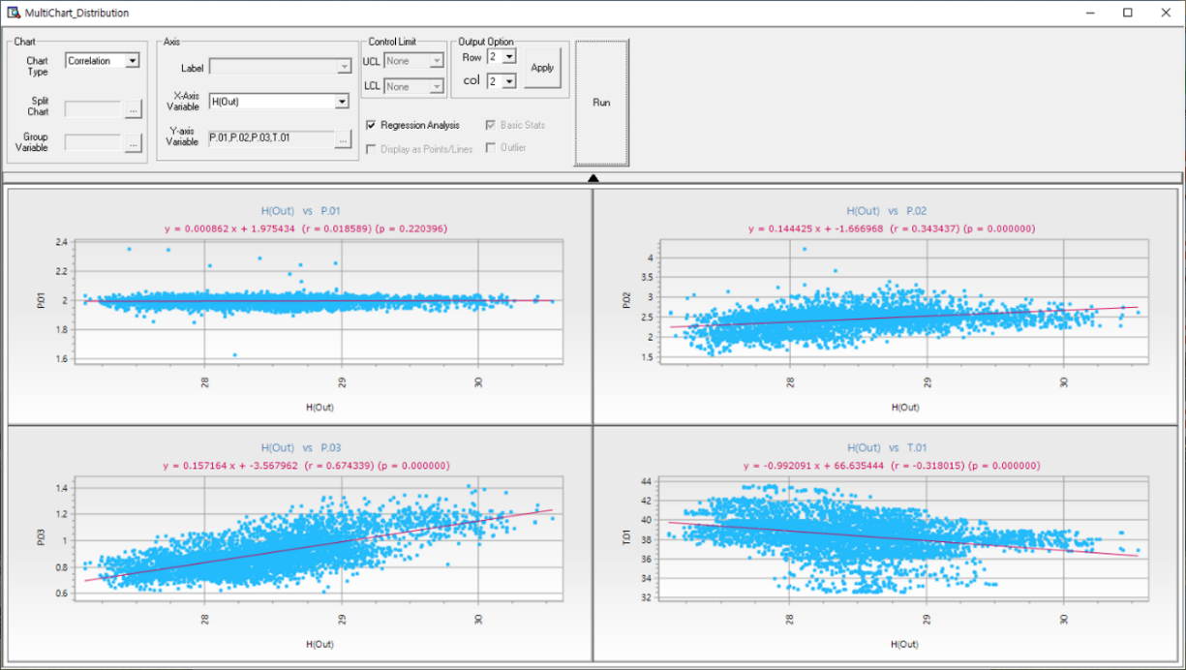

### 3.3.11 Parallel Coordinates GL Chart

|  |  |
| --- | --- |
|  | **Parallel Coordinates GL Chart** connects multiple variables as lines across parallel axes, enabling clear identification of data patterns and relationships. |

Usage

|  |  |  |  |  |  |  |  |
| --- | --- | --- | --- | --- | --- | --- | --- |
|  | |  |  | | --- | --- | |  | Select variable | |  | Invert the Select variables and the unselect variables | |  | Select variable type or variable name | |
| * At least 3 variables must be selected in the **Select Variables**. * Optional  Group Display | |

Node Properties

|  |  |  |  |  |
| --- | --- | --- | --- | --- |
| Property group | Property Name | Description | Misc. | Note |
| Group Variable Options | Group Display | Specify whether to disable group display or Color by category. | Optional | Do not use groups, Color by category |
| Group Variable | Select a group variable. | Optional |  |
| Select Variables | Variable List | Specify at least 3 variables to be plotted. | Required |  |

Results

* Results of selecting 7 variables

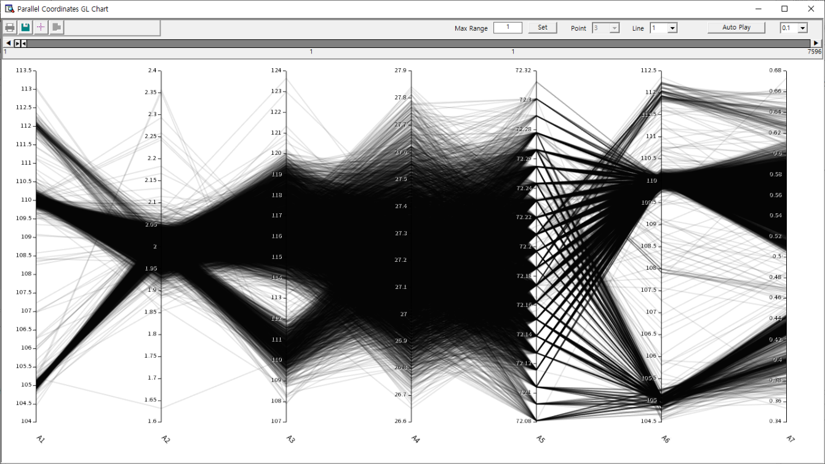

* Specify the range for each axis by dragging.

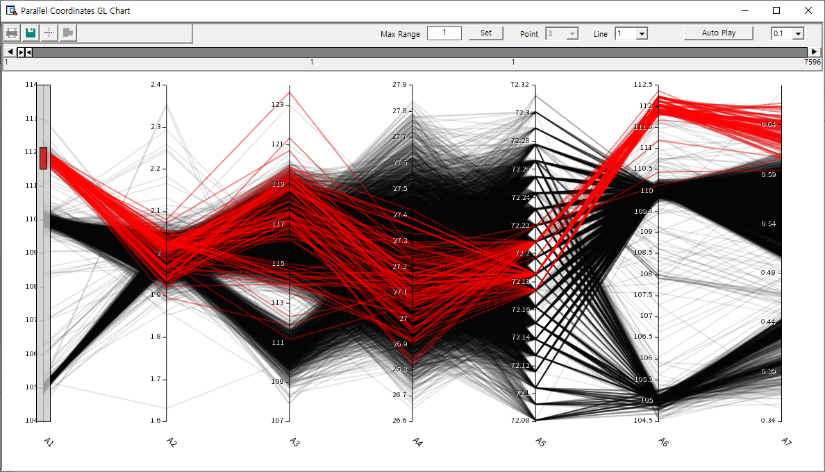

* Color by category.

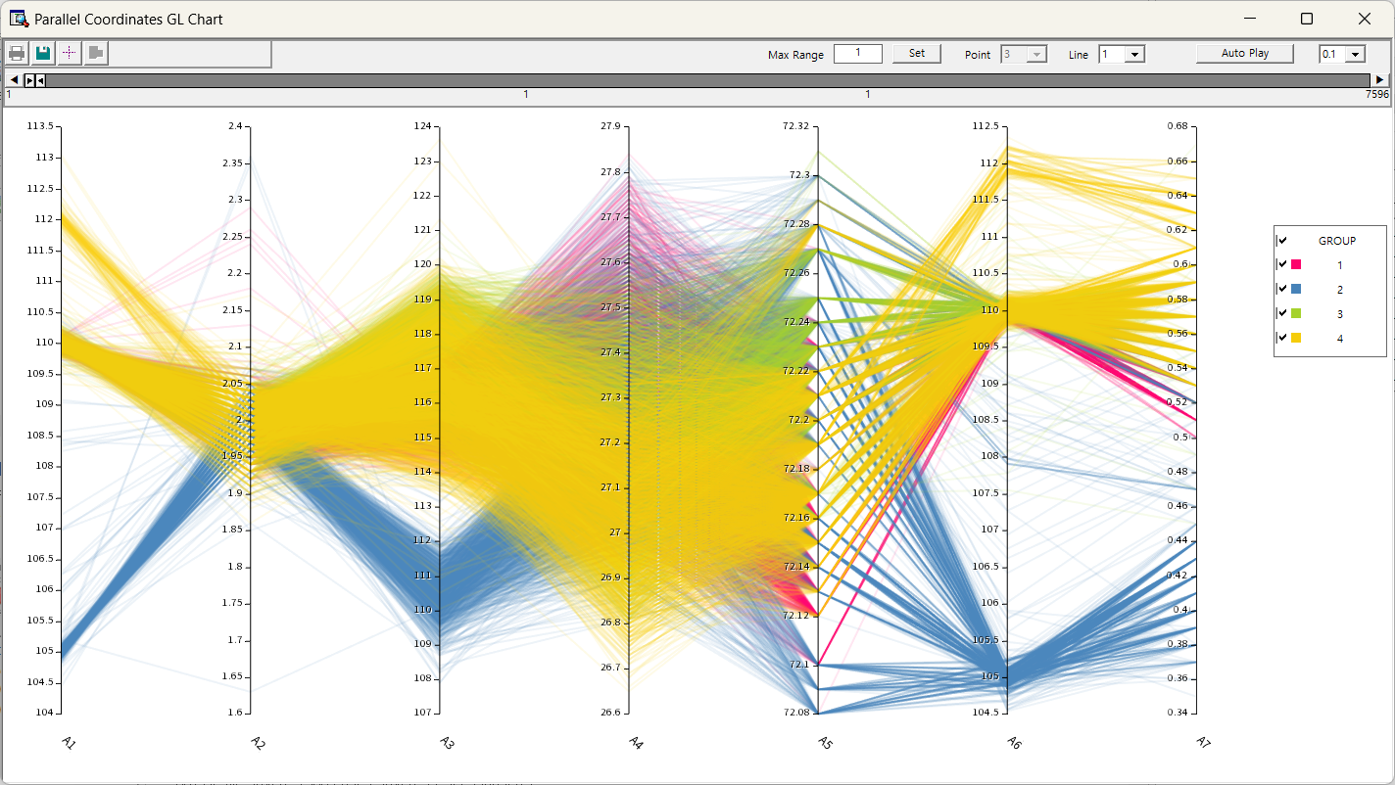

### 3.3.12 Pareto Chart

|  |  |
| --- | --- |
|  | **Pareto Chart** draws a Pareto chart using data. Pareto charts are primarily used to visualize the distribution of data for discrete variables. |

Usage

|  |  |
| --- | --- |
|  | * Specify the variable to be represented in the chart within the variable properties of the Series List properties window.   Optional   * Specify Label properties * Click the 'Add Series' button as many times as needed to add the required number of series |

Node Properties

|  |  |  |  |  |  |
| --- | --- | --- | --- | --- | --- |
| Property group | Property Name | | Description | Misc. | Note |
| Chart options | Number of Data Points | | Specify the number of data categories to plot. The data categories are sorted in descending order based on quantity, and only the specified number of data categories are plotted. Any remaining data categories are represented as **Other** | Required | Natural Number |
| Add | | Used to plot multiple series on a single chart. Adds selected series. | button |  |
| Delete | | Deletes last added series. | button |  |
| Edit | | Removes unselected series. | button |  |
| Series List | Series #00 | Variable | Specify the variable to be displayed as a bar chart | Required |  |
| Label | Specify the variable to be used as the label. If the type of the specified variable is discrete, this property will be ignored |  |  |

### 3.3.13 Pie Chart

|  |  |
| --- | --- |
|  | **Pie Chart Node** draws a pie chart using data. Pie charts are primarily used to view the relative ratios of data for discrete variables. |

Usage

|  |  |
| --- | --- |
|  | * Specify the variable to be represented in the chart within the variable properties   Optional   * Click the Add button for more charts. |

Node Properties

|  |  |  |  |  |  |
| --- | --- | --- | --- | --- | --- |
| Property group | Property Name | | Description | Misc. | Note |
| Chart options | Add | | Used to plot multiple series on a single chart. Adds selected series. | button |  |
| Delete | | Deletes last added series. | button |  |
| Edit | | Removes unselected series. | button |  |
| Series List | Series #00 | Variable | Specify the variable to be displayed as a pie chart | Required |  |
| Label | Specify the variable to be used as the label. If the type of the specified variable is discrete, this property will be ignored |  |  |

### 3.3.15 Radar Chart

|  |  |
| --- | --- |
|  | **Radar Chart** displays values of multiple variables along radiating axes from the center for comparison. |

Usage

|  |  |  |  |  |  |  |  |
| --- | --- | --- | --- | --- | --- | --- | --- |
|  | |  |  | | --- | --- | |  | Select variable | |  | Invert the Select variables and the unselect variables | |  | Select variable type or variable name | |

* At least 3 variables must be selected.

Node Properties

|  |  |  |  |  |
| --- | --- | --- | --- | --- |
| Property group | Property Name | Description | Misc. | Note |
| Chart options | Specify Legend | Specify whether to display the legend or not. | Required | None, Legend Variable |
| User-defined maximum/minimum | Y-axis | Decide whether to use manually specified Y-axis values. | Required | Yes, No |
| Y-axis minimum | Minimum value of Y-axis |  | Real Number |
| Y-axis maximum | Maximum value of Y-axis |  | Real Number |
| Select Variables | Variable list | Specify the variables to be plotted a chart. | Required |  |

### 3.3.14 Process Contribution Chart

|  |  |
| --- | --- |
|  | **Process Contribution Chart** draws model visualization using data and Model Node. |

* **Control Chart**: Displays a dashed ellipse representing the 95% confidence interval and a solid ellipse representing the 99% confidence level. Detect outliers and identify operational deviations through a Control Chart.

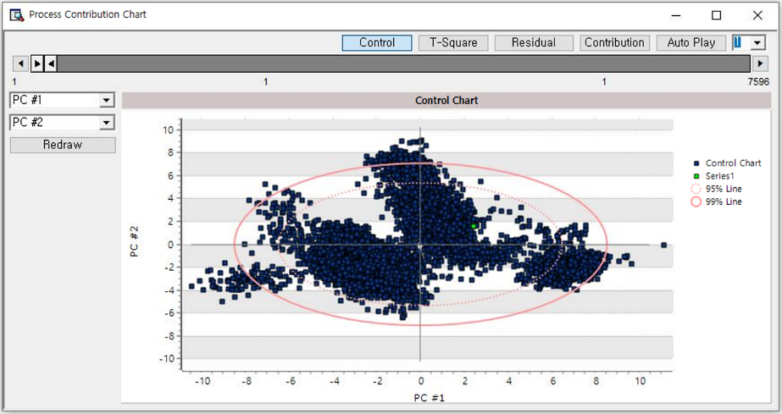

* **T-Square plot**: Indicates the extremity of the current state by measuring the T-square value. Use the provided guide line to detect outliers.

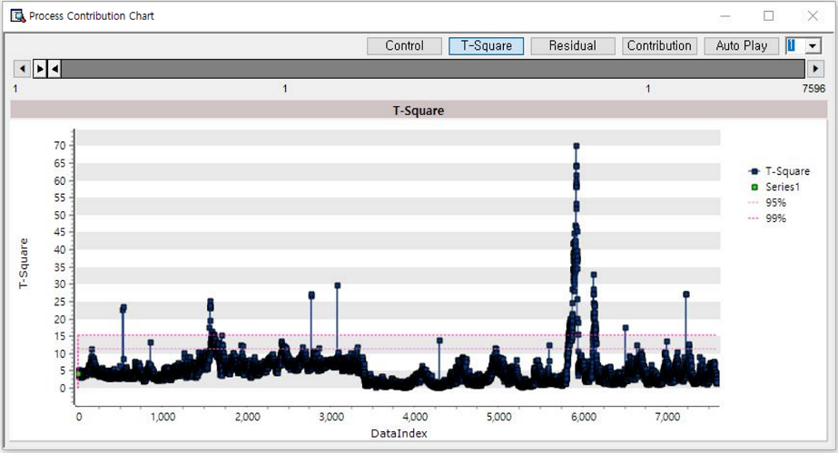

* **Residual plot**: Measure the distance of the data from the reduced space using the residual value. Use the provided guide line to detect outliers.

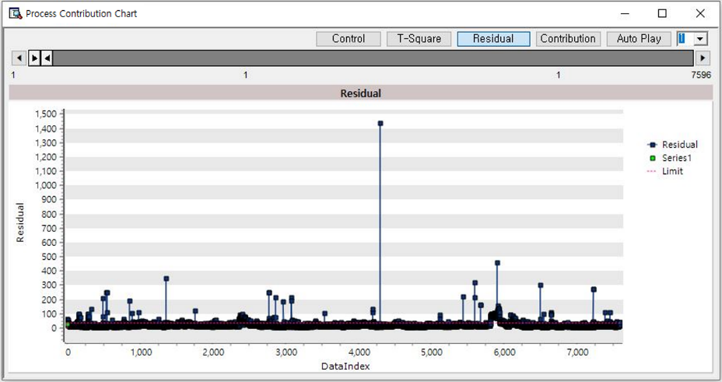

* **Contribution plot**: Shows the contribution of variables affecting deviations in the extracted data. Uses red to represent positive correlations and blue to represent negative correlations.

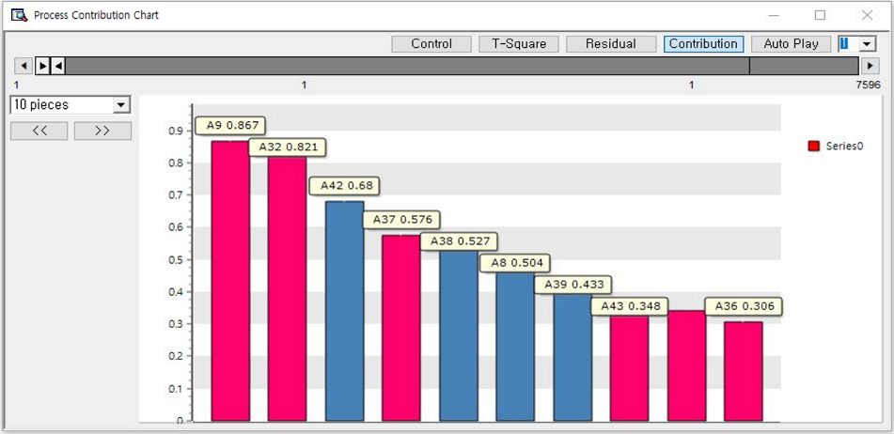

### 3.3.16 SPC Chart

|  |  |
| --- | --- |
|  | **SPC (Statistical Process Control) chart** is a quality control tool that monitors and analyzes data fluctuations to support process stability and compliance with quality standards. |

Usage

|  |  |
| --- | --- |
|  | * Select Chart form  ▪ XBar-R chart ▪ XBar-S chart ▪ I-MR chart ▪ MA chart ▪ EWMA chart ▪ CUSUM chart ▪ P chart ▪ NP chart ▪ C chart ▪ U chart |

(1) XBar-R / XBar-S

Xbar-R chart monitors the mean (X-bar) and range (R) within a subgroup based on samples taken at regular intervals. Xbar-S chart monitors the standard deviation (S) instead of the range (R). The XBar-R chart is used when the subgroup size is between 2 and 5, and the XBar-S chart is used when the subgroup size is 6 or more.

Usage

* Select the XBar-R chart or XBar-S chart, and set the variable for chart.
* Specify the appropriate subgroup size for the analysis.
* If you want to change population mean and population standard deviation, then **Using the population mean** and **Using the population standard deviation** to Yes, then specify the value.

Node Properties

|  |  |  |  |  |
| --- | --- | --- | --- | --- |
| Property group | Property Name | Description | Misc. | Note |
| Chart options | Chart | XBar-R chart or XBar-S. |  |  |
| Variable setting | Variable | Select the variable |  |  |
| Subgroup Size | Size of the subgroup |  |  |
| Parameter estimation | Using the population mean | Decide whether to draw the chart using the population mean. | Default:  No | Yes, No |
| Population mean | Specify the population mean if **Using the population mean** is **Yes** |  | real type |
| Using the population standard deviation | Decide whether to draw the chart using the population standard deviation. | Default:  No | Yes, No |
| Population standard deviation | Specify the population standard deviation if **Using the population standard deviation** is **Yes** |  | real type |

Results

* XBar-R chart

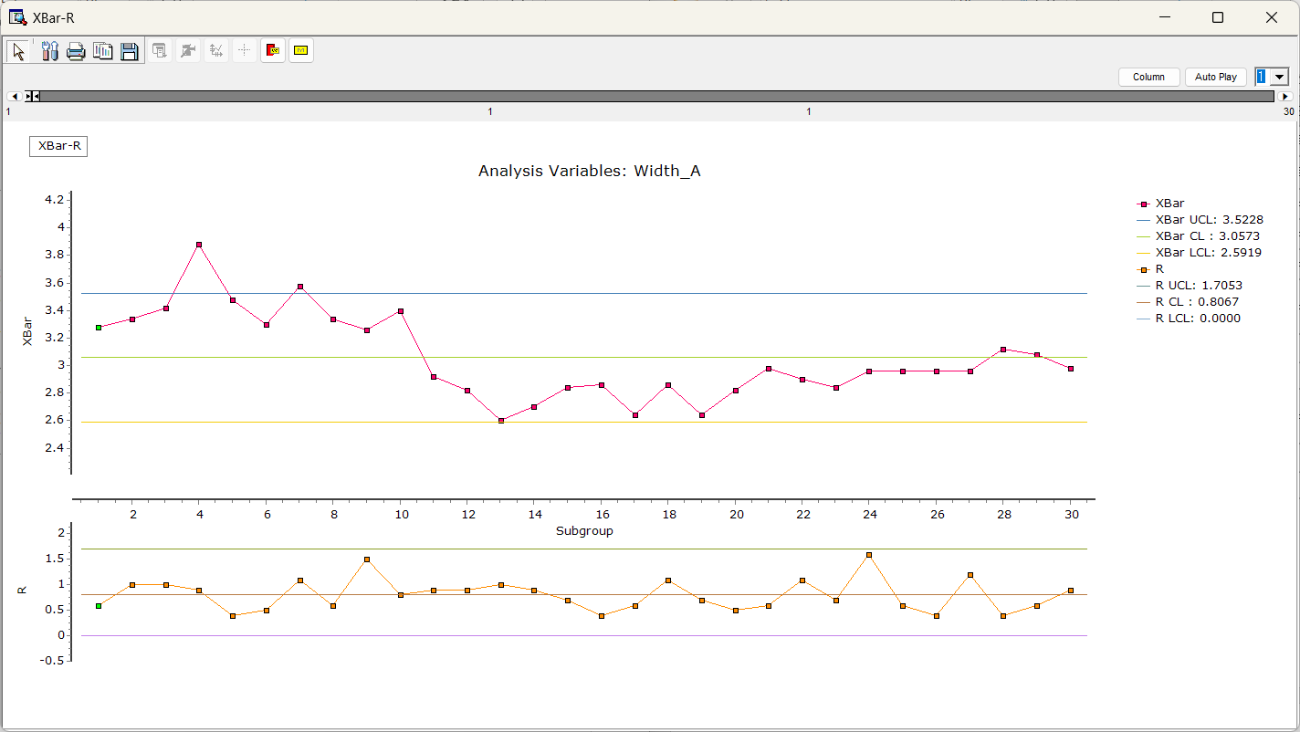

* XBar-S chart

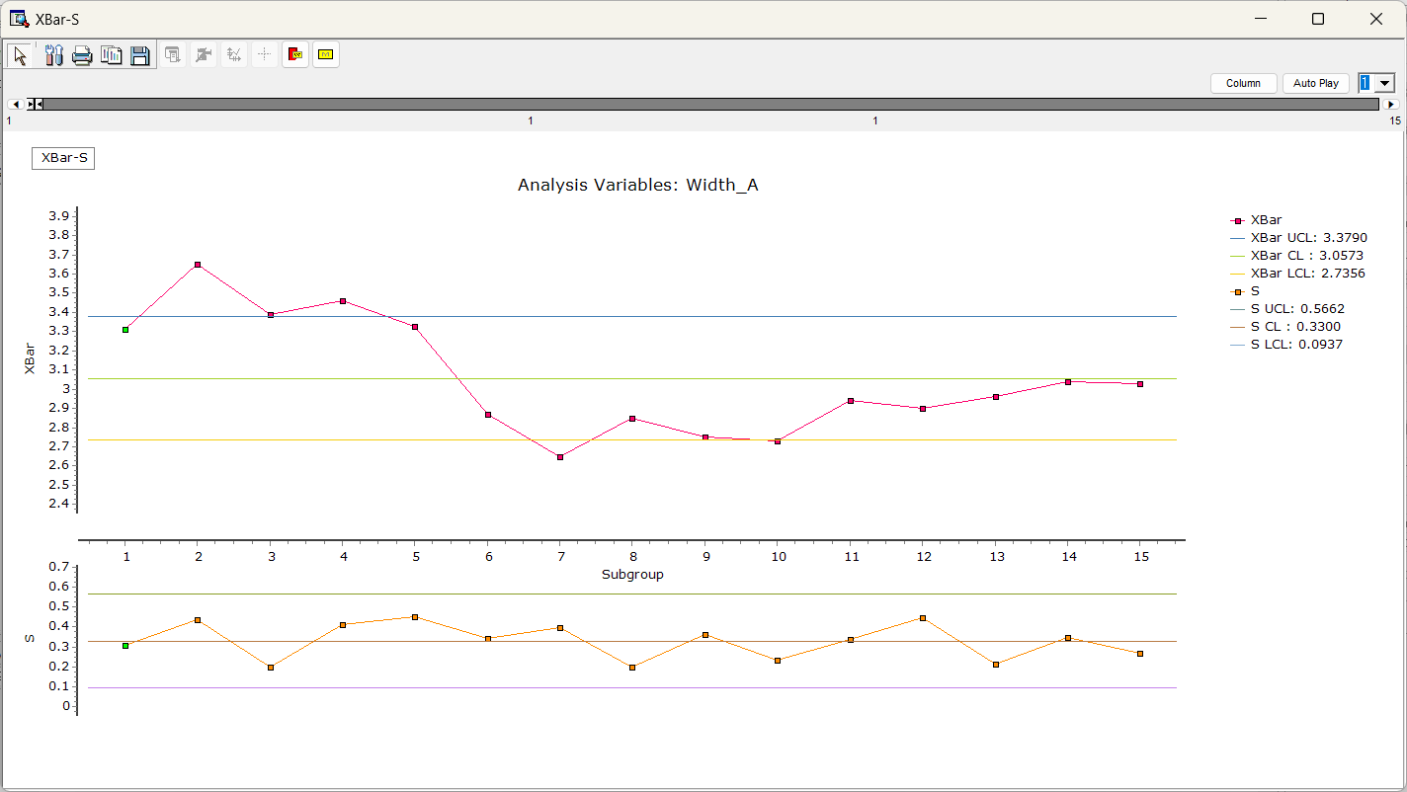

(2) I-MR (Individual-Moving Range) chart

The I-MR chart consists of two charts, Individual(I) chart and Moving Range (MR) chart. Individual chart plots individual points over time, and MR chart plots the absolute differences between consecutive individual measurement in moving ranges. It monitors the stability of a process.

Usage

* Select the I-MR chart, and choose the variable
* If you want to change population mean and population standard deviation, then Using the population mean and Using the population standard deviation to Yes, then specify the value.

Node Properties

|  |  |  |  |  |
| --- | --- | --- | --- | --- |
| Property group | Property Name | Description | Misc. | Note |
| Chart options | Chart | I-MR chart. | Required |  |
| Variable setting | Variables | Select variables. | Required |  |
| Parameter estimation | Using the population mean | Decide whether to draw the chart using the population mean. | Default:  No | Yes, No |
| Population mean | Specify the population mean if **Using the population mean** is **Yes** |  | real type |
| Using the population standard deviation | Decide whether to draw the chart using the population standard deviation. | Default:  No | Yes, No |
| Population standard deviation | Specify the population standard deviation if **Using the population standard deviation** is **Yes** |  | real type |
| Other Options | Moving Range Length | Set the length of the moving range when using an **I-MR chart**. | Required | real type |

Results

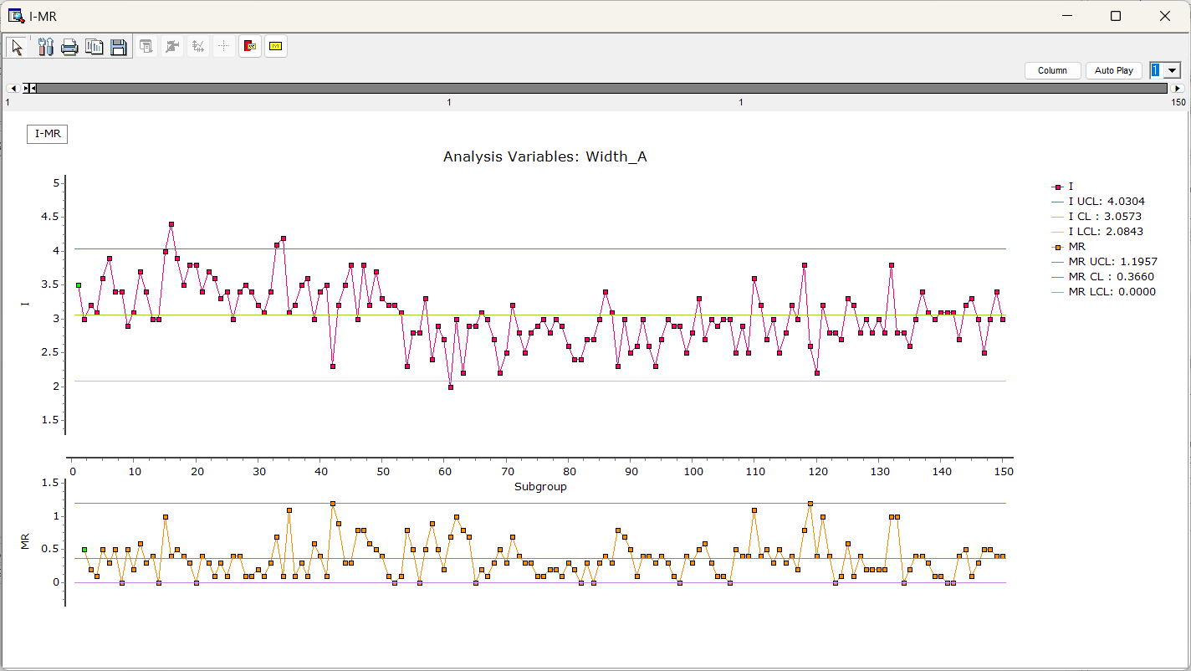

(3) MA(Moving Average) / EWMA(Exponentially Weighted Moving Average)

MA chart monitors moving average (MA). EWMA chart monitors exponentially weighted moving average (EWMA). EWMA is similar to MA, but EWMA assigns exponentially decreasing weights to older data points, giving more emphasis to recent data, allowing it to react more quickly to shifts or trends.

Usage

* Select the MA chart or EWMA chart, and choose the variable
* Specify the appropriate subgroup size.
* Enter the length of the movement average length or weight.
* If you want to change population mean and population standard deviation, then Using the population mean and Using the population standard deviation to Yes, then specify the value.
* The EWMA chart is specifically designed to detect smaller mean shifts more effectively than the Shewhart chart.

Node Properties

|  |  |  |  |  |
| --- | --- | --- | --- | --- |
| Property group | Property Name | Description | Misc. | Note |
| Chart options | Chart | MA chart or EWMA chart. | Required |  |
| Variable setting | Variables | Select variables. | Required |  |
| Subgroup Size | Size of the subgroup | Required | real type |
| Parameter estimation | Using the population mean | Decide whether to draw the chart using the population mean. | Required | Yes, No |
| Population mean | Specify the population mean if **Using the population mean** is **Yes** |  | real type |
| Using the population standard deviation | Decide whether to draw the chart using the population standard deviation. | Required | Yes, No |
| Population standard deviation | Specify the population standard deviation if **Using the population standard deviation** is **Yes** |  | real type |
| Other options | Moving Average Length | Set control limits by entering the length of the moving averange when using an **MA chart**. | Required | real type |
| Weight | Enter weight values when using an **EWMA chart**. | Required | 0≤real number≤1 |
| NOTE: The weight option determines the influence of recent data points. Recent data points have a higher weight, while older data points have progressively lower weights. | | | | |

Results

* MA

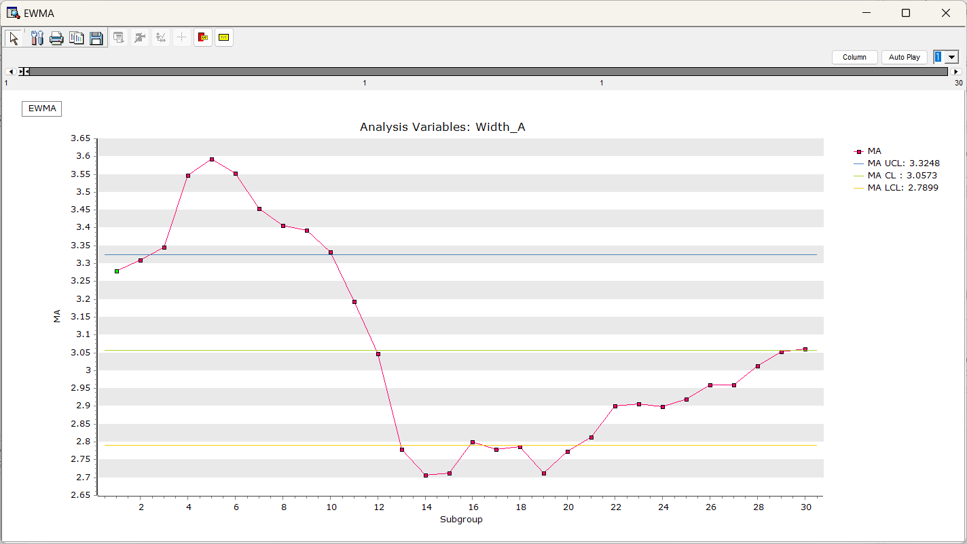

* EWMA

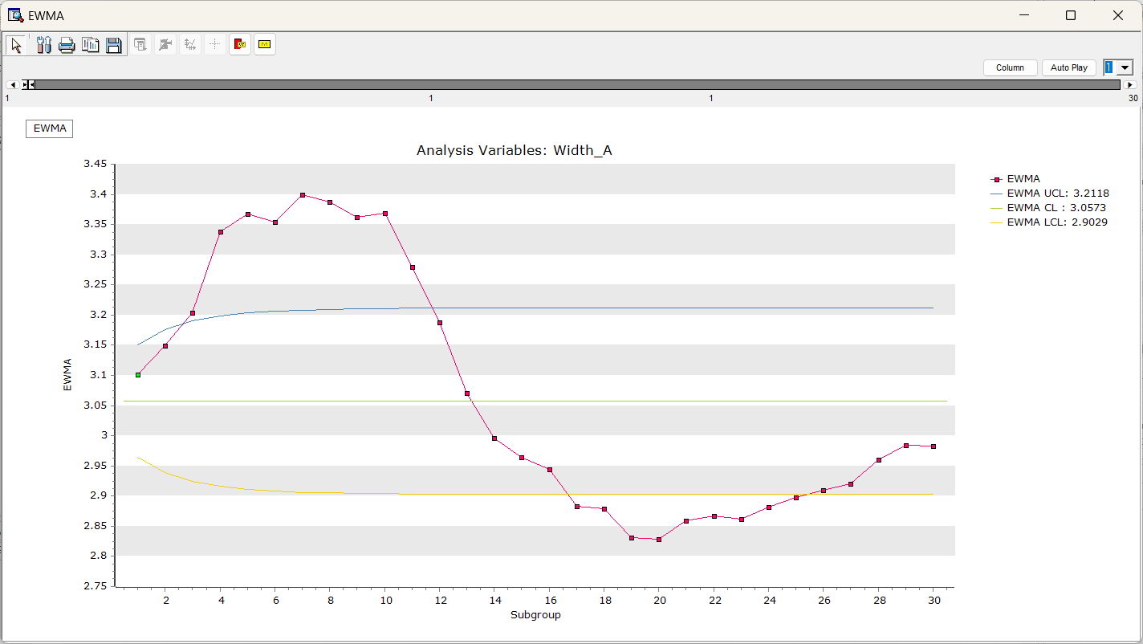

(4) CUSUM (Cumulative Sum)

CUSUM chart visualizes cumulative sum of thedifferences between a **target** value and actual measurement. The cumulative sum of deviations makes the chart sensitive to even small changes, allowing for the early detection of process variations.

Usage

* Select the CUSUM chart, and choose the variable
* Specify the appropriate subgroup size
* If you want to change population mean and population standard deviation, then Using population mean to Yes, then specify the value.
* Set appropriate target, decision interval(h), and reference(k) values to draw the chart.

Node Properties

|  |  |  |  |  |
| --- | --- | --- | --- | --- |
| Property group | Property Name | Description | Misc. | Note |
| Chart options | Chart | CUSUM chart. | Required |  |
| Variable setting | Variables | Select variables. | Required |  |
| Parameter estimation | Using the population mean | Decide whether to draw the chart using the population mean. | Required | Yes, No |
| Population mean | Specify the population mean if **Using the population mean** is **Yes** |  | real type |
| Using the population standard deviation | Decide whether to draw the chart using the population standard deviation. | Required | Yes, No |
| Population standard deviation | Specify the population standard deviation if **Using the population standard deviation** is **Yes** |  | real type |
| Other option | Target | Enter the target values. | Required | real type |
| h | The threshold for determining whether a process is out of control. If exceeds this interval, the process would be abnormal state | Required | real type |
| k | value or allowable bound | Required | real type |

Results

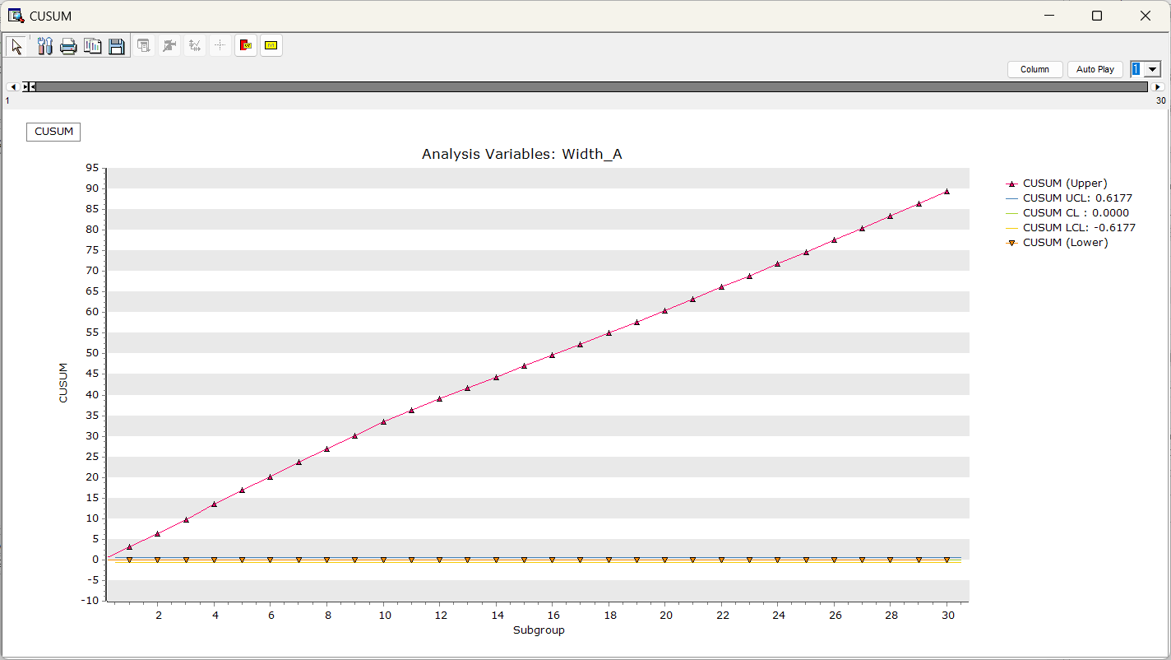

(5) P / NP

P chart monitors the proportion of defective items within a subgroup. NP chart monitors the number of defective items within a subgroup. The P chart is used when the sample sizes vary, and the NP chart is used when all sample sizes are constant.

Usage

* Select the P chart or NP chart, and set the variable for chart.
* Specify the appropriate subgroup size for the analysis.
* Specify Sample size variable if you choose P chart and the sample sizes of the test execution numbers differ.
* It assumes that you are monitoring the number of defects or the defect rate found in each sample group, so a user-defined defect rate is not required. However, if you have an expected defect rate, set User-defined Defect Rate to Yes and specify the value

Node Properties

|  |  |  |  |  |
| --- | --- | --- | --- | --- |
| Property group | Property Name | Description | Misc. | Note |
| Chart options | Chart | P chart or NP chart. | Required |  |
| Variables setting | Variables | Select variables. | Required |  |
| Options for Attribute Control Charts | Sample Size Variable | Specify a variable if you choose a **P chart** and the sample size varies. If you choose a **NP chart,** select **<None>.** |  |  |
| Fixed Sample Size | Enter the total number of inspections performed if **Test execution number variable** is **<None>** | Required | real type |
| User-defined Defect Rate | Decide whether to customize the defect rate. | Required | Yes, No |
| Defect Rate | Enter the defect rate if **User-defined Defect Rate** is **Yes** |  | real type |

Results

* P chart

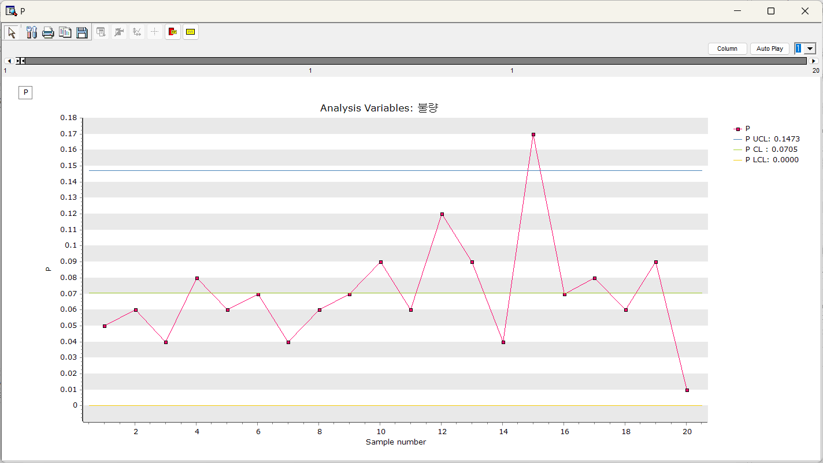

* NP chart

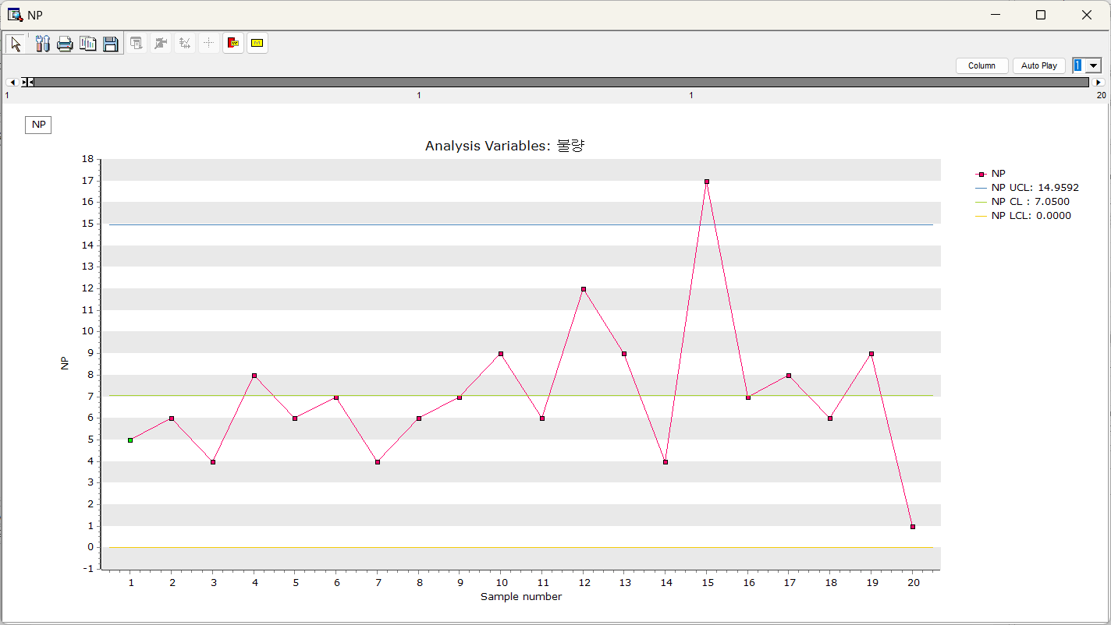

(6) C / U

These are charts used to monitor defects in a mass production environment. The C chart monitors the number of defects in a fixed inspection unit, while the U chart monitors the number of defects per unit in varying inspection units.

Usage

* Select the C chart or U chart
* Specify the appropriate subgroup size
* Specify the Sample size variable if you choose U chart and the sample sizes of the test execution numbers differ.
* It assumes that you are monitoring the number of defects or the defect rate found in each sample group, so a user-defined defect rate is not required. However, if you have an expected defect rate, set User-defined Defect Rate to Yes and specify the value.

Node Properties

|  |  |  |  |  |
| --- | --- | --- | --- | --- |
| Property group | Property Name | Description | Misc. | Note |
| Chart options | Chart | C chart or U chart. | Required |  |
| Variable setting | Variables | Select variables. | Required |  |
| Other options | Sample Size Variable | Specify a variable if you choose a **U chart** and the sample size varies. If the number of inspections per test is consistent, select **<None>**. | Default:  None |  |
| Fixed Sample Size | Enter the total number of inspections performed if **Test execution number variable** is **<None>** | Required | real type |
| User-Defined Average Defect Count | Decide whether to customize the average defect count. | Required | Yes, No |
| Average Defect Count | Enter the average defect count. if **Customize Average Defect Count** is **Yes** |  | real type |

Results

* C chart

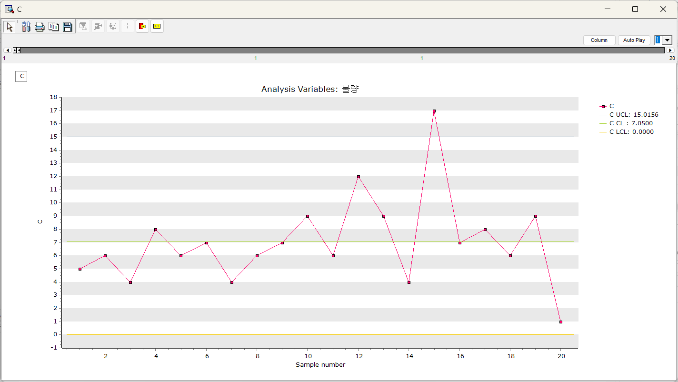

* U chart

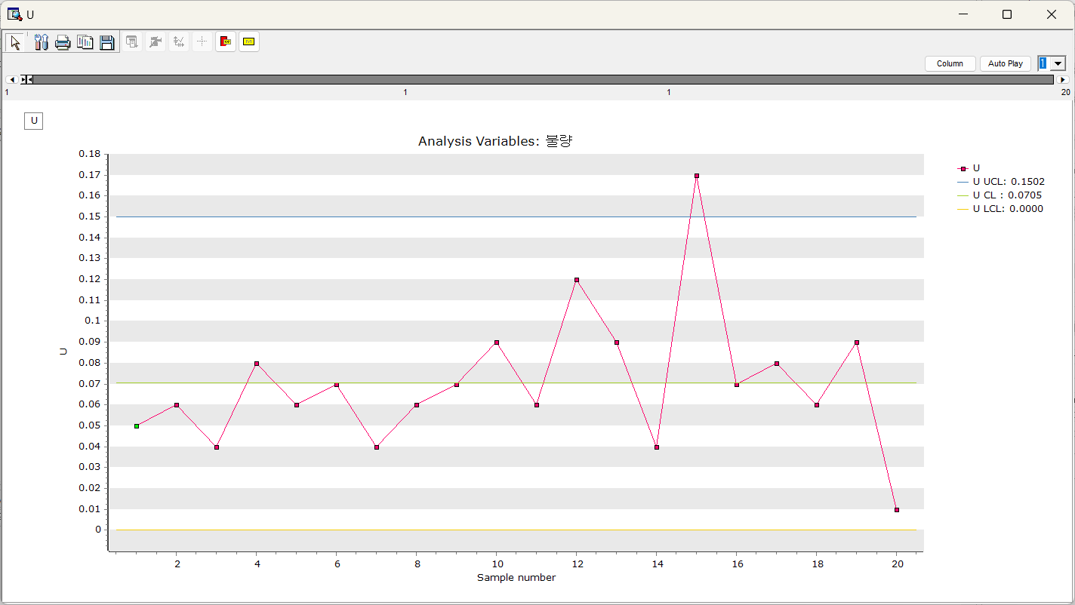

### 3.3.17 Statistic Chart

|  |  |
| --- | --- |
|  | **Statistic Chart** is to draw a chart comparing the statistics of variable. In chart, variables are displayed on the **X-axis** and statistics are displayed on the **Y-axis**, allowing you to see changes in statistics between variables at a glance**.** |

Usage

|  |  |  |  |  |  |  |  |
| --- | --- | --- | --- | --- | --- | --- | --- |
|  | |  |  | | --- | --- | |  | Select variable | |  | Invert the Select variables and the unselect variables | |  | Select variable type or variable name | |

* Optional

Change **Chart options** properties.

Change **Select Statistics** properties.

Node Properties

|  |  |  |  |  |
| --- | --- | --- | --- | --- |
| Property group | Property Name | Description | Misc. | Note |
| Chart options | Drawing Type | Determine the chart output format (Line, Point, Bar). | Required |  |
| Select Statistics | List of statistics | Select the statistic you want to chart (Average, Minimum Value, Maximum Value, Range, Total, Variance, Standard Deviation, Median). | Required |  |
| Select Variables | Variable List | Specify the variables to be plotted. | Required |  |

### 3.3.18 Scatter plot

|  |  |
| --- | --- |
|  | **Scatter plot** visualizes the relationship between two variables using data, allowing for correlation analysis and pattern identification. |

Usage

|  |  |  |  |  |  |  |  |
| --- | --- | --- | --- | --- | --- | --- | --- |
|  | |  |  | | --- | --- | |  | Select variable | |  | Invert the Select variables and the unselect variables | |  | 텍스트, 스크린샷, 폰트, 번호이(가) 표시된 사진  AI가 생성한 콘텐츠는 부정확할 수 있습니다.  Select variable type or variable name. | |

* Specify X-variable for plotting x-axis.

Node Properties

|  |  |  |  |  |
| --- | --- | --- | --- | --- |
| Property group | Property Name | Description | Misc. | Note |
| Chart options | Create Axis for Each Variable | Specify whether to display the Y variable in separate charts for each variable or in a single combined chart. | Required | Yes, No |
| X-variable | Specify the variable for X-axis. |  |  |
| Group Variable Options | Group Display | Specify how to display data groups. | Optional | Separate by Series |
| Group Variable #1 | Select the first group variable. |  |  |
| Group Variable #2 | Select the second group variable. |  |  |
| Group Variable #3 | Select the third group variable. |  |  |
| Group Variable #4 | Select the fourth group variable. |  |  |
| Group Variable #5 | Select the fifth group variable. |  |  |
| User-defined maximum/minimum | Y-axis | Decide whether to use manually specified Y-axis values. | Required | Yes, No |
| Y-axis minimum | Minimum value of Y-axis |  | Real Number |
| Y-axis maximum | Maximum value of Y-axis |  | Real Number |
| Select Variables | Variable list | Specify the variables to be plotted. | Required |  |

Output plots

* Scatter plot of X and Y

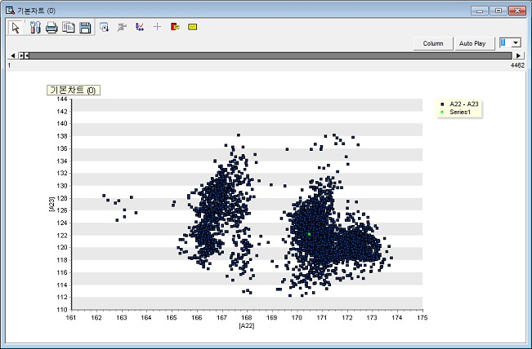

### 3.3.19 Trend Chart

|  |  |
| --- | --- |
|  | **Trend Chart** is two-dimensional scatter plots or time series charts. |

Usage

|  |  |  |  |  |  |  |  |
| --- | --- | --- | --- | --- | --- | --- | --- |
|  | |  |  | | --- | --- | |  | Select variable | |  | Invert the Select variables and the unselect variables | |  | Select variable type or variable name. | |

* Specify Display Method.
* Specify Time Scale Variable for Time Series Y.

Node Properties

|  |  |  |  |  |
| --- | --- | --- | --- | --- |
| Property group | Property Name | Description | Misc. | Note |
| Chart options | Display method | **Points**: Plot the data at each observation time as dots.  **Line:** Draw a line connecting the values from before and after.  **Points with line**: Plot the data as points at each observation time and connect them with lines. | Required | Points, Line, Points with line |
| Create Axis for Each Variable | Specify whether to display the Y variable in separate charts for each variable or in a single combined chart. | Required | Yes, No |
| Separate Y-Axis for Each Variable | When **Separate Y-Axis for Each Variable** is set to **No, s**pecify whether to use a separate Y axis or a single axis |  | Yes, No |
| Time Scale Variable | For **Time Series** **Y**, specify the time scale variable to use for the X-axis. Use the Data Index if a time scale variable does not exist. |  |  |
| Group Variable Options | Group Display | Specify how to display data groups. | Optional | Separate by Series, Color by category, Display as Label |
| Group Variable #1 | Select the first group variable. |  |  |
| Group Variable #2 | Select the second group variable. |  |  |
| Group Variable #3 | Select the third group variable. |  |  |
| Group Variable #4 | Select the fourth group variable. |  |  |
| Group Variable #5 | Select the fifth group variable. |  |  |
| User-defined maximum/minimum | Y-axis | Decide whether to use manually specified Y-axis values. | Required | Yes, No |
| Y-axis minimum | Minimum value of Y-axis |  | Real Number |
| Y-axis maximum | Maximum value of Y-axis |  | Real Number |
| Select Variables | Variable list | Specify the variables to be plotted. | Required |  |

Output plots

* Time series chart for Y data in time scale.

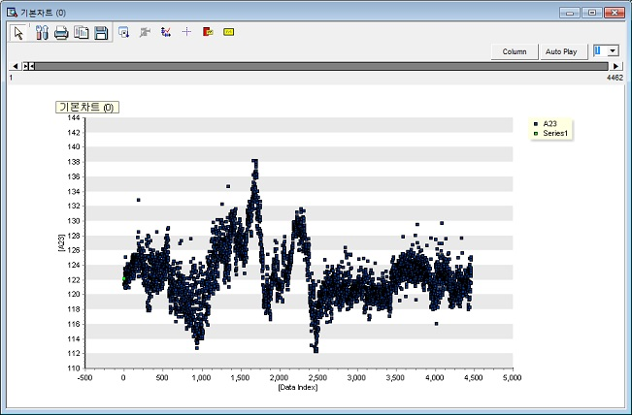

### 3.3.20 Word Cloud

|  |  |
| --- | --- |
|  | **Word Cloud** is a tool that visually represents the frequency of words in text data. The size of each word is proportional to its frequency. |

Usage

To visualize word frequency, it is necessary to create two variables: one for the list of words and another for their respective counts.Therefore, use the **Tagging Node** to generate the variable for words, and apply the **Group By Node** to create a variable for the counts of these words.

|  |  |
| --- | --- |
|  |  |

* Specify the Word List Variable. The variable should be of character.
* Specify the Word Count List Variable. The variable should be of numeric.
* Optional

Chart form: Spiral or Typewriter.

Node Properties

|  |  |  |  |  |
| --- | --- | --- | --- | --- |
| Property group | Property Name | Description | Misc. | Note |
| Default Chart options | Word List Variable | Select the variables you want to use in Word Cloud. | character type |  |
| Word Count List Variable | Select a variable with the number of variables used in the word list variable. | Required |  |
| Chart form | Choose either Spiral or Typewriter. | Spiral, Typewriter |  |

Results

**(1) Spiral**

Words are positioned at the center of the chart in descending order of frequency, and the size of the words decreases as they move away from the center.  
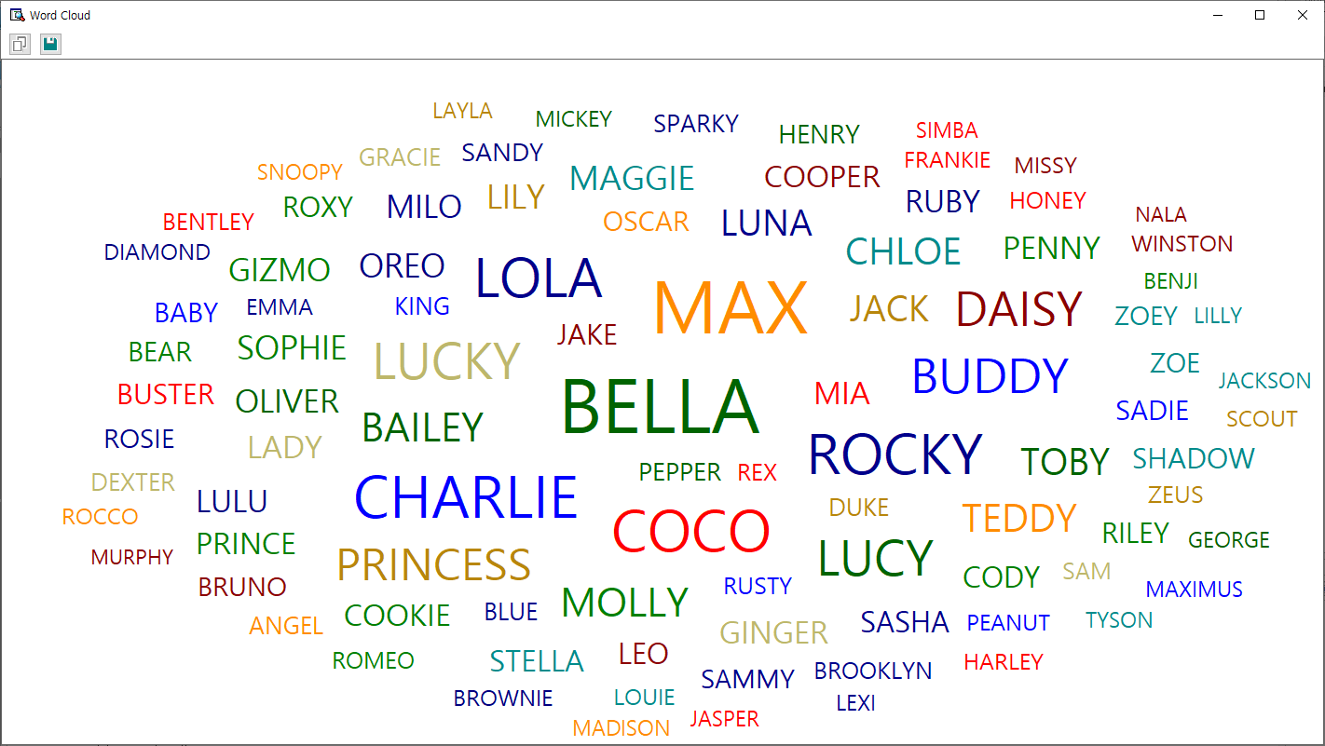

**(2) Typewriter**Words are listed in order from the most frequent to the least, with their sizes progressively decreasing.

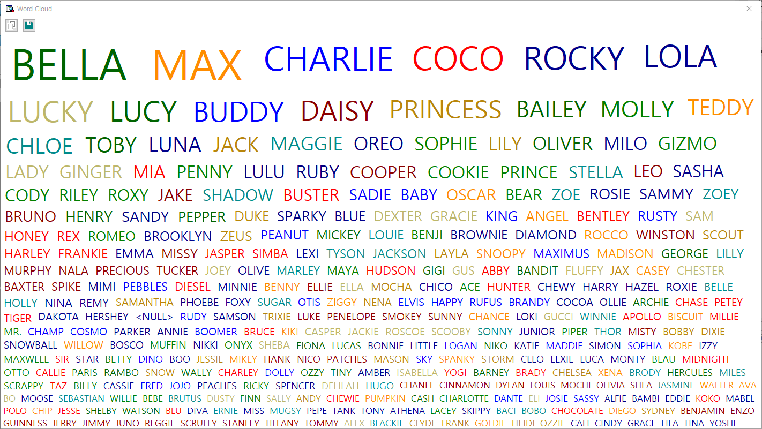

## 3.4 Modeling Node

Modeling Nodes supported by ECMiner™ are the following.

* [Adaptive NN](#_3.4.1_Adaptive_NN)  
  Adjust learning processes or structures to suit input data and the learning environment.
* [Association Rules (AR)](#_3.4.2_Association_Rules(AR))  
  Discover relationships between items in large datasets using the Apriori algorithm.
* [AutoEncoder](#_3.4.3_AutoEncoder)  
  Encode and decode data to produce outputs similar to inputs for compression or anomaly detection.
* [CART](#_3.4.4_CART)  
  Use decision trees for classification and regression tasks.
* [CCA](#_3.4.5_CCA(Canonical_Correlation)  
  Analyze the relationship between two sets of multivariate variables.
* [CNN](#_3.4.6_CNN)  
  Automatically learn features from images to perform tasks like classification and prediction.
* [DeepNN](#_3.4.7_Deep_NN)  
  Use multiple hidden layers in a neural network to understand complex data relationships.
* [ElmanNet](#_3.4.8_ElmanNet)  
  Use recurrent neural networks for predictive analysis with context layers to store past data.
* [Factor Analysis](#_3.4.8_Factor_Analysis)  
  Extract common factors among variables to analyze or connect multiple factors.
* [Hierarchical Clustering](#_3.4.10_Hierarchical_Clustering)  
  Group similar data objects into clusters.
* [K-Means](#_3.4.10_K-MEANS)  
  Partition data into k clusters based on centroid positions.
* [K-NN](#_3.4.11_K-NN)  
  Classify data based on the proximity of nearest neighbors.
* [LDA](#_3.4.12_LDA(Linear_Discriminant)  
  Perform classification by maximizing between-class separation with a linear decision boundary.
* [Local Outlier Factor (LOF)](#_3.4.13_Local_Outlier)  
  Detect outliers by evaluating local density relative to neighbors.
* [Logistic Regression](#_3.4.14_Logistic)  
  Predict categorical outcomes based on input data.
* [MLR](#_3.4.15_MLR)  
  Model the linear relationship between dependent and multiple independent variables.
* [Naive Bayes](#_3.4.16_Naïve_Bayes)  
  Classify data based on the assumption that features are conditionally independent.
* [PCA](#_3.4.17_PCA)  
  Reduce dimensionality by transforming variables into uncorrelated principal components.
* [PCR](#_3.4.18_PCR)  
  Use PCA for dimensionality reduction and handle multicollinearity in regression models.
* [PLS](#_3.4.19_PLS)  
  Reduce predictors into latent variables for dimensionality reduction and regression analysis.
* [QDA](#_3.4.20_QDA)  
  Perform classification with non-linear decision boundaries and class-specific covariance matrices.
* [Random Forest](#_3.4.21_RandomForest)  
  Improve accuracy and stability by combining the output of multiple decision trees.
* [RBF](#_3.4.22_RBF)  
  Use radial basis functions in neural networks for supervised learning.
* [RBF DDA](#_3.4.23_RBF_DDA)  
  Automatically determine the number of RBFs and their values to optimize model performance.
* [Regularized Regression](#_3.4.25_Regularized_Regression)  
  Prevent overfitting by penalizing large coefficients in regression models.
* [RL\_AC](#_3.4.25_RL_AC(Actor_Critic))

Use actor-critic reinforcement learning to update policies and Q functions simultaneously.

* [RL\_DDPG](#_3.4.26_RL_DDPG(Deep_Deterministic)  
  Predict continuous actions with reinforcement learning and separate networks for policy and Q function.
* [RL\_DQN](#_3.4.27_RL_DQN(Deep_Q)  
  Use deep Q networks to estimate action values and perform Q-learning.
* [RL\_PPO](#_3.4.28_RL_PPO(Proximal_Policy)  
  Apply stable policy updates with clipping to improve reinforcement learning.
* [RL\_PG](#_3.4.29_RL_PG(Policy_Gradient))  
  Use policy gradient methods to gradually improve decision-making in reinforcement learning.
* [RL\_TD3](#_3.4.30_RL_TD3(Twin_Delayed)  
  Use twin critic networks to improve reinforcement learning stability and avoid errors.
* [RL\_SAC](#_3.4.31_RL_SAC(Soft_Actor-Critic))  
  Promote action diversity in reinforcement learning with entropy in the value function.
* [ScoreCard](#_3.4.32_ScoreCard)  
  Model the impact of variables on a discrete dependent variable using logistic regression, commonly for credit scoring.
* [Sequential AR](#_3.4.33_Sequential_AR)  
  Discover relationships between products or services over time to find meaningful patterns.
* [SimpleRNN](#_3.4.34_SimpleRNN)  
  Use recurrent neural networks for sequential data processing like time series.
* [SOM](#_3.4.35_SOM)  
  Visualize and interpret high-dimensional data in lower-dimensional spaces using self-organizing maps.
* [SVC](#_3.4.36_SVC)  
  Classify data into predefined categories using support vector machines.
* [SVR](#_3.4.37_SVR)  
  Apply support vector regression for modeling relationships between variables.
* [t-SNE](#_3.4.38_t-SNE)  
  Visualize data classification and distribution in lower dimensions using non-linear dimensionality reduction.

### 3.4.1 Adaptive NN

|  |  |
| --- | --- |
|  | **Neural Network (NN)** is a machine learning model with hidden layers to uncover the complex, non-linear relationships between the data. **Adaptive Neural Networks (Adaptive NNs)** are neural networks that adjust their learning process or structure to suit input data or the learning environment. |

Overview

A common type of NN is the multilayer feedforward network, which consists of an input layer, one or more hidden layers, and an output layer. In this process, the input signal advances layer-by-layer. Each layer's neurons (or nodes) are connected to those in other layers through connections that have a bias and an adjustable weight. The figure below illustrates the structure of an NN with two hidden layers.

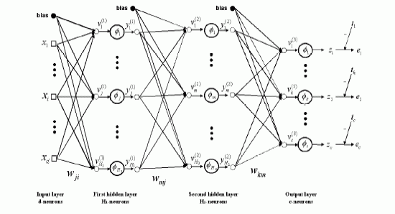

Backpropagation is a widely used algorithm in training artificial neural networks, primarily for minimizing the error by adjusting the weights through gradient descent. consists of two stages:

* (1) Forward pass

The input is passed through the network layer by layer. It passes through the input and hidden layers in the forward direction. Finally, the network produces output, which is an estimate of the desired output, at the output layer. During the forward pass, the network computes its output, but the weights remain unchanged.

* (2) Backward pass (Backpropagation)

The weights are updated in the backward direction based on the error correction rule (back propagation algorithm). The weights are adjusted so that the network's actual output moves closer to the desired output.

Applications

* Independent variables must be continuous.
* Dependent variable can be either continuous or discrete.

Usage

* Read the data using Input Node.
* Specify the type of data using Type Change Node. (independent, or target)
* Connect Type Change Node to Adaptive NN Node and select the options.
* Connect Adaptive NN Node to Display Node.
* An example of Adaptive NN stream is as follows.

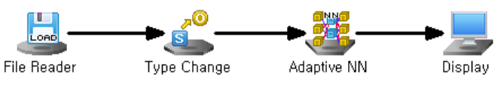

Node Properties

|  |  |  |  |  |
| --- | --- | --- | --- | --- |
| Property group | Property Name | Description | Misc. | Note |
| Model File | Save Model File | Decide whether to save model file. | Required | Yes, No |
| Model File Path | Set the path for the model file to be saved. | Conditionally Required |  |
| Selection options | Optimizing Method | Set the method of weight updates. | Required | Steepest Descent. Conjugate Gradient. Levenberg Marquardt. |
| Number of Hidden Layers | Select Number of Hidden Layers. | Required | 1 or 2 |
| Number of nodes in Hidden Layers #1 | Set the number of nodes in the first hidden layer. | Required | 0<integer |
| Number of nodes in Hidden Layers #2 | Set the number of nodes in the second hidden layer. | Required | 0<integer |
| Activation Function of Hidden Layer #1 | Select the activation function of the first hidden layer. | Required | Linear, Tanh, Sigmoid |
| Activation Function of Hidden Layer #2 | Select the activation function of the second hidden layer. | Required | Linear, Tanh, Sigmoid |
| Output Layer Activation Function | Select the activation function of the output layer. | Required | Linear, Tanh, Sigmoid |
| Momentum | Set the degree to which the weight reflects the existing direction of movement if **Optimizing Method** is **Steepest Descent.** | Required | Default:0.90 0≤real number<1 |
| Learning Rate | Set the degree of weight updates if **Optimizing Method** is **Steepest Descent.** | Required | 0<real number≤1 |
| Run Count | Enter the maximum number of iterations. | Required | Default:100, 0<integer |
| Final Target Error | Set the target error at which the algorithm stops iterating once the error between the actual and desired responses is reached. | Required |  |
| Epsilon 1 | Enter Epsilon 1 if **Optimizing Method** is **Levenberg Marquardt.** | Required |  |
| Epsilon 2 | Enter Epsilon 2 if **Optimizing Method** is **Levenberg Marquardt.** | Required |  |
| Structural Optimization | Decide whether to optimize the structure when the **Split Node** is connected. | Required | Yes, No |
| Start Node Count of Hidden Layer #1 | Set the number of starting nodes in the first hidden layer if **Structural Optimization** is **Yes.** | Conditionally Required | 0<integer |
| Increase In Nodes of Hidden Layer #1 | Set the number of nodes to increase in the first hidden layer if **Structural Optimization** is **Yes.** | Conditionally Required | 0<integer |
| Test Case Count of Hidden Layer #1 | Set the number of test cases in the first hidden layer if **Structural Optimization** is **Yes.** | Conditionally Required | 0<integer |
| Start Node Count of Hidden Layer #2 | Set the number of starting nodes in the second hidden layer if **Structural Optimization** is **Yes.** | Conditionally Required | 0<integer |
| Increase In Nodes of Hidden Layer #2 | Set the number of nodes to increase in the second hidden layer if **Structural Optimization** is **Yes.** | Conditionally Required | 0<integer |
| Test Case Count of Hidden Layer #2 | Set the number of test cases in the second hidden layer if **Structural Optimization** is **Yes.** | Conditionally Required | 0<integer |

|  |
| --- |
| ***NOTE***  For example, if the number of starting nodes is 1, the number of incremental nodes is 2, and the number of test cases is 4, then we will test for cases 1, 3, 5, and 7. If the number of tests in the first hidden layer is 4 and the number of tests in the second hidden layer is 5, then we will test for a total of 20 cases. |

**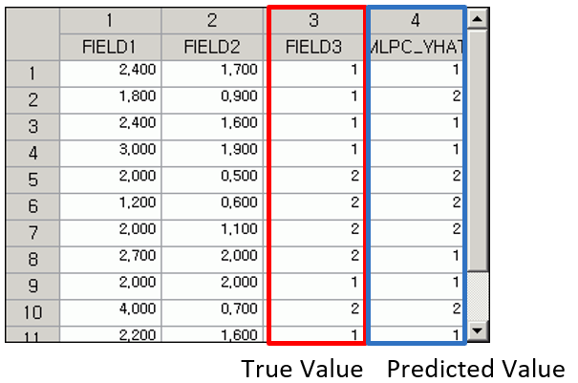**

Results

The analysis Results are displayed using Display Node.

**Modeling Result**

**Click Modeling Result in Node Property of Model node to view the Results.**

* Option Information

It shows which options were used when modeling using MLP. This allows you to determine how the Results change when the options are changed.

* Weight Information

The weight information of the node entering Hidden Layer #1 from the input layer and the weight information of the node entering the output layer from Hidden Layer #1 are displayed.

* ANOVA TABLE

Applicable only for regression analysis. An F test is performed to test whether the independent variable is statistically significant in explaining the dependent variable y. If the p-value is greater than the significance level and is not significant, interpretation of the regression coefficient is meaningless.

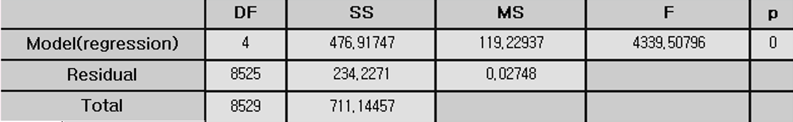

* Confusion Matrix

Applicable only for classification. A cross-tabulation of the original and predicted classes shows the number and percentage of incorrectly predicted observations.

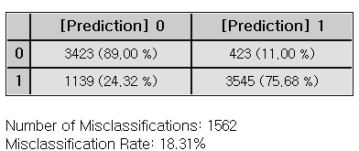

* Standard Error Information

This applies only to regression analysis and indicates the fitting and predictive power of the model.

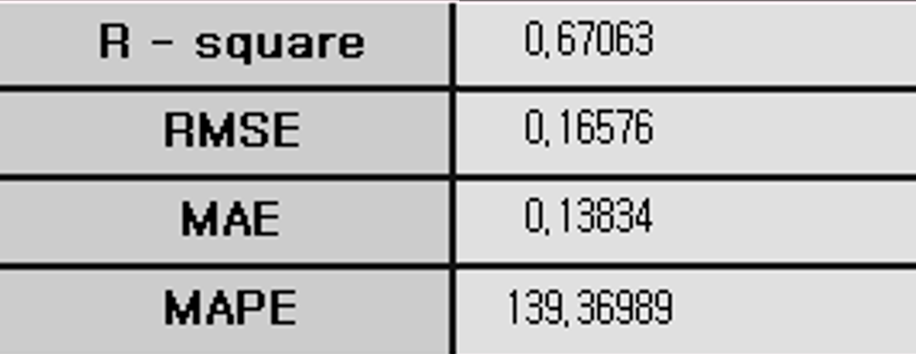

* (1) R-square (coefficient of determination)

It is a value that checks whether the derived regression equation is representative of the measured values, that is, how well the estimated regression line explains the observations. The closer it is to 1, the better the regression equation describes the data.

* (2) RMSE (Root-Mean Square Error)
$$RMSE=\sqrt{MSE}=\sqrt{SSE/(n-p-1)}$$

* (3) MAE (Mean Absolute Error)

$$MAE= \frac{\sum_{i=1}^{n}{{|y}_{i}- \hat{y_{i}}}|}{n}$$

* (4) MAPE (Mean Absolute Percentage Error)

$$MAPE= \frac{\sum_{i=1}^{n}{\left|{(y}_{i}- \hat{y_{i}}\right)/y_{i}|}}{n}×100$$

Numbers (2) to (4) all represent the error between the original value and the predicted value of the dependent variable. The smaller the value, the better the model.

Example file

* Run “**NN.ecm**”

### 3.4.2 Association Rules (AR)

|  |  |
| --- | --- |
|  | **Association Rules (AR)** is a techniqueused to discover relationships or patterns between items in large transaction datasets. ECMiner™ provides the Apriori algorithm for **Association Rules (AR).** |

Overview

**Association Rules (AR)** is an exploratory data analysis method used to identify the relevance of items included in transaction or event. This technique, known as market basket analysis, is used to identify associations between items that frequently co-occur in transactions. Association Rules (AR) is that "if you buy product A, you buy product B as well." This technique can be applied for cross-selling of products, recommendation systems, and fraud detection.

However, finding a correlation rule with too granular items can lead to meaningless interpretation, and low-transaction items are more likely to be excluded from rule discovery.

Example: "10% of customers who buy shoes buy socks at the same time."

Applications

* Both continuous and discrete data type is allowed.
* The following data preprocessing steps are required.

**Association Rules (AR)** can be applied only for data withtransactions and items recorded at the point of sale.

It is an unsupervised learning method since it does not have a target.

The data type of the transactions can be either 0 / 1 (continuous) or by the item names (discrete). The structure of the data file should follow either of the examples below.

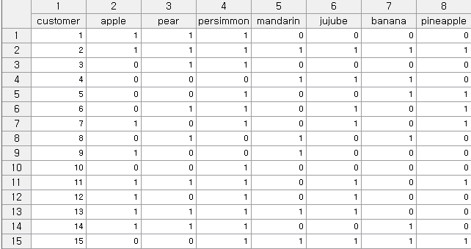

Continuous data type where 1 is for transaction and 0 is for non-transaction. The options for such data file are recommended to be set as **Transaction (TID) Option = ‘Row is TID’, Item Option = ‘Exist by Number’**.

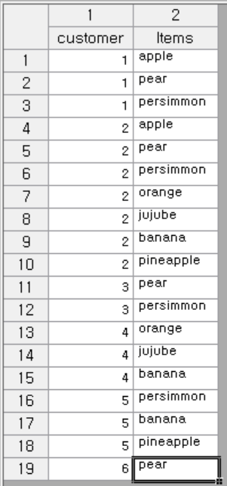

Discrete data type where the transaction information is by the item names. The options for such data file are recommended to be set as **Transaction (TID) Option = ‘sorted by TID’, Item Option = ‘Exist by Item Name’**.

Usage

* Read the data using Input Node.
* Connect Input Node to Association Rules (AR) Node select the options.
* An example of Sequential AR stream is as follows.

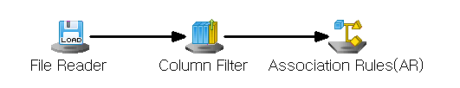

Node Properties

|  |  |  |  |  |
| --- | --- | --- | --- | --- |
| Property group | Property Name | Description | Misc. | Note |
| Model File | Save Model File | Decide whether to save model file. | Required | Yes, No |
| Model File Path | Set the path for the model file to be saved. | Conditionally Required |  |
| Selection options | Min Support | Set the minimum support value.  (default value is 0.5) | Required | Natural Number |
| Max Itemsize | Maximum itemset size  The algorithm will generate itemsets of all possible lengths (starting from 1 itemset up to the maximum possible length) | Required | >1 |
| Min Confidence | Minimum confidence value  (default value is 0.5) | Required | 0-1 |
| Result Itemset | Enter the Result Itemset. You can choose either a single outcome or multiple outcomes. | Required | Single Result,  Multiple outcomes |
| Transaction (TID) Option | Choose whether you need to sort by Transaction ID, if it is already sorted, or if you want to view a single row by ID. | Required | Must be sorted by TID, sorted by TID, row is TID |
| Item Option | Select whether the current data type is represented by the number of items or a single transaction by the item name. | Required. | Exists by item name, exists by number |

**Modeling Result**

**Click Modeling Result button in Node Property of Model node to view the analysis Results.**

* Option Information

It shows which options were used when modeling using AR.

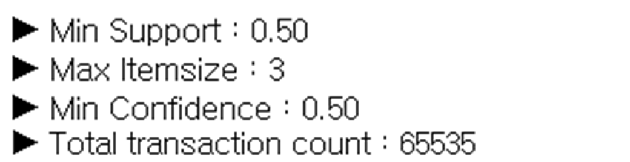

* Weight Information

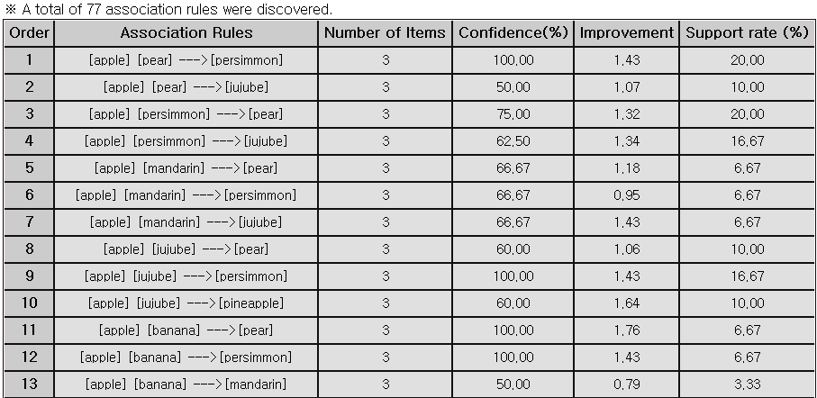

* (1) Association Rules

[A->B] means “If product A is purchased, product B is also purchased.”

* (2) Number of Items

The total number of items that define an association.

* (3) Confidence (%)

The degree of correlation. The probability that item B will be included in a transaction containing item A.

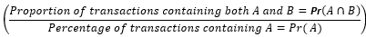

* (4) Improvement(lift)

The ratio of when item A is purchased and that transaction includes item B compared to when item B is purchased randomly.



* (5) Support rate (%)

The number of transactions containing A and B is described as the value obtained by dividing that number by the total number of transactions.



Note

1. In association analysis, the support (basic purchase rate) must reach a certain threshold to be considered meaningful.

2. Lift is considered meaningful when its value exceeds 1.

Example file

Run the **“AR.ecm“**

### 3.4.3 AutoEncoder

|  |  |
| --- | --- |
|  | **AutoEncoder** is a type of neural network that produces an output closely resembling the input through encoding and decoding processes. The encoded **Results** can be used for data compression, or you can identify anomalies by comparing the input with the output. |

Overview

**AutoEncoder** is a type of neural network that compresses and then restores data. The neural network consists of a symmetrical hidden layer that functions as both an encoder and decoder, along with a feature hidden layer that represents the compressed data. You can observe the Results of data compression through the Results of the Feature layer and verify the restoration of the input data through the output layer.

Applications

* All input nodes must be continuous.

Usage

* Read the data using Input Node.
* Connect Input node to AutoEncoder Node and select the options.
* Connect AutoEncoder Node to Display Node.
* An example of AutoEncoder stream is as follows.

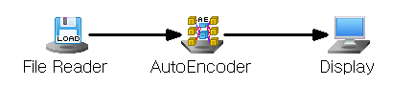

Node Properties

|  |  |  |  |  |
| --- | --- | --- | --- | --- |
| Property group | Property Name | Description | Misc. | Note |
| Model File | Save Model File | Decide whether to save model file. | Required | Yes, No |
| Model File Path | Set the path for the model file to be saved. | Conditionally Required |  |
| Selection options | Optimization Technique | Select the Numerical Method to optimize the objective function. | Required | Gradient Descent, AdaGrad, RMSProp, ADAM |
| Hidden Layer Count Configuration | Select Number of Hidden Layers. | Required | 1, 3 |
| Feature Hidden Layer Node Count | Enter the number of nodes in the Feature hidden layer. | Required | natural number |
| Feature Hidden Layer Activation Function | Feature Specifies the activation function of the hidden layer. | Required | Linear, Tanh, Sigmoid, ReLU, Leaky ReLU, ELU |
| Symmetric Hidden Layer Node Count | Enter the number of nodes in the symmetric hidden layer. | Required | natural number |
| Symmetric Hidden Layer Activation Function | Specifies the activation function of the symmetric hidden layer. | Required | Linear, Tanh, Sigmoid, ReLU, Leaky ReLU, ELU |
| Output Layer Activation Function | Specifies the activation function of the output layer. | Required | Linear, Tanh, LogSig, ReLU, Leaky ReLU, ELU |
| Run Count | Enter the maximum number of training iterations. | Required | natural number |
| Final Target Error | Learning stops when the target error is reached. | Required | Real number |
| Batch Size | Set the batch size. | Required | natural number |
| Learning Rate | Set the Learning Rate when learning weights. | Required | Real number |
| Momentum | When calculating the weight for the opposite direction of the gradient, enter the amount of reflection of the direction from the previous step. | Required | Real number |
| Gamma | Specifies the Gamma value used in the RMSProp algorithm. | Required | Real number |
| Beta1 | Specifies the Beta1 value used in the ADAM algorithm. | Required | Real number |
| Beta2 | Specifies the Beta2 value used in the ADAM algorithm. | Required | Real number |

Results

**The analysis Results are displayed using Display Node.**

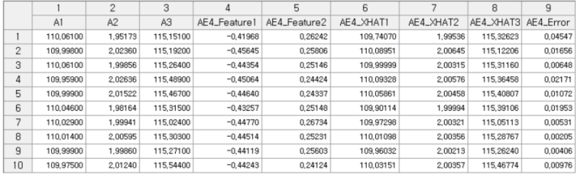

Modeling Result

**Click Modeling Result in Node Property of Model node to view the analysis Results.**

* Option Information

It shows which options were used when modeling using Deep NN. This allows you to determine how the **Results** change when the options are changed.

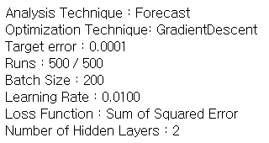

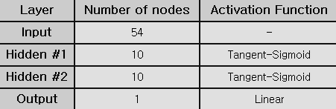

* Weight Information

The weight information of the node entering Hidden Layer #1 from the input layer and the weight information of the node entering the output layer from Hidden Layer #1 are displayed.

### 3.4.4 CART

|  |  |
| --- | --- |
|  | **CART (Classification and Regression Trees)** isa type of decision tree algorithm. CART is used for Random Forests and Gradient Boosted Trees. |

**Overview**

**Decision Trees** is a classification model which is interpretable and easy to understand. Tree structure shows the decision-making process.

**(1) Growing the Tree**   
The data is split recursively at different nodes based on the feature such as splitting criterion, and stopping rule. Gini impurity is used for classification, and LSD (Least Squared Deviation) is used for regression.

**(2) Pruning**  
The decision tree is stopped from growing before it reaches its maximum complexity. This can be done by setting a limit on the depth of the tree, the minimum number of samples required to split a node, or the minimum gain in impurity reduction needed to make a split. To avoid overfit, pruning is needed.

**(3) Classification**  
The algorithm creates a classification tree where each node represents a decision rule on a feature.

Applications

* Decision trees can be used for both classification and regression tasks.
* The CART algorithm uses different impurity functions depending on the task: Gini, Twoing, or Entropy for classification tasks with discrete target variable, and LSD (Least Squared Deviation) for regression tasks with continuous target variable.

Usage

* Read the data using Input Node.
* Specify the type of data using Type Change Node. (independent, or target)
* Connect Type Change Node to CART Node and select the options.
* Connect CART Node to Display Node.
* Additional option: Set the Misclassification Cost and Occupancy ratio.

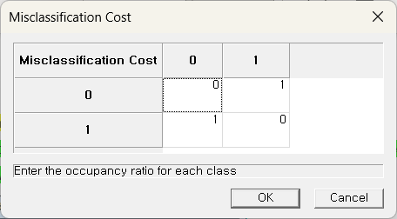 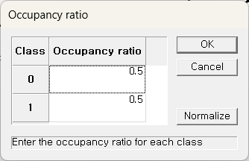

* An example of CART stream is as follows.

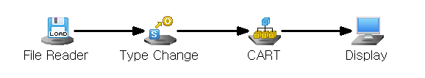

Node Properties

|  |  |  |  |  |
| --- | --- | --- | --- | --- |
| Property group | Property Name | Description | Misc. | Note |
| Model File | Save Model File | Decide whether to save model file. | Required | Yes, No |
| Model File Path | Set the path for the model file to be saved | Conditionally Required |  |
| Selection options | Impurity Function | Specify the impurity function  (Default is Gini) | Required | Gini, Twoing, Entropy, LSD |
| Misclassification Cost | ‘Default’ sets the misclassification cost as 1 for correct classifications and 0 for misclassifications across all classes.  To assign different costs to each class, select Custom and specify the values. | Required | Default, Custom |
| Occupancy Input | Occupancy Input refers to the proportion of each class within the data. By default, the same percentage is applied to all classes. | Required | Default,  Custom |
| Criterion | Define whether to build the tree automatically or manually based on the selected options. | Required | Automatic, Manual |
| Min Samples Split | Set the minimum number of data required to split a tree node. Activated when the Criterion option is set to ‘Automatic’. (Default is 5) | Conditionally  Required | Value>0 |
| Pruning | Choose whether to prune the generated tree. Activated when the Criterion option is set to ‘Automatic’. | Conditionally  Required | Yes, No |
| Max Tree Depth | The maximum depth of the tree. Activated when the Criterion option is set to ‘Automatic’.  **Default**: None (nodes are expanded until all leaves are pure or contain fewer than Min Samples Split) | Conditionally  Required | Value>0 |
| Impurity Threshold | A node becomes a stationary node if its impurity is below the specified impurity threshold. Activated when the Criterion option is set to ‘Automatic’. | Conditionally  Required | 0≤value≤1 |
| Impurity Change Threshold | If the impurity change for a node is below the specified threshold, the node is considered a terminal node. Activated only when the Criterion option is set to ‘Automatic’, and Pruning option is set to ‘No’. | Conditionally  Required | 0≤value≤1 |

Results

The analysis Results are displayed using Display Node.

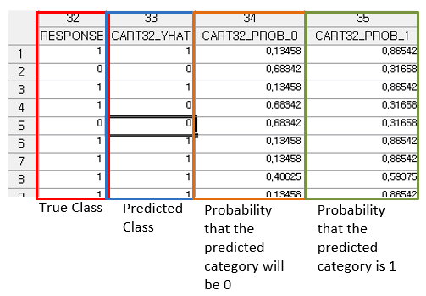

Modeling Result

Click Modeling Result in Node Property of Model node to view the Results.

* Option Information

It shows which options were used when modeling using CART.

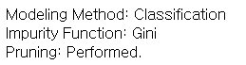

* Model Information

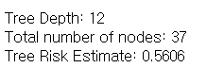

* Confusion Matrix

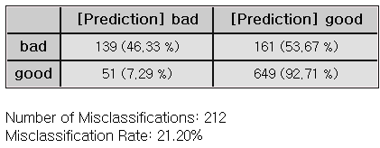

* Decision Tree

There are two rules that can be obtained through the tree structure below, and the group is determined by the value of CHK\_ACCT. If the variable CHK\_ACCT is 0.14286, 0.25, 0.37755, 0.65285, it is divided into groups with good credit ratings and can be used as a rule. When CHK\_ACCT is 0.70732, 0.84615, 0.86871, it appears as a group with a bad credit rating. In this case, it can also be used as a rule.

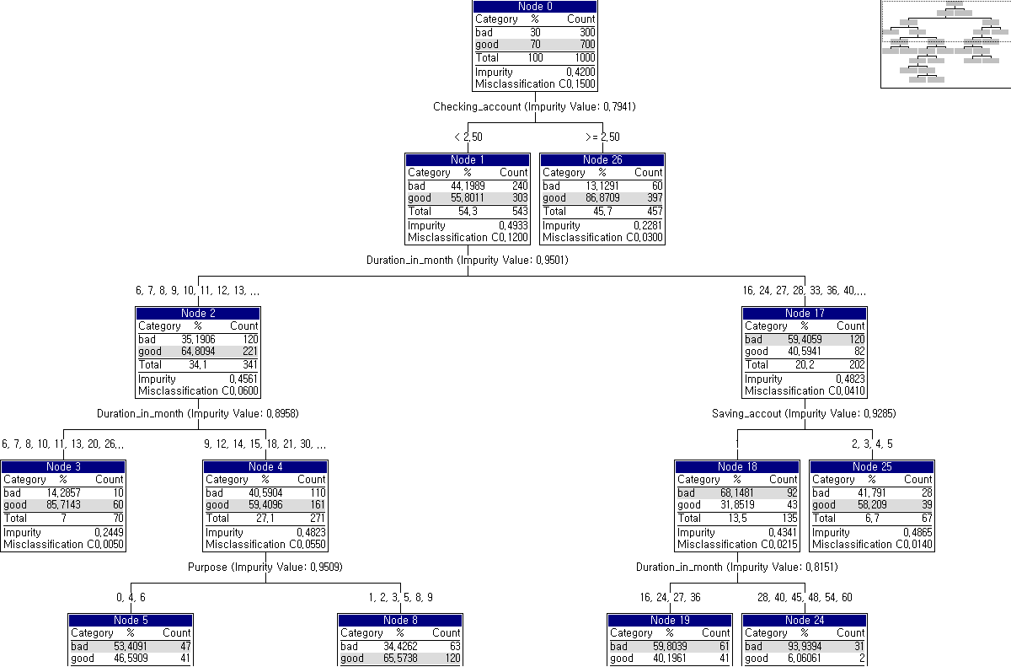

Example file

▪ Run **“CART.ecm“**

### 3.4.5 CCA(Canonical Correlation Analysis)

|  |  |
| --- | --- |
|  | **Canonical Correlation Analysis (CCA)** is a multivariate statistical method that finds the relationship between two sets of multivariate variables. |

Overview

**Canonical Correlation Analysis (CCA)** is used to identify the linear correlation between two sets of multivariate variables. **CCA** examines the relationships between multiple independent and dependent variables. **CCA** consists of $q$ variables $x_{1}$, $x_{2}$, …, $x_{q}$ and $p$ variables $y_{1}$, $y_{2}$, …, $y_{p}$ aiming to find the dependency relationship between the two sets of variables.

In CCA, the new variables $U$ and $V$ are canonical variables generated as linear combinations of the variables in each set, representing the direction that best explains the correlation within each set of variables.

The linear combination form for canonical variables $U$ and $V$, which summarize $q$ and $p$ variables, are as follows.

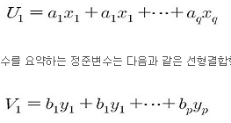



**Matrix Type** option is used when creating canonical variables, allowing you to choose between a **Covariance Matrix** and a **Correlation Matrix**. The **Covariance Matrix** is used when the variables in both sets have the same units or scale, while the **Correlation Matrix** is used when the variables have different units or scales.

The **Number of Canonical Correlations** represents the linear combinations that explain the correlations between two sets of variables and can range from 1 to the smaller number of variables in the two sets.

Applications

* Independent variables must be continuous.
* Dependent variable must be continuous.

Usage

* Read the data using Input Node.
* Specify the type of data using Type Change Node. (independent, or target)
* Connect Type Change Node to CCA Node and select the options.
* Connect CCA Node to Display Node.
* An example CCA stream is as follows.

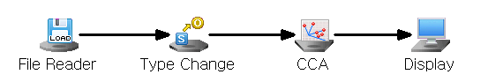

Node Properties

|  |  |  |  |  |
| --- | --- | --- | --- | --- |
| Property | Property Name | Description | Misc. | Note |
| Model File | Save Model File | Decide whether to save model file. | Required | Yes, No |
| Model File Path | Set the path for the model file to be saved. | Conditionally Required |  |
| Selection options | Matrix Type | Set the Matrix Type. | Required | Covariance Matrix, Correlation Matrix |
| Number of Canonical Correlations | Set the number of Canonical Correlation Coefficient. | Required | 1 ≤integer≤N (N: Minimum Number of Independent and Dependent variables) |

Results

The CCA results and the scores of independent and dependent variables are displayed using Display Node.

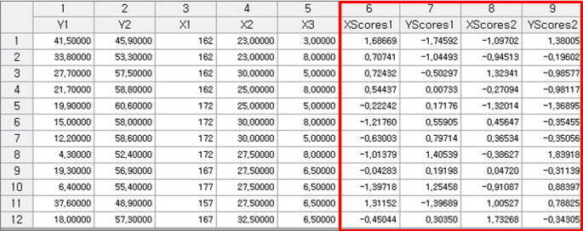

Graphic Result

Click Graphic Result in Node Property of Model node to view the charts. The results can also be viewed in the Modeling Result of Model node.

* Correlation Plot

Indicates the correlation coefficient between independent and dependent variables.

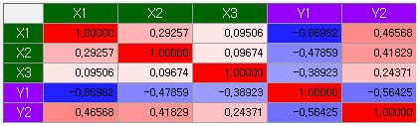

* Score Plot

Plot of the score values for the independent and dependent variables.

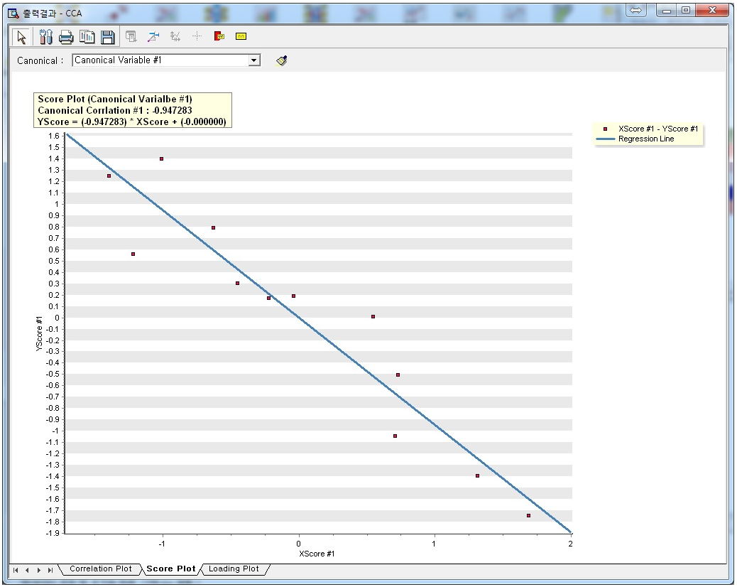

* Loading Plot

Scatter plot of the loading values for the independent and dependent variables. The loading value is the correlation coefficient between individual variables and the canonical variables.

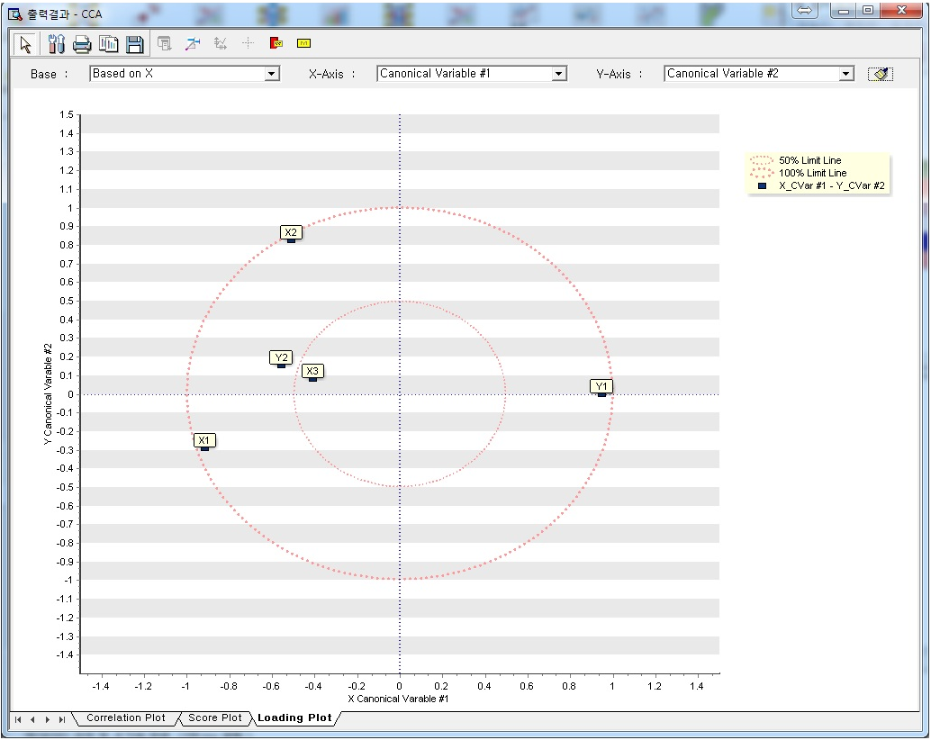

Modeling Result

**Click Modeling Result in Node Property of Model node to view the results.**

* Canonical Correlation Coefficient Test - Wilks' Lambda Statistic

Wilks’ Lambda statistic for testing the canonical correlation coefficient.



* Canonical Correlation Coefficient

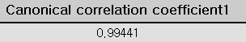

* Coefficient X and Y

The linear combination form of the canonical variables of the independent variables and dependent variables is provided in the form of formulas and tables.



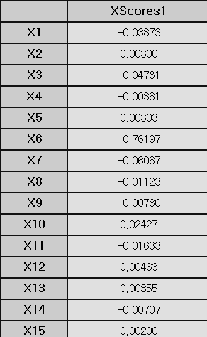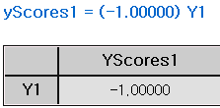

* Canonical Loading

Canonical loading information between canonical variables and independent variables, as well as between canonical variables of independent and dependent variables, and between dependent variables and canonical variables.

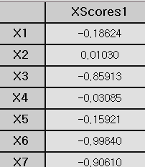

* Variance Information

It shows how much information each canonical variable explains about the entire data.

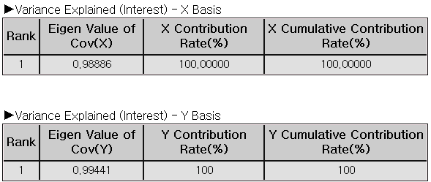

Example file

Run the “**CCA.ecm”**

### 3.4.6 CNN

|  |  |
| --- | --- |
|  | **Convolutional Neural Network (CNN)** is a type of deep learning model that utilizes multiple convolutional and pooling layers to automatically learn features from input images. These features enable CNN to perform tasks such as classification or prediction. CNN excels at understanding the spatial structure within image data, allowing it to identify and extract intricate patterns or structure. |

Overview

Convolutional Neural Network (CNN) is a machine learning methodology inspired by the similarities between the patterns of connections among neurons and those found in the visual cortex of animals. It is a type of feed-forward neural network that automatically learns features from images through filter or kernel optimization. CNN is widely used for characterizing and classifying of 2D data, such as images, across various field.

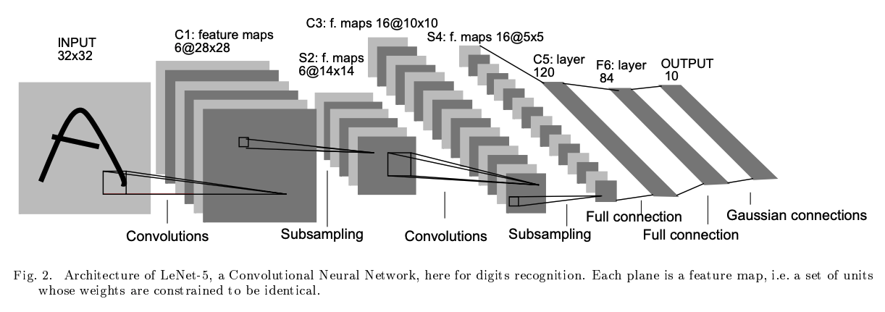

The figure above illustrates a CNN architecture, like LeNet-5, using convolutional and subsampling layers to extract features, and fully connected layers for digit recognition**.**

Convolutional neural networks comprise **three primary types of layers**.

**(1) Convolution layer**  
The convolutional layer is the most important feature of a CNN, applying filters to the previous layer’s feature map to generate a new, more compact, and informative feature map. The filters move across the input with a set stride, controlling the amount of overlap and affecting the size of the output. Padding is often used in convolutional layers to control the output size and preserve information at the edges. In certain CNN architectures like LeNet, AlexNet, and VGGNet, both stride and padding values are fixed for each layer type and cannot be modified.

**(2) Pooling layer**  
The pooling layer, or sub-sampling layer, reduces the number of weights parameters by down sampling, optimizing computational efficiency and mitigating overfitting.

**(3) Fully connected layer**   
Finally, the fully connected layer, or classification layer, processes the extracted features and performs classification. The output of the final fully connected layer is a probability map, indicating the likelihood of the input image belonging to each class. The class with the highest probability is considered the final classification result.

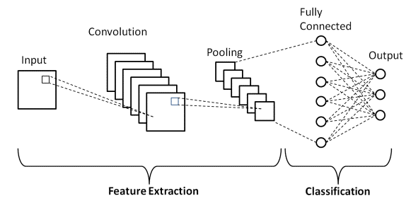

Applications

* Select a string-type variable from the CNN Node's properties that contains the path to the input image.
* Set the string-type variable containing the labeling information as the dependent variable.

Usage

* Read the data using Image Reader Node.
* Add label column using Preprocessing Node. (Column Filter, Derived Column, etc)
* Specify the type of data using Type Change Node. (independent, or target)
* Connect Type Change Node to CNN Node and select the options.
* Connect CNN Node to Display Node.
* An example of CNN stream is as follows.

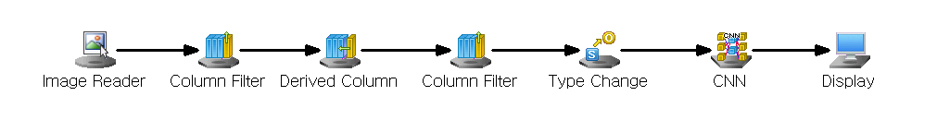

Node Properties

|  |  |  |  |  |
| --- | --- | --- | --- | --- |
| **Property group** | **Property Name** | **Description** | **Misc.** | **Note** |
| **Model File** | Save Model File | Decide whether to save model file. | Required | Yes, No |
| Model File Path | Set the path for the model file to be saved. | Conditionally Required |  |
| **Selection options** | Input Image Path Variable | Select the Input Image string-type variable that contains the source path information. | Required | variable name |
| Image Color Space | Decide whether the input image is color or black and white. | Required | Color, black and white |
| Network Type | Specify structure of the convolution neural network for modeling | Required | LeNet-5, AlexNet, VGGNet |
| Use Initial Padding | Decide whether to apply Initial Padding to the Input Image. | Required | Yes, No |
| Top Padding | Sets the initial padding size to be applied to the top of the Input Image if Use Initial Padding is **Yes**.. | Conditionally Required | 0≤Integer |
| Bottom Padding | Sets the initial padding size to be applied to the Bottom of the Input Image if Use Initial Padding is **Yes**... | Conditionally Required | 0≤Integer |
| Left Padding | Sets the initial padding size to be applied to the left side of the Input Image if **Use Initial Padding** is **Yes**. | Conditionally Required | 0≤Integer |
| Right Padding | Sets the initial padding size to be applied to the right of the Input Image if **Use Initial Padding** is **Yes**. | Conditionally Required | 0≤Integer |
| Optimization Technique | Set the method of weight updates. | Required | Gradient Descent with Momentum, AdaGrad, RMSProp, ADAM |
| Learning Rate | Set the degree of weight updates during the Optimization Technique. | Required | 0<real number≤1 |
| Momentum | Set the degree to which the weight reflects the existing direction of movement if **Optimizing Method** is **Gradient Descent with Momentum.** | Conditionally Required | 0<real number≤1 |
| Gamma | Set the rate at which previously updated weights are remembered if **Optimization Technique** is **RMSProp.** | Conditionally Required | 0≤real number<1 |
| Beta1 | Set the degree to which the weight reflects the existing direction of movement if **Optimization Technique** is **ADAM.** | Conditionally Required | 0≤real number<1 |
| Beta2 | Set the rate for remembering previously updated weights if the **Optimization Technique** is ADAM. | Conditionally Required | 0≤real number<1 |
| Batch Size | Set the number of data to update at once in mini-batch gradient descent. | Required | 0<integer≤k (k: number of data) |
| Number of Epochs | Set the number of epochs | Required | 0<integer |

Note

* Activation Function

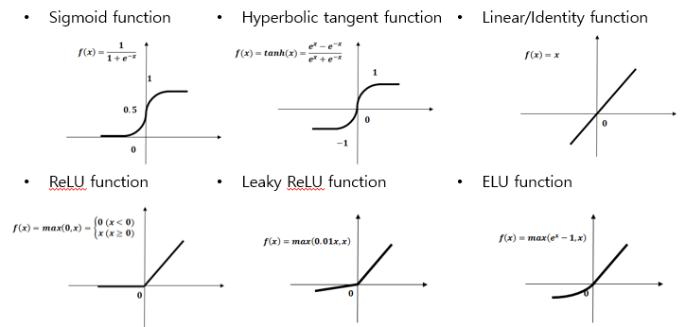

* Batch Size

In mini-batch gradient descent, learning is performed by calculating the loss function for each batch. When the batch size approaches the size of the entire dataset, it behaves similarly to one-batch gradient descent, which updates the entire dataset at once. This makes it robust to outliers but weak against local minima. Conversely, when the batch size is closer to 1, the updates become more like stochastic gradient descent, making it less resistant to outliers but better at escaping local minima. By adjusting the batch size, we can balance between outlier resistance and the ability to overcome the local minima problem.

* Optimization algorithm

**(1) Gradient Descent with Momentum**

Weights are updated in a way similar to the concept of inertia, where an object tends to continue moving in the same direction. The closer the Momentum coefficient is to 1, the more it maintains the current direction, while values which are closer to 0 approach standard gradient descent. When the Momentum coefficient is 1, a new gradient is added without changing the current direction. Conversely, if the Momentum coefficient is 0, it is identical to regular gradient descent.

**(2) Adagrad**

For variables that fluctuate significantly during training, we reduce the learning rate. For instance, if one variable is updated more frequently than another, its learning rate is adjusted accordingly.

**(3) RMSProp**

Adagrad adjusts the learning rate for each parameter individually, but it can get stuck with a very low learning rate due to accumulating past gradients. RMSprop addresses this by giving more weight to recent gradients, preventing the learning rate from becoming too small too quickly.

**(4) ADAM**

Adam is a learning method that combines the strengths of momentum and RMSprop. Momentum helps maintain the direction of movement, while RMSprop reduces the learning rate for frequently updated variables. Adam uses two hyperparameters beta1 and beta2. The closer the Beta1 value is to 1, like the momentum coefficient, the more it maintains the direction in which the gradient value is moving. The Beta2 value is a ratio that maintains the size of the gradient before the current point, similar to the gamma value of RMSProp. The closer the Beta2 value is to 1, the greater the influence of reducing the current learning strength due to the previous update time.

Message

Display the batch-wise classification accuracy (%) in the message window for each batch, and show the mean square error and root mean square error for each epoch in the message window.

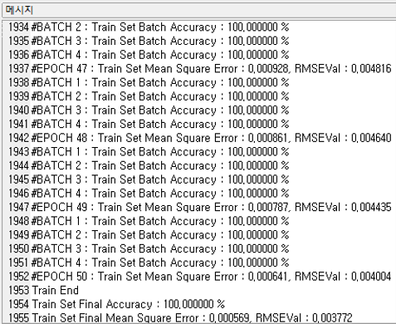

Results

**The analysis results are displayed using Display Node.**

The figure below shows the results of the CNN learning process, showing the predicted classification results (CNN#\_YHAT) for the dependent variable based on input image data. CNN#\_MaxOut indicates the confidence level (classification probability) with which the fCNN model classified the prediction result (CNN# YHAT).

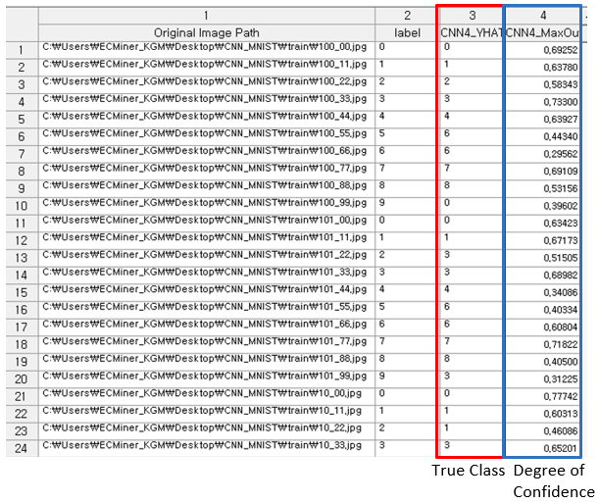

Modeling Result

**Click Modeling Result in Node Property of Model node to view the results.**

* Option Information

It shows which options were used when modeling using CNN.

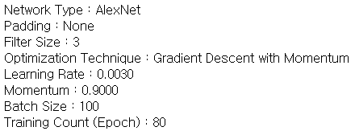

* Confusion Matrix

Displays the classification results and accuracy obtained by applying the model to the data. The bottom of the table shows the total number of misclassifications and the misclassification rate.

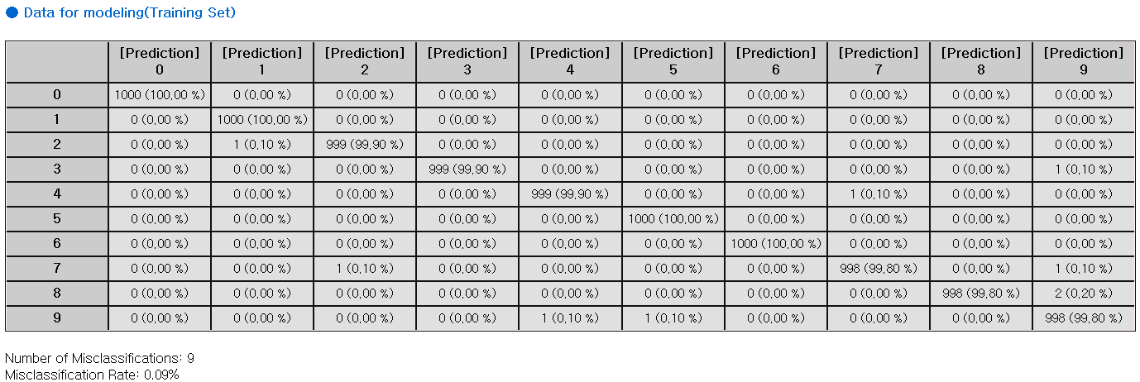

### 3.4.7 Deep NN

|  |  |
| --- | --- |
|  | The **Deep Neural Network (Deep NN)** is a type of artificial neural network with multiple hidden layers to understand the complex, non-linear relationships between the data. |

Overview

A common type of NN is the multilayer feedforward network, which consists of an input layer, one or more hidden layers, and an output layer. In this process, the input signal advances layer-by-layer. Each layer's neurons (or nodes) are connected to those in other layers through connections that have a bias and an adjustable weight. The figure below illustrates the structure of an NN with two hidden layers.



Backpropagation is a widely used algorithm in training artificial neural networks, primarily for minimizing the error by adjusting the weights through gradient descent. consists of two stages:

* (1) Forward pass

The input is passed through the network layer by layer. It passes through the input and hidden layers in the forward direction. Finally, the network produces output, which is an estimate of the desired output, at the output layer. During the forward pass, the network computes its output, but the weights remain unchanged.

* (2) Backward pass (Backpropagation)

The weights are updated in the backward direction based on the error correction rule (back propagation algorithm). The weights are adjusted so that the network's actual output moves closer to the desired output.

Applications

* Independent variables must be continuous.
* Dependent variable can be either continuous or discrete.
* If the dependent variable is discrete, One-Hot Encoding is applied.

Usage

* Read the data using Input Node.
* Specify the type of data using Type Change Node. (independent, or target)
* Connect Type Change Node to DeepNN Node and select the options.
* Connect DeepNN Node to Display Node.
* An example of DeepNN stream is as follows.

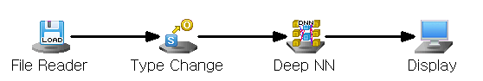

Node Properties

|  |  |  |  |  |
| --- | --- | --- | --- | --- |
| Property group | Property Name | Description | Misc. | Note |
| Model File | Save Model File | Decide whether to save model file. | Required | Yes, No |
| Model File Path | Set the path for the model file to be saved. | Conditionally Required |  |
| Selection options | Run Count | Select the maximum number of times to train the dataset. | Required | natural number |
| Final Target Error | Select the minimum error condition for learning to end. | Required | 0<real number |
| Loss Function | Select the type of loss function. If Loss Function is Cross Entropy, SoftMax activation function is automatically applied. | Required | Sum of Squared Error,  Cross Entropy |
| Output Layer Activation Function | Select the activation function of the output layer if Loss Function is Sum of Squared Error. | Conditionally Required | Linear, Tanh, Log Sigmoid, ReLU, Leaky ReLU, ELU |
| Optimization Technique | Set the method of weight updates. | Required | Gradient Descent With Momentum,  ADAM,  Adagrad,  RMSProp |
| Batch Size | Set the number of data to update at once in mini-batch gradient descent. | Required | 0<integer≤k (k: number of data) |
| Learning Rate | Set the degree of weight updates during optimization technique. | Required | 0<real number≤1 |
| Momentum | Set the degree to which the weight reflects the existing direction of movement if Optimization Technique is Gradient Descent with Momentum. | Conditionally Required | 0≤real number<1 |
| Gamma | Set the rate at which previously updated weights are remembered if Optimization Technique is RMSProp. | Conditionally Required | 0≤real number<1 |
| Beta1 | Set the degree to which the weight reflects the existing direction of movement if Optimization Technique is ADAM. | Conditionally Required | 0≤real number<1 |
| Beta2 | Set the rate at which ADAM Optimization Technique remembers previously updated weights if Optimization Technique is ADAM. | Conditionally Required | 0≤real number<1 |
| Selection options  -Hidden Layer Configuration | Add Hidden Layer | Add a hidden layer of the model. | button |  |
| Remove Last Hidden Layer | Remove the last hidden layer of the model. | button |  |
| Selection options  -Hidden Layer # | Number of Nodes | Set the number of perceptron in the hidden layer. | Required | natural number |
| Activation Function | Select the activation function of the hidden layer. | Required | Linear, Tanh, Log Sigmoid, ReLU, Leaky ReLU, ELU |

Note.

* Activation Function



* Batch Size

In mini-batch gradient descent, learning is performed by calculating the loss function for each batch. When the batch size approaches the size of the entire dataset, it behaves similarly to one-batch gradient descent, which updates the entire dataset at once. This makes it robust to outliers but weak against local minima. Conversely, when the batch size is closer to 1, the updates become more like stochastic gradient descent, making it less resistant to outliers but better at escaping local minima. By adjusting the batch size, we can balance between outlier resistance and the ability to overcome the local minima problem.

* Optimization algorithm

**(1) Gradient Descent with Momentum**

Weights are updated in a way similar to the concept of inertia, where an object tends to continue moving in the same direction. The closer the Momentum coefficient is to 1, the more it maintains the current direction, while values which are closer to 0 approach standard gradient descent. When the Momentum coefficient is 1, a new gradient is added without changing the current direction. Conversely, if the Momentum coefficient is 0, it is identical to regular gradient descent.

**(2) Adagrad**

For variables that fluctuate significantly during training, we reduce the learning rate. For instance, if one variable is updated more frequently than another, its learning rate is adjusted accordingly.

**(3) RMSProp**

Adagrad adjusts the learning rate for each parameter individually, but it can get stuck with a very low learning rate due to accumulating past gradients. RMSprop addresses this by giving more weight to recent gradients, preventing the learning rate from becoming too small too quickly.

**(4) ADAM**

Adam is a learning method that combines the strengths of momentum and RMSprop. Momentum helps maintain the direction of movement, while RMSprop reduces the learning rate for frequently updated variables. Adam uses two hyperparameters beta1 and beta2. The closer the Beta1 value is to 1, like the momentum coefficient, the more it maintains the direction in which the gradient value is moving. The Beta2 value is a ratio that maintains the size of the gradient before the current point, similar to the gamma value of RMSProp. The closer the Beta2 value is to 1, the greater the influence of reducing the current learning strength due to the previous update time.

Message

The RMSE value is displayed in the message every 10th iteration.

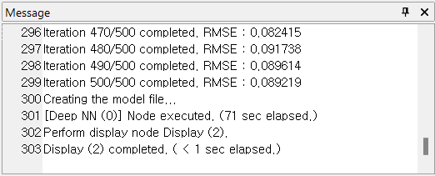

Results

**The analysis results are displayed using Display Node.**

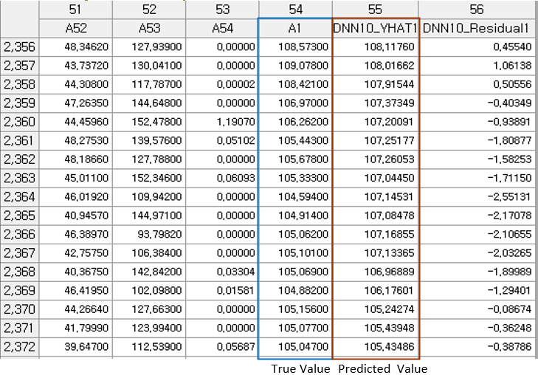

Modeling Result

Click **Modeling Result** button in Node Property of **Model node** to view the analysis results.

* Option Information

It shows which options were used when modeling using NN. This allows you to determine how the results change when the options are changed.

* Weight Information

The weight information of the node entering Hidden Layer #1 from the input layer and the weight information of the node entering the output layer from Hidden Layer #1 are displayed.

* ANOVA TABLE

Applicable only for regression analysis. An F test is performed to test whether the independent variable is statistically significant in explaining the dependent variable y. If the p-value is greater than the significance level and is not significant, interpretation of the regression coefficient is meaningless.



* Confusion Matrix

Applicable only for classification. A cross-tabulation of the original and predicted classes shows the number and percentage of incorrectly predicted observations.



* Standard Error Information



* (1) R-square (coefficient of determination)

It is a value that checks whether the derived regression equation is representative of the measured values.

* (2) Adjust R2

It adjusts the r-squared value by considering the degree of freedom of the model.

* (3) RMSE (Root-Mean Square Error)

The square root of the average squared differences between the predicted values and the dependent variable.

* (4) MAE (Mean Absolute Error)

The average of the absolute differences between the predicted values and the dependent variable.

* (5) MAPE (Mean Absolute Percentage Error)

The average of the absolute differences between the predicted values and the dependent variable as a percentage

Numbers (3) to (5) all represent the error between the original value and the predicted value of the dependent variable. The smaller the value, the better the model.

### 3.4.8 ElmanNet

|  |  |
| --- | --- |
|  | ElmanNet is type of the recurrent neural with a single hidden layer, commonly used for predictive analysis (Regression). It features a context layer that stores information from previous time steps, allowing the network to make predictions based on past data. |

Overview

ElmanNet is a recurrent neural network with a single hidden layer. It includes a Context Layer, which serves as a memory component, retaining information about previous states. The Context Layer has the same number of nodes as the hidden layer and stores the hidden layer's state values through recurrent feedback. By using the influence of independent variables from previous time points, ElmanNet predicts the dependent variable at each time point. It is commonly used for predictive tasks and is classified as a supervised neural network.

Applications

* Independent variable must be continuous
* Dependent variable must be continuous.
* Since the dependent variable is continuous, only predictive analysis is performed, and the activation function is fixed to the identity function.
* ElmanNet has only one hidden layer.

Usage

* Read the data using Input Node.
* Specify the type of data using Type Change Node. (independent, or target)
* Connect Type Change Node to ElmanNet Node and select the options.
* Connect ElmanNet Node to Display Node.
* An example of ElmanNet stream is as follows.

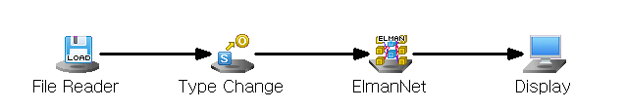

Node Properties

|  |  |  |  |  |
| --- | --- | --- | --- | --- |
| Property group | **Property Name** | **Description** | **Misc.** | **Note** |
| Model File | Save Model File | Decide whether to save model file. | Required | Yes, No |
| Model File Path | Set the path for the model file to be saved. | Conditionally Required |  |
| Selection options | Number of Nodes | Specify the number of nodes in the hidden layer. | Required | Integer < 100 |
| Hidden Layer Activation Function | Specify the activation function of the hidden layer. | Required | Sigmoid |
| Weighting Initialization Specification | Specify whether to manually set the initial weights of the neural network. | Required | Yes, No |
| Initial Weighting From | Specify the starting point of the random range for weight initialization. | Selection options | -1 **≤** Real Number **≤** 1. -0.5 by default |
| Initial Weighting To | Specify the ending point of the random range for weight initialization. | Selection options | -1 ≤ Real Number ≤ 1. 0.5 by default |
| Number of Epochs | Specifies **the maximum number of epochs** for performing the algorithm | Required | natural number |
| Target Error | Specify the maximum allowable target error for learning. | Required | 0≤real number≤1 |
| Learning Rate | Specify the step size when calculating the weight for the gradient direction during training. | Required | 0≤real number≤1 |
| Momentum | Specify the extent to which the previous step's direction is incorporated when calculating the weight for the gradient direction during training. | Required | 0≤real number≤1 |
|  | Batch Size | Specify the batch size to be used for the BPTT(Back Propagation Through Time) algorithm during training. | Required | natural number ≤ 200 |
|  | Learning Log | Specify the interval for displaying logs during training | Required | Natural Number |

Results

Prediction results are displayed using Display Node.

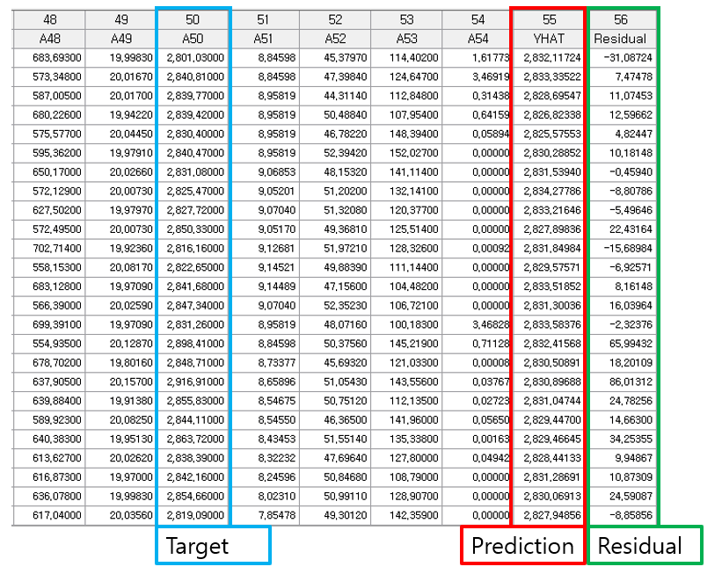

Graphic Result

Click Graphic Result button in Node Property of Model node to view the charts. The results can also be viewed in the Modeling Result of Model node.

* RMSE Plot

Monitor the change in error rate (learning rate) according to the number of repetitions during the model learning process.

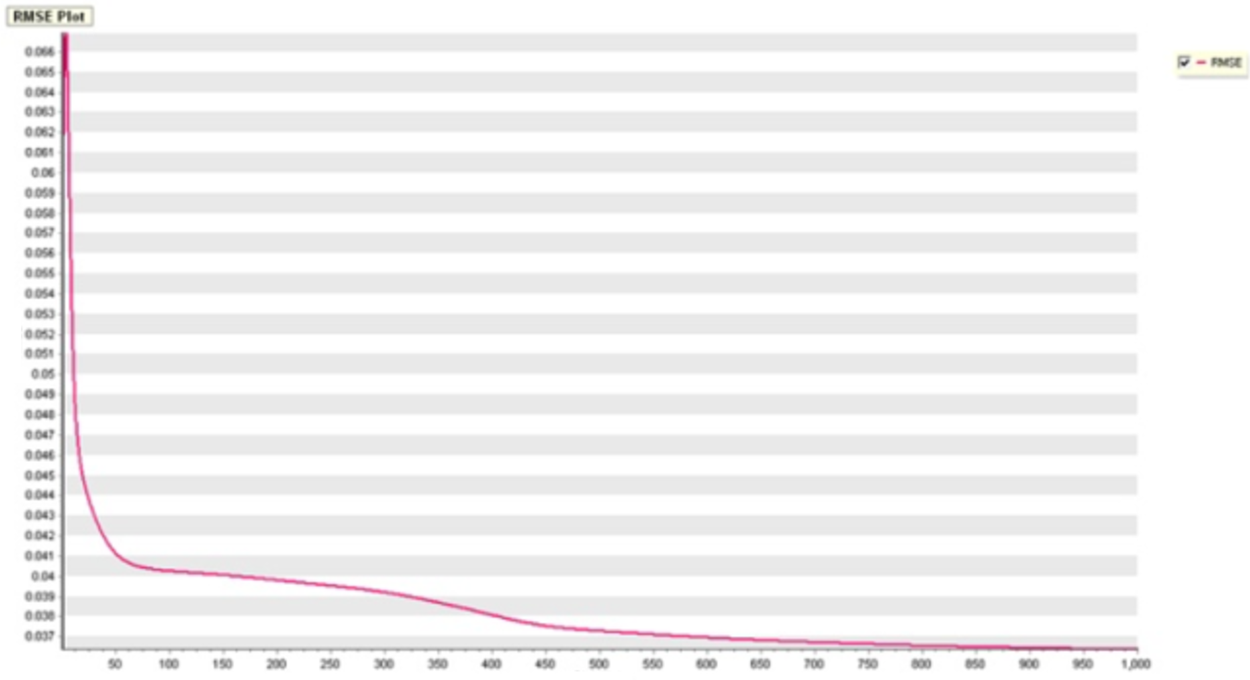

* Compare Plot

Compare the distribution of actual values and values predicted by the model.

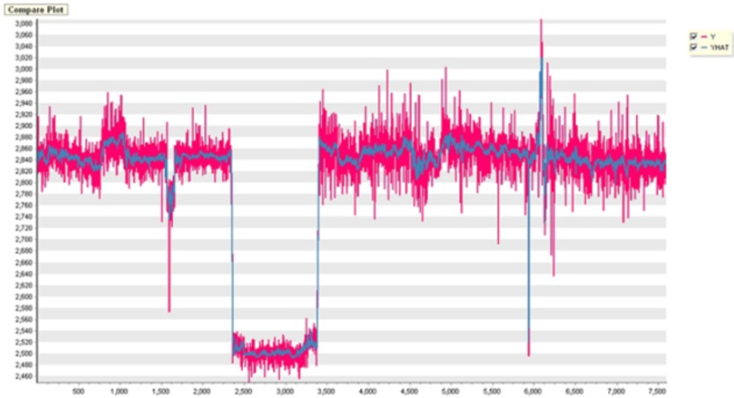

* Residual Plot

Examine the residual between the actual value and the predicted values generated by the model.

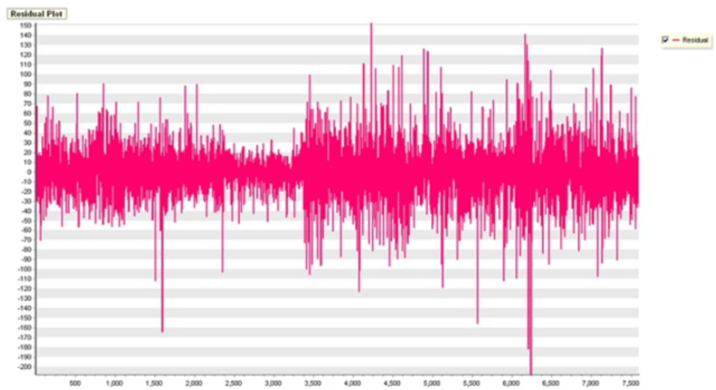

Modeling Result

Click Modeling Result button in Node Property of Model node to view the analysis results.

* Error information about dependent variable

Provides ANOVA Table and Standard Error information.

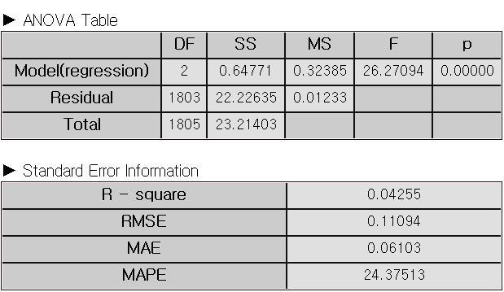

### 3.4.9 Factor Analysis

|  |  |
| --- | --- |
|  | **Factor analysis** is the statistical technique that extracts a common factor among various variables. This allows you to analyze or connect multiple factors. |

Overview

Factor Analysis is a methodology that explains observed variables with small numbers of variables. The small numbers of variables are called common factors and are difficult to find because these are not observed. The purpose of Factor Analysis is to find unobserved common factors and know how the unobserved common factors affect each observed variable.

For example, several students have grades in math, English, Korean, social studies, science, and technology. Empirically, students who are good at math are often good at science and technology, and students who are good at Korean are often good at English and social studies. This may be because grades in mathematics, science, and technology are greatly influenced by human quantitative abilities, and Korean, English, and social studies are greatly influenced by human linguistic abilities.

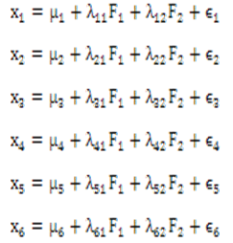

The above mathematical formula describes the followings: $x_{i}$ represents the grade of subject $i$, $μ_{i}$ refers to the population average of the grade of subject $i$. The set of $λ$ is called factor loading and is represented as follows; , . F1 can be a common factor which represents human quantitative abilities and F2 can be a common factor which represents human linguistic abilities. $ε_{i}$ represents the part that is not explained by common factors of subject $i$.

Applications

* Only explanatory variables (independent variable) are included in factor analysis. All variables must be continuous.
* The Factor Analysis node contains standardized pre-processing.

Usage

* Read the data using Input Node.
* Connect Input Node to Factor Analysis Node and select the options.
* Connect Factor Analysis Node to Display Node.
* An example of Factor Analysis stream is as follows.

Node Properties

|  |  |  |  |  |
| --- | --- | --- | --- | --- |
| **Property group** | **Property Name** | **Description** | **Misc.** | **Note** |
| **Model File** | Save Model File | Decide whether to save model file. | Required | Yes, No |
| Model File Path | Set the path for the model file to be saved. | Conditionally Required |  |
| **Selection options** | Number of Factors | Enter the number of common factors. The number of common factors must be less than the number of input variables. | Required | natural number |
| Pre-processing Method | Choose standardization as a pre-processing method. | Required | standardization. |
| Optimization Method | Choose the extraction method of common factors. You can choose maximum likelihood estimation as the extraction method of common factors. | Required | Maximum Likelihood  Estimation |
| Maximum Optimization Iterations | Set the maximum number of iterations of the optimization algorithm. | Required |  |
| Rotation Method | Choose the rotation method: None, Equimax, Varimax, Quartimax. | Required | None, Equimax, Varimax, Quartimax |

Results

**The analysis results are displayed using Display Node.**

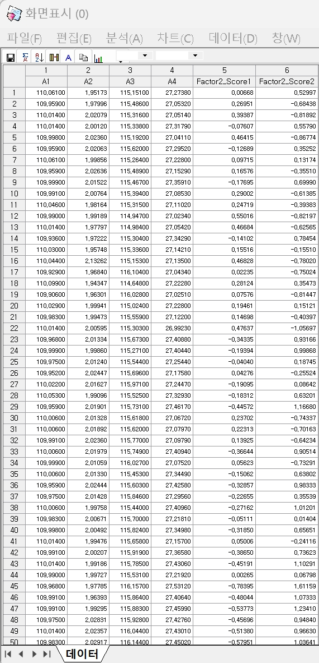

The results of factor analysis are displayed by using **Trend Chart** or **Enhanced Basic Chart**.

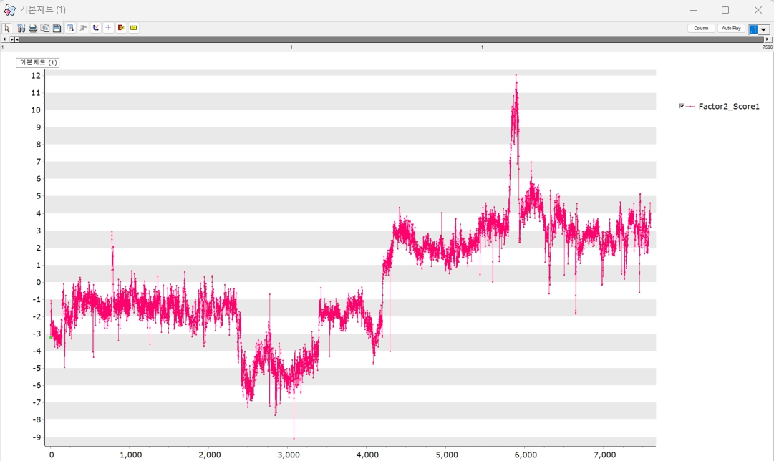

Graphic Result

Click Graphic Result in Node Property of Model node to view the charts. The results can also be viewed in the Modeling Result of Model node.

* Control Chart

The Control Chart shows the distribution of rotation/non-rotation of a common factor. The example of control chart is as follows;

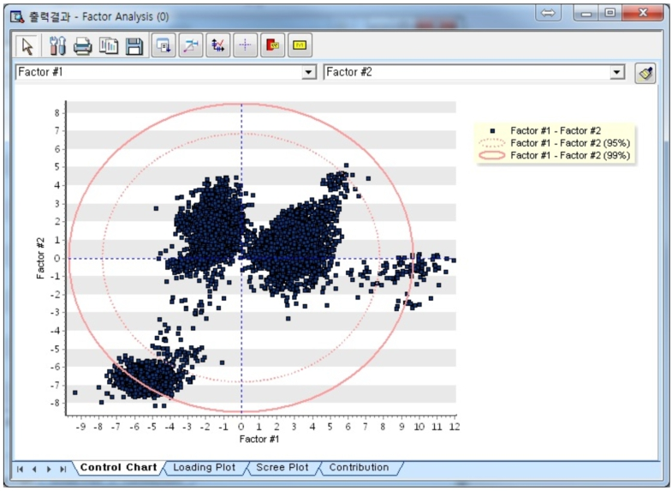

* Loading Plot

The Loading Plot shows the factor loading value of a common factor or data which are included in a circle.

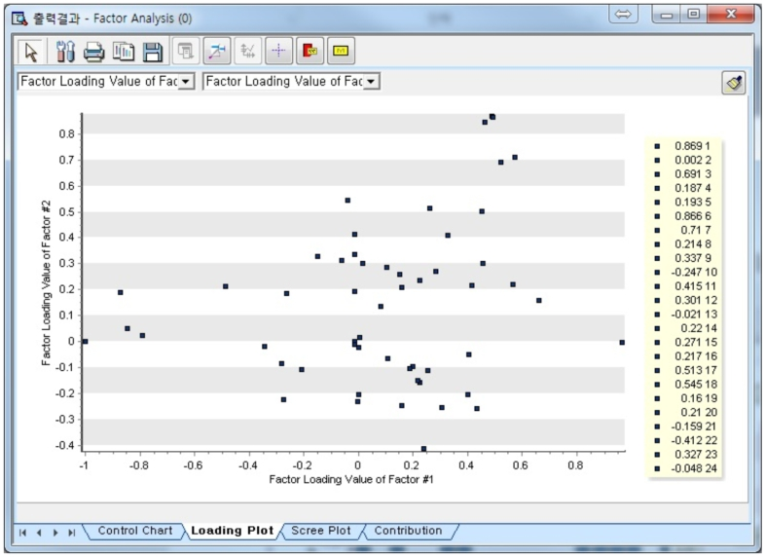

* Scree Plot

The Scree Plot shows the eigenvalue of a common factor. A common factor can be decided at the point that the eigenvalue is changed largely.

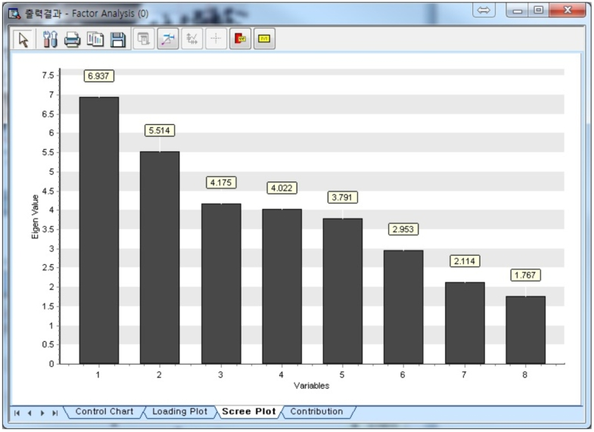

* Contribution

1. After two groups that have large variation in a control chart are set for analysis target, the first group should be dragged like ①, and then the dragged data would be extracted by clicking ② button. The second group should perform like the first group.

2. If data selection is finished, you can choose a common factor and group data. After this, you can click the drawing button to display contribution plot as follows;

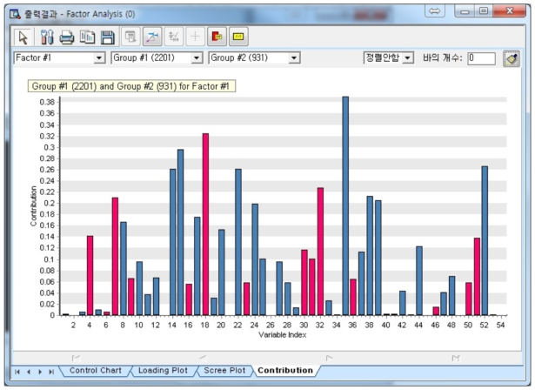

Modeling Result

Click Modeling Result button in Node Property of Model node to view the analysis results.

* Factor Loading Values (With Rotation)

Factor loading by the rotated method.



* Factor Loading Values (No Rotation)

Factor loading without rotation



* Eigenvalue Information

Information about variance proportion explained by the factor



* Correlation Coefficient Information by Factor

Coefficient of each factor.



* Control Limit by Factor

Control limit of each factor.



### 3.4.10 Hierarchical Clustering

|  |  |
| --- | --- |
|  | **Hierarchical Clustering** is grouping data objects with similar characteristics. |

Overview

**Hierarchical clustering** is a useful method for small datasets. It generates a dendrogram, a tree-like structure that illustrates how data objects are grouped. The vertical axis of the dendrogram shows the similarities (or distances) between clusters.

**(1) Distance Measure**

Hierarchical clustering differs depending on **distance measure** and **linkage method**. The distance between clusters or data points influences whether they are merged or not.

|  |  |
| --- | --- |
| **Name** | **formula** |
| Euclidean | $$d_{euclidean}\left(p, q\right)=\sqrt{\sum_{i=1}^{n}{{\left(p_{i}-q_{i}\right)}^{2}}}$$ |
| Squared Euclidean | $$d_{sqr_euclidean}\left(p, q\right)=\sum_{i=1}^{n}{{\left(p_{i}-q_{i}\right)}^{2}}$$ |
| Manhattan |  |
| Minkowski |  |

If p=1 for Minkowski, then it corresponds to the **Manhattan distance**. If p=2 for Minkowski, then it corresponds to the **Euclidean distance**.

**Hamming distance** and **Jaccard distance** are effective for evaluating similarity of binary vectors or text.

**(2) Linkage Method**

**Linkage method** determines the distance criteria used to decide whether clusters should be merged. This approach ensures that the impact on the overall structure of the clustering is kept as small as possible. Linkage methods are as follows.

|  |  |
| --- | --- |
| Name | **Description** |
| Single | Minimum distance between points in two clusters |
| Complete | Maximum distance between points in two clusters |
| Average | Average distance between points in two clusters |
| Centroid | Distance between their centroids (mean vector on each cluster) |
| Ward | Minimize the increase in the total within-cluster variance across all clusters. |

**(3) Cluster Criterion**

Users can select a **Cluster criterion** based on their objectives.

1. The **Number of clusters** specifies how many groups will be formed.

2. **Distance threshold** is to cut the dendrogram at a certain level to determine the number of clusters. The advantage of **Distance threshold** is that users do not have to fix the number of clusters. If the distance threshold is low, you will get more clusters. If the distance threshold is high, you will get fewer clusters.

**(4) Preprocessing Method**

Two preprocessing techniques, **standardization** and **mean correction**, can be applied before clustering. **Standardization** scales the dataset so that it has a mean of 0 and a variance of 1. **Mean correction** subtracts the mean from each data point, resulting in an adjusted dataset with a mean of 0.

Applications

* Dependent variable is not used. (Clustering is an unsupervised learning method.)

Usage

* Read the data using Input Node.
* Connect Input Node to Hierarchical Clustering Node and select the options.
* Connect Hierarchical Clustering Node to Display Node.
* An example of Hierarchical Clustering stream is as follows.

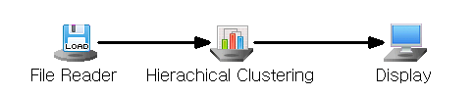

Node Properties

|  |  |  |  |  |
| --- | --- | --- | --- | --- |
| Property group | Property Name | Description | Misc. | Note |
| Model File | Save Model File | Decide whether to save model file. | Required | Yes, No |
| Model File Path | Set the path for the model file to be saved. | Conditionally Required |  |
| Selection options | Cluster Criterion | Specify the cluster criterion. | Required | Number of Clusters, Distance Threshold |
| Number of Clusters | Enter the number of clusters if **Cluster Criterion** is **Number of Clusters**.Default is 5. | Conditionally  Required | Integer |
| Distance Threshold | To cut the dendrogram at a certain level to determine the number of clusters. If **Cluster Criterion** is **Distance threshold, set the value.** Default is 100 | Conditionally  Required | real number |
| Distance Measure | A distance metric (e.g., Euclidean distance) between two data points | Required | Euclidean,  Squared Euclidean,  Manhattan,  Minkowski  Hamming, Jaccard |
| Linkage Method | How distances between clusters are calculated | Required | Single, Complete,  Average, Centroid, Ward |
| Minkowski  Coefficient | Set the coefficients when **distance measurement** is **Minkowski distance**.  If the coefficient is 1, it is same as the **Manhattan distance.** If it is 2, it is same as **Euclidean distance**. | Conditionally Required |  |
| Preprocessing Method | Standardization, Mean Correction | Required | None,  Standardization, Mean Correction |

Results

Clustering results are displayed using Display Node.

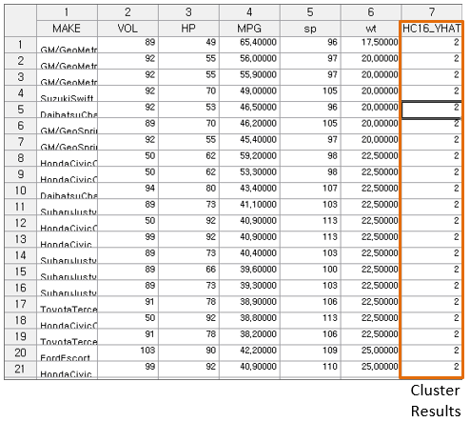

Graphic result

Click Graphic Result in Node Property of Model node to view the clustering result. The results can also be viewed in the Modeling Result of Model node.

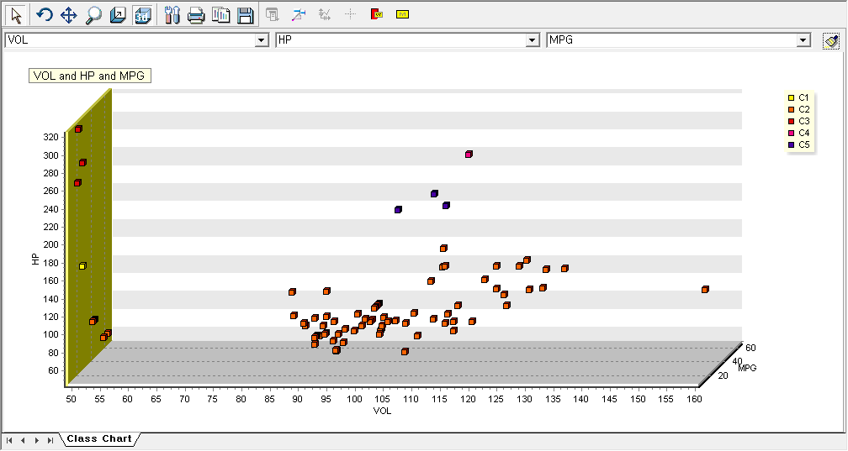

Modeling Result

Click Modeling Result in Node Property of Model node to view the results.

* Options of cluster analysis

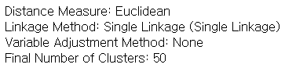

* Cluster Information

Information of then number of objects in each cluster and the distance between data within the cluster.

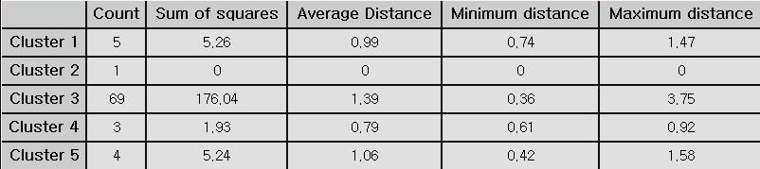

* Number of elements within a cluster

Provides the frequency and percentage of elements belonging to each cluster.

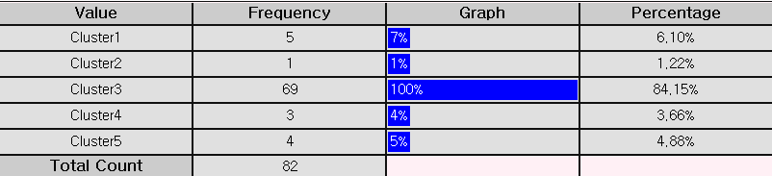

* Cluster Centroid of Variables

Centroid of variables in each cluster

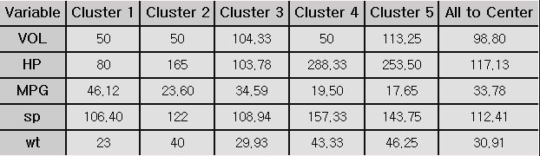

* Distance between clusters

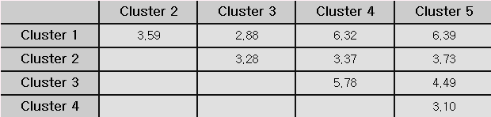

* Dendrogram Result

A dendrogram is a tree-like diagram that summarizes the clustering process. Records are displayed at the bottom of the chart. Similar records are connected by vertical lines, the length of which reflects the distance between records. This allows you to see at a glance the process by which each observation is grouped.

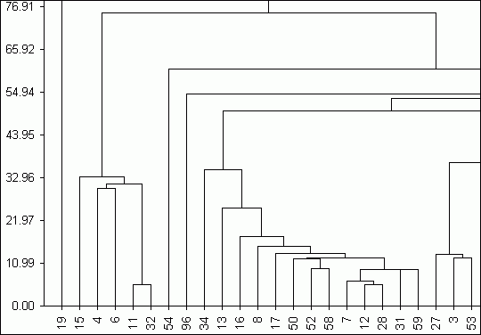

Example file

* Run “ClusterAnalysis.ecm”

### 3.4.11 K-MEANS

|  |  |
| --- | --- |
|  | **K-means** is a popular clustering method. K-means algorithm is to partition a dataset into k-clusters **until the centroid no longer change significantly**. |

Overview

K-means is non-HIERARCHICAL cluster method assigns data points to k-clusters. The process of cluster analysis is as follows

* (1) k-cluster

Choose the number of clusters k

* (2) Initialization

Randomly assign K initial cluster centroids.

* (3) Assign data to cluster

Assign each data point to the closest centroid by the specified distance measure.

* (4) Update Centroid

Update of the centroids by taking the mean of data points assigned to each cluster.

* (5) Iteration

Repeat the assigning data and the update centroid to maximum iteration number or no longer change centroid significantly (Repeat Steps 3 and 4 are repeated)

Clustering results are shown in Graphic Results

Applications

* Independent variables must be continuous.
* Dependent variable is not used. It is an unsupervised method.

Usage

* Read the data using Input Node.
* Connect Input Node to K-MEANS Node and select the options.
* Connect K-MEANS Node to Display Node.
* An example of K-MEANS stream is as follows.

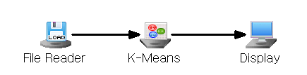

Node Properties

|  |  |  |  |  |
| --- | --- | --- | --- | --- |
| Property group | Property Name | Description | Misc. | Note |
| Model File | Save Model File | Decide whether to save model file. | Required | Yes, No |
| Model File Path | Set the path for the model file to be saved. | Conditionally Required |  |
| Selection options | Number of Clusters | Enter the number of clusters. | Required | Integer |
| Max Iteration | Maximum number of iterations. Default is 100 | Required | Integer |
| Initial Runs | Number of times the algorithm will run with different centroid seeds | Required | Integer |
| Distance Measure | Select the distance metric.  Default is Euclidean. | Required | Euclidean,  Squared Euclidean, Manhattan, Minkowski |
| Minkowski  Coefficient | Set the coefficients when distance measurement is Minkowski distance.  If the coefficient is 1, it is same as the Manhattan distance. If it is 2, it is same as Euclidean distance. | Conditionally Required |  |
| Preprocessing Method | Standardization, Mean Correction | Required | None,  Standardization, Mean Correction |

Results

Clustering results are displayed using Display Node.

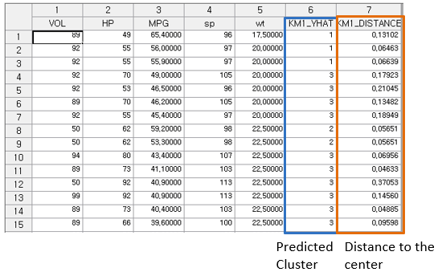

Graphic result

Click Graphic Result in Node Property of Model node to view the result of clustering. The results can also be viewed in the Modeling Result of Model node.

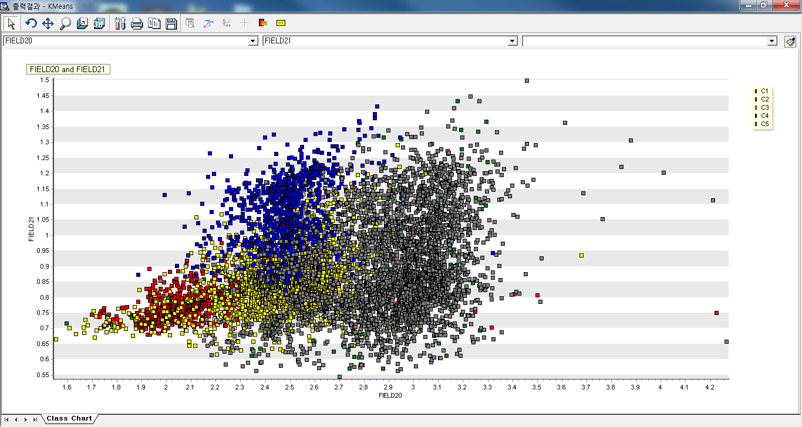

Modeling Result

Click Modeling Result in Node Property of Model node to view the results.

* Number of elements within a cluster

Provides the frequency and percentage of elements belonging to each cluster.

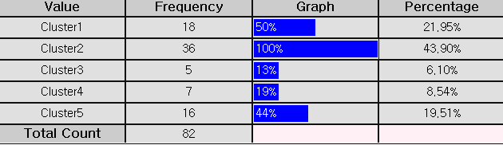

* Cluster Centroid of Variables

Centroid of variables in each cluster.

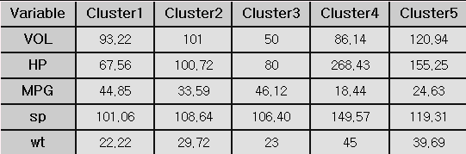

* Distance between clusters

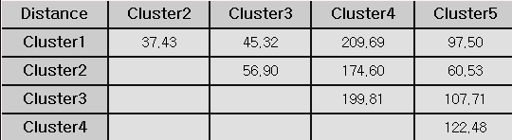

Example file

* Run the “**Clustering.ecm”**

### 3.4.12 K-NN

|  |  |
| --- | --- |
|  | **K-Nearest Neighbor(K-NN)** is a simple non-parametric method for classification analysis to classify data. |

Overview

**K-Nearest Neighbor (K-NN)** is a non-parametric machine learning algorithm that assumes no specific data distribution. Each sample is treated as a point in an n-dimensional space, with new samples classified based on the most common category among their k nearest neighbors in this space.

**K-NN** uses train data, but it doesn’t derive rules from the train data. **K-NN** finds the closest samples in the train data to the new sample and classifies the new sample into the most common category among these nearby samples.

* (1) K-Value selection

The choice ‘k’ is crucial for new data point to assign to the category.

A small **k** can lead to overfitting, while a large **k** might result in underfitting. Cross-Validation helps test various k-values to identify the optimal one for the model.

* (2) Data Preprocessing

If data preprocessing is need, then you may do Standardization or Mean Correction in the Preprocessing Method option. Mean Correction is adjusting the data each variable's mean to zero.

* (3) Leave-One-Out setup

Leave-One-Out setup is the process of evaluating each data individually to ensure thorough assessment of the model's performance, reducing bias, and improving generalization. In Leave-One-Out Cross-Validation (LOOCV), the model is trained on all data except one, which is used for testing. This process repeats for each data, ensuring each is tested once. The final LOOCV error is the average error rate across all iterations, offering an unbiased estimate of the model's generalization error.

Applications

* Independent variables must be continuous.
* Dependent variable must be discrete.

Usage

* Read the data using Input Node.
* Specify the type of data using Type Change Node. (independent, or target)
* Connect Type Change Node to K-NN Node and select the options.
* Connect K-NN Node to Display Node.
* An example of K-NN stream is as follows.

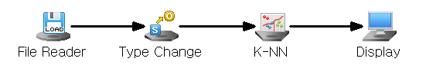

Node Properties

|  |  |  |  |  |
| --- | --- | --- | --- | --- |
| **Property group** | **Property Name** | **Description** | **Misc.** | **Note** |
| **Model File** | Save Model File | Decide whether to save model file. | Required | Yes, No |
| Model File Path | Set the path for the model file to be saved. | Conditionally Required |  |
| **Selection options** | k-Value | Set the number of nearest neighbors to consider. | Required | integer |
| Preprocessing Method | Set the data preprocessing method before performing the K-NN. | Required | No Preprocessing, Standardization,  Mean Correction |
| Leave-One-Out | Decide whether to use Leave One Out. | Required | Yes, No |

Results

Classification analysis results are displayed using Display Node.

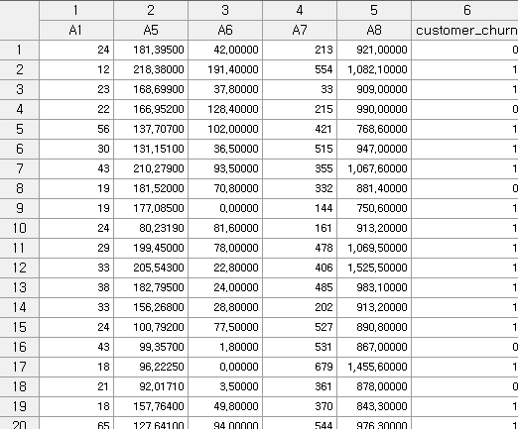

Modeling Result

Click Modeling Result button in Node Property of Model node to view the analysis results.

* Average of independent variables by class

When performing KNN, it provides information about the number of classes and K, and preprocessing method.

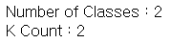

* Statistical Information
* Variable sorting table

Sort and output the preprocessed sample data.  
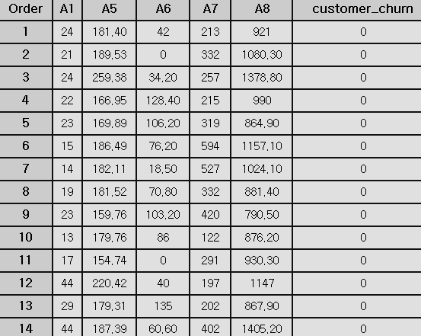

* Confusion Matrix

If you select the Leave-One-Out option as Yes in the properties window of the K-NN node, you can check the misclassification rate.

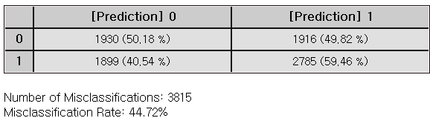

Example File

* Run the “KNN.ecm”

### 3.4.13 LDA(Linear Discriminant Analysis)

|  |  |
| --- | --- |
|  | **LDA (Linear Discriminant Analysis)** is a supervised classification algorithm, assuming all classes share a common covariance matrix. It maximizes between-class separation while minimizing within-class variance, resulting in linear decision boundaries. |

Overview

Each object is represented by p variables $x'=(X_{1},...,X_{p})$, and it is assumed that each object belongs to either Category 1 or Category 2. The mean vector and the **variance-covariance matrix** is as follows.

$$E[x]=\left\{\begin{matrix}μ_{1} & x is in category 1 \\ μ_{2} & x is in category 2\end{matrix}\right.$$

$$Var\left[x\right]=Σ (same regardless of category)$$

Fisher's method transforms a linear combination of the original variables, and then creating a classification rule based on this new variable. A linear combination of the original variables is referred to as a discriminant function

$$Z=w_{1}X_{1}+w_{2}X_{2}+...+w_{p}X_{p}=w'x$$

By determining the coefficient vector 𝑤 of the discriminant function, we classify object 𝑥 into one of the categories according to the following classification rules:

$$If |\hat{w}'(x-{\bar{x}}^{(1)})|≤|\hat{w}'(x-{\bar{x}}^{(2)})|, classify x as category 1.$$

$$If \left|{\hat{w}}^{'}\left(x-{\bar{x}}^{\left(1\right)}\right)\right|>\left|{\hat{w}}^{'}\left(x-{\bar{x}}^{\left(2\right)}\right)\right|, classify x as category 2.$$

Applications

* Independent variables can be either continuous or discrete.
* Dependent variable must be discrete.
* The feature vector 𝑥 follows a multivariate normal distribution.
* The covariance matrices are assumed as the same for all classes.

Usage

* Read the data using Input Node.
* Specify the type of data using Type Change Node. (independent, or target)
* Connect Type Change Node to LDA Node and select the options.
* Connect LDA Node to Display Node.
* Additional option: Set the Occupancy ratio.

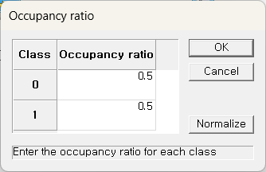

* An example of LDA stream is as follows.

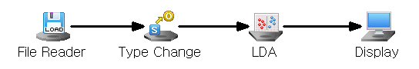

Node Properties

|  |  |  |  |  |
| --- | --- | --- | --- | --- |
| Property group | Property Name | Description | Misc. | Note |
| Model File | Save Model File | Decide whether to save model file. | Required | Yes, No |
| Model File Path | Set the path for the model file to be saved. | Conditionally Required |  |
| Selection options | Prior Probability | Decide whether to manually input the prior probabilities. Manual prior is useful for imbalanced data | Required | Base Value, Manual Input |

Results

Classification analysis results are displayed using Display Node.

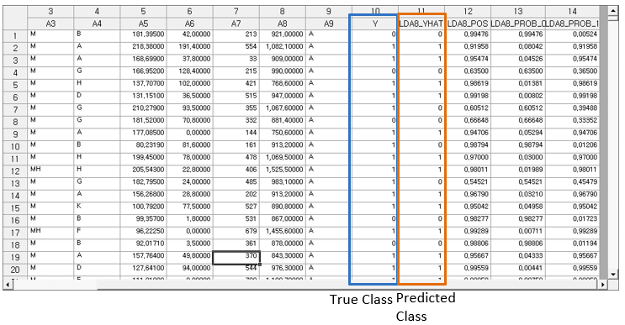

Modeling Result

Click Modeling Result in Node Property of Model node to view the results.

* Average of independent variables by class

Indicates the average value of variables for each classified class.

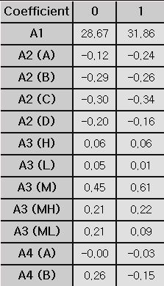

* Variance-covariance matrix of the class

Since the variance-covariance is assumed to be the same for each group, a single variance-covariance matrix is output.

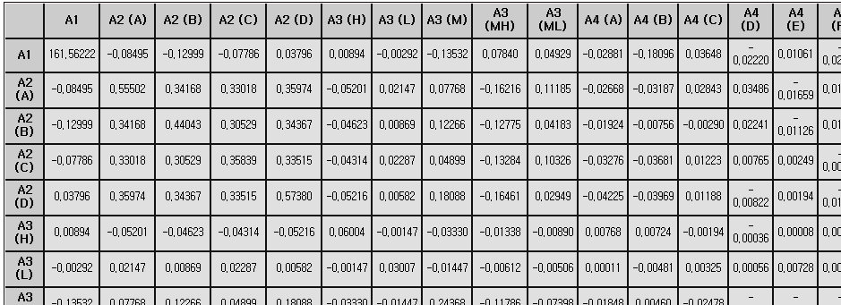

* Prior probability

Shows the probability value for each class specified in the prior probability option

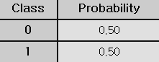

* Linear Discriminant Function

Indicates the constants and coefficients of the linear function for each class.

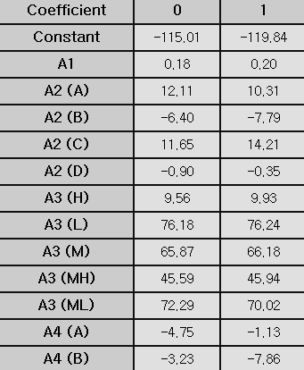

* Confusion Matrix

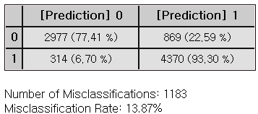

Example File

* Run the “LDA,QDA.ecm”

### 3.4.14 Local Outlier Factor(LOF)

|  |  |
| --- | --- |
|  | **Local Outlier Factor (LOF)** detects outliers by evaluating the local density of a data point relative to its neighbors. Data points with significantly lower density than other neighbor points are defined as outliers. |

Overview

Local Outlier Factor (LOF) is a density-based method used for **outlier** **detection**, which identifies data points that deviate significantly from their neighbors. One of the key inputs in LOF is the **number of neighbors (k)**, which determines how many neighboring points are considered computing the local density.

To identify whether a point is an outlier, LOF compares the densities of each point to its neighbors. If a point has a lower density compared to its neighbors, it is considered an anomaly. The extent of this deviation is quantified through an outlier threshold score, which determines the boundary between normal points and potential anomalies. The LOF score for point A is calculated as:

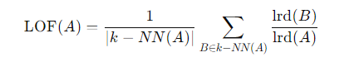

The **distance measurement method** is a key parameter. In LOF, when applying the Minkowski distance, the **Minkowski coefficient** can be adjusted to various distance metrics.

Applications

* Independent variables must be continuous.

Usage

* Read the data using Input Node.
* Connect Input Node to LOF Node and select the options.
* Connect LOF Node to Display Node.
* An example of a LOF stream is as follows.

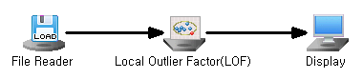

Node Properties

|  |  |  |  |  |
| --- | --- | --- | --- | --- |
| Property group | Property Name | Description | Misc. | Note |
| Model File | Save Model File | Decide whether to save model file. | Required | Yes, No |
| Model File Path | Set the path for the model file to be saved. | Conditionally Required |  |
| Selection options | Number of Neighbors | Determine the number of Neighbors. | Required | Integer |
| Outlier Detection | Identify data points with lower local density to detect anomalies. | Required | Yes, No |
| Outlier Threshold | Set a threshold to identify anomalies | Required | Real number |
| Distance Measure | Select the distance metric: Euclidean, Manhattan, and Minkowski. | Required | Euclidean, Manhattan, Minkowski |
| Minkowski Coefficient | Enter the coefficient if Distance Measurement is Minkowski. | If you enter Minkowski | Real number |

Results

The analysis results are displayed using Display Node.

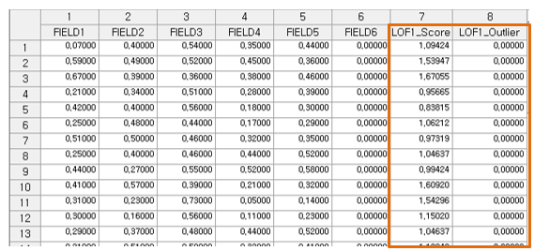

Modeling Result

Click Modeling Result button in Node Property of Model node to view the analysis results.

* Score Information

If LOF1\_Outlier value exceeds Outlier Threshold, the data is indicated as an outlier.

A point with a high LOF score is considered an outlier because it resides in a low-density. Threshold can be specified based on domain knowledge or the LOF scores' distribution.

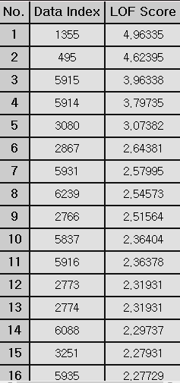

* LOF Score Plot

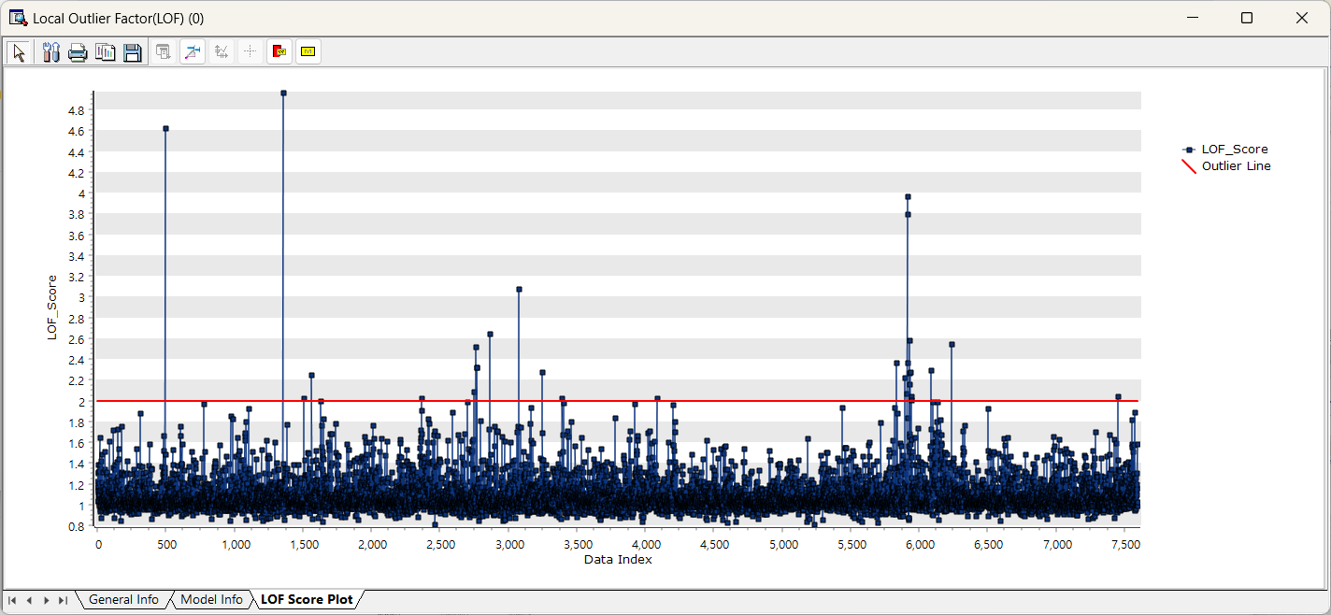

Example File

* Run the “LOF.ecm”

### 3.4.15 Logistic

|  |  |
| --- | --- |
|  | **Logistic regression** is a statistical method used for classification that the outcome is categorical typically binary but sometimes with more than two categories. Logistic regression predicts the probability that a given case belongs to a specific category (yes/no, 0/1). |

Overview

**Logistic regression** is a classification analysis used to predict outcomes in categories with two values, such as yes/no or success/failure. If the dependent variable has three or more categories, use Nominal Logistic Regression

* (1) Variable Selection

Variable selection is the process of selecting important variables. In the **Variable Selection Technique** option, you can choose Stepwise, Forward, Backward, or None. **Forward** selection adds from the most important variable to least important one in the model, while **Backward** selection removes unimportant variables from a full model. **Stepwise** selection combines with Forward, Backward methods to iteratively add or remove variables, refining the model with significant predictors.

* (2) Link Function

The link function transforms the nonlinear relationship between independent and dependent variables into probabilities. Link functions such as **Logit, Probit (Normit)**, and **Gompertz** can be selected from the options.

|  |  |  |
| --- | --- | --- |
| **Name** | **distribution** | **function** |
| Logit | Binomial, Multinomial | $$logit(p)=log(\frac{p}{1-p}​)$$ |
| Probit | Binomial | $$probit(p)=Φ^{-1}(p)$$ |
| Gompertz | Binomial | $$cloglog(p)=log(-log(1-p))$$ |

* (3) Log-likelihood Function

The log-likelihood function measures how well the model parameters fit the given data, and by maximizing this function, the optimal parameters of the model are determined. The log-likelihood function varies depending on the distribution that the data follows.

$$Bernoulli Dist. \sim log{L}=\sum_{i=1}^{n}{y_{i}}(β_{0}+β_{1}X_{i})-\sum_{i=1}^{n}{\log{(}1+e^{β_{0}+β_{1}X_{i}})}$$

$$Binomial Dist. \sim log L=\prod_{i=1}^{n}{\left(\begin{matrix}r_{i} \\ y_{i}\end{matrix}\right){P_{i}}^{y_{i}}(1-P_{i})^{r_{i}-y_{i}}}$$

In the optimization process, the **Maximum Run Count** and **Convergence Error** options are used to control the iterative estimation of parameters.

* (4) Binary Threshold

The parameters $(β_{k})$ estimated from the above likelihood function are used to fit the model below.

$$Logit(p_{i})=β_{0}+β_{1}X_{1}+...+β_{k}X_{k}$$

The categories are classified based on the calculated $p_{i}$. The default is 0.5.

$${if P}_{i}>0.5, class, y object i as{{}_{}^{'}1}^{'}$$

$${if P}_{i}≤0.5, class, y object i as '0'$$

The threshold can be adjusted in the **Splitting Threshold** option.

You can evaluate how well the model fits the data by using the Pearson statistic through the **Goodness-of-Fit Test** option.

Applications

* Independent variable can be either continuous or discrete.
* Dependent variable must be discrete.

Usage

* Read the data using Input Node.
* Specify the type of data using Type Change Node. (independent, or target)
* Connect Type Change Node to Logistic Node and select options.
* Connect Logistic Node to Display Node.
* An example of Logistic stream is shown below.

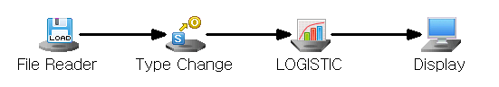

Node Properties

|  |  |  |  |  |
| --- | --- | --- | --- | --- |
| **Property group** | **Property Name** | **Description** | **Misc.** | **Note** |
| **Model File** | Save Model File | Decide whether to save model file. | Required | Yes, No |
| Model File Path | Set the path for the model file to be saved. | Conditionally Required |  |
| **Selection options** | Maximum Run Count | Enter the maximum number of iterations. | Required | 0<integer |
| Variable Selection Technique | Set the method of variable selection. | Required | Stepwise, Forward, Backward, None |
| Significance Level for Entry | Enter Significance Level of Entry if **Variable Selection** **Technique** is **Stepwise** or **Forward**. The smaller the significance level, the fewer independent variables are added to the model. | Conditionally Required | Default:0.15 |
| Significance Level for Removal | Enter Significance Level of Removal if **Variable Selection** **Technique** is **Stepwise** or **Backward**. The bigger the significance level, the fewer independent variables are likely to be added to the model. | Conditionally Required | Default:0.15 |
| Splitting Threshold | Enter the threshold(cut-off) to use for binary split. | Required |  |
| Link Function | Select the Link function to use for binary analysis. | Required | Logit, Probit, Gompertz |
| Goodness-of-Fit Test | Decide whether to display the Goodness-of-Fit test results. | Required | Yes, No |
| Convergence Error | Set the convergence error value for the iterative method. | Required |  |

Results

Classification analysis results are displayed using Display Node.

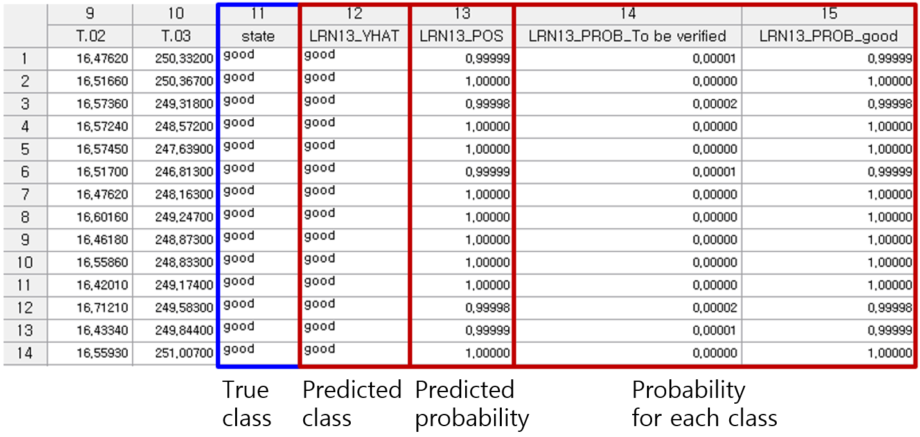

Modeling Result

Click Modeling Result in Node Property of Model node to view the results.

* Number of Classes and Total Number of trials

The number of classes in the dependent variable and the total number of trials the algorithm was run on can be found.

* Y Value

Shows the frequency and ratio of dependent variable Y by class.

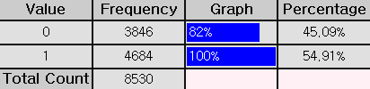

* Logistic Table

**Parameter Estimate**: The coefficient value of each variable

**Standard Error**: The standard error of each coefficient (Beta).

**z-value**: The number of standard deviations a data point (or estimate) is from the mean. In regression analysis, the z-value measures how significant a regression coefficient is relative to its standard error. It is used to assess the statistical significance of a predictor variable.

**p-value**: The probability that the observed effect occurred by random chance. Typically, if the P-value is less than the significance level, the variable is considered statistically significant.

**Odds Ratio**: A value that indicates the degree of influence of input variables on the classification decision. An odds ratio less than 1 means that the input variable xi has a negative influence, and an odds ratio greater than 1 means that the input variable xi has a positive influence.

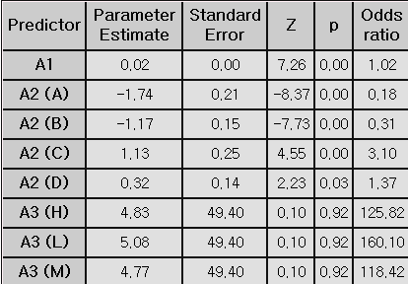

※ If the value appears like 1. #IO, 1#QO, or 1.#INF, the value is either too large or too small.

* Confusion Matrix

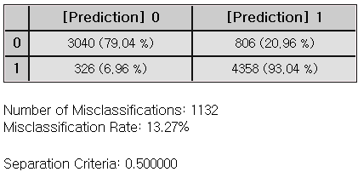

Example File

* Run the “Logistic.ecm”

### 3.4.16 MLR

|  |  |
| --- | --- |
|  | **Multiple Linear Regression (MLR)** is a statistical technique that models the linear relationship between a dependent variable and two or more independent variables. |

Overview

Regression models are used to predict the dependent variable through the linear equation of independent variables.

* : Dependent variable, : Independent variables
* : Intercept
* : Coefficients corresponding to each independent variable (the impact of each independent variable on the dependent variable)
* $ϵ$: Error term
* The four assumptions of linear regression

For valid regression model, the following assumptions should be met.

- **Linearity**: The relationship between the independent and dependent variables is linear

- **Independence of Errors**: Residuals (errors) are independent of each other.

- **Homoscedasticity**: The variance of the errors should be constant for all values of the independent variables

- **Normality** **of** **Errors**: Residuals (errors) is normally distributed

* Variable Selection

Variable selection is the process of selecting important variables. In the **Variable Selection** option, you can choose Stepwise or General. **Stepwise** selection combines with Forward, Backward methods to iteratively add or remove variables, refining the model with significant predictors.

(\* **Forward** selection adds from the most important variable to least important one in the model, while B**ackward** selection removes unimportant variables from a full model.)

General selection includes all the input independent variables.

* Multicollinearity

Multicollinearity occurs due to high correlations between independent variables. Using the Variance Inflation Factor (VIF), variables with VIF>10 needs to be double-checked. The **Calculate VIFs** option gives VIF values, and the **Remove Multicollinearity** option allows to remove variables with VIF values over 10.

Applications

* Independent variable can be either continuous or discrete.
* Dependent variable must be continuous.
* The four assumptions of regression should be checked for valid prediction model.

Usage

* Read the data using Input Node.
* Specify the type of data using Type Change Node. (independent, or target)
* Connect Type Change Node to MLR Node and select options.
* Connect MLR Node to Display Node.
* An example of MLR stream is as follows.

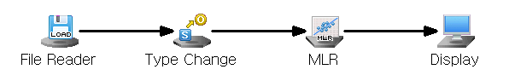

Node Properties

|  |  |  |  |  |
| --- | --- | --- | --- | --- |
| Property group | Property Name | Description | Misc. | Note |
| Model File | Save Model File | Decide whether to save model file. | Required | Yes, No |
| Model File Path | Set the path for the model file to be saved. | Conditionally Required |  |
| Selection options | Variable selection | Set the method of variable selection. | Required | General,  Stepwise |
| Significance Level for Entry | Enter **Significance Level of Entry** for **Stepwise.** The smaller the **significance level**, the fewer independent variables are likely to be added to the model. | Required |  |
| Significance Level for Removal | Enter **Significance Level of Removal** for **Stepwise.** The bigger the **significance level**, the fewer independent variables are likely to be added to the model. | Required |  |
| Calculate VIFs | Decide whether to **calculate VIFs**.  Multicollinearity is considered present if the VIF exceeds 10. | Required | True,  False |
| Save Confidence Intervals | Decide whether to save 95% Confidence Intervals for the dependent variable. | Required | True,  False |
| Save Prediction Intervals | Decide whether to save 95% of prediction intervals. | Required | True,  False |
| Remove Multicollinearity | Decide whether to remove variables to mitigate multicollinearity among independent variables. | Required | True,  False |

Result

Prediction analysis results are displayed using Display Node.

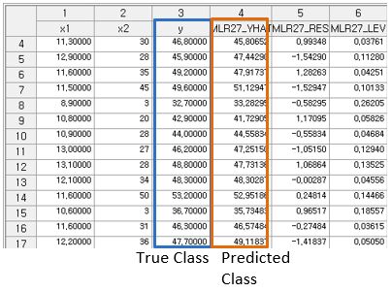

Residual plot is displayed using the Trend Chart or Enhanced Basic Chart.

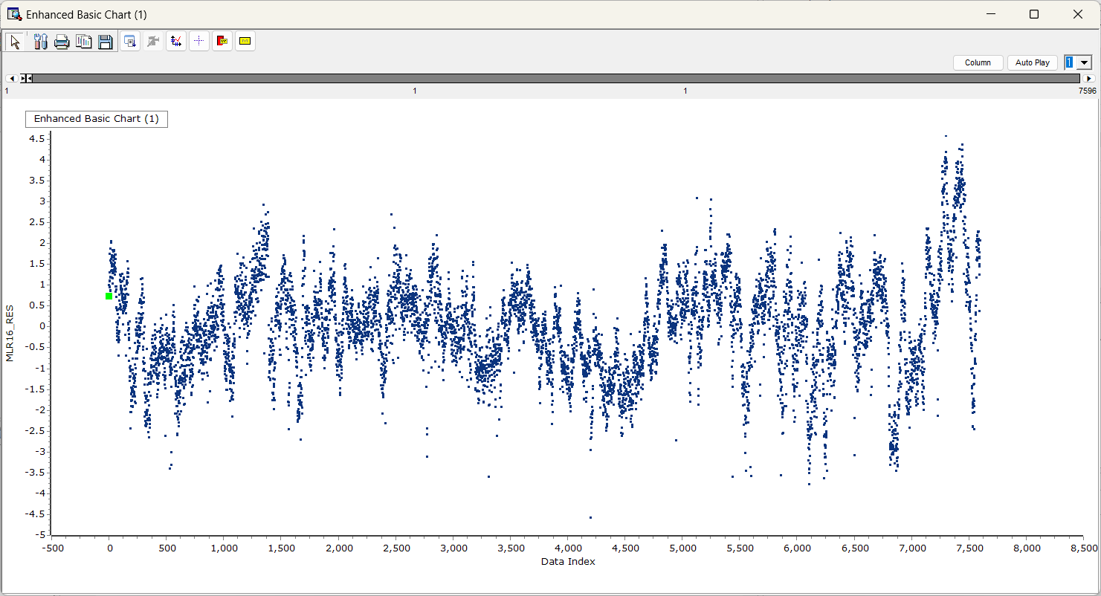

If the regression model is well-fitted, the errors should have a mean of 0 and constant variance. Running the Chart Node with Data Index on the X-axis and Residual (MLR\_RES) on the Y-axis will produce a plot similar to the one shown above.

Graphic Result

Click Graphic Result in Node Property of Model node to view the charts.

The results can also be viewed in the Modeling Result of Model node.

* Coefficient Plot

The graph displays coefficients for each independent variable.

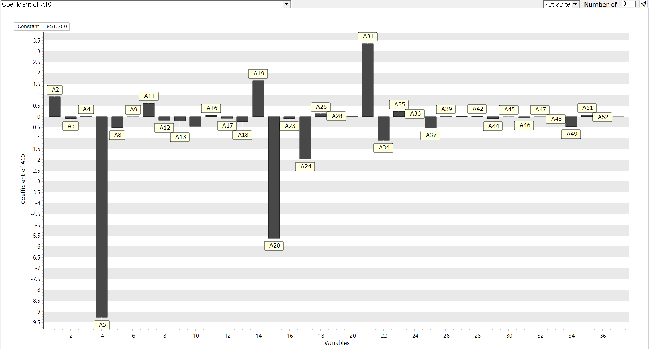

* Data Chart

The graph displays the difference between actual value and predicted value, residual, contribution for each observation.

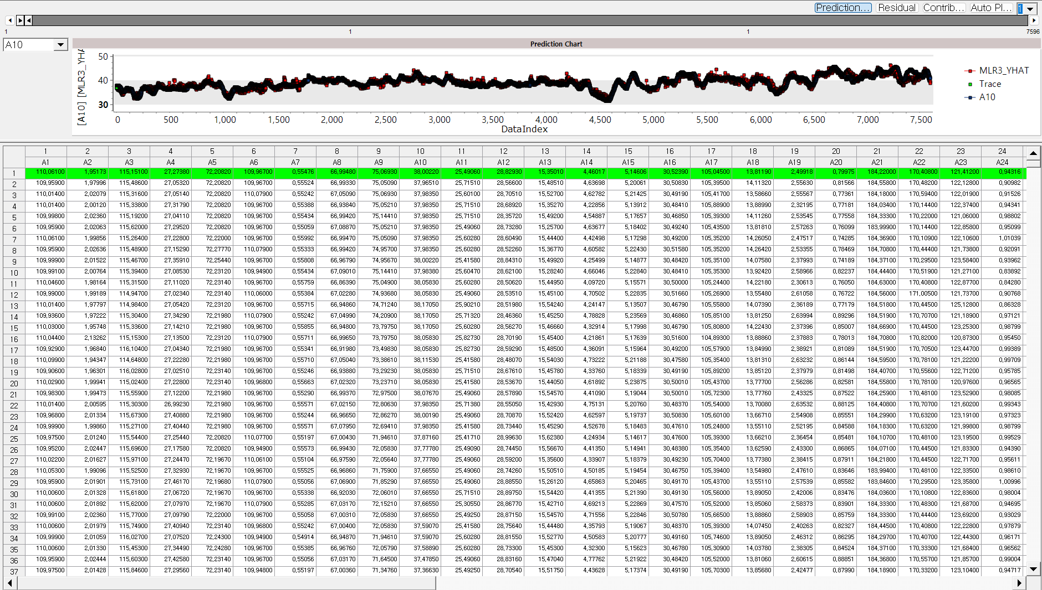

Modeling Result

Click Modeling Result in Node Property of Model node to view the results.

* Regression Equation & Regression table

Determine the significance and regression coefficient value of each independent variable.

Regression coefficient estimation 

Dependent variable prediction 

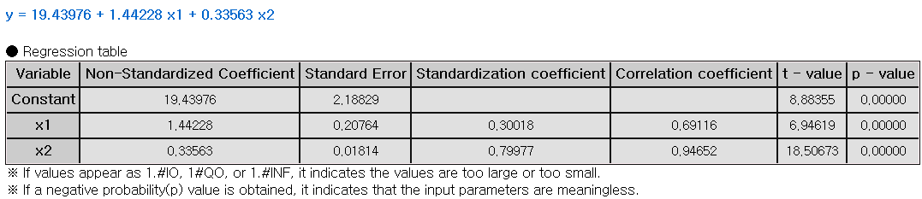

**(1) Non-Standardized Coefficient**

The actual effect of each independent variable on the dependent variable in its original units.

**(2) Standard Error**

The measure of uncertainty around the estimate of a regression coefficient. It shows how precise the estimate is.

**(3) Standardization Coefficient**

The change in the dependent variable, measured in standard deviations, for a one standard deviation change in the independent variable.

**(4) t-value**

A statistic used to test if a regression coefficient is significantly different from zero. It compares the coefficient to its standard error to assess its significance.

**(5) p-value**

The probability that the observed effect occurred by chance. If the p-value is less than the significance level, the effect is statistically significant, and the null hypothesis can be rejected.

* ANOVA TABLE

F-test is a test whether the independent variable is statistically significant in explaining the dependent variable. If the p-value is greater than the significance level then it is not significant, the interpretation of the regression coefficient is meaningless.

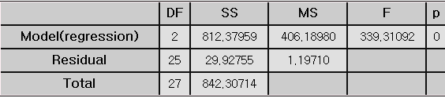

**(1) DF (Degree of Freedom)**

The number of independent variables

**(2) SS (Sum of Squares)**

Total variations in the data. It is a calculation of the squared deviations from the mean value.

**(3) MS (Mean Square)**

The average of the squared deviations. (SS/DF)

**(4) F-value**

The ratio of the mean square for the residual variance and the independent variable variance.

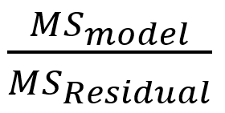

**(5) p-value**

probability of observing the data if the null hypothesis is true. Lower p-value suggests that the group variances are statistically significant.

* Standard Error Information

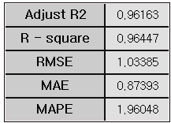

**(1) R-square (coefficient of determination)**

It is a value that checks whether the derived regression equation is representative of the measured values.

**(2) Adjust R2**

It adjusts the r-squared value by considering the degree of freedom of the model.

**(3) RMSE (Root-Mean Square Error)**

The square root of the average squared differences between the predicted values and the dependent variable.

**(4) MAE (Mean Absolute Error)**

The average of the absolute differences between the predicted values and the dependent variable.

**(5) MAPE (Mean Absolute Percentage Error)**

The average of the absolute differences between the predicted values and the dependent variable as a percentage

Numbers (3) to (5) all represent the error between the original value and the predicted value of the dependent variable. The smaller the value, the better the model.

* Trace and Statistical Table

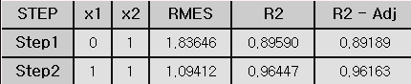

(1) This result is output only when the technique option is selected as stepwise. The model for each step is explained and trace values indicate which variables were entered at each step.

(2) In Step 1, you can see that only x2 has a trace value of 1. This means that the x2 variable was added to the model in Step 1.

(3) In Step2, you can see that the x1 variable has been added to the model. You can see that when x1 variable was added to the model, the R2 (R-Square) value became better than Step1.

(4) If Stepwise is selected, only the variables included in the last step in the previous regression table are output, and in the case above, a regression table for variables x1 and x2 is created.

Example File

* Run the “MLR.ecm”

### 3.4.17 Naive Bayes

|  |  |
| --- | --- |
|  | **Naïve Bayes** is a probabilistic machine learning used for classification tasks. It is based on the Bayes’ theorem with assumption that the features are conditionally independent of each other. |

Overview

The Naïve Bayes model is based on the Bayes’ theorem which describes the probability of an event, based on the knowledge of conditions that might be related to the event. Naïve Bayes model highly relies on the assumption that all features are independent of each other. Naïve Bayes defines probability through the calculations below.

$$P\left(Y_{i}|x_{1},…,x_{n}\right)=\frac{{P\left(y_{i})P(x_{1},…,\left.x_{n}\right|y_{i}\right)}^{ }}{P\left(x_{1}…x_{n}\right)}$$

$$P\left(y_{i} | x_{1},…,x_{n}\right)={the probability of the value y in state x}_{1},…,x_{n}$$

$$y_{i}=dependent variable$$

$$x_{1}…x_{n}= independent variable$$

There are several variations of the Naïve Bayes model, depending whether the feature is continuous or discrete. When the feature is continuous, Gaussian Naïve Bayes is applied assuming that the feature follows a Gaussian distribution. The probability of the feature is calculated using the Gaussian distribution formula. However, if the feature is discrete, multinomial Naïve Bayes is applied especially when the features represent counts or frequencies. The probability of the feature is calculated as the frequency within the given feature class.

**Laplace smoothing** is a technique used in **Naive Bayes** to handle the issue of zero probabilities, which can arise when a feature value that was not observed in the training data needs to be predicted. **For text classification,** a word appears in a test document but was not present in the training documents of a particular class. If a word is never seen in a particular class during training, the model assigns a probability of zero to that word in the test set, which is problematic. The Laplace smoothing value is typically set to 1 and whether to use the technique can be decided in the **Laplace Smoothing** option.

In addition, the amount of influence each feature has on the classification can be personalized by selecting **Manual Input** in the **Weighting** option. If the **Weighting** option is set to **Base Value,** the weight of each feature is set to 1. Features with higher likelihood probabilities for a particular class will influence more, “weight” more heavily, in the decision for that class.

Applications

* Independent variable can be either continuous or discrete.
* Dependent variable must be discrete.

Usage

* Read the data using Input Node.
* Specify the type of data using Type Change Node. (independent, or target)
* Connect Type Change Node to NaiveBayes Node and select options.
* Connect NaiveBayes Node to Display Node.
* An example of Naïve Bayes stream is as follows.

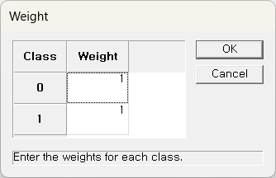

* If Weighting is Manual Input, a pop-up window will appear once the stream is executed to set the weight for each data class.

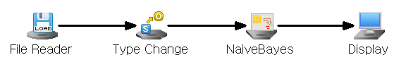

Node Properties

|  |  |  |  |  |
| --- | --- | --- | --- | --- |
| **Property group** | **Property Name** | **Description** | **Misc.** | **Note** |
| Model File | Save Model File | Decide whether to save model file. | Required | Yes, No |
| Model File Path | Set the path for the model file to be saved. | Conditionally Required |  |
| Selection options | Weighting | Select the weighting method. | Required | Default, Custom |
| Laplace Smoothing | Decide whether to use Laplace Smoothing. | Required | Yes, No |

Results

Classification analysis results are displayed using Display Node.

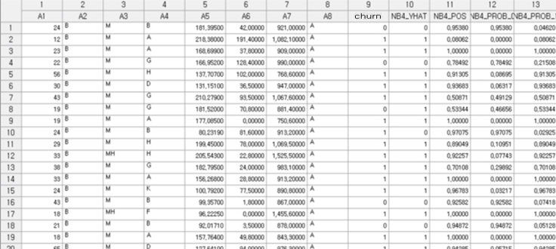

Modeling Result

Click Modeling Result in Node Property of Model node to view the results.

* Summary of Classification Information

If the independent variable is continuous, it indicates the mean and standard deviation information, and if the independent variable is discrete, it indicates the probability for each class.

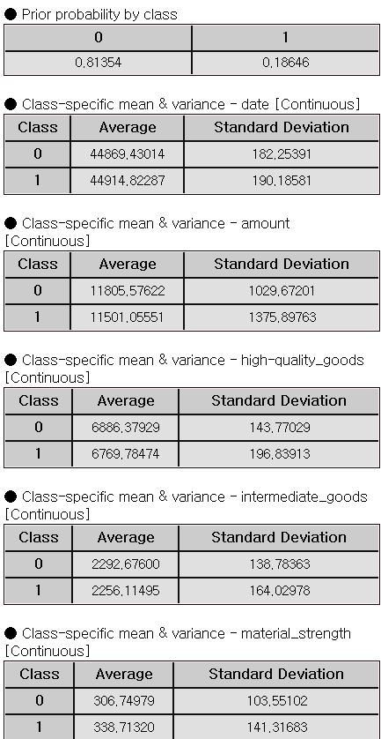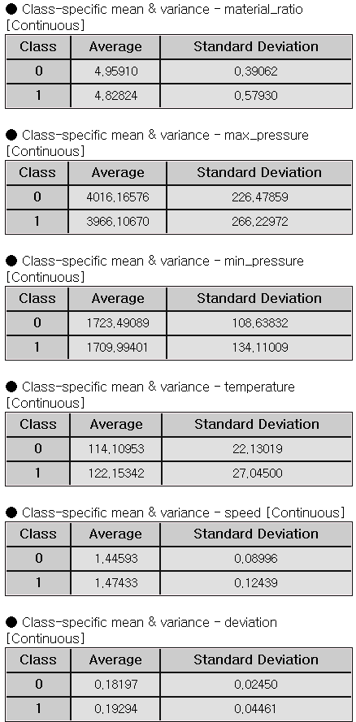

* Confusion Matrix

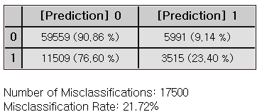

### 3.4.18 PCA

|  |  |
| --- | --- |
|  | **Principal component analysis** is a multivariate data analysis technique used for dimensionality reduction. PCA transforms the original variables into a set of uncorrelated components (called principal components) that explains the maximum variance in x-space. |

Overview

The main idea of PCA is to represent the variability in data using new variables (principal components) formed by linear combinations of the original variables in multivariate data. PCA identifies linear relationships between variables, reduces their number, uncovers meaningful new variables, and simplifies the dataset's dimensional structure.

PCA can be used for anomaly detection, production deviation analysis, and process monitoring.

Applications

* Only independent variables. They must be continuous.
* Standardization is automatically applied.

Usage

* Read the data using Input Node.
* Connect Input Node to PCA Node and select the options.
* Connect PCA Node to Display Node.
* An example of PCA stream is as follows.

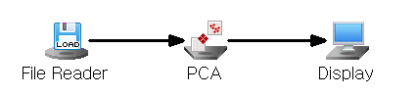

Node Properties

|  |  |  |  |  |
| --- | --- | --- | --- | --- |
| **Property group** | **Property Name** | **Description** | **Misc.** | **Note** |
| **Model File** | Save Model File | Decide whether to save model file. | Required | Yes, No |
| Model File Path | Set the path for the model file to be saved. | Conditionally Required |  |
| **Selection options** | View Results | Control Chart, Loading Plot,  T-Square Plot, Scree Plot, Residual Plot, Contribution Plot, and Data Chart are output. | Click | Click after modeling |
| Number of Principal Components | Set the number of principal components (Must be less than the number of independent variables.) | Required | natural number |
| Preprocessing Method | Preprocessing method for the input data. | Required | Standardization, Mean centering |
| Matrix Type | Decide on the matrix type. | Required | Covariance, Correlation |

Results

* Control Chart

Outliers can be identified through the Control Chart.

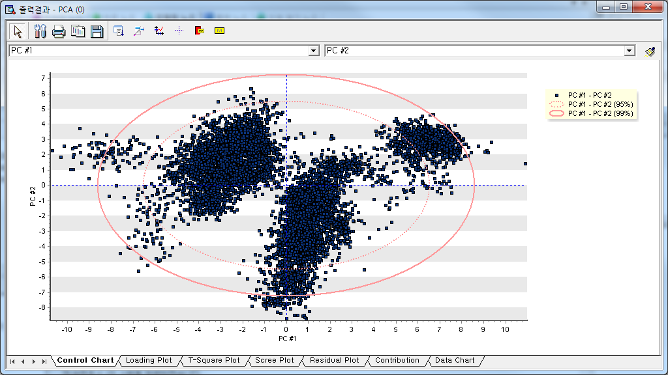

* Loading Plot

**Loading values** ("loadings") represent the correlation or relationship between the original variables and the principal components. Higher absolute loading values indicate that the variable has a greater influence on the component. The Loading plot provides information about the loading values of the selected two raw data or principal components.

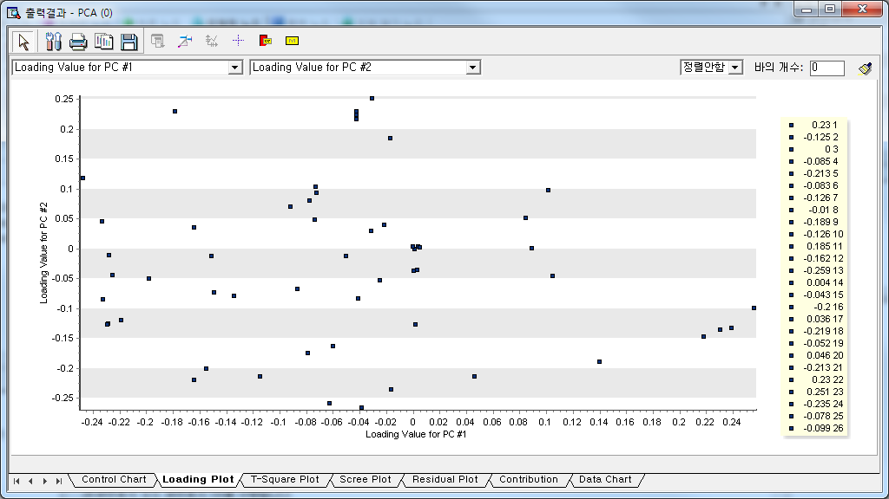

* T-Square plot

High T² values suggest that an observation lies far from the center of the data distribution in the principal component space, making it a potential outlier.

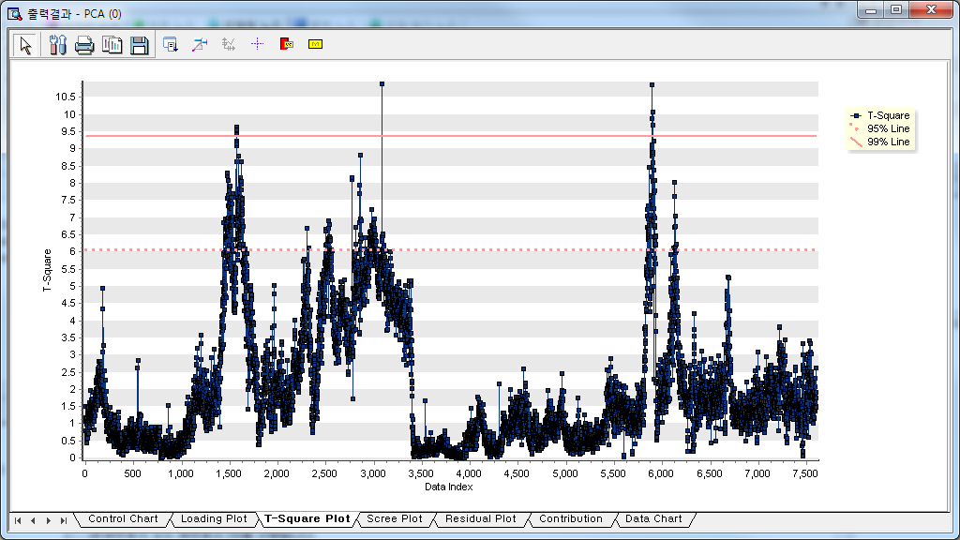

* Residual plot

The residual plot shows how far the data is from the reduced space. As the value on the graph increases, it indicates that the distance between the current data and the reduced space is larger, and data that exceeds the displayed guide line can be considered outliers.

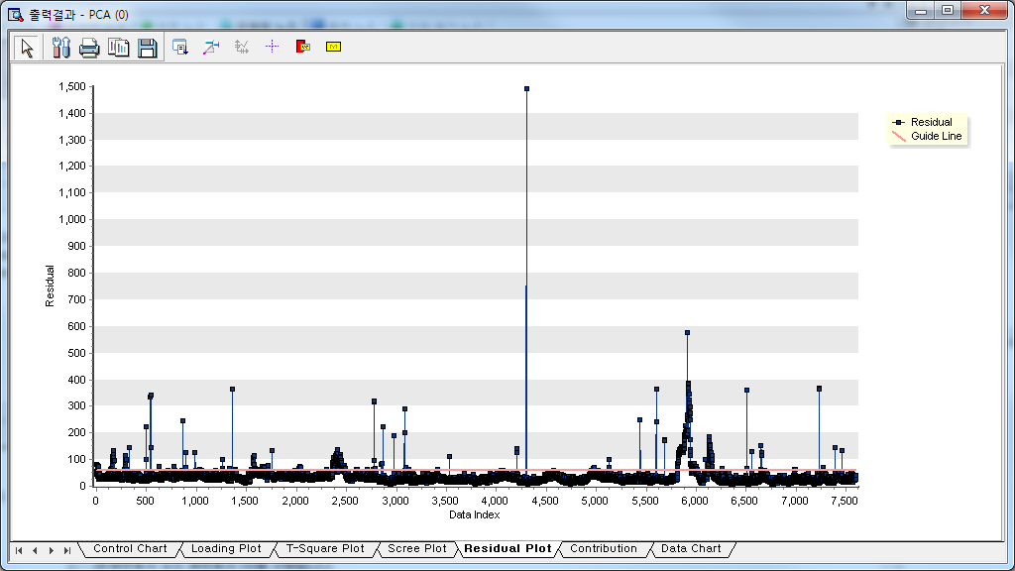

* Scree Plot

The Scree plot displays the Eigenvalue values for each principal component. It can determine the number of principal components in the step where the Eigenvalue value changes rapidly.

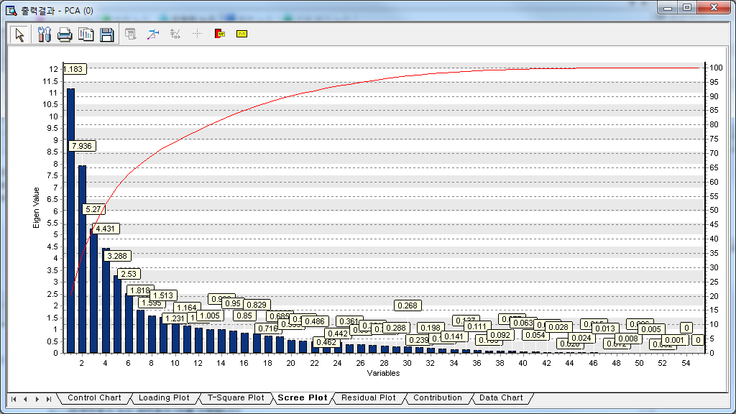

* Contribution plot

This chart shows the weight or influence (also called **loadings**) of each variable on a given principal component. Variables with higher absolute loadings contribute more to the corresponding principal component.

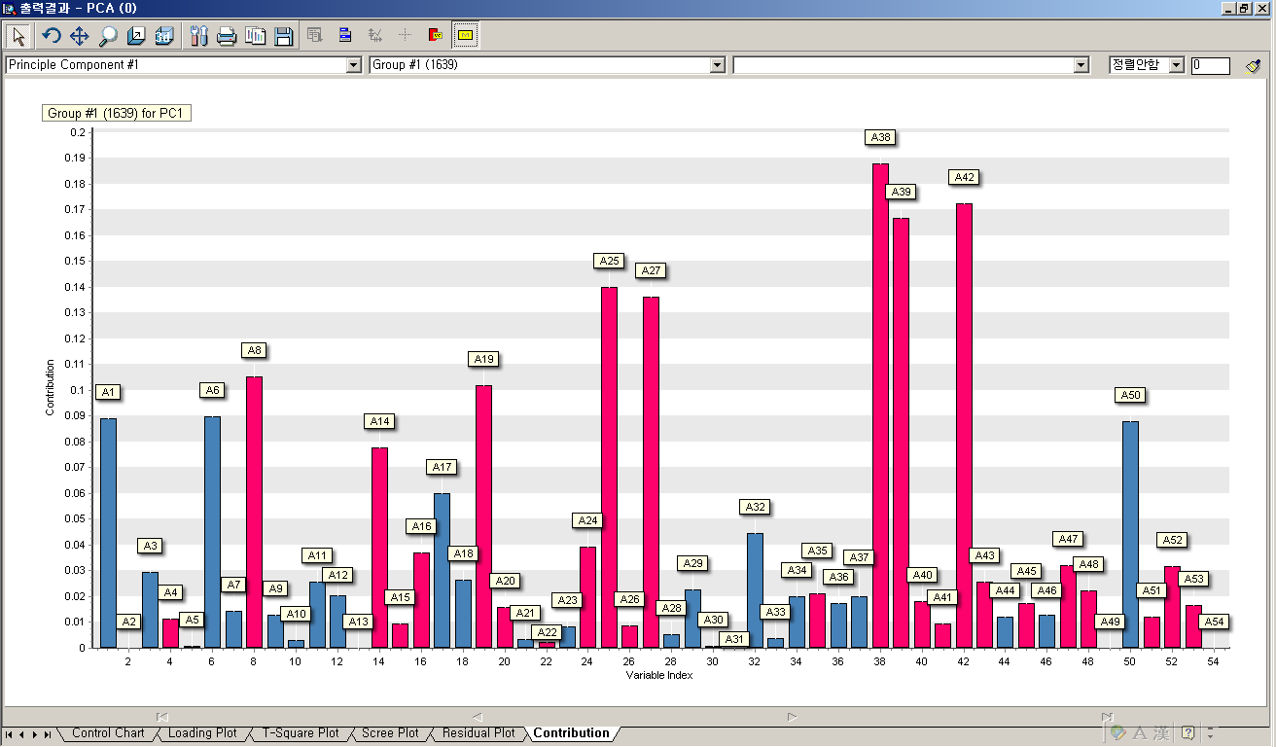

How to create a group:

1. Select a group with large deviations in the control chart, drag the group as ① and click ② button to extract the data. If there is another group to examine, repeat the same for the group.

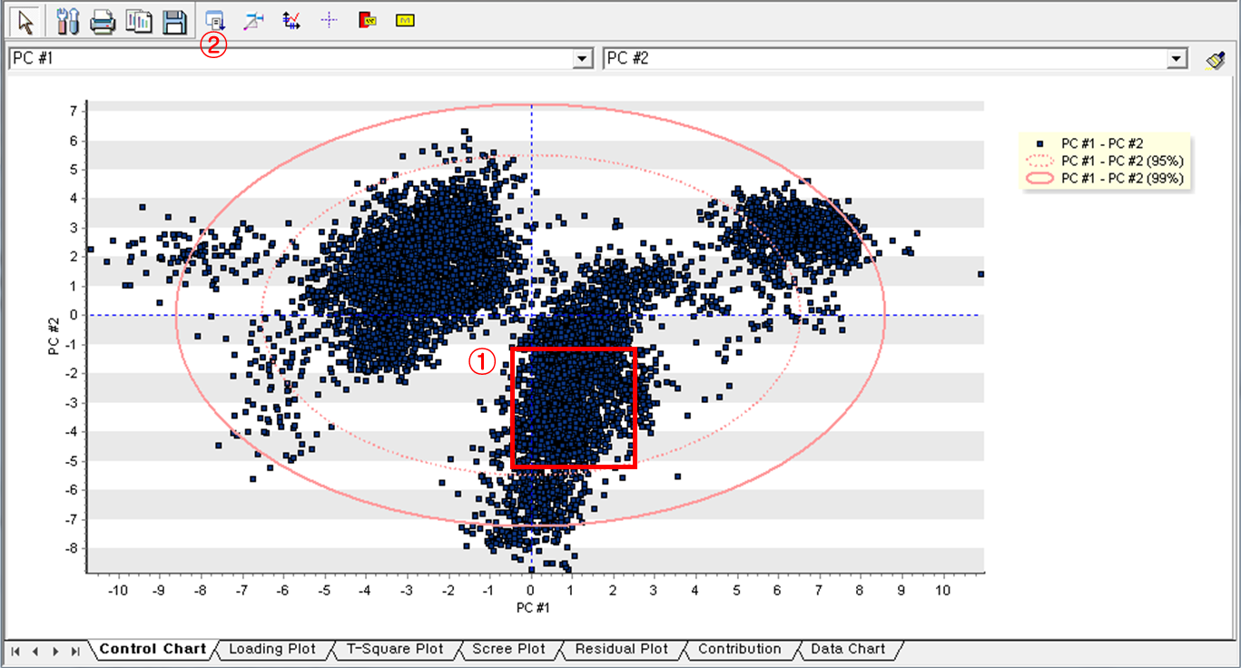

2. After extracting data, go to Contribution Plot and choose the principal component and group data, and sorting method. Click the **Draw (****)** to get Contribution Plot.

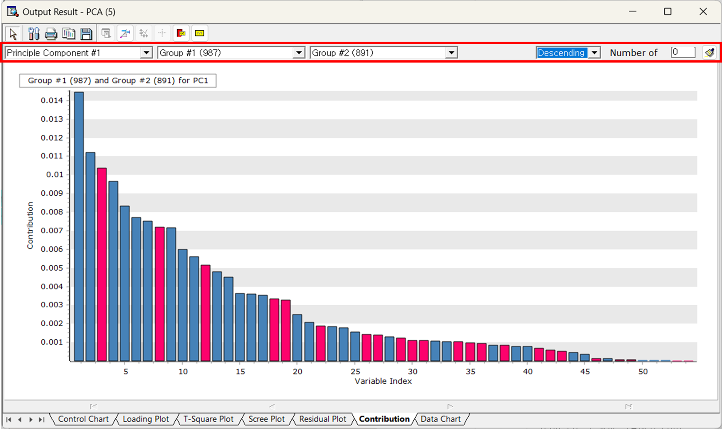

* Data chart

The data chart provides a matching function between data and charts by simultaneously showing the chart and the data used for analysis. You can also view multiple charts at once for comparison.

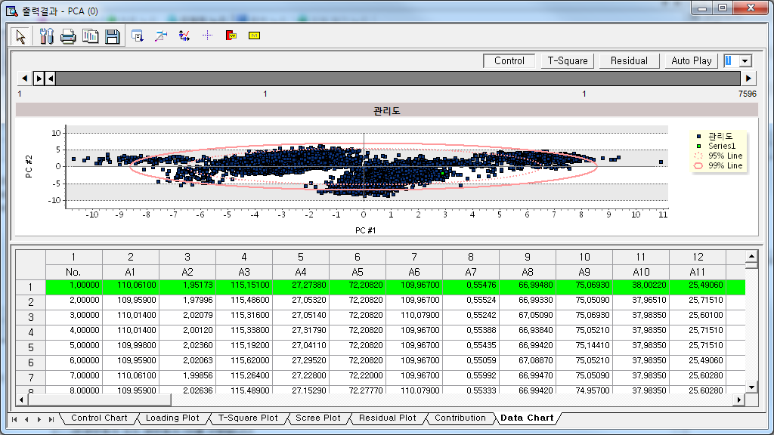

You can match data with charts and track progress using the data slider at the top. The buttons in the upper-right corner allow you to view multiple charts.

(2) Analysis result information

The score and T-square values of each principal component can be observed in **Display Node**.

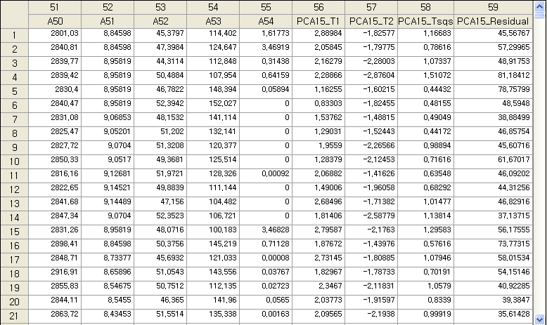

Modeling Result

Click Modeling Result in Node Property of Model node to view the results.

* PCA performance information

Displays the number of principal components reduced from the entire variables and show the T² limit.

* Loading vectors for each component

Principal component is calculated for each variable. For example, principal component 1 is calculated as follows:

PCA 1 = (-0.24360\*A1) + (0.00132\*A2) + (-0.24335\*A3) + …

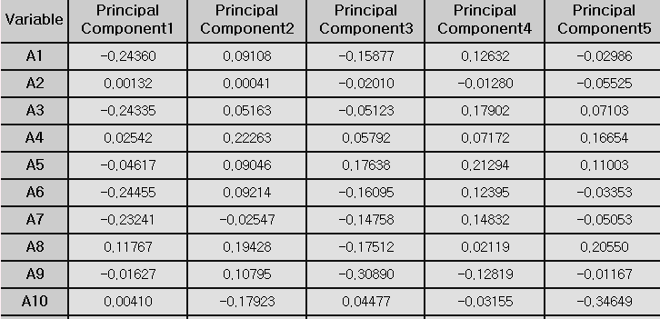

* Variance explanation

Each principal component explains a certain percentage of the total variance in the dataset. Indicates.

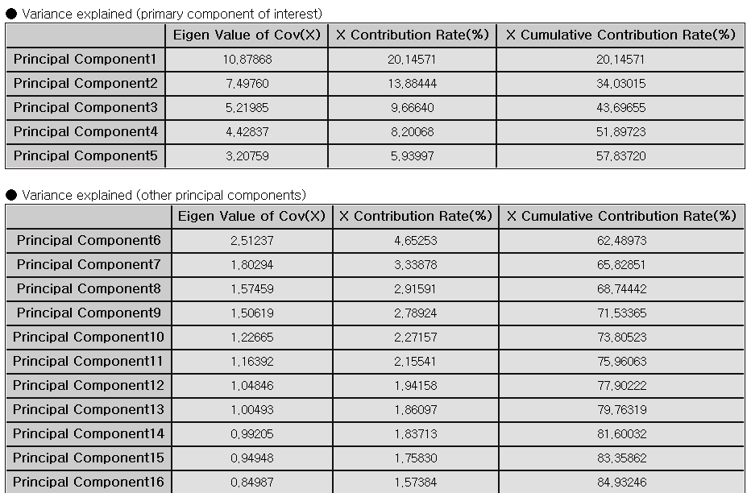.

* Loading Plot

The loading plot of the Modeling node can also be viewed in the Model node. The loading plot provides information about the loading values ​​of the two selected raw data or principal components.

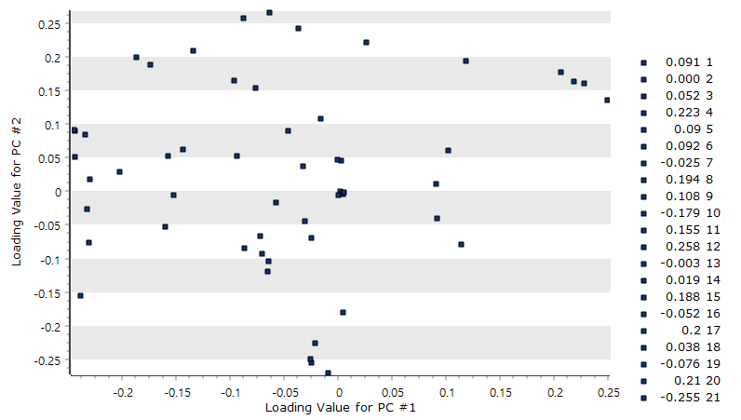

* Scree Plot

The scree plot of the Modeling node can also be viewed in the Model node. The scree plot displays the Eigenvalue value for each principal component. It can determine the number of principal components in numbers where the Eigenvalue value changes rapidly.

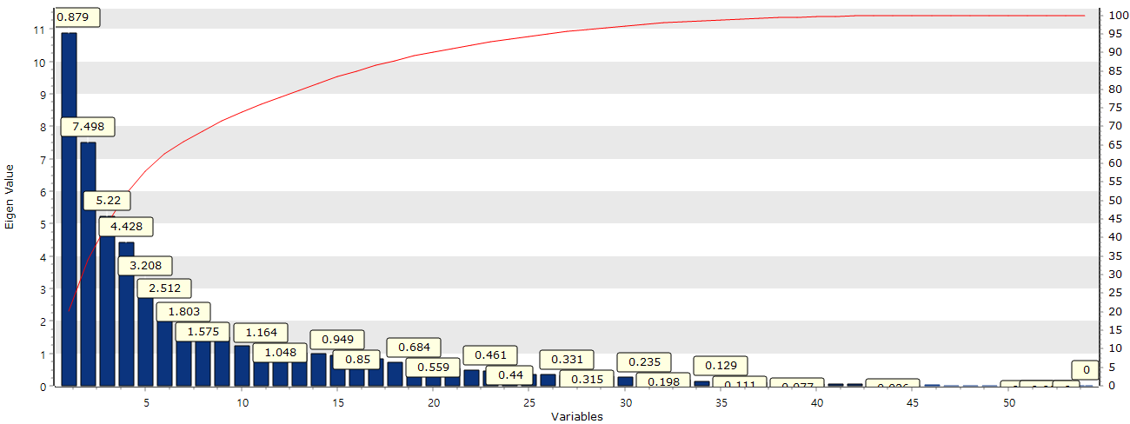

Example File

* Run the “**PCA.ecm”**

### 3.4.19 PCR

Predicted value

|  |  |
| --- | --- |
|  | **Principal Component Analysis (PCA)** is a multivariate technique used for dimension reduction. **Principal Component Regression (PCR)** is one of regression technique to handle multicollinearity in multiple linear regression. PCA transforms the original variables into a set of uncorrelated components (called principal components) that explains the maximum variance in x-space. |

Overview

When Y is a dependent vector and X is the matrix of independent vectors, the regression model for Y is expressed as follows.

$$Y=Xβ+ε$$

Here, β is the regression coefficient vector, and ε is the error vector. If multicollinearity exists among the independent variables (X), use Principal Component (T) for regression.

$$T=x_{1}p_{1}^{T}+x_{2}p_{2}^{T}+...+x_{A}p_{A}^{T}$$

$$y=Tq^{T}+f= q_{1}t_{1}+q_{2}t_{2}+...+q_{A}t_{A}+f$$

Here, we apply PCA to obtain the principal component score matrix T, and then perform a regression analysis based on this matrix.

Applications

* Independent and dependent variables must be continuous.
* Standardization is automatically applied.

Usage

* Read the data using Input Node.
* Specify the type of data using Type Change Node. (independent, or target)
* Connect Type Change Node to PCR Node and select the options.
* Connect PCR Node to Display Node.
* An example of PCR stream is as follows.

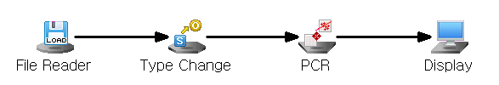

Node Properties

|  |  |  |  |  |
| --- | --- | --- | --- | --- |
| **Property group** | **Property Name** | **Description** | **Misc.** | **Note** |
| **Model File** | Save Model File | Decide whether to save model file. | Required | Yes, No |
| Model File Path | Set the path for the model file to be saved. | Conditionally Required |  |
| **Selection options** | Number of Principal Components | Enter the number of principal components to reduce the number of variables.  (Must be less than the number of independent variables**.)** | Required | natural number |
| Confidence Intervals | To save the 95% confidence interval for the specified target. | Required | True, False |
| Prediction Intervals | To save the 95% prediction interval | Required | True, False |

Results

Prediction analysis results are displayed using Display Node.

Principal component values (PRC\_T\*), estimated Y values (PCR\_YHAT), and residuals (PCR\_Res) are displayed. The 95% confidence and prediction intervals may also be shown if you select the Save Confidence/Prediction Intervals option.

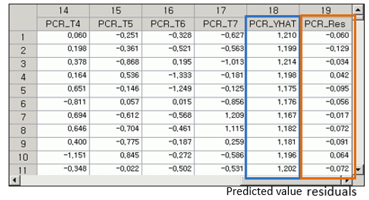

Modeling Result

Click **Modeling Result** in Node Property of **Model node** to view the results.

* Variance explanation

It shows the variance proportion explained by each principal component

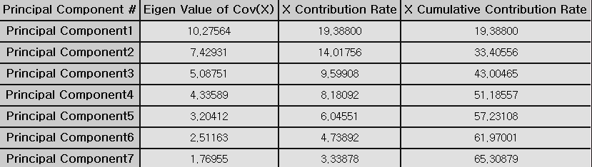

* Loading vectors for each component

Principal component is calculated for each variable. For example, principal component 1 is calculated as follows:

PCA 1 = (-0.00143\*A2) +(0.23957\*A3) +(-0.03681\*A4) +…

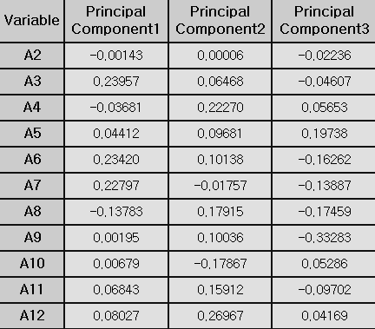

* Regression coefficients and model performance measures

The regression coefficients are interpreted as same as in multiple linear regression.

**(1) R-square (coefficient of determination)**

Represent the percentage of the variance in the dependent variable that is explained by the regression equation. The closer it is to 1, the better the regression equation explains the variability in the data

**(2) Adjust R2**

As more independent variables are added, R-square tends to increase. The adjusted R-square(adj) is considered the number of independent variables.

**(3) RMSE (Root-Mean Square Error)**

$$RMSE=\sqrt{MSE}=\sqrt{SSE/(n-p-1) }$$

**(4) MAE (Mean Absolute Error)**

$$MAE= \frac{\sum_{i=1}^{n}{{|y}_{i}- \hat{y_{i}}}|}{n}$$

**(5) MAPE (Mean Absolute Percentage Error)**

$$MAPE= \frac{\sum_{i=1}^{n}{\left|{(y}_{i}- \hat{y_{i}}\right)/y_{i}|}}{n}×100$$

Note that numbers (3) to (5) all represent the error between the original and predicted values of the dependent variable. Therefore, a smaller value indicates a better model.

Example File

* Run the “pcr.ecm”

### 3.4.20 PLS

|  |  |
| --- | --- |
|  | **Partial least squares (PLS)** is a statistical method commonly used for **dimensionality reduction**, **regression analysis.** PLS is used to analyze data where there is a large **correlation between independents** or where the number of variables is greater than the number of observations. If there is a multicollinearity problem**, PLS** reduces the number of predictors by transforming them into latent variables. The application fields are chemometrics, bioinformatics, and finance. About Principal Component Analysis (PCA) and PLS, PLS focuses on explaining variance in both predictors and responses while PCA focuses only on explaining variance in the predictors. |

Overview

PLS is a method of projecting the information of [X(n x k), Y(n x m)] into a low-dimensional space with a small number of latent variables, especially when the number of process variables (k) and the dimension of quality characteristics (m) are very large.

The PLS model assumes that X and Y can be decomposed into latent structures. A latent variable is $t_{1},t_{2},...,t_{A}$, matrix T(n x A).

$$X=TP^{T}+E$$

$$Y=UQ^{T}+F$$

***T*** : Scores (latent variables) for X

***Y*** : Scores (latent variables) for Y

***P*** and ***Q*** : Loadings (coefficients relating scores to original variables).

***E*** and ***F*** : Residuals (unexplained variation in X and Y)

The main idea of PLS is to explain Y with X by maximizing the covariance between T and U.

Applications

* Independent variable must be continuous
* Dependent variable must be continuous.
* PLS can predict multiple targets.
* PLS include a standardized pre-processing process.

Usage

* Read the data using Input Node.
* Specify the type of data using Type Change Node. (independent, target)
* Connect Type Change Node to PLR Node and select the options.
* Connect PLR Node to Display Node.
* An example of PLR stream is as follows.

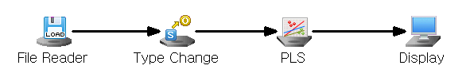

Node Properties

|  |  |  |  |  |
| --- | --- | --- | --- | --- |
| Property group | Property Name | Description | Misc. | Note |
| **Model File** | Save Model File | Decide whether to save model file. | Required | Yes, No |
| Model File Path | Set the path for the model file to be saved. | Conditionally Required |  |
| **Selection options** | Number of Latent Variable | Set the number of Latent Variables. | Required | Integer  (less than the number of independent variables) |
| Save Confidence Intervals | Stores the 95% **confidence interval** for the specified target. | Required | True, False |
| Save Prediction Intervals | Save the 95% prediction interval. | Required | True, False |

Results

Prediction analysis results are displayed using Display Node.

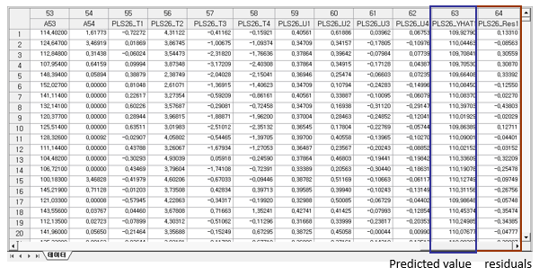

* Analysis chart information

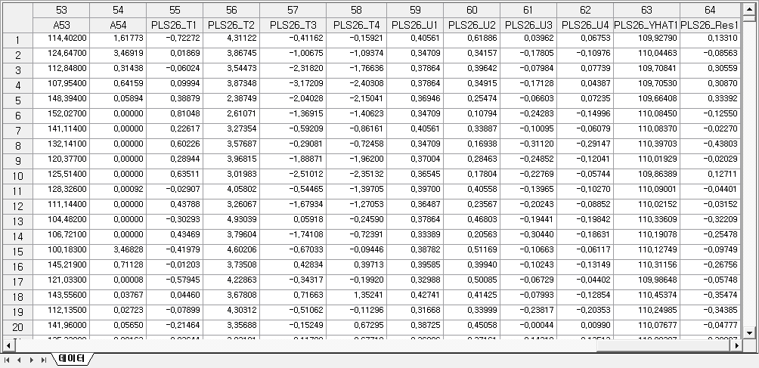

Graphic Result

Click **Graphic Result** button in Node Property of **Model node** to view the charts. The results can also be viewed in the **Modeling Result** of **Model node**.

* Scree Plot of X

This plot shows how much variance of X is explained by each latent variable

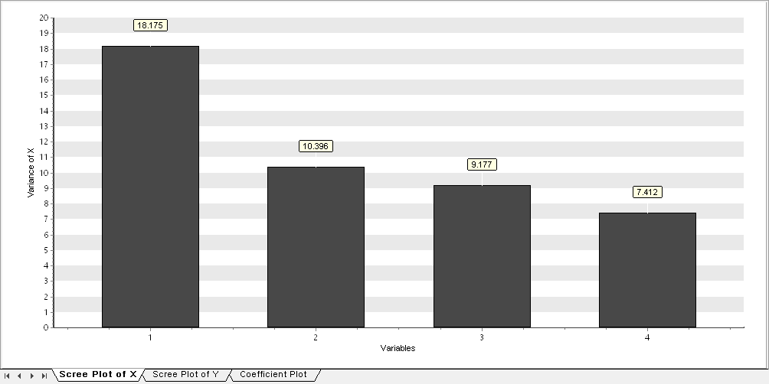

* Scree Plot of Y

This plot shows how much variance of Y explained by each latent variable

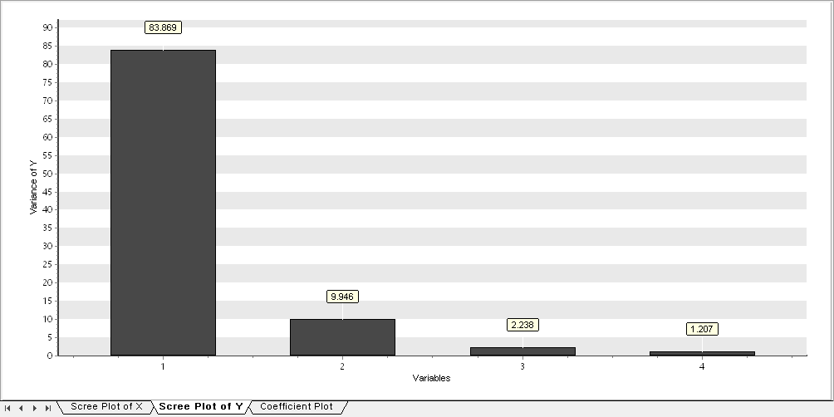

* Coefficient Plot

For target variable, you can see which variables have the most impact. In addition, it can be sorted according to coefficient size.

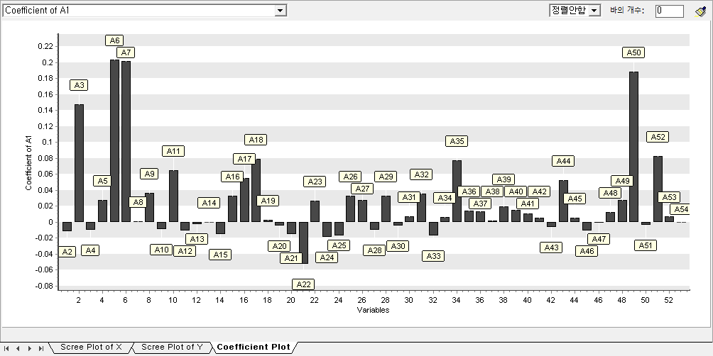

* Data Chart

With Data Chart, you can see trend charts of target values and forecast values. You can also view the Residual and Contribution charts along with this trend chart.

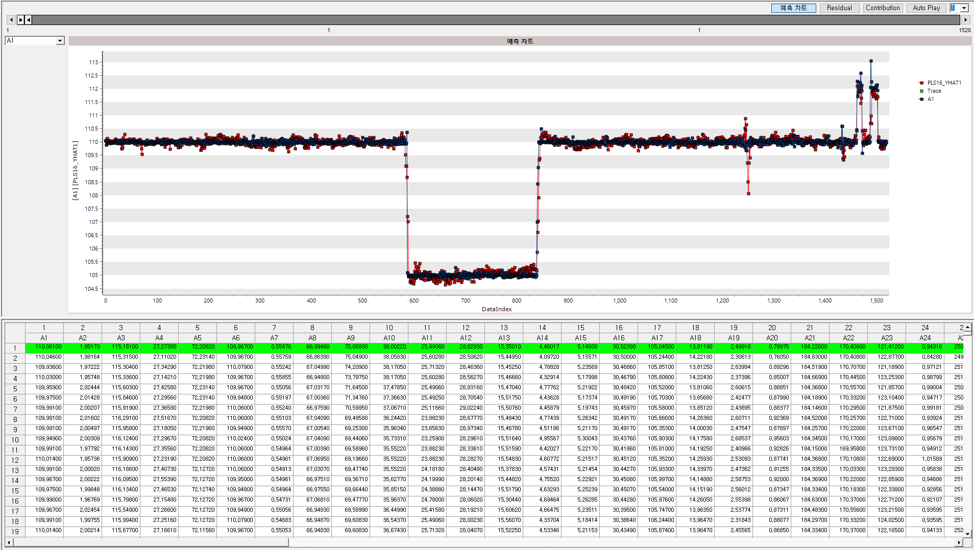

Modeling Result

Click **Modeling Result** in Node Property of **Model node** to view the results.

* Coefficient Information

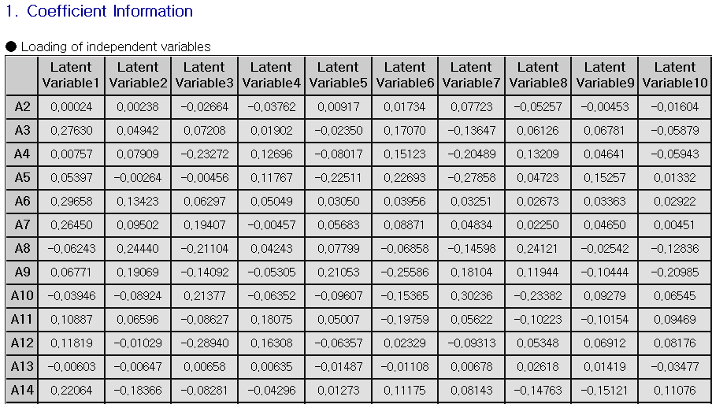

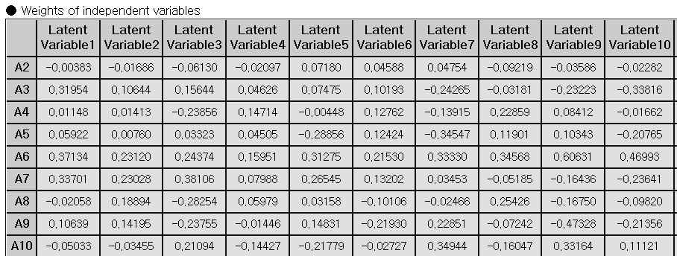

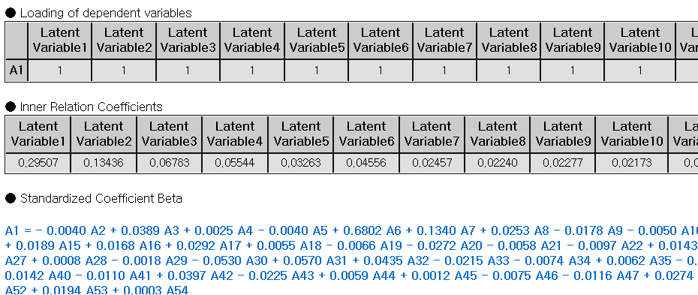



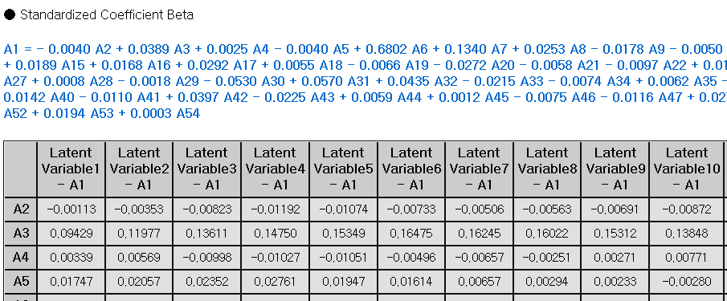

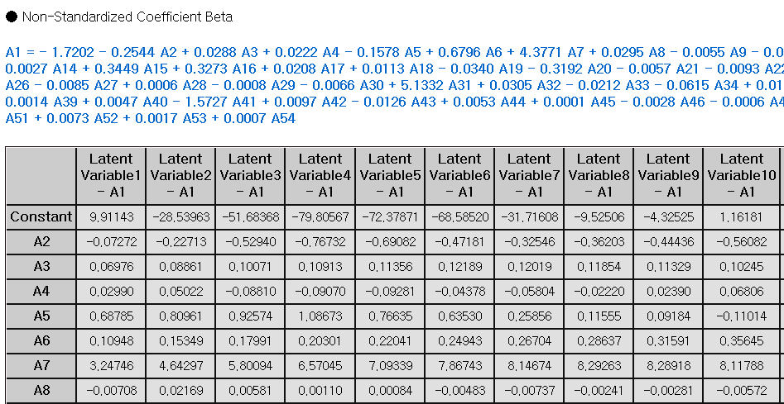

* Variance Information

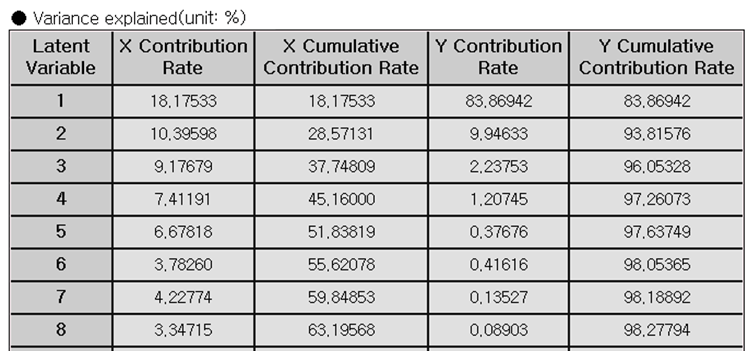

* Standard Error Information

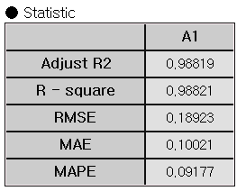

Example File

* Run the “pls.ecm”

### 3.4.21 QDA

|  |  |
| --- | --- |
|  | **QDA (Quadratic Discriminant Analysis)** is a supervised classification algorithm allowing non-linear boundaries. QDA maximizes between-class separation while assuming that each class has its own covariance matrix. |

Overview

LDA assumes that the variance-covariance matrix is the same for all classes. QDA allows the covariance matrix different, and forms quadratic decision boundaries between classes. QDA assumes normality of data within each class same as LDA.

(1) Calculate the average vector for each class.

$${\hat{μ}}_{j}←{\bar{x}}^{(j)}←\frac{1}{n_{j}}\sum_{i=1}^{n_{j}}{x_{i}^{(j)}}\text{ ,}j=1,2$$

(2) Calculate the sample covariance matrix for a class.

$${\overset{∧}{Σ}}_{j}←S_{j}←\frac{1}{n_{j}-1}\sum_{i=1}^{n_{j}}{(x_{i}-{\bar{x}}^{(j)})}(x_{i}-{\bar{x}}^{(j)})' j=\text{1,2}$$

(3) The discriminant function for class k is shown below.

$$U_{k}=\ln{π_{k}}-\frac{1}{2}\ln{|}Σ_{k}|-\frac{1}{2}(x-μ_{k})'{Σ_{k}}^{-1}(x-μ_{k})$$

(4) The classification rules are as follows.

$$U_{k}=\max_{j}U_{j} , categorize x into category k$$

Applications

* Independent variable can be either continuous or discrete.
* Dependent variable must be discrete.
* The feature vector 𝑥 follows a multivariate normal distribution.
* The variance-covariance matrix is different for each class.

Usage

* Read the data using Input Node.
* Specify the type of data using Type Change Node. (independent, or target)
* Connect Type Change Node to QDA Node and select the options.
* Connect QDA Node to Display Node.
* Select Prior probability and set the appropriate prior.



* An example of QDA stream is as follows.

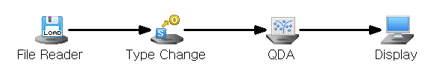

Node Properties

|  |  |  |  |  |
| --- | --- | --- | --- | --- |
| **Property group** | **Property Name** | **Description** | **Misc.** | **Note** |
| **Model File** | Save Model File | Decide whether to save model file. | Optional | Yes, No |
| Model File Path | Set the path for the model file to be saved. | Conditionally Required |  |
| **Selection options** | Prior probability | Decide whether to manually input the prior probabilities. Manual prior is useful for imbalanced data | Required | Base Value, Manual Input |

Results

Classification analysis results are displayed using Display Node.

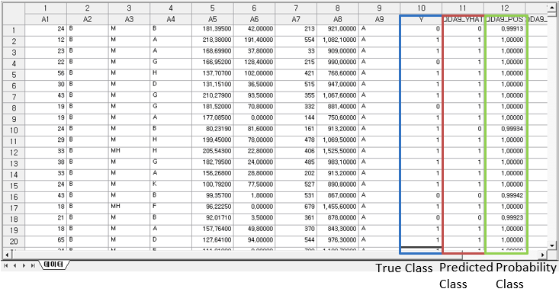

Modeling Result

Click **Modeling Result** button in Node Property of **Model node** to view the analysis results.

* Average of independent variables by class

Indicates the average value of variables for each classified class.

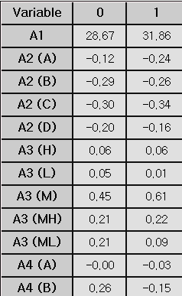

* Variance-covariance matrix of the class

Since the variance-covariance matrix of each group differs from the class variance-covariance matrix, a separate variance-covariance matrix is output for each group.

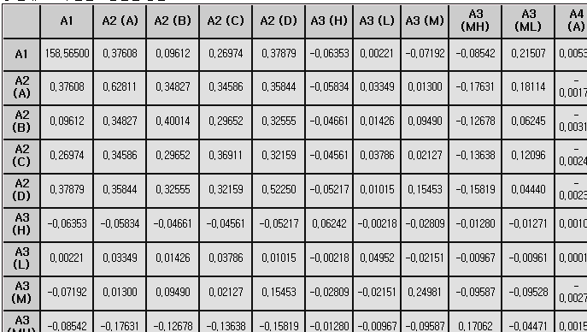

* Prior probability

Shows the probability value for each class specified in the prior probability option.

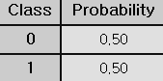

* Confusion matrix

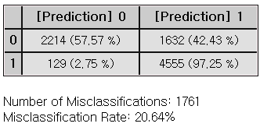

Example File

* Run the “LDA,QDA.ecm”

### 3.4.22 RandomForest

|  |  |
| --- | --- |
|  | **Random Forest** is a supervised learning algorithm that combines the output of multiple decision trees to improve overall accuracy and stability. |

Overview

The concept of Random Forest is illustrated below.

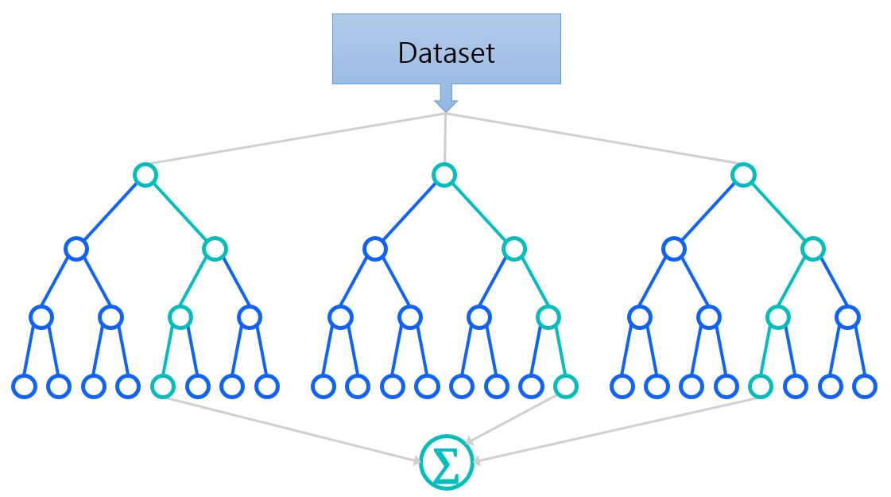

As an ensemble learning technique, bagging is a key idea of the Random Forest model. Bagging, short for Bootstrap Aggregating, creates multiple subsets of the original dataset, allowing repeated instances. The sample size for bagging can be specified as either **Percentage** or **Count** in the **Selected Variable Count** of the **Selection options**.

Each bootstrap subset is then used to train an individual decision tree, forming a “forest”. The options for the decision trees are **Total Number of Trees, Maximum Separation Data Size, Maximum Tree Depth, Impurity Condition, Impurity Change Condition** and **Variable Selection Method**.

For classification, the final output is determined by majority vote, while for regression, it is the average of the predictions made by all the trees.

Out-of-bag (OOB) error is calculated to estimate its internal validation using **OOB** option in the **Selection options**. Since each tree is trained on a bootstrap sample, the remaining data is left out (out-of-bag) and can be used to test the model. After each tree is trained, it is tested on the data points not included in its bootstrap sample. The OOB error is the average error rate across all trees and serves as an unbiased estimate of the model's generalization error.

Applications

* Independent variables can be either continuous or discrete.
* Dependent variable can be either continuous or discrete.

Usage

* Read the data using Input Node.
* Specify the type of data using Type Change Node. (independent, or target)
* Connect Type Change Node to RandomForests Node and select the options.
* Connect RandomForests Node to Display Node.
* An example of Random Forest stream is as follows.

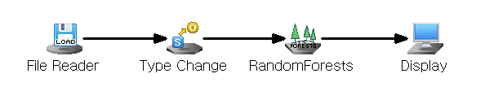

Node Properties

|  |  |  |  |  |
| --- | --- | --- | --- | --- |
| Property group | **Property Name** | **Description** | **Misc.** | **Note** |
| Model File | Save Model File | Decide whether to save model file. | Required | Yes, No |
| Model File Path | Set the path for the model file to be saved. | Conditionally Required |  |
| Selection options | Total Number of Trees | Set the number of branches to be generated. (Default : 100) | Required | Natural Number |
| Variable Selection Method | Selection for the number of features in tree. (Default : Automatic, sqrt(k) for classification, and k/3 for regression. k: number of independent variables) | Required | Automatic, Designate |
| Selected Variable Count | Set the number of variables to be used in tree if Variable Selection Method option is set to be Designate. | Required | Natural number |
| Sample Size Specification Method | Set sample size for bagging technique | Required | Percentage, Count |
| Percentage | Specify the sample size as a percentage when ‘Percentage’ is selected for the Sample Size Specification Method. | Optional | 0<real number <100 |
| Count | Specify the sample size as a count when ‘Count’ is selected for the Sample Size Specification Method. | Optional | 0< integer <N  (N: number of data) |
| Impurity Function | Specify the impurity function. (Default : Gini) | Required | Gini, Twoing, Entropy, LSD |
| Use OOB | Decide whether to use Out-of-bag testing. | Required | Yes, No |
| Min Samples Split | Set the minimum number of data required to split a tree node  (Default : 5) | Required |  |
| Max Tree Depth | Specify the maximum depth of each tree. **Default**: None (nodes are expanded until all leaves are pure or contain fewer than Min Samples Split) | Required |  |
| Impurity Threshold | A node becomes a stationary node if its impurity is below the specified impurity threshold. | Required |  |
| Impurity Change Threshold | If the impurity change for a node is below the specified threshold, the node is considered a terminal node. | Required |  |

Results

Classification and prediction results can be seen in Display Node.

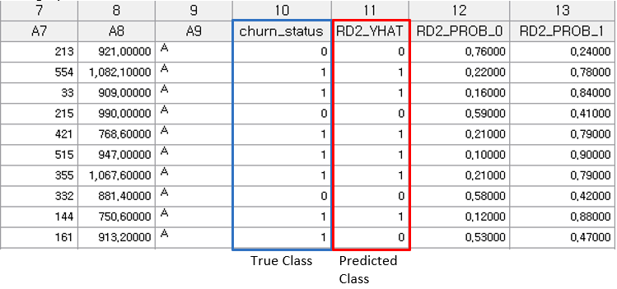

Graphic Result

Click **Graphic Result** button in Node Property of **Model node** to view the charts. The results can also be viewed in the **Modeling Result** of **Model node**.

* Variable importance

Random Forest provides feature importance information for making prediction. Variable importance measure is useful for variable selection.

* (1) Mean Decrease Accuracy (MDA)

measures the impact of each variable on the accuracy of the Random Forest model. It is calculated by removing each variable and observing the reduction in accuracy. The difference in accuracy is averaged for each variable. A larger MDA value indicates that the variable significantly contributes to the model’s classification accuracy.

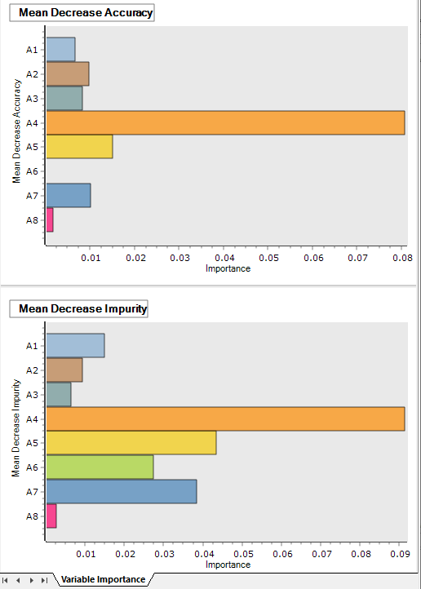

* (2) Mean Decrease Impurity (MDI) or Mean Decrease Gini (MDG)

represents the average reduction in impurity across all decision trees in the Random Forest. As each decision tree splits based on different variables, MDI quantifies the overall contribution of each variable to reducing impurity throughout the forest. A higher MDI or MDG value indicates that the variable is more important in improving the purity of the splits.



Modeling Result

Click **Modeling Result** button in Node Property of **Model node** to view the analysis results.

* Option Information

It shows which options were used when modeling using RandomForest.

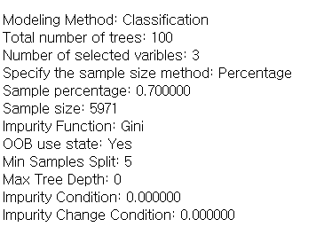

* Primary Factor Information

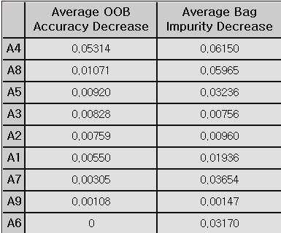

* Confusion Matrix

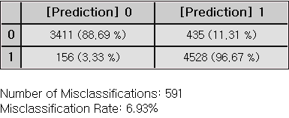

Example File

Run the “**RF.ecm**”

### 3.4.23 RBF

|  |  |
| --- | --- |
|  | **RBF(Radial-Basis Function)** network is a supervised neural network with a single hidden layer. Its mathematical form is similar to a standard neural network, but it uses a radial basis function as the combination function in the hidden layer, instead of a typical activation function. |

Overview

RBF (Radial-Basis Function) network is a supervised neural network often used for tasks like curve fitting by transforming data into a high-dimensional space. RBF network learns by finding a surface that best matches the patterns in the training data within this high-dimensional space.

The network has three layers, each with a specific role. The Input layer is responsible for connecting the network to the external environment by receiving data, often referred to as “sensory” information. The hidden layer performs a nonlinear transformation on the input data, altering it in a way that helps the network recognize complex patterns more easily. This layer uses radial-basis functions, which are the core components of the RBF network. Finally. The output layer produces the final result or prediction based on the transformed data from the hidden layer, typically combining the data in a simple, linear way.

RBF networks are often used for solving complex pattern classification tasks by transforming the data into a high-dimensional space through a nonlinear process. This transformation makes the patterns more linearly separable compared to those in a lower-dimensional space. As a result, RBF networks typically increase the dimensionality of the hidden layer to improve performance. An important factor to consider is that the dimensionality of this hidden space plays a key role in the accuracy of the network's ability to map input to output. In simple terms, the higher the dimensionality of the hidden layer, the more precisely the network can learn to match the training data.

Applications

* RBF node automatically selects an appropriate execution method based on the target’s data type, performing predictive analysis when the target is continuous and classification analysis when the target is discrete.

Usage

* Read the data using Input Node.
* Define ‘data type’ in Type Change Node. (Specify independent, target)
* Connect Type Change to RBF Node and select the options.
* Connect RBF Node to Display Node.
* An example RBF is as follows.

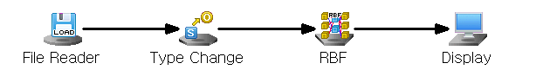

Node Properties

|  |  |  |  |  |
| --- | --- | --- | --- | --- |
| Property group | Property Name | Description | Misc. | Note |
| Model File | Save Model File | Decide whether to save model file. | Required | Yes, No |
| Model File Path | Set the path for the model file to be saved. | Conditionally Required |  |
| Selection options | Number of Centers | This is the number of centers of the Radial Basis Function. | Required | 0<Integer<N (number of data) |
| Lambda | Regularization parameter | Required |  |

Results

Prediction analysis results are displayed using Display Node.

In the case of predictive analysis, you can see the forecast value and residuals, and in the case of classified analysis, you can see the classified results.

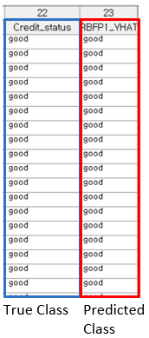

Modeling Result

Click **Modeling Result** in Node Property of **Model node** to view the results.

* Center Information

**Center**: Central values of the RBF for each variable.

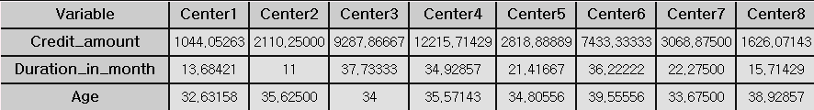

* Classification Accuracy

**Confusion Matrix**

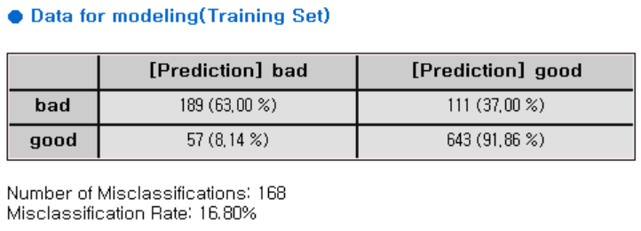

Example File

* Run “RBF.ecm”

### 3.4.24 RBF DDA

|  |  |
| --- | --- |
|  | **RBF DDA** is an algorithm that solves the difficulty of determining the parameters that the user needs to enter to run the algorithm by automatically determining the number of RBFs and the $σ$ value of each RBF. |

Overview

RBF DDA is an abbreviation of Radial Basis Function with Dynamic Decay Adjustment, and it is an algorithm created to compensate for the shortcomings of existing RBF. The existing RBF algorithm requires that the user specifies the number of RBFs, the σ value of each RBF and so on. However, this is very burdensome for the user who has basic understanding of data.

To solve this problem, RBF DDA automatically determines the number of RBFs, and the σ value of each RBF. RBF DDA has the limitation that performs only classification (that is, it cannot perform regression), but it shows better performance than the existing RBF.

RBF - The easiest and most concise way to describe the DDA's algorithm is to add RBF when very new data comes in. First of all, the RBF-DDA is expressed as follows.

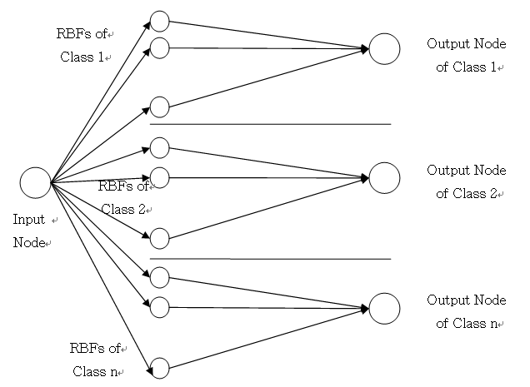

The jth RBF of the ith class has three characteristic values as follows

$\overset{→}{r_{j}^{i}}$: Coordinates of the center of the jth RBF of the ith class

$σ_{j}^{i}$: jth sigma of ith class

$A_{j}^{i}$: jth weight of ith class

At this time, when x data enters the $j^{th}$ RBF of the $i^{th}$ class, the following response value is obtained.

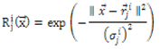

Using these response values, the output of each class is as follows;

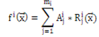

At this time, x data is classified into the class with the largest value above.

Applications

* Independent value and target value must be entered. Independent value must be continuous and target value must be discrete.
* The RBF DDA node itself includes a standardization preprocessing process.

Usage

* Read the data using Input Node.
* Specify independent value and target value by using Type Change.
* Connect RBF DDA to Type Change and select options.
* An example RBF DDA is as follows.

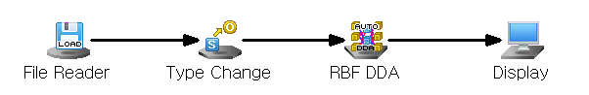

Node Properties

|  |  |  |  |  |
| --- | --- | --- | --- | --- |
| Property group | Property Name | Description | Misc. | Note |
| Model File | Save Model File | Decide whether to save model file. | Required | Yes, No |
| Model File Path | Set the path for the model file to be saved. | Conditionally Required |  |
| Selection options | $$θ^{+}$$ | Add a new RBF if the responses of RBFs of the class to which the data belongs to new data are all less than this value, during the RBF DDA training process. | Required |  |
| $$θ^{-}$$ | Set the default value to adjust the value of RBF during the RBF DDA training process. | Required |  |
| Percentage of Min Extraction Data | Set percentage of RBFs to search during the training. This parameter is to speed up the algorithm. Due to the nature of the RBF DDA algorithm, each time new data comes in and a new RBF is created, it changes or adds the value while searching all existing RBFs. Training time can be reduced by selecting only some RBFs in this process. | Required |  |

Results

The analysis results are displayed using Display Node.

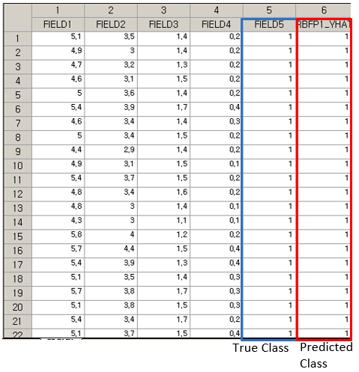

Residual plot is displayed using the Trend Chart or Enhanced Basic Chart.

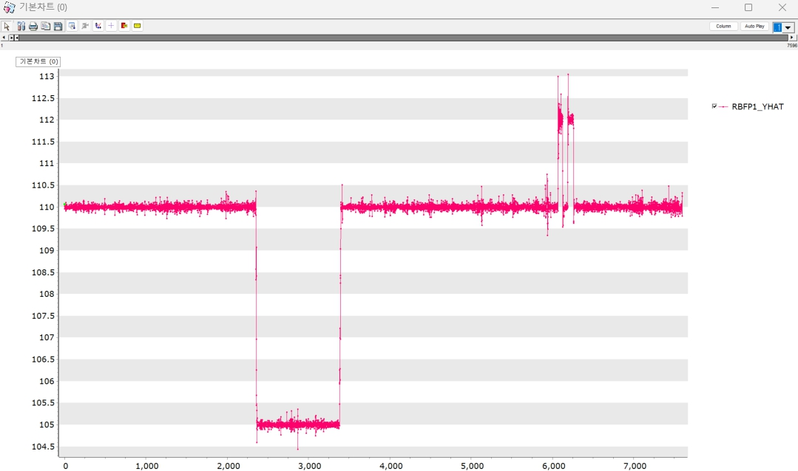

Modeling Result

Click Modeling Result in Node Property of Model node to view the results.

* Weight, Sigma, Center

It shows the value of weight, sigma and center that is obtained on the training of RBF DDA.

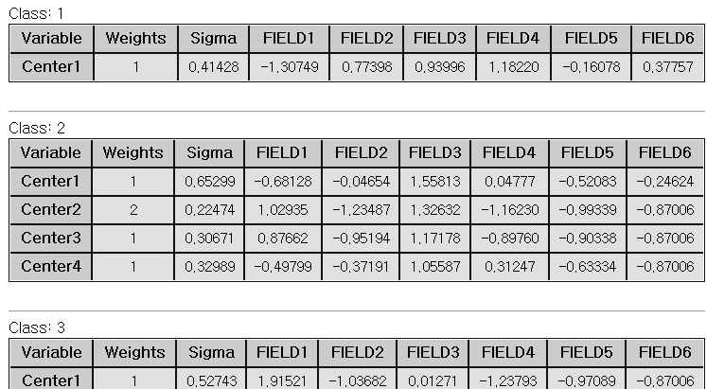

* Confusion Matrix

The confusion matrix shows the number and percentage correctly/incorrectly predicted observations. The cross-tabulation part of the confusion matrix describes the number and percentage of incorrectly predicted observations. The lower the number of misclassifications and the percentage of misclassifications is, the better the model can be judged to be.

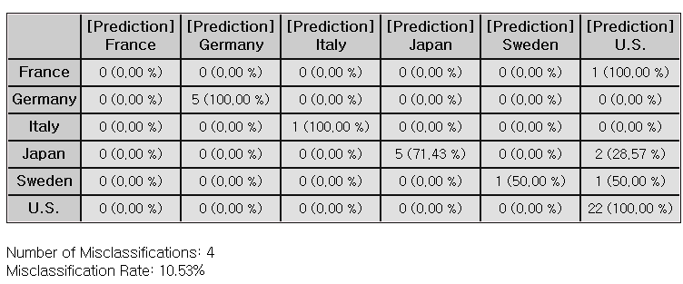

### 3.4.25 Regularized Regression

|  |  |
| --- | --- |
|  | **Regularized regression** is a regression method with a penalty for larger coefficients in order to prevent overfitting and improve model generalization. It is called shrinkage model. |

Overview

Regression models are used to predict the dependent variable through the linear equation of independent variables.

* : Dependent variable, : Independent variables
* : Intercept
* : Coefficients corresponding to each independent variable (the impact of each independent variable on the dependent variable)
* $ϵ$: Error term
* (1) The four assumptions of linear regression

For valid regression model, the following assumptions should be met.

- **Linearity**: The relationship between the independent and dependent variables is linear.

- **Independence** **of** **Errors**: Residuals (errors) are independent of each other.

- **Homoscedasticity**: The variance of the errors should be constant for all values of the independent variables.

- **Normality** **of** **Errors**: Residuals (errors) is normally distributed.

* (2) Variable Selection

Variable selection is the process of selecting important variables. In the **Variable Selection** option, you can choose **Stepwise** or **General**. **Stepwise** selection combines with Forward, Backward methods to iteratively add or remove variables, refining the model with significant predictors. (\* **Forward** selection adds from the most important variable to least important one in the model, while **Backward** selection removes unimportant variables from a full model.) General selection includes all the input independent variables.

* (3) Multicollinearity

Multicollinearity occurs due to high correlations between independent variables. Using the Variance Inflation Factor (VIF), variables with VIF>10 needs to be double-checked. The **Calculate VIFs** option gives VIF values, and the **Remove Multicollinearity** option allows to remove variables with VIF values over 10.

Applications

* Independent variables can be either continuous or discrete.
* Dependent variable must be continuous.
* The four basic assumptions of regression analysis must be satisfied.

Usage

* Read the data using Input Node.
* Specify the type of data using Type Change Node.
* Connect Type Change Node to Regularized Regression Node and select options.
* Connect Regularized Regression Node to Display Node.
* An example of Regularized Regression stream is as follows.

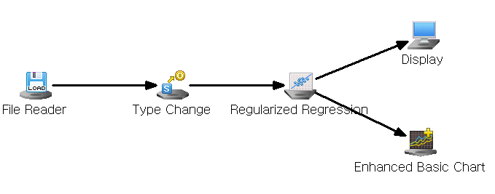

Node Properties

|  |  |  |  |  |
| --- | --- | --- | --- | --- |
| **Property group** | **Property Name** | **Description** | **Misc.** | **Note** |
| **Model File** | Save Model File | Decide whether to save model file. | Required | Yes, No |
| Model File Path | Set the path for the model file to be saved. | Conditionally Required |  |
| **Selection options** | Technique | Set the method of variable selection. | Required | General,  Stepwise |
| Significance Level for Entry | Enter Significance Level of Entry if **Technique** is **Stepwise.** The smaller the significance level, the fewer independent variables are likely to be added to the model. | Required |  |
| Significance Level for Removal | Enter Significance Level of Removal if **Technique** is **Stepwise.** The bigger the significance level, the fewer independent variables are likely to be added to the model. | Required |  |
| Calculate VIFs | Decide whether to calculate VIFs.  Multicollinearity is considered present if the VIF exceeds 10. | Required | True,  False |
| Save Confidence Intervals | Decide whether to save 95% Confidence Intervals for the dependent variable. | Required | True,  False |
| Save Prediction Intervals | Decide whether to save 95% of prediction intervals. | Required | True,  False |
| Remove Multicollinearity | Decide whether to remove variables to mitigate multicollinearity among independent variables. | Required | True,  False |
| Regression Method | Select a regression analysis method. | Required | OLS, Ridge, Lasso, Elastic Net |
| Ridge Penalty | Enter the Penalty for Ridge if **Regression Method** is **Ridge.** | Required |  |
| Lasso Penalty | Enter the Penalty for LASSO if **Regression Method** is **Lasso** | Required |  |

Results

Prediction analysis results are displayed using Display Node.

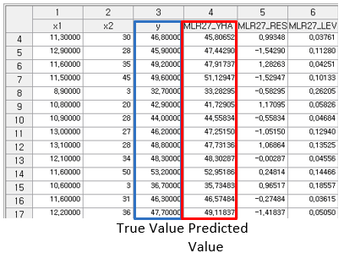  
The residual plot is displayed using the **Trend Chart** or **Enhanced Basic Chart**.



If the regression model is well-fitted, the errors should have a mean of 0 and constant variance. Running the Chart Node with Data Index on the X-axis and Residual (MLR\_RES) on the Y-axis will produce a plot similar to the one shown above**.**

Graphic Result

Click **Graphic Result** in Node Property of **Model node** to view the charts. The results can also be viewed in the **Modeling Result** of **Model node**.

* Coefficient Plot

The graph displays coefficients for each independent variable.

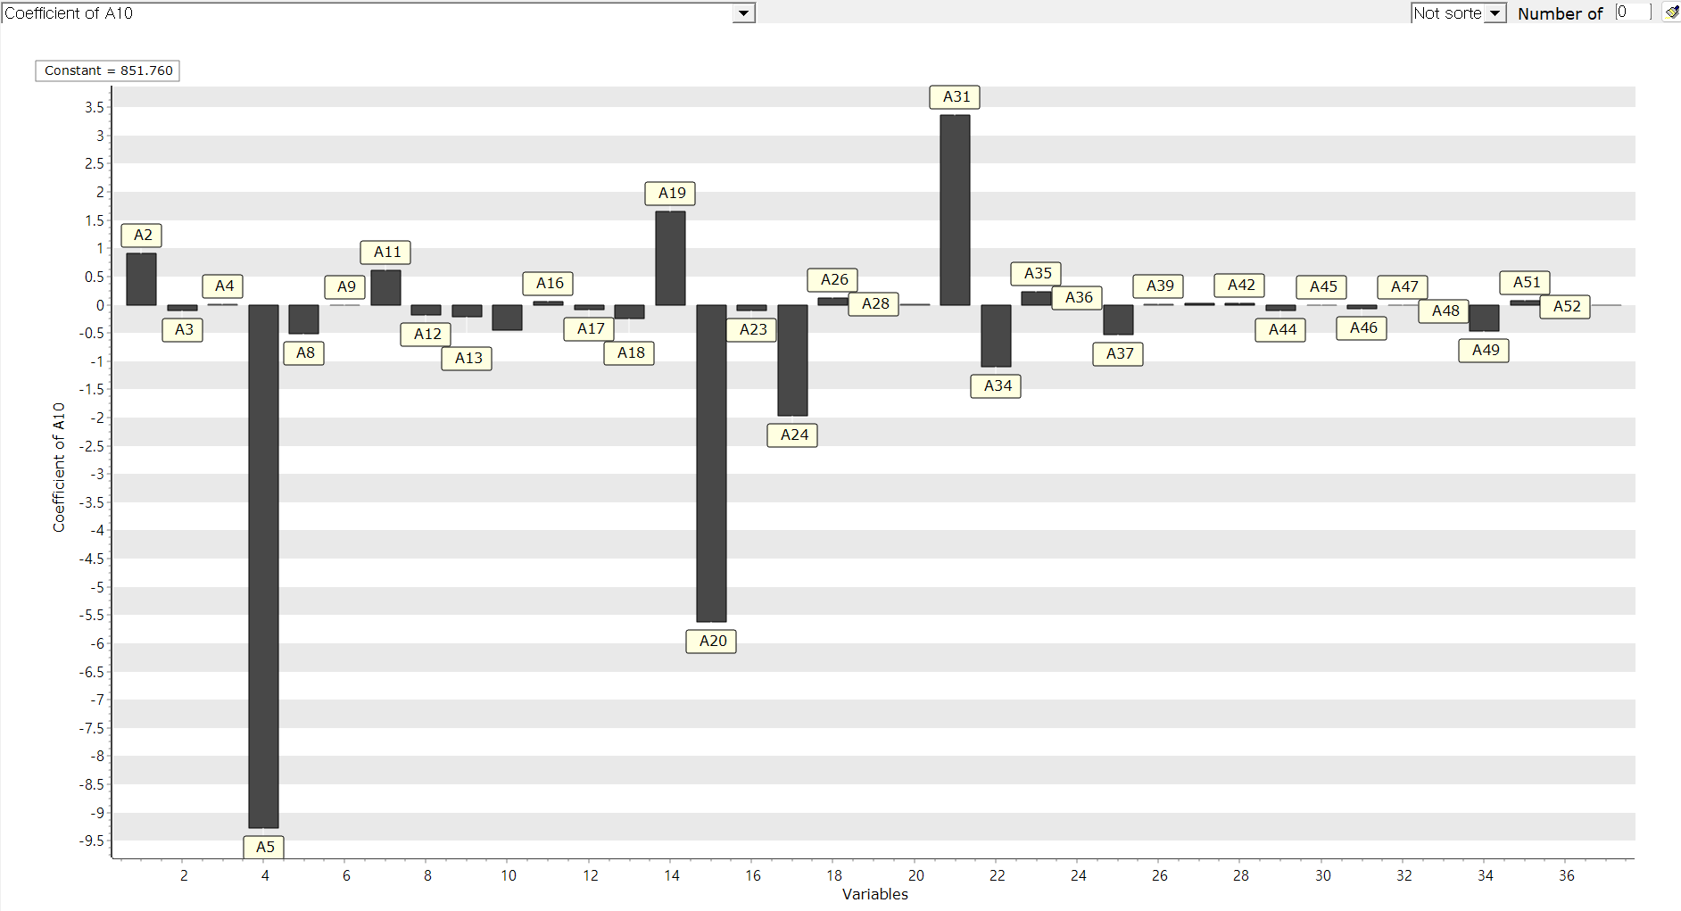

* Data Chart

The graph displays the difference between actual value and predicted value, residual, contribution for each observation.

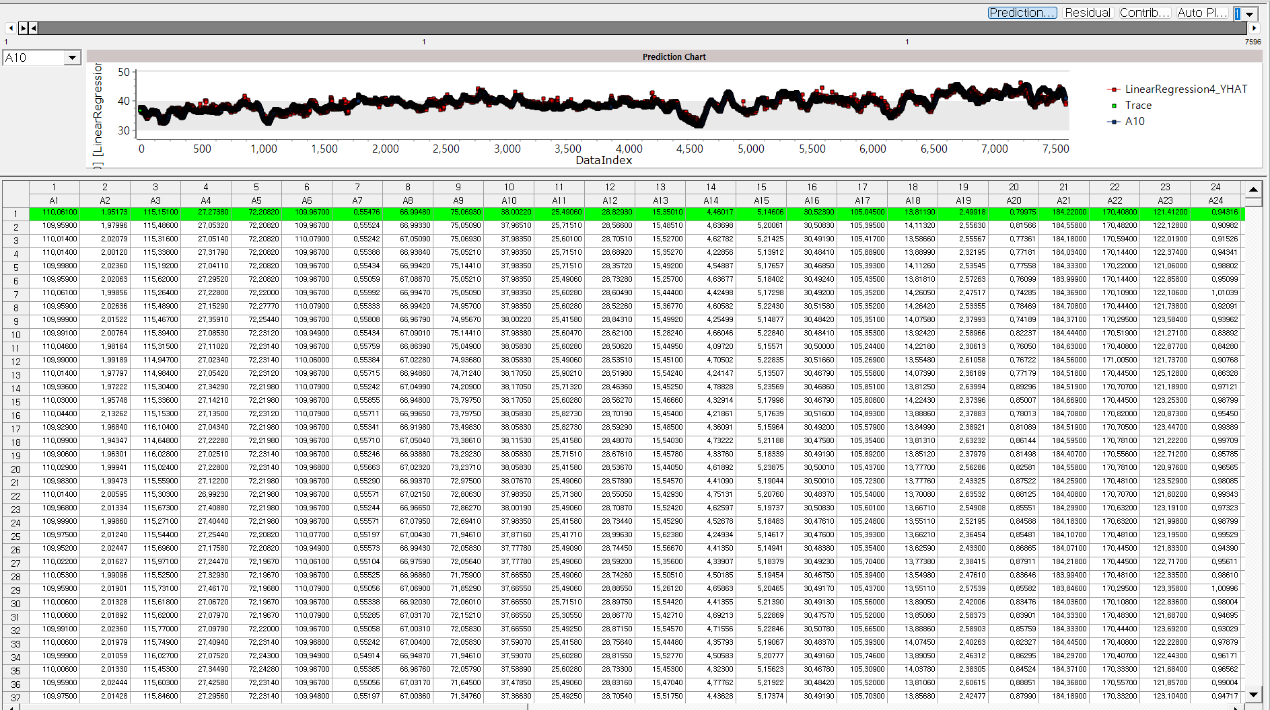

Modeling Result

Click **Modeling Result** button in Node Property of **Model node** to view the analysis results.

* Regression table & Regression Equation

Determine the significance and regression coefficient value of each independent variable.

Regression coefficient estimation 

Dependent variable prediction 

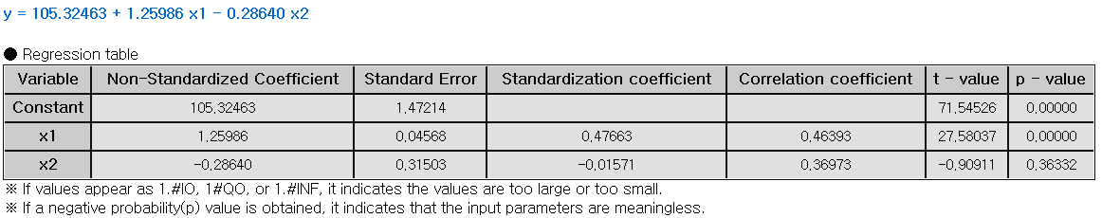

**(1) Non-Standardized Coefficient**

The actual effect of each independent variable on the dependent variable in its original units.

**(2) Standard Error**

The measure of uncertainty around the estimate of a regression coefficient. It shows how precise the estimate is.

**(3) Standardization Coefficient**

The change in the dependent variable, measured in standard deviations, for a one standard deviation change in the independent variable.

**(4) t-value**

A statistic used to test if a regression coefficient is significantly different from zero. It compares the coefficient to its standard error to assess its significance.

**(5) p-value**

The probability that the observed effect occurred by chance. If the p-value is less than the significance level, the effect is statistically significant, and the null hypothesis can be rejected.

* ANOVA TABLE

F-test is a test whether the independent variable is statistically significant in explaining the dependent variable. If the p-value is greater than the significance level then it is not significant, the interpretation of the regression coefficient is meaningless.

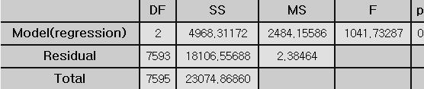

**(1) DF (Degree of Freedom)**

The number of independent variables

**(2) SS (Sum of Squares)**

Total variations in the data. It is a calculation of the squared deviations from the mean value.

**(3) MS (Mean Square)**

The average of the squared deviations. (SS/DF)

**(4) F-value**

The ratio of the mean square for the residual variance and the independent variable variance.



**(5) p-value**

probability of observing the data if the null hypothesis is true. Lower p-value suggests that the group variances are statistically significant.

* Standard Error Information

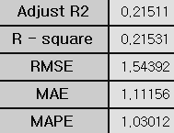

**(1) R-square (coefficient of determination)**

It is a value that checks whether the derived regression equation is representative of the measured values.

**(2) Adjust R2**

It adjusts the r-squared value by considering the degree of freedom of the model.

**(3) RMSE (Root-Mean Square Error)**

The square root of the average squared differences between the predicted values and the dependent variable.

**(4) MAE (Mean Absolute Error)**

The average of the absolute differences between the predicted values and the dependent variable.

**(5) MAPE (Mean Absolute Percentage Error)**

The average of the absolute differences between the predicted values and the dependent variable as a percentage

Numbers (3) to (5) all represent the error between the original value and the predicted value of the dependent variable. The smaller the value, the better the model.

* Stepwise result



(1) This result is output only when the technique is selected as stepwise. The model for each step is explained. Trace values ​​indicate which variables were entered at each step.

(2) In Step 1, you can see that only x2 has a trace value of 1. This means that the x2 variable was added to the model in Step 1.

(3) In Step2, you can see that the x1 variable has been added to the model. You can see that when this x1 variable was added to the model, the R2 (R-Square) value became better than Step1.

(4) If Stepwise is selected, only the variables included in the last step in the previous regression table are output, and in the case above, a regression table for variables x1 and x2 is created.

Example File

* Run the **Regression.ecm**

### 3.4.26 RL\_AC(Actor Critic)

|  |  |
| --- | --- |
|  | **Actor Critic (AC)** is a reinforcement learning algorithm in the Policy Gradient method that introduces an additional neural network, allowing two networks to be updated simultaneously. One network approximates the policy, while the other serves as a replacement for the Q function. |

Overview

The Actor-Critic algorithm is a reinforcement learning method that combines two neural networks: one for estimating the value function and one for determining the policy. The Policy network, known as the “actor”, selects actions based on the current state, while the value function network, known as the “critic”, evaluates the actions chosen by the actor. The actor observes the current state from the environment and determines the optimal action based on the policy. The critic then evaluates the action chosen by the actor using the value function.

Applications

* Independent and dependent variable used in Environmental Model are required.
* Independent variable can be either continuous or discrete

Usage

* Read data using Input Node.
* Connect Input Node to RL \_AC Node and select the options.
* Connect the RL\_AC Node to Display Node.
* An example of RL\_AC stream is as follows.

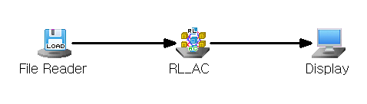

Node Properties

|  |  |  |  |  |
| --- | --- | --- | --- | --- |
| Property group | Property Name | Description | Misc. | Note |
| Model File | Save Model File | Decide whether to save model file. | Required | Yes, No |
| Model File Path | Set the path for the model file to be saved. | Conditionally Required |  |
| Selection options | Model Setting | Select the gms file to load as an environment model. | Required |  |
| Discount Rate(gamma) | Set the discount rate(gamma) for the future reward. | Required | 0<real number<1 |
| Actor Learning Rate | Specify the Learning Rate for the Actor neural network. | Required | 0<real number<1 |
| Critic Learning Rate | Specify the learning rate of the Critic neural network. | Required | 0<real number<1 |
| Max Episodes | Specify the maximum number of episodes to learn. | Required | Integer |
| Max Steps | Specify the number of maximum steps in an episode. | Required | Integer |
| Target Variable | Specifies a Target value for the variable to be controlled. | Required | Discrete Variables |
| Target Tolerance | Specify the allowable error margin for the target value when defining the environmental reward. | Required | Integer |
| Target Upper Limit | Specify the condition for ending an episode. The episode ends when the predicted value in the environmental model exceeds the specified value | Required | Real number |
| Target Lower Limit | Specify the condition for ending an episode. The episode ends when the predicted value in the environmental model is below the specified value | Required | Real number |
| Control Variable | Specify the control variables in Environmental Model. | Required |  |
| Control Amount | Specify the Control Amount of the control variable. | Required | Integer |
| Batch Normalization | Decide whether to use batch normalization. | Required | Yes, No |
| Output Layer Activation Function | Specifies the Activation Function of the output layer. | Required | Linear, Sigmoid, ReLU, Leaky ReLU, SoftMax |
| Hidden Layer Configuration | Add Hidden Layer | Add hidden layer | Optional |  |
| Remove Last Hidden Layer | Remove the last hidden layer. | Optional |  |
| Hidden Layer # | Number of nodes | Specify the number of nodes for each specified hidden layer | Required | Integer |
| Activation Function | Select the activation function for the specified hidden layer. | Required | Linear, Sigmoid, ReLU, Leaky ReLU, SoftMax |

Results

The analysis results are displayed using **Display Node.**

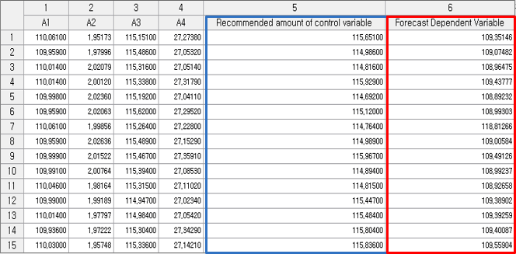

### 3.4.27 RL\_DDPG(Deep Deterministic Policy Gradients)

|  |  |
| --- | --- |
|  | **Deep Deterministic Policy Gradients (DDPGs)** is reinforcement learning algorithm thatpredicts a continuous action. Similar to the Actor-Critic method, it uses one neural network to approximate the policy and another to update the Q function. |

Overview

**DDPG (Deep Deterministic Policy Gradient)** is based on an off-policy, continuous Actor-Critic DPG method, enhanced by the use of deep learning to handle more complex environments and tasks. Similar to Actor-Critic, DDPG utilizes two neural networks: one to approximate the policy (Actor) and the other to estimate the value function (Critic).

**The Actor network** observes the current state of the environment and calculates the optimal actions by following the learned policy. It is responsible for deciding which action to take at any given moment.

**The Critic network** evaluates the behavior output by the Actor using the Q function. The Critic’s loss function is used to update the Critic network, ensuring it accurately evaluates the Actor’s performance.

The Actor network is updated by using feedback from the Critic, which helps it learn a policy that maximizes the long-term reward.

Applications

* An Environmental Model is needed.
* Independent and dependent variable used in **Environmental Model** are required.
* Independent variable can be used for continuous variables in **RL\_DDPG**.
* Dependent variable is not used in **RL\_DDPG**.

Usage

* Read data using **Input Node**.
* Connect Input Node to RL\_DDPG Node and select the options.
* Connect the RL\_DDPG Node to Display Node.
* An example of **RL\_DDPG stream** is as follows.

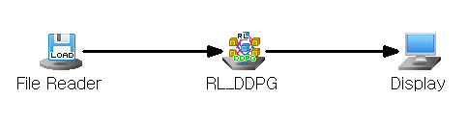

Node Properties

|  |  |  |  |  |
| --- | --- | --- | --- | --- |
| Property group | Property Name | Description | Misc. | Note |
| Model File | Save Model File | Decide whether to save model file. | Required | Yes, No |
| Model File Path | Set the path for the model file to be saved. | Conditionally Required |  |
| Selection options | Model Setting | Select the gms file to load in model. | Required |  |
| Discount Rate(gamma) | Set the discount rate(gamma) for the future reward. | Required | 0<real number <1 |
| Actor Learning Rate | Specify the learning rate for the **Actor network.** | Required | 0<real number <1 |
| Critic Learning Rate | Specify the learning rate of the **Critic neural network.** | Required | 0<real number <1 |
| Epsilon | Specify the probability of choosing actions. When the probability is set to 0, the action with the highest Q-value is selected; when set to 1, actions are chosen completely at random. | Required | 0<real number <1 |
| Epsilon Decay Rate | Specify the decay rate of epsilon. | Required | 0<real number <1 |
| Minimum Epsilon Value | Specify the minimum value of Epsilon. | Required | 0<real number <1 |
| Min Replay Memory Size | Specifies the minimum size of replay memory for starting training. | Required | 0<Integer<N |
| Max Replay Memory Size | Specify the maximum number of samples to be stored in replay memory. | Required | Integer |
| Batch Size | Specify the number of sample batches to extract from memory for training. | Required | Integer |
| Max Episodes | Specify the maximum number of episodes to learn. | Required | Integer |
| Max Steps | Specify the number of maximum steps in an episode. | Required | Integer |
| Target Tolerance | Specify the allowable error margin for the target value when defining the environmental reward. | Required | Integer |
| Batch Normalization | Decide whether to use batch normalization. | Required | Yes, No |
| Set control, target Variable | Specify control and target variables | Required, Button |  |
| Output Layer Activation Function | Specifies the Activation Function of the output layer. |  | Linear, Sigmoid, ReLU, Leaky ReLU, SoftMax |
| Hidden Layer Configuration | Add hidden layer | Add hidden layer. | Optional |  |
| Remove Last Hidden Layer | Remove the last hidden layer | Optional |  |
| Hidden Layer # | Number of nodes | Specify the number of nodes for each specified hidden layer | Required | Integer |
| Activation Function | Select the activation function for the specified hidden layer. | Required | Linear, Sigmoid, ReLU, Leaky ReLU, SoftMax |

Results

The results of the generated variables are displayed using Display Node.

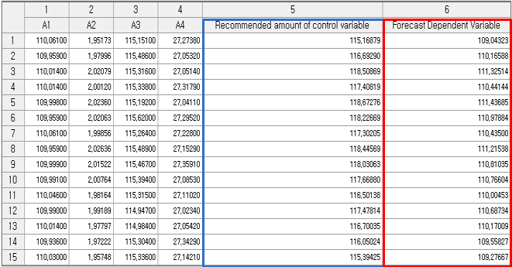

### 3.4.28 RL\_DQN(Deep Q Network)

|  |  |
| --- | --- |
|  | **Deep Q Network (DQN)** is a reinforcement learning algorithm that uses a neural network to perform Q-learning. It works by estimating the value of different actions in a given state and selecting the action with the highest value. |

Overview

Q-learning is a reinforcement learning technique that learns the optimal policy by learning the Q function, which predicts the sum of expected future rewards when a specific action is taken in a given state.

The Q function reflects the concept of policy in the value function, representing the decision of which action the agent will take in a particular state.

Based on the Q function, the agent assigns a Q value for every possible state-action pair. This allows the agent to express the potential reward for the next step by using the Q function. The Q function can be expressed as:

$$\left(Q function\right)=\left(reward\right)+\left(discount rate\right)*\left(next Q function\right)$$

The reward represents the immediate value obtained, the discount rate accounts for the decrease in the value of future rewards, and the next Q function refers to the maximum Q value that can be achieved in the next stage.

DQN (Deep Q-Network) builds on the State-Action-Reward-State-Action (SARSA) algorithm, applying Q-learning at each time step. To update the Q function, the current Q value is adjusted based on the error between the predicted value and the actual outcome, using a one-step sample.

Since the goal of reinforcement learning is maximize cumulative rewards, DQN updates the current Q function by using the maximum possible value of the next Q function to guide the learning process.

Applications

* Independent and dependent variable used in Model Setting are required.
* Independent variable can be either continuous or discrete

Usage

* Read data using Input Node.
* Connect Input Node to RL\_DQN Node and select the options.
* Connect the RL\_DQN Node to Display Node.
* An example of RL\_DQN stream is as follows.

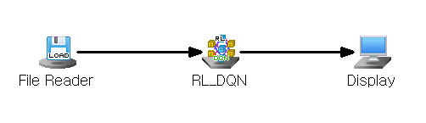

Node Properties

|  |  |  |  |  |
| --- | --- | --- | --- | --- |
| Property group | **Property Name** | **Description** | **Misc.** | **Note** |
| Model File | Save Model File | Decide whether to save model file. | Required | Yes, No |
| Model File Path | Set the path for the model file to be saved. | Conditionally Required |  |
| Selection options | Model Setting | Select the gms file to load as an environment model. | Required |  |
| Discount Rate(gamma) | Set the discount rate(gamma) for the future reward. | Required | 0<real number<1 |
| Learning Rate | Set the learning rate of the neural network. | Required |  |
| Epsilon | Specify the probability of choosing actions randomly. When the probability is set to 0, the action with the highest Q-value is selected; when set to 1, actions are chosen completely at random. | Required | 0<Real number<1 |
| Epsilon Decay Rate | Specify the decay rate of epsilon. | Required | 0<Real number<1 |
| Minimum Epsilon Value | Specify the minimum value of Epsilon. | Required | 0<Real number<1 |
| Min Replay Memory Size | Specify the minimum size of replay memory for starting training. | Required | 0<Integer<N |
| Max Replay Memory Size | Specify the maximum number of samples to be stored in replay memory. | Required | Integer |
| Batch Size | Specify the number of sample batches to extract from memory for training. | Required | Integer |
| Max Episodes | Specify the maximum number of episodes to learn. | Required | Integer |
| Max Steps | Specify the number of Maximum Steps in an episode. | Required | Integer |
| Target variable | Specify the variable that contains the target value for the variable to be controlled. | Required | Discrete variables |
| Target Tolerance | Specify the allowable error margin for the target value when defining the environmental reward. | Required | Integer |
| Target Upper Limit | Specify the condition for ending an episode. The episode ends when the predicted value in the environmental model exceeds the specified value | Required | Integer |
| Target Lower Limit | Specify the condition for ending an episode. The episode ends when the predicted value in the environmental model is below the specified value | Required | Integer |
| Control Variable | Specify the control variables in Environmental Model. | Required |  |
| Control Amount | Specify the Control Amount of the control variable. | Required | Integer |
| Batch Normalization | Decide whether to use batch normalization. | Required | Yes, No |
| Output Layer Activation Function | Specifies the Activation Function of the output layer. | Required | Linear, Sigmoid, ReLU, Leaky ReLU, SoftMax |
| Hidden Layer Configuration | Add Hidden Layer | Add hidden layer | Optional |  |
| Remove Last Hidden Layer | Remove the last hidden layer. | Optional |  |
| Hidden Layer # | Number of nodes | Specify the number of nodes for each specified hidden layer. | Required | Integer |
| Activation Function | Select the activation function for the specified hidden layer. | Required | Linear, Sigmoid, ReLU, Leaky ReLU, SoftMax |

Results

The results of the generated variables are displayed using Display Node.

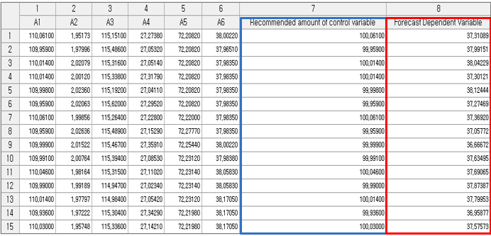

### 3.4.29 RL\_PPO(Proximal Policy Optimization)

|  |  |
| --- | --- |
|  | **Proximal Policy Optimization (PPO)** is a reinforcement learning algorithm that uses clipping mechanism to limit the difference between the old and new policies, ensuring updates happen gradually. This allows for more stable and controlled policy improvements compared to traditional reinforcement learning algorithms. |

Overview

In Actor-Critic methods, even small changes to the policy parameters can lead to large shifts in the policy itself. Proximal Policy Optimization (PPO) addresses this by applying constraints to ensure that policy updates happen more gradually.

PPO uses a clipping mechanism to keep the ratio between the old and new policies within a set range, preventing excessive changes. As a result, PPO ensures that policy updates remain stable and controlled within these constraints.

Applications

* An Environmental Model is needed.
* Independent and dependent variable used in Environmental Model are required.
* Independent variable can be either continuous or discrete.
* Dependent variable is not used in PPO.

Usage

* Read data using Input Node.
* Connect Input Node to RL\_PPO Node and select the options.
* Connect the RL\_PPO Node to Display Node.
* An example of RL\_PPO stream is as follows.

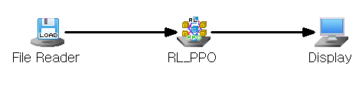

Node Properties

|  |  |  |  |  |
| --- | --- | --- | --- | --- |
| Property group | Property Name | Description | Misc. | Note |
| Model File | Save Model File | Decide whether to save model file. | Required | Yes, No |
| Model File Path | Set the path for the model file to be saved. | Conditionally Required |  |
| Selection options | Model Setting | Select the gms file to load as an environment model. | Required |  |
| Discount Rate(gamma) | Set the discount rate(gamma) for the future reward. | Required | 0<real number <1 |
| Actor Learning Rate | Specify the Learning Rate for the Actor neural network. | Required | 0<real number <1 |
| Critic Learning Rate | Specify the learning rate of the Critic neural network. | Required | 0<real number <1 |
| Lambda | Specify the Lambda value. Lambda controls the balance between bias and variance in advantage estimation, where higher values lead to more accurate estimates with increased variability. | Required | 0<real number <1 |
| Learning Epoch | Specify the number of epochs. | Required | Integer |
| Clip value | Specify the Clipping value for the Loss Function. | Required | Real number |
| Batch Size | Specify the number of sample batches to extract from memory for training. | Required | Integer |
| Max Episodes | Specify the maximum number of episodes to learn. | Required | Integer |
| Max Steps | Specify the number of maximum steps in an episode. | Required | Integer |
| Target Tolerance | Specify the allowable error margin for the target value when defining the environmental reward. | Required | Integer |
| Batch Normalization | Decide whether to use batch normalization. | Required | Yes, No |
| Set control, target Variable | Specify control and target variables | Required, Button |  |
| Output Layer Activation Function | Specifies the Activation Function of the output layer. | Required | Linear, Sigmoid, ReLU, Leaky ReLU, SoftMax |
| Hidden Layer Configuration | Add hidden layer | Add hidden layer. | Optional |  |
| Remove Last Hidden Layer | Remove the last hidden layer | Optional |  |
| Hidden Layer # | Number of nodes | Specify the number of nodes for each specified hidden layer | Required | Integer |
| Activation Function | Select the activation function for the specified hidden layer. | Required | Linear, Sigmoid, ReLU, Leaky ReLU, SoftMax |

Results

The results of the generated variables are displayed using Display Node.

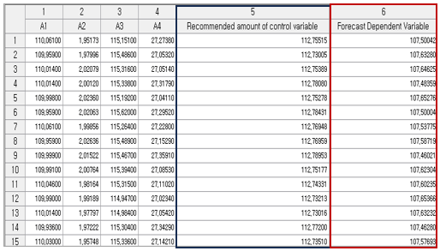

### 3.4.30 RL\_PG(Policy Gradient)

|  |  |
| --- | --- |
|  | **Policy Gradient (PG)** is a reinforcement learning algorithm that helps a system learn the best actions to take by gradually improving its decisions. |

Overview

The Policy Gradient algorithm is a reinforcement learning approach that directly optimizes the policy to maximize rewards, instead of relying on the value function. This method aims to achieve the maximum reward by optimizing an objective function, which is the sum of the expected rewards along a given path.

In policy-based reinforcement learning, the goal is to adjust the policy to maximize this objective function. This is done by updating the neural network parameters in the direction that increases the objective function, a process known as Gradient Ascent.

The gradient of the objective function is called the Policy Gradient.

The objective function can be adjusted by introducing a discount factor to the rewards. Policy Gradient training often uses the Monte-Carlo method, where the policy is updated after each complete episode, a process known as Monte-Carlo Policy Gradient training.

Applications

* The independent variable in the RL\_PG Node, representing the state or observation, can be either continuous or discrete.

Usage

* Read data using Input Node.
* Connect Input Node to RL\_PG Node and select the options.
* Connect RL\_PG Node to Display Node
* An example of RL\_PG stream is as follows.

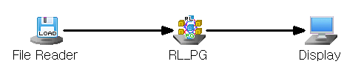

Node Properties

|  |  |  |  |  |
| --- | --- | --- | --- | --- |
| Property group | Property Name | Description | Misc. | Note |
| Model File | Save Model File | Decide whether to save model file. | Required | Yes, No |
| Model File Path | Set the path for the model file to be saved. | Conditionally Required |  |
| Selection options | Model Setting | Select the gms file to load as an environment model | Required |  |
| Discount Rate(gamma) | Set the discount rate(gamma) for the future reward. | Required | 0<real number<1 |
| Learning Rate | Set the learning rate of the neural network. | Required | 0<real number<1 |
| Max Episodes | Specify the maximum number of episodes to learn. | Required | Integer |
| Max Steps | Specify the maximum number of steps in an episode. | Required | Integer |
| Target variable | Specify the value for the variable to be controlled. | Required | Discrete Variables |
| Target Tolerance | Specify the allowable error margin for the target value when defining the environmental reward. | Required | Integer |
| Target Upper Limit | Specify the condition for ending an episode. The episode ends when the predicted value in the environmental model exceeds the specified value | Required | Real Number |
| Target Lower Limit | Specify the condition for ending an episode. The episode ends when the predicted value in the environmental model is below the specified value | Required | Real Number |
| Control Variable | Specify the control variables | Required |  |
| Control Amount | Specify the amount of control for the control variable. | Required | Integer |
| Batch Normalization | Decide whether to use batch normalization. | Required | Yes, No |
| Output Layer Activation Function | Specify the activation function for the output layer. | Required | Linear, Sigmoid, ReLU, Leaky ReLU, SoftMax |
| Hidden Layer Configuration | Add Hidden Layer | Add a hidden layer. | Optional |  |
| Remove Last Hidden Layer | Remove the last hidden layer. | Optional |  |
| Hidden Layer # | Number of nodes | Specify the number of nodes for each specified hidden layer. | Required | natural number |
| Activation Function | Select the activation function for the specified hidden layer. | Required | Linear, Sigmoid, ReLU, Leaky ReLU, SoftMax |

Results

The analysis results are displayed using Display Node.

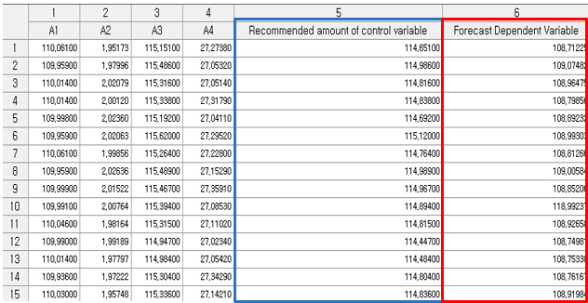

### 3.4.31 RL\_TD3(Twin Delayed DDPG)

|  |  |
| --- | --- |
|  | **Twin Delayed DDPG (TD3**) is a reinforcement learning algorithm that uses two Critic Networks to improve stability and prevent overestimation errors, offering more reliable learning compared to the single Critic Network used in DDPG. |

Overview

Twin Delayed DDPG(TD3) is a reinforcement learning algorithm designed to address the instability and overestimation issues in DDPG. Unlike DDPG, TD3 uses two Critic Networks and updates them by taking the minimum of Q-value from both, leading to more stable approximation. While the Critic Networks are updated at every step, the Actor Network is updated less frequently, after a set number of steps, which reduces policy changes and makes the learning process more stable.

Applications

* An Environmental Model is needed.
* Independent and dependent variable used in Environmental Model are required.
* Independent variable can be either continuous or discrete.
* Dependent variable is not used.

Usage

* Read data using Input Node.
* Connect Input Node to RL\_TD3 Node and select the options.
* Connect the RL\_TD3 Node to Display Node.
* An example of RL\_TD3 stream is as follows.

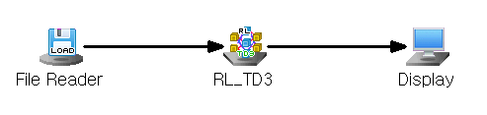

Node Properties

|  |  |  |  |  |
| --- | --- | --- | --- | --- |
| Property group | Property Name | Description | Misc. | Note |
| Model File | Save Model File | Decide whether to save model file. | Required | Yes, No |
| Model File Path | Set the path for the model file to be saved. | Conditionally Required |  |
| Selection options | Model Setting | Select the gms file to load in model | Required |  |
| Policy Delay | Specify the update frequency for the Actor network. | Required | Integer |
| Action Clip Value | Specify the target policy smoothing constant value. | Required | Real number |
| Discount Rate(gamma) | Set the discount rate(gamma) for the future reward. | Required | 0<real number <1 |
| Actor Learning Rate | Specify the Learning Rate for the Actor neural network. | Required | Real number |
| Critic Learning Rate | Specify the learning rate of the Critic neural network. | Required | Real number |
| Epsilon | Specify the probability of choosing actions randomly. When the probability is set to 0, the action with the highest Q-value is selected; when set to 1, actions are chosen completely at random. | Required | 0<real number <1 |
| Epsilon Decay Rate | Specifies the decay rate of Epsilon. | Required | 0<real number <1 |
| Minimum Epsilon Value | Specifies the minimum value of Epsilon. | Required | 0<real number <1 |
| Min Replay Memory Size | Specify the minimum size of replay memory for starting training. | Required | 0<Integer<N |
| Max Replay Memory Size | Specify the maximum number of samples to be stored in replay memory. | Required | Integer |
| Batch Size | Specify the number of sample batches to extract from memory for training. | Required | Integer |
| Max Episodes | Specify the maximum number of episodes to learn. | Required | Integer |
| Max Steps | Specify the number of maximum steps in an episode. | Required | Integer |
| Target Tolerance | Specify the allowable error margin for the target value when defining the environmental reward. | Required | Integer |
| Batch Normalization | Decide whether to use batch normalization. | Required | Yes, No |
| Set control, target Variables | Specify control and target variables**.** | Required, Button |  |
| Output Layer Activation Function | Specifies the Activation Function of the output layer. | Required | Linear, Sigmoid, ReLU, Leaky ReLU, SoftMax |
| Hidden Layer Configuration | Add hidden layer | Add hidden layer. | Optional |  |
| Remove Last Hidden Layer | Remove the last hidden layer | Optional |  |
| Hidden Layer # | Number of nodes | Specify the number of nodes for each specified hidden layer | Required | Integer |
| Activation Function | Select the activation function for the specified hidden layer. | Required | Linear, Sigmoid, ReLU, Leaky ReLU, SoftMax |

Results

The analysis results are displayed using Display Node.

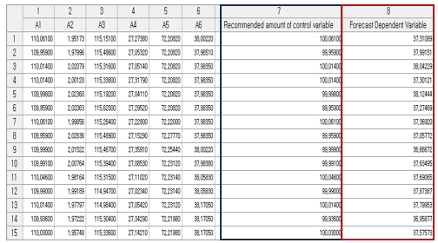

### 3.4.32 RL\_SAC(Soft Actor-Critic)

|  |  |
| --- | --- |
|  | **Soft Actor-Critic (SAC)** is a reinforcement learning algorithm that promotes action diversity by incorporating entropy into the value function. |

Overview

**Soft Actor-Critic (SAC)** is a reinforcement learning algorithm that addresses the issue of biased action selection in traditional Actor-Critic methods. In traditional Actor-Critic, as the training progresses, actions tend to become biased toward certain choices. To prevent this, SAC incorporates entropy into the value function, encouraging more diverse action selection throughout training.

Applications

* An Environmental Model is needed.
* Independent and dependent variable used in Environmental Model are required.
* Independent variable can be either continuous or discrete.
* Dependent variable is not used in RL\_SAC.

Usage

* Read data using Input Node.
* Connect Input Node to RL\_SAC Node and select the options.
* Connect RL\_SAC Node to Display Node.
* An example of RL\_SAC stream is as follows.

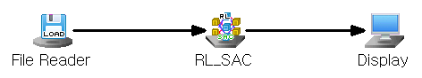

Node Properties

|  |  |  |  |  |
| --- | --- | --- | --- | --- |
| Property group | Property Name | Description | Misc. | Note |
| Model File | Save Model File | Decide whether to save model file. | Required | Yes, No |
| Model File Path | Set the path for the model file to be saved. | Conditionally Required |  |
| Selection options | Model Setting | Select the gms file to load as an environment model. | Required |  |
| Actor Policy | Specify policy for the actor neural network. | Required | Gaussian  Deterministic |
| Actor Learning Rate | Specify the learning rate for the Actor neural network. | Required | Real number |
| Critic Learning Rate | Specify the learning rate for the Critic neural network. | Required | Real number |
| Discount Rate(gamma) | Set the discount rate(gamma) for the future reward. | Required | 0<real number<1 |
| Max Replay Memory Size | Specify the maximum number of samples to be stored in replay memory. | Required | Integer |
| Batch Size | Specify the number of sample batches to extract from memory for training. | Required | Integer |
| Target Neural Network Update | Specify the interval of episodes for updating the target neural network. | Required | Integer |
| Max Episodes | Specify the maximum number of episodes to learn. | Required | Integer |
| Max Steps | Specify the number of maximum steps in an episode. | Required | Integer |
| Target Tolerance | Specify the allowable error margin for the target value when defining the environmental reward. | Required | Integer |
| Batch Normalization | Decide whether to use batch normalization. | Required | Yes, No |
| Set control, target Variable | Specify control and target variables. | Required, Button |  |
| Output Layer Activation Function | Specifies the Activation Function of the output layer. | Required |  |
| Hidden Layer Configuration | Add hidden layer | Add hidden layer. | Optional |  |
| Remove Last Hidden Layer | Remove the last hidden layer | Optional |  |
| Hidden Layer # | Number of nodes | Specify the number of nodes for each specified hidden layer | Required | Integer |
| Activation Function | Select the activation function for the specified hidden layer. | Required |  |

Results

The results of the generated variables are displayed using Display Node.

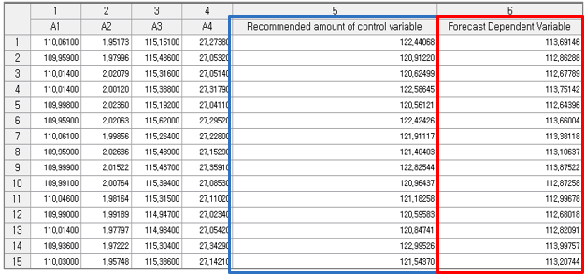

### 3.4.33 ScoreCard

|  |  |
| --- | --- |
|  | **Scorecard** is a modeling method that uses the logistic regression algorithm to calculate the impact of independent variables on the dependent variable (Discrete Type) in the form of a score. This modeling method allows to easily understand the influence of independent variables. It is commonly used in the financial sector for evaluating customer credit scores. |

Overview

Scorecard uses the methodology of logistic regression analysis. In order to perform the scorecard function, it is necessary to first divide variables into bins using a binning node. With these binned variables, you can create a scorecard using the Scorecard node.

Applications

* ECL file which set dependent variable is required in order to use Binning Node.
* The dependent variable must be discrete and has two classes.
* Scorecard algorithm can only accept discrete variables.

Usage

* Read data using Input Node.
* Change the type of data to discrete variable and set dependent and independent variables by using Type Change Node.
* Use Binning Node to create interval variables with independents.
* Use Column Filter Node to exclude variables other than interval variables and dependent variable.
* Create a Scorecard using ScoreCard Node.

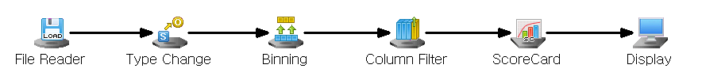

Node Properties

|  |  |  |  |  |
| --- | --- | --- | --- | --- |
| Property group | Property Name | Description | Misc. | Note |
| Model File | Save Model File | Decide whether to save model file. | Required | Yes, No |
| Model File Path | Set the path for the model file to be saved. | Conditionally Required |  |
| Selection options | Maximum Run Count | Determine the maximum number of iterations when maximum likelihood Estimate for logistic regression analysis. | Required |  |
| Maximum Value | Set the Maximum Value of Score. | Required |  |
| Minimum Value | Set the Minimum Value of the Score. | Required |  |

Results

The predicted class, the predicted probability, and the score values can be viewed through Display Node.

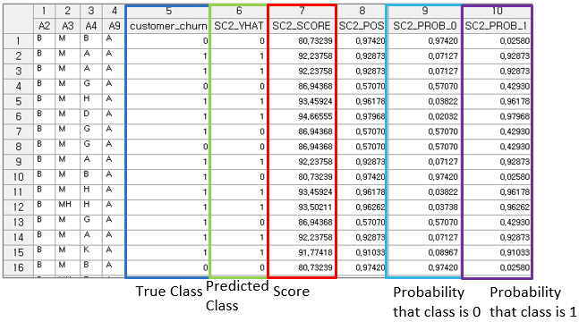

Modeling Result

Click **Modeling Result** in Node Property of **Model node** to view the results.

* Number of Classes and Number of Classes

Determine the number of classes of the dependent variable and the total number of iterations the algorithm has executed

* Y Value

Shows the frequency and ratio of dependent variable Y by class.

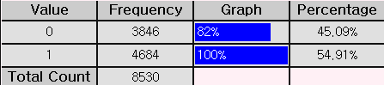

* Logistic Table

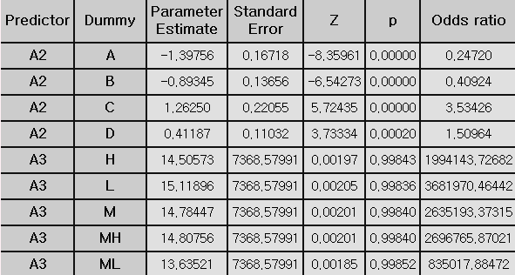

**Parameter Estimate**: The coefficient value of each variable

**Standard Error:** The standard error of each coefficient (Beta).

**z-value:** The number of standard deviations a data point (or estimate) is from the mean. In regression analysis, the z-value measures how significant a regression coefficient is relative to its standard error. It is used to assess the statistical significance of a predictor variable.

**p-value:** The probability that the observed effect occurred by random chance. Typically, if the P-value is less than the significance level, the variable is considered statistically significant.

**Odds Ratio:** A value that indicates the degree of influence of input variables on the classification decision. An odds ratio less than 1 means that the input variable xi has a negative influence, and an odds ratio greater than 1 means that the input variable xi has a positive influence.

* Score Table

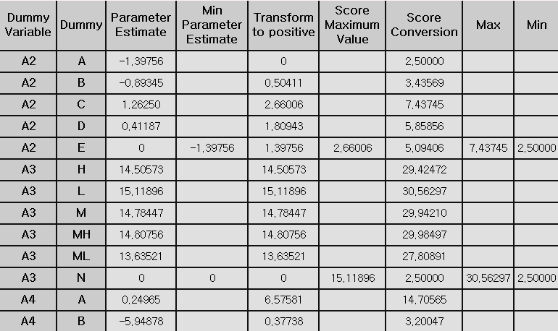

The results of the logistic regression analysis can be easily interpreted through the score table.

* Confusion Matrix

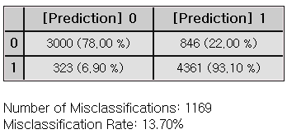

Example File

* Run the **ScoreCard.ecm**

### 3.4.34 Sequential AR

|  |  |
| --- | --- |
|  | **Sequential AR** is a technique used to discover relationships between products or services over time and find meaningful rules from them. |

Overview

**Sequential Association Rules (Sequential AR)** extend the capabilities of traditional Association Rules (AR) by incorporating the temporal order of events. Like AR, it is an exploratory data analysis method used to identify meaningful correlations or relationships within a dataset. However, Sequential AR focuses specifically on patterns that occur in sequence, making it particularly useful for analyzing behaviors or events regarding time.

Applications

* Both continuous and discrete data type is allowed.
* Variables must consist of only three variables in the following order: customer ID (CID), time (TID), and product (ITEMID). An example of the data file is shown below.

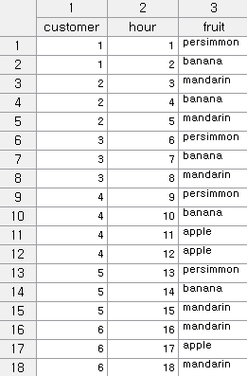

Usage

* Read data using Input Node.
* Connect Input Node to Sequential AR Node select the options.
* Connect Sequential AR Node to Display Node.
* An example of Sequential AR stream is as follows.

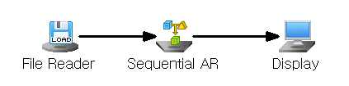

Node Properties

|  |  |  |  |  |
| --- | --- | --- | --- | --- |
| Property group | Property Name | Description | Misc. | Note |
| Model File | Save Model File | Decide whether to save model file. | Required | Yes, No |
| Model File Path | Set the path for the model file to be saved. | Conditionally Required |  |
| Selection options | Min Support | Set the minimum support value  (default value is 0.5) | Required | Natural Number |
| Max Itemsize | Maximum itemset size  The algorithm will generate itemsets of all possible lengths (starting from 1 itemset up to the maximum possible length) | Required | >1 |
| Min Confidence | Minimum confidence value  (default value is 0.5) | Required | 0-1 |

Modeling Result

Click Modeling Result in Node Property of Model node to view the results.

* Model Info



* Associated rule information

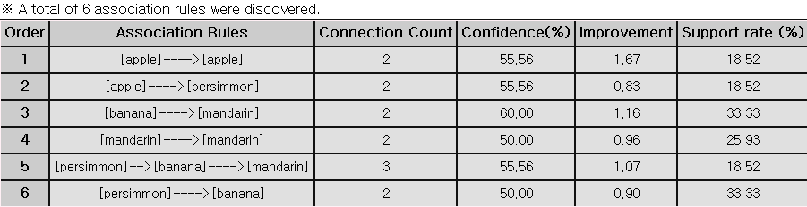

* Association Rules

[A->B] means “If product A is purchased, product B is also purchased.”

* Connection Count

The total number of items that define an association.

* Confidence (%)

The degree of correlation. The probability that item B will be included in a transaction containing item A.

$$\left(\frac{Proportion of transactions containing both A and B=\text{Pr}(A∩B)}{Percentage of transactions containing A=\operatorname{Pr}{(}A)}\right)$$

* Improvement(lift)

The ratio of when item A is purchased and that transaction includes item B compared to when item B is purchased randomly.



* Support rate (%)

The number of transactions containing A and B is described as the value obtained by dividing that number by the total number of transactions.

Guide

1. In association analysis, the support (basic purchase rate) must reach a certain threshold to be considered meaningful. 2. Lift is considered meaningful when its value exceeds 1.

Example File

* Run the “**AR.ecm**“

### 3.4.35 SimpleRNN

|  |  |
| --- | --- |
|  | **RNN (Recurrent Neural Network)** is a neural network designed for sequential data, like time series, by using previous steps to inform the current step. |

Overview

SimpleRNN is a type of recurrent neural network, which is an artificial neural network with two or more hidden layers. While the original form of this recurrent neural network is DeepRNN, SimpleRNN features a simpler structure with up to three hidden layers. Each hidden layer includes a context layer, which helps the network remember previous states.

The context layer has the same number of nodes as the hidden layer and retains the state values of the hidden layer through the recurrent feedback. To generate predictions for each time step, SimpleRNN calculates the influence of independence at the previous time points and uses it for prediction. This makes it a supervised neural network, suitable for a variety of applications.

Applications

* Both independent and target variables must be continuous.
* Since the target is continuous, it is a predictive model. The activation function is fixed to the identity function.
* SimpleRNN supports up to 3 hidden layers.
* SimpleRNN allows setting the number of nodes for each hidden layer.

Usage

* Read data using Input Node.
* Specify the type of data using Type Change Node. (independent, or target)
* Connect Type Change Node to SimpleRNN Node and select the options.
* Connect SimpleRNN Node to Display Node.
* An example of SimpleRNN stream is shown below.

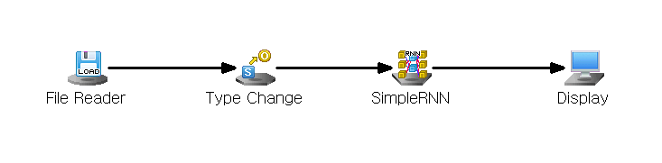

Node Properties

|  |  |  |  |  |
| --- | --- | --- | --- | --- |
| Property group | Property Name | Description | Misc. | Note |
| Model File | Save Model File | Decide whether to save model file. | Required | Yes, No |
| Model File Path | Set the path for the model file to be saved. | Conditionally Required |  |
| Selection options | Number of hidden layers | Enter the number of hidden layers. | Required | Integer ≤ 3 |
| Number of Nodes of hidden layers #1 | Enter the number of nodes in the first hidden layer. | Required | Integer ≤ 100 |
| Number of Nodes of hidden layers #2 | Enter the number of nodes in the second hidden layer. | Conditionally Required | Integer ≤ 100 |
| Number of Nodes of hidden layers #3 | Enter the number of nodes in the third hidden layer. | Conditionally Required | Integer ≤ 100 |
| Hidden Layer Activation Function | Specifies the activation function of the hidden layer. | Required | ReLU, Tanh, Sigmoid |
| Weighting Initialization Specification | Set the initial weight setting method for the neural network. | Required | Xavier, He, Custom |
| Weighting Initialization Standard Deviation | Set the standard deviation of the initial weight values of the neural network. | Conditionally Required | 0.001≤real number≤100 |
| Number of Epochs | Specifies the maximum Number of Epochs for algorithm execution. | Required | natural number |
| Target Error | Specifies the maximum allowable target error for training. | Required | 0≤real number |
| Optimization Technique | Select Optimization Technique. | Required | SGD with Momentum, RMSProp, ADAM |
| Learning Rate | When calculating the weight for the gradient direction during learning, enter the size of the degree of reflection of the direction from the previous step. | Required | 0≤real number≤1 |
| Momentum | In Gradient descent with momentum Optimization Technique, we set the degree to which the weight reflects the existing direction of movement. | Conditionally Required | 0≤real number≤1 |
| Beta1 | In ADAM Optimization Technique, sets the degree to which the weight reflects the existing direction of movement. | Conditionally Required | 0≤real number≤1 |
| Beta2 | Sets the rate at which ADAM Optimization Technique remembers previously updated weights. | Conditionally Required | 0≤real number≤1 |
| Gamma | Sets the rate at which previously updated weights are remembered in the RMSProp Optimization Technique. | Conditionally Required | 0≤real number≤1 |
| Batch Size | Specifies the Batch Size to be used when performing the BPTT algorithm for learning. | Required | Integer ≤ 200 |
| Batch-Wise Method for Setting Initial Hidden Layer Value | Select how to set the initial state of the hidden layer for each batch. | Required | Stateful, Stateless |
| Batch-Wise Initial Hidden Layer Value | If you select Stateless as the method for setting the initial state of the hidden layer, enter the initial state setting value of the hidden layer for each batch. | Conditionally Required | 0≤real number≤1 |
| Dropout | If you select Stateless as the method for setting the initial state of the hidden layer, enter the initial state setting value of the hidden layer for each batch. | Required | Use, Not use |
| Dropout Proportion | If you want to use Dropout, set the ratio to apply it. | Conditionally Required | 0≤real number≤1 |
| Learning Log | Sets the iteration frequency for displaying learning logs. |  |  |

Results

Prediction analysis results are displayed using Display Node.



Graphic result

Click **Graphic Result** in Node Property of **Model node** to view the charts. The results can also be viewed in the **Modeling Result** of **Model node**.

* RMSE Plot

Monitor the change in error rate (learning rate) according to the number of repetitions during the model learning process.

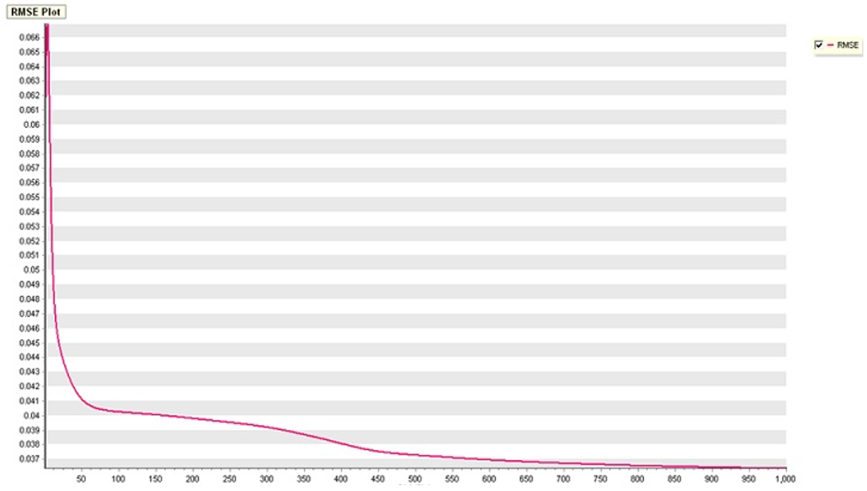

* Compare Plot

Compare the distribution of actual values and values predicted by the model.

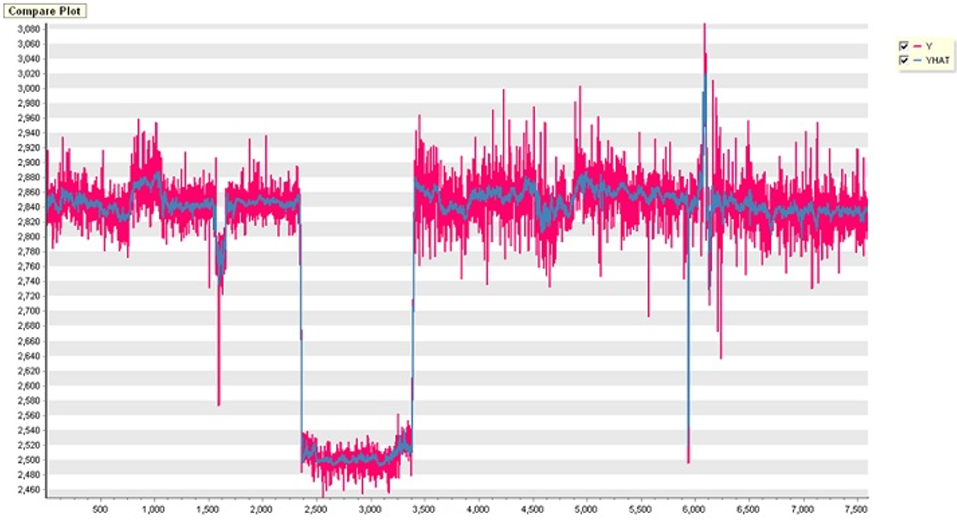

* Residual Plot

Examine the residual between the actual value and the predicted values generated by the model.

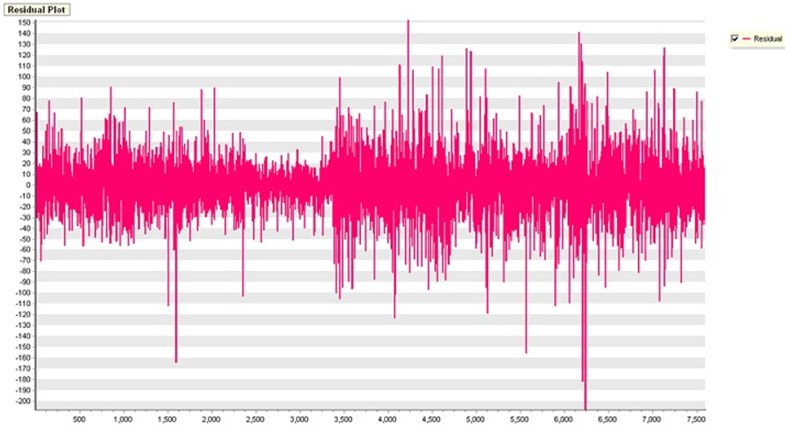

Modeling Result

Click **Modeling Result** button in Node Property of **Model node** to view the analysis results.

* Error information about dependent variable

Provides ANOVA Table and Standard Error information.



### 3.4.36 SOM

|  |  |
| --- | --- |
|  | **Self-Organizing Map (SOM)** is aneural network algorithm inspired by the structure of the human cerebral cortex, where different regions perform specific functions. SOMs allow high-dimensional data to be visualized and interpreted in lower-dimensional spaces. |

Overview

**A Self Organizing Map (SOM)**, also known as a Self-Organizing Feature Map, is a type of neural network inspired by how the visual cortex in the brain works. It’s an unsupervised learning method used for clustering data and visualizing it by reducing dimensions.

SOMs learn by themselves and generate low-dimensional (usually two-dimensional) maps. These maps provide a simplified version of the input data while trying to maintain the structure and relationships found in the original high-dimensional space. SOMs are great for converting complex, high-dimensional data into simpler, more visual forms.

SOM operates in two phases: training and mapping. Training involves creating the map using input data, which is done through competitive process called vector quantization. Mapping is when new data is automatically categorized based on the training results.

Applications

* Only independent variables. Variables must be continuous.
* SOM node includes a standardized pre-processing procedure.

Usage

* Read data using Input Node.
* Connect Input Node to SOM Node and select the options.
* Connect SOM Node to Display Node.
* An example of SOM stream is shown below.

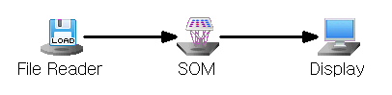

Node Properties

|  |  |  |  |  |
| --- | --- | --- | --- | --- |
| Property group | Property Name | Description | Misc. | Note |
| Model File | Save Model File | Decide whether to save model file. | Required | Yes, No |
| Model File Path | Set the path for the model file to be saved. | Conditionally Required |  |
| Selection options | Number of Horizontal Grid Points | Enter the number of horizontal grids in the topology. | Required | Natural Number |
| Number of Vertical Grid Points | Enter the number of vertical grids in the topology. | Required | Natural Number |
| Maximum Iteration Count | Enter the maximum number of iterations for the algorithm. | Required |  |
| Topology Selection | There are two topologies available: Choose a topology between Hexagonal and Grid. | Required | Grid, Hexagonal |
| Initial Learning Rate | As the algorithm repeats, the Learning Rate continues to decrease. Enter the learning rate value used when training starts. | Required |  |
| Initial Neighbor Radus | As the algorithm iterates, the value of the neighborhood radius becomes continuously smaller. Be sure to enter a value for the neighborhood radius that Training will use when it starts. | Required |  |

Results

The analysis results are displayed using Display Node. It is possible to identify the group to which each data belongs.

**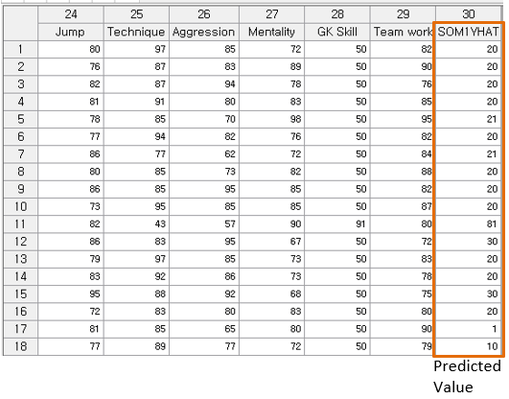**

Graphic Result

Click **Graphic Result** button in Node Property of **Model node** to view the charts. The results can also be viewed in the **Modeling Result** of **Model node**.

* SOM Weight Position Chart

Displays the arrangement of weights in space and illustrates the connections between each weight.

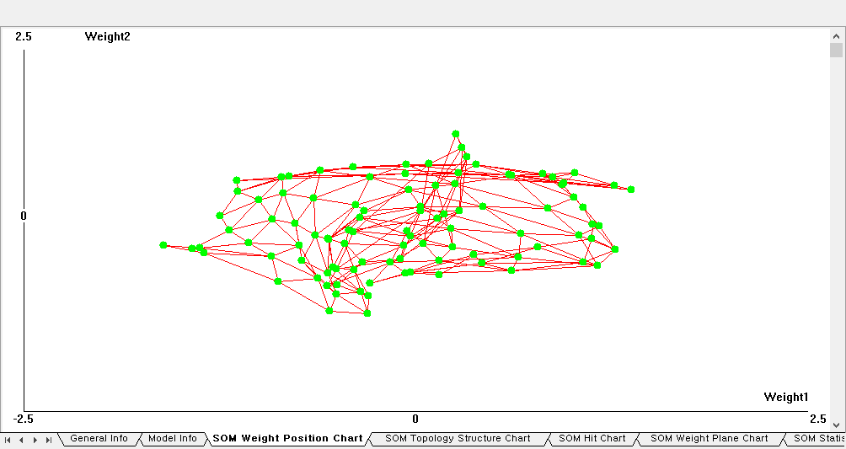

* SOM Topology Structure Chart

Displays the topology's structure. The example below illustrates a visualization of a hexagonal structure.

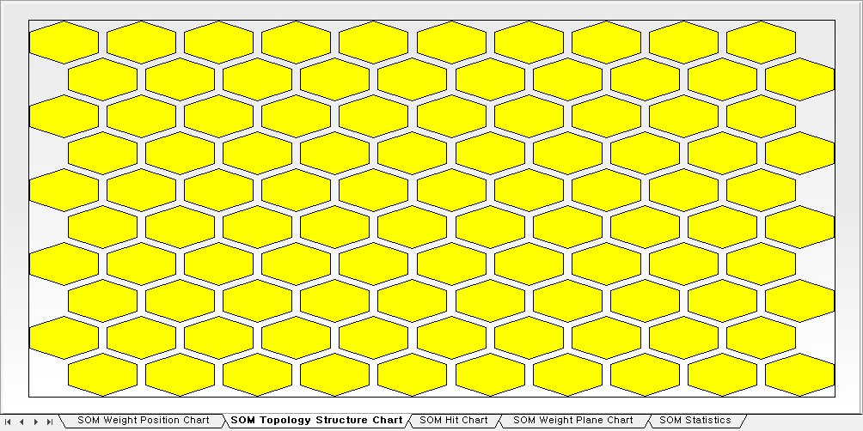

* SOM Hit Chart

Displays how many data points are closest to each group.

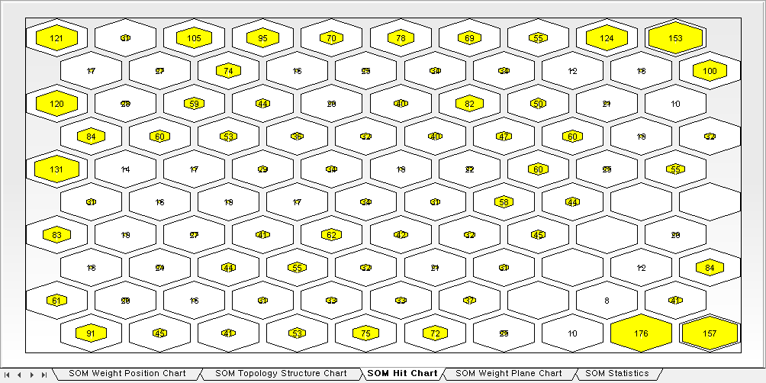

* SOM Weight Plane Chart

Displays the value of each weight component. Weight 1 refers to the first component of the Weight Vector. In Topology, a higher value for each weight component (in this case, the first component) corresponds to a lighter color, while a lower value results in a darker color. In the ECMiner™ SOM, if the component value of the weight is greater than 0 based on the red color, it will appear closer to yellow, while values less than 0 will appear closer to black.

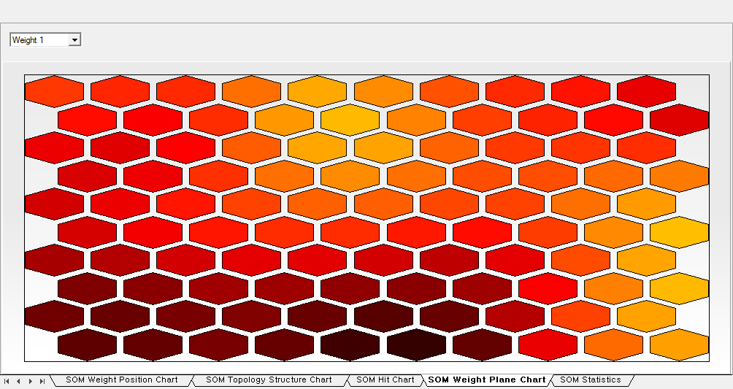

* SOM Statistics

This statistic displays component values of the Weight Vector positioned on the topology, along with the corresponding horizontal and vertical grid order indicated by SOM\_YHAT.

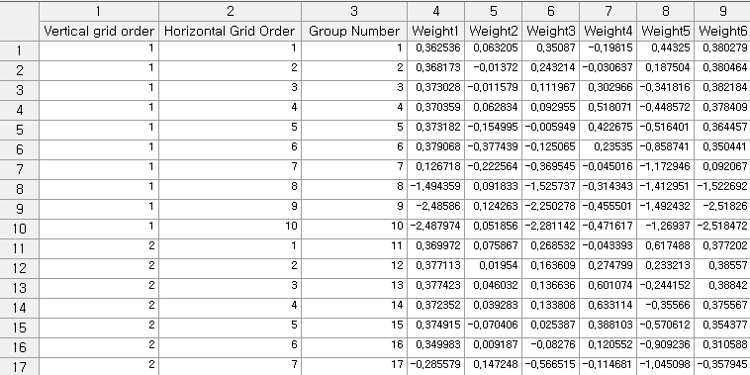

Example File

* Run SOM.ecm

### 3.4.37 SVC

|  |  |
| --- | --- |
|  | **Support Vector Classification (SVC)** is based on the Support Vector Machine theory that classifies data with multiple attributes or variables into one of the predetermined classes or categories. |

Overview

SVC is a supervised machine learning algorithm that finds the optimal hyperplane to maximize the margin between classes for classification. When linear separable vector is not easy, kernel function to transform the data into high-dimensional space for easy separable boundary as shown the below figure.

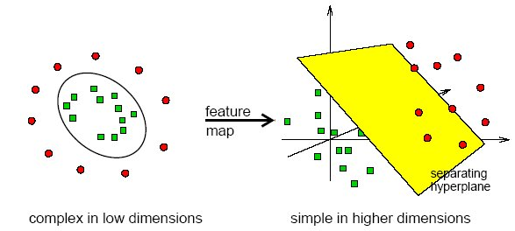

**1. Kernel function for SVC**

The types of kernel functions are **LINEAR, POLY, RBF,** and **SIGMOID** which can be selected in the **Kernel Type** option.

Depending on the type of kernel selected, there are different options that need to be set.

* LINEAR

It is used a linearly separable data. No options need to be set.



* POLY (polynomial)

The primary parameter that controls the complexity of the polynomial function is the **degree** parameter.  
**Degree**: default=3, set the degree value.

  
**Gamma (optional)**: scaling factor default=0. It is calculated as **1 / (n\_features \* X.var())  
Ceof0 (optional):** constant term. Default=scale

* RBF (Radial Basis Function)

The Gaussian kernel which is non-linear kernel

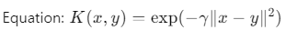  
**Gamma**: width of the Gaussian function

* SIGMOID

It is similar to a neural network’s activation function.

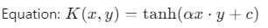  
**Gamma**: scaling factor   
**Coef0**: constant term that shifts the boundary

**2. Regularization parameter for SVC**

The **SVC** uses a regularization parameter *C* to control the trade-off. C is the most important parameter with kernel function. The C parameter controls the trade-off between maximizing the margin and minimizing classification errors. A smaller C value will lead to a wider margin (but may result in more misclassifications), while a larger C will classify all training examples correctly (potentially at the cost of overfitting). C is typically set within a range from a **small positive value (e.g., 0.01 or 0.1)** to **a reasonably large value. Default is 1.**

**3. Degree & Gamma**

Degree of the polynomial kernel function (used only when **kernel='poly'**).

Gamma is a kernel coefficient for ‘rbf’, ‘poly’, and ‘sigmoid’ kernels. **Default is 1.**

**4. Coeff**

For ‘poly’ and ‘sigmoid’, Coeff is set to define.

Applications

* Independent variables must be continuous.
* Dependent variable must be discrete.

Usage

* Read the data using Input Node.
* Specify the type of data using the Type Change Node.
* Connect Type Change Node to SVC Node and select the options.
* Connect SVC Node to Display Node.
* An example of SVC stream is shown below.

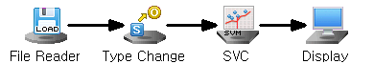

Node Properties

|  |  |  |  |  |
| --- | --- | --- | --- | --- |
| Property group | Property Name | Description | Misc. | Note |
| Model File | Save Model File | Decide whether to save model file. | Required | Yes, No |
| Model File Path | Set the path for the model file to be saved. | Conditionally Required |  |
| Selection options | Type | Select the type of SVC algorithm. | Required | SVC(C), SVC(Nu) |
| Kernel Type | Select the kernel function. | Required | LINEAR, POLY, RBF, SIGMOID |
| Degree | Set the degree of the polynomial kernel if Kernel Type is POLY. Default is 3 | Optional |  |
| Gamma | Set the scaling factor of the kernel if Kernel Type is either POLY, RBF, or SIGMOID. | Optional |  |
| Coef0 | Set the constant term of the kernel if Kernel Type is either POLY or SIGMOID. | Optional |  |
| Nu | Set the Nu value of the SVC(Nu) if Type is SVC(Nu). | Optional | **(**0<Nu≤1) |
| C | The parameter C controls how much you want to avoid misclassifying. Set the C value of the SVC if Type is SVC(C). Default is 1 | Optional |  |
| Optimal Parameter Estimation | Estimate the optimal Nu and C values. | Required | Yes, No |

Results

Classification analysis results are displayed using Display Node.

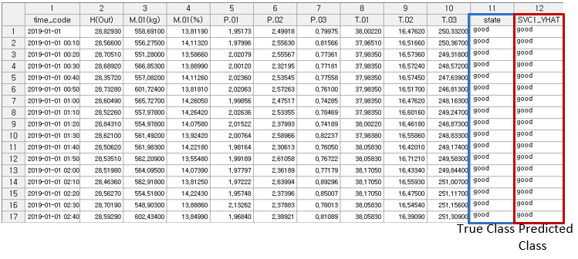

Modeling Result

Click **Modeling Result** button in Node Property of **Model node** to view the analysis results.

* Option Information

It shows which options were used when modeling using SVC.

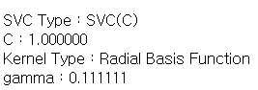

* Confusion Matrix

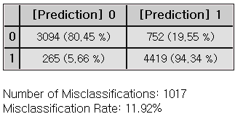

Example File

* Run the SVC.ecm

### 3.4.38 SVR

|  |  |
| --- | --- |
|  | **Support Vector Regression (SVR)** is a regression analysis technique that implies the principles of the SVM algorithms. It is used to determine the degree and the direction of the influence of one are more variables on another variable. |

Overview

SVR(Nu) ($ν$-Support Vector Regression) and SVR(Epsilon) ($ϵ$-Support Vector Regression) are two different variants of Support Vector Regression (SVR), and they differ in how they control the trade-off between margin size and errors. Both methods are commonly used for regression tasks, but they offer different parameters to manage the model's complexity and error tolerance.

**(1) SVR(Epsilon):** The ε parameter controls the size of the margin where errors are not penalized. The trade-off between margin size and errors is handled by the **C** parameter, which acts as a regularization parameter (penalty for large errors).

**(2) SVR(Nu)**: The $ν$ parameter controls both the fraction of support vectors (data points used to build the model) and the number of margin violations. This offers a more direct way to control model complexity and outliers.

The **SVR(Epsilon)** sets the margin of tolerance as 𝜖, where deviations within this margin are not penalized. The 𝜖 is a threshold value that determines the width of the "Epsilon tube" around the regression function. Errors outside this margin are penalized proportionally as shown in the equation below.

A larger 𝜖 allows for more tolerance, while a smaller 𝜖 demands a closer fit to the data. The 𝜖 value can be set in the Epsilon option.

**SVR(Nu) ( $ν$-SVR)** gives more direct control over model complexity and the number of support vectors or margin violations, using the $ν$ parameter. The $ν$- (Nu) value is typically between 0 and 1. A higher value for nu will allow more margin errors and use more support vectors

As for the kernel functions of the **SVR** model, the types of kernel functions provided are the same to that of **SVM; LINEAR, POLY, RBF,** and **SIGMOID** which can be selected in the **Kernel Type** option.

Depending on the type of kernel selected, there are different options that need to be set.

* (1) LINEAR kernel

It is the simplest kernel function that represents the dot product of two vectors in the input space. No options need to be set.

* (2) POLY (polynomial) kernel:

It represents the similarity of vectors in a polynomial feature space.   
**Degree**: flexibility of the decision boundary  
**Gamma**: scaling factor   
**Ceof0**: constant term that shifts the boundary

* (3) RBF kernel

The Gaussian kernel maps the data into an infinite-dimensional space.   
**Gamma**: width of the Gaussian function

* (4) SIGMOID kernel

It is similar to a neural network’s activation function.  
**Gamma**: scaling factor   
**Coef0**: constant term that shifts the boundary

Applications

* Independent variables must be continuous.
* Dependent variable must be continuous.

Usage

* Read the data using Input Node.
* Specify the type of data using the Type Change Node.
* Connect Type Change Node to SVR Node and select the options.
* Connect SVR Node to Display Node.
* An example of SVR stream is as follows.

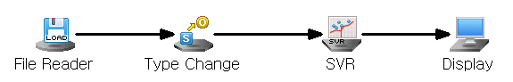

Node Properties

|  |  |  |  |  |
| --- | --- | --- | --- | --- |
| Property group | Property Name | Description | Misc. | Note |
| Model File | Save Model File | Decide whether to save model file. | Required | Yes, No |
| Model File Path | Set the path for the model file to be saved. | Conditionally Required |  |
| Selection options | Type | Select the type of SVR algorithm. | Required | SVR(Epsilon)  SVR(NU) |
| Kernel Type | Select the kernel function. | Required | LINEAR, POLY, RBF, SIGMOID |
| Degree | Set the degree of the polynomial kernel if Kernel Type is POLY. | Optional |  |
| Gamma | Set the scaling factor of the kernel if Kernel Type is either POLY, RBF, or SIGMOID. | Optional |  |
| Coef0 | Set the constant term of the kernel if Kernel Type is either POLY or SIGMOID. | Optional |  |
| C | The parameter C controls how much you want to avoid misclassifying. Default is 1 | Optional |  |
| Nu | Set the Nu value of the SVR(Nu) if Type is SVR(Nu). | Optional | (0<Nu≤1) |
|  | Epsilon | Set the Nu value of the SVR(Epsilon) if Type is SVR(Epsilon). Epsilon defines the margin of tolerance where no penalty is given to errors (default = 0.1) | Optional |  |

Results

Prediction analysis results are displayed using Display Node.

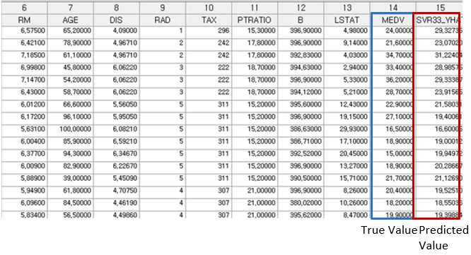

Modeling Result

Click **Modeling Result** in Node Property of **Model node** to view the results.

* Option Information

It shows which options were used when modeling using SVR.

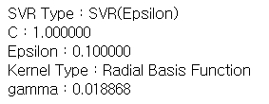

* ANOVA TABLE

F-test is a test whether the independent variable is statistically significant in explaining the dependent variable. If the p-value is greater than the significance level then it is not significant, the interpretation of the regression coefficient is meaningless.



**(1) DF (Degree of Freedom)**

The number of independent variables

**(2) SS (Sum of Squares)**

Total variations in the data. It is a calculation of the squared deviations from the mean value.

**(3) MS (Mean Square)**

The average of the squared deviations. (SS/DF)

**(4) F-value**

The ratio of the mean square for the residual variance and the independent variable variance.



**(5) p-value**

probability of observing the data if the null hypothesis is true. Lower p-value suggests that the group variances are statistically significant.

* Standard Error Information



**(1) R-square (coefficient of determination)**

It is a value that checks whether the derived regression equation is representative of the measured values.

**(2) Adjust R2**

It adjusts the r-squared value by considering the degree of freedom of the model.

**(3) RMSE (Root-Mean Square Error)**

The square root of the average squared differences between the predicted values and the dependent variable.

**(4) MAE (Mean Absolute Error)**

The average of the absolute differences between the predicted values and the dependent variable.

**(5) MAPE (Mean Absolute Percentage Error)**

The average of the absolute differences between the predicted values and the dependent variable as a percentage

Numbers (3) to (5) all represent the error between the original value and the predicted value of the dependent variable. The smaller the value, the better the model.

Example File

* Run the SVR.ecm

### 3.4.39 t-SNE

|  |  |
| --- | --- |
|  | **t-SNE (t-distributed Stochastic Neighbor Embedding)** is a multivariate data analysis technique that visualizes the classification and distribution in low dimensions through non-linear dimensionality reduction. It outperforms traditional linear dimensionality reduction methods, such as PCA and MDS, in visualizing data classification. |

Overview

**t-SNE (t-distributed Stochastic Neighbor Embedding)** is a non-linear dimensionality reduction technique use for visualizing high-dimensional data in lower dimensions. It helps uncover patterns in the data by preserving the similarity between points as they are reduced to two or three dimensions, which are easier to visualize.

t-SNE maintains the relationships between data points more effectively, allowing for better data classification and visualization.

Using N observations from independent D individual input matrix, t-SNE maps data points into a lower-dimensional space d (≤ D). The points generated in this process are called map points. Each time the algorithm operates, a random process is involved, such as selecting a reference point from the input data, which can lead to variation in the results even with the same input.

Applications

* Only independent variables. They must be continuous.
* t-SNE Node itself includes a standardization preprocessing process.

Usage

* Read the data using Input Node.
* Connect Input Node to t-SNE node and select the options.
* Among t-SNE Node settings, Initial Perplexity must be less than 1/3 of the number of input data (number of input matrix rows).
* t-SNE Node does not create model files.
* An example of t-SNE stream is as follows.

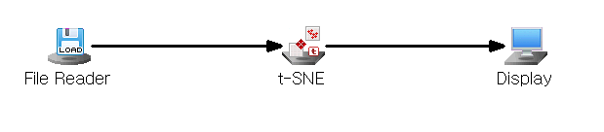

Node Properties

|  |  |  |  |  |
| --- | --- | --- | --- | --- |
| Property group | Property Name | Description | Misc. | Note |
| Model File | Save Model File | Decide whether to save model file. | Required | Yes, No |
| Model File Path | Set the path for the model file to be saved. | Conditionally Required |  |
| Selection options | Execution Count | Set the total number of learning iterations. | Required | integer≥0  Default: 1000 |
| Initial Perplexity | Set the initial Perplexity value. | Required | The value should be between 5 and 50. However, it must be less than 1/3 of the number of input data (number of input matrix rows). |
| Learning Rate Constant | Set the Learning Rate Constant value. | Required | The default is 100, and may be adjusted depending on the case. |
| Threshold | Set the precision of calculation. | Required | The closer the threshold value is to 0, the higher the accuracy, but the longer the calculation time. Set to a real value greater than or equal to 0. Default: 0.5 |
| Initial Momentum | Set the initial momentum value. | Required | The Initial Momentum value is used for learning until the Number of Epochs reaches 250.  Default: 0.5. |
| Final Momentum | Set the final momentum value. | Required | The Final Momentum value is used for learning until the Number of Epochs reaches 250.  Default: 0.8 |
| Dimension Reduction | Set the number of lower-dimensional dimensions you want to reduce. | Required | The dimensions that are easiest for visualization are 2D or 3D, so it is usually set to 2 or 3. Default: 2. |

Results

The source data points information and the coordinate information of the map points in the compact dimension are displayed using Display Node.

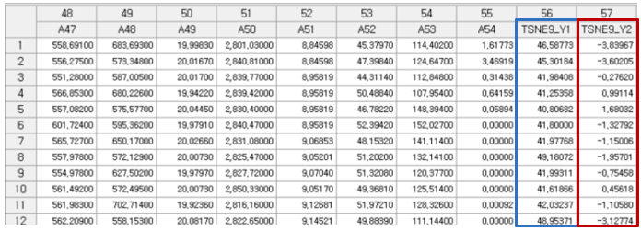

2D or 3D visualizations are displayed using the linked **Chart Node**.

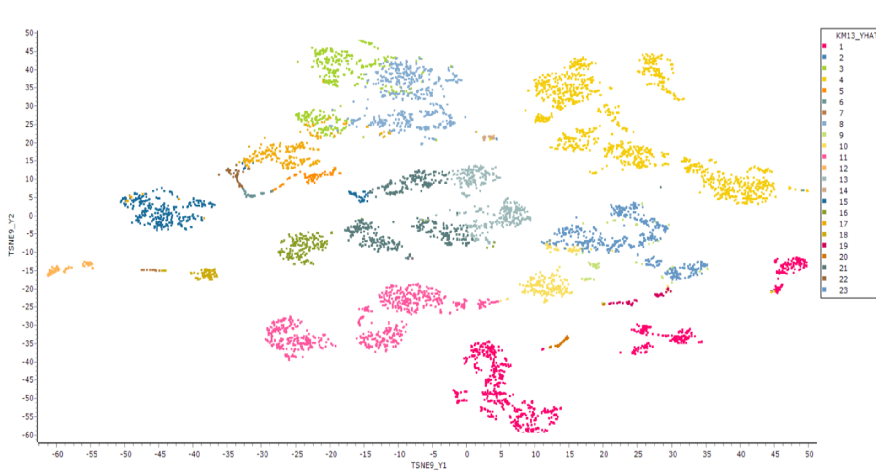

Running the Chart Node with **TSNE\_Y1** on the X-axis and **TSNE\_Y2** on the Y-axis will produce a plot similar to the one shown above**.** As for the differentiation of classes, select **Separate by Series** on **Group Display** option and select the appropriate group variable.

## 3.5 Output Node

**Output** node is a tool used to save the output file, including predicted modeling values, in various database formats.

ECMiner™ provides the following data output nodes:

* [ODBC Writer](#_3.5.1_ODBC_Writer)

Store data in a database using ODBC.

* [OLEDB Writer](#_3.5.2_OLEDB_Writer)

Store data in a database using OLE DB technology. It can manipulate dbases with better performance than ODBC.

* [Result Pivoting](#_3.5.3_Pivot_Node)

Perform pivoting according to the entered information.

* [Oracle DB Writer](#_3.5.4_Oracle_DB_1)

Store data in Oracle database.

* [Statistics](#_3.5.5_Statistics)

Perform statistical analysis of a variable.

* [File Writer](#_3.5.6_File_Writer)

Save data to a file.

* [Display](#_3.5.7_Display)

Display a result on screen.

* [Separate File](#_3.5.8_Separate_File)

Separate and store data.

### 3.5.1 ODBC Writer

|  |  |
| --- | --- |
|  | ODBC Writer is a node that stores data in a database using ODBC (Open Database Connectivity) technology. |

Usage

|  |  |
| --- | --- |
|  |  |

* Enter data source, user name, and password to access the database.
* Add a new DSN (Data Source Name) by if there is no database want to connect.

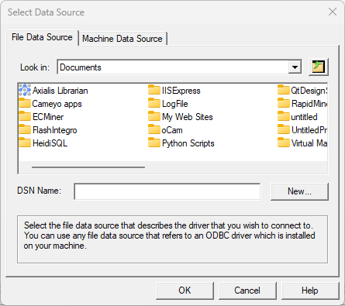

* Retrieve the information of the specified database by clicking the button of ‘Fetch DB information’.
* Select a schema and enter the table name to save data.
* Changing the ‘Create Table’ option, the ‘Remove Table’ or ‘Empty Table’ options are activated.
* When executed, data are saved into the selected DB.

Node Properties

|  |  |  |  |  |
| --- | --- | --- | --- | --- |
| Property group | Property Name | Description | Misc. | Note |
| DB Connection | ODBC Editing | Create a new DSN (Data Source Name) to connect ODBC. | button |  |
| Data Source | Select the DSN to use in the list of ODBC DSNs which are registered on a PC. Add the DSN by using ODBC editing if the DSN does not exist. | Required |  |
| User Name | Enter the user’s name to access a database. | Required |  |
| Password | Enter the user password to access a database. | Required |  |
| Table to save | Fetch DB Information | Load the information such as the schema, table and view, etc of a database by using database connection information. | button |  |
| Create Table | Select ‘Yes’ to create a new table. Select ‘No’ to use an existing table. |  | Yes, No |
| Select  Schema | Select the database schema to be listed in table. Supports tables and views. |  | All, Table, View |
| Table Name to Save | Specify the table name to be saved in a DB. |  |  |
| Selection options | Remove  Table | Removes the existing table when ‘Create Table’ option is ‘Yes’. |  |  |
| Empty  Table | Decide whether to delete all data (Yes) from an existing table, or to leave it and save more (No). Activated when ‘Create Table’ is ‘No’. |  |  |
| Save Method | Choose whether to match in order of variables or by name of variables. | Required |  |
| Variable Information | Variable Information | Show the field name and type of the variable to be saved in a DB. |  |  |

### 3.5.2 OLEDB Writer

|  |  |
| --- | --- |
|  | OLEDB Writer is the node that stores data in a database using OLEDB (Object Linking and Embedding, Database) technology. Data is saved correspondingly by directly selecting a table or entering a new table name. OLEDB is recommended when a database supports both ODBC and OLEDB. |

Usage

|  |  |
| --- | --- |
|  | * Specify a driver to be connected in database * Enter DB server connection information, user name, and password to connect the database. * Retrieve the information of a database by clicking the button of ‘Fetch DB information’. * Check the data showed in the part of a variable before saving * An error may occur if data type does not match in an existing table. * Select the table to save data or enter a table name. |

* Decide whether to delete an existing table and whether to clear the contents of an existing table by selecting the ‘Create Table’ option.
* When data are saved in an existing table, an error occurs if ‘Yes’ for the option of ‘remove table’ doesn’t selected after the option of ‘create table’ is selected in ‘Yes’.

Node Properties

|  |  |  |  |  |
| --- | --- | --- | --- | --- |
| Property group | Property Name | Description | Misc. | Note |
| DB Connection | Select the Driver | Select the OLEDB driver to be connected in database. ECMiner™ accesses the database through the selected OLEDB driver. | Required |  |
| DB Server Connection Information | Enter IP address of a database server in SQL server. Enter TNS name in case of Oracle. | Required |  |
| User Name | Enter the user’s name to access a database. | Required |  |
| Password | Enter the user password to access a database. | Required |  |
| Table to save | Fetch DB Information | Load the information about the schema, table and view | button |  |
| Create Table | Select ‘Yes’ to create a new table. Select ‘No’ to use an existing table. | Required | Yes, No |
| Select Schema | Select the database schema to be listed in table. Supports tables and views. |  |  |
| Table Name to Save | Specify the table name to be saved in a DB. | Required |  |
| Selection options | Remove Table | Removes the existing table when ‘Create Table’ option is ‘Yes’. | Required | Yes, No |
| Empty Table | Decide whether to delete all data (Yes) from an existing table, or to leave it and save more (No). Activated when ‘Create Table’ is ‘No’. | Required | Yes, No |
| Save Method | Choose whether to match in order of variables or by name of variables. |  | Order of a variable, Match variable name |
| Variable Information | Variable Information | Show the field name and type of the variable to be saved in a DB. |  | Integer, Real,  Character, Date |

### 3.5.3 Pivot Node

|  |  |
| --- | --- |
|  | Pivot is a node that shows a data variable as a table by grouping the rows and columns of data |

Usage

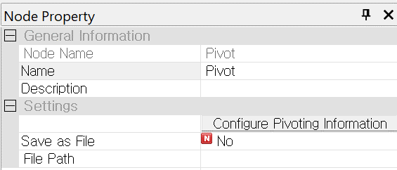

* Click the ‘Configure Pivoting Information’ button.

|  |  |
| --- | --- |
|  |  |

* Select a data variable and specify column grouping variables and row grouping variables.
* Check the grouped data according to the row and column group variables.

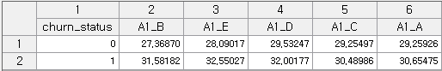

Node Properties

|  |  |  |  |  |
| --- | --- | --- | --- | --- |
| Property group | **Property Name** | **Description** | **Misc.** | **Note** |
| Settings | Configure Pivoting Information | Specify row and column grouping variables and data variables. | Required |  |
| Save as File | Choose whether to save data as a file. | Optional | Yes, No |
| File Path | Save a file in specified file path. | Optional |  |

### 3.5.4 Oracle DB Writer

|  |  |
| --- | --- |
|  | Oracle DB Writer is a node that stores Oracle data in a database. |

Usage

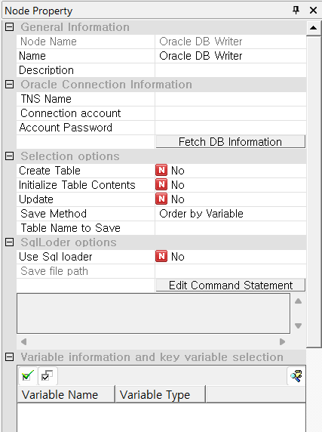

* Enter TNS(Transparent Network Subtrate) name, connection account and password to access a database.
* Retrieve the information of a specified database by clicking the button of ‘Fetch DB information’.
* Select a schema and enter the table name to save data.
* Changing the ‘Create Table’ option activates the ‘Remove Table’ or ‘Empty Table’ option.
* When executed, data are saved to a specified DB.

Node Properties

|  |  |  |  |  |
| --- | --- | --- | --- | --- |
| Property group | **Property Name** | **Description** | **Misc.** | **Note** |
| Oracle Connection Information | TNS Name | Enter TNS name of the Oracle database you connect. | button |  |
| Connection Account | Enter connection account name of a database. | Required |  |
| Account Password | Enter connection account password of a database. | Required |  |
| Selection options | Fetch DB Information | Load the information such as the schema, table and view, etc of a database by using database connection information. The information is showed at the bottom. | button |  |
| Create Table | Select ‘Yes’ to create a new table. Select ‘No’ to use an existing table. |  | Yes, No |
| Initialize Table Contents | Initialize table contents. |  | All, Table, View |
| Update | Update the data matching the selected key variable. |  |  |
| Save Method | Choose whether to match in order of variables or by name of variables. |  |  |
| Table Name to Save | Select the table name to save. |  |  |
| SqlLoader options | Use Sql loader | Decide whether to use Sql Loader. |  |  |
| Save file path | Specify the path of the file to save. |  |  |
| Edit Command Statement | Edit a query statement. |  |  |
| Variable Information | Variable Information | Show the field name and type of the variable to be saved in a DB. |  |  |

### 3.5.5 Statistics

|  |  |
| --- | --- |
|  | Statistics Node is a node that displays the result of statistical analysis. |

Usage

Statistics Node has the following interface: Select variables in a statistics value or select variables to group by rows or columns.

|  |  |  |  |  |  |  |  |  |  |  |
| --- | --- | --- | --- | --- | --- | --- | --- | --- | --- | --- |
|  | |  |  |  | | --- | --- | --- | | bin_select | the selected variables. | | | bin_reverse | Invert selected and unselected variables. | | | btn_condition |  | Select variables based on conditions such as variable type or variable name. | |

Usage

* Select the statistic to know from Selection options.
* Select the variable to analyze and drag the grouping variable.

Node Properties

|  |  |  |  |  |
| --- | --- | --- | --- | --- |
| Property group | **Property Name** | **Description** | **Misc.** | **Note** |
| Selection options | Variance Statistics | Variance, standard deviation, and kurtosis of a continuous variable. | Required | Yes, No |
| Distribution Statistics | Skewness, median, Q0, Q1, Q2, Q3, Q4 and IQR of a continuous variable. | Required | Yes, No |
| Number of Data Points | Specify how many discrete variables are displayed in a descending order. | Required |  |
| Grouping Variables and Statistical Variables | Row Group | Select a variable for row grouping |  |  |
| Column Group | Select a variable for column grouping |  |  |
| Statistic Variables | Select the variable field for which you want to obtain the result of statistic. |  |  |

Result

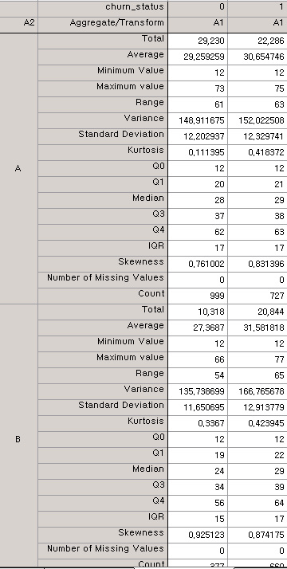

### 3.5.6 File Writer

|  |  |
| --- | --- |
|  | File Writer is a node that save the result of data analysis. |

Usage

|  |  |
| --- | --- |
|  | * Specify the path of the file to save. * Select ‘No’ to the field of ‘Save Variable Name’ if variable names are not saved * Select ‘Overwrite’ to the field of ‘Storage Method’ if data are saved in overwriting. * Select the character delimiter if a delimiter is a character. If the delimiter does not exist, enter the delimiter directly in the field of ‘Other Delimiters’. |

Node Properties

|  |  |  |  |  |
| --- | --- | --- | --- | --- |
| Property group | **Property Name** | **Description** | **Misc.** | **Note** |
| Selection options | Save Variable Names | Select 'Yes' in the 'Save Variable Names' field saves it. Select 'No' creates a variable name automatically. | Optional | Yes, No |
| Storage Method | Select 'overwrite' in the 'Storage Method' will discard existing data and write new data. If an identical file exists, the data will not be saved, and an error will occur. | Optional | Overwrite, Error if same file exists |
| Delimiter | Select the type of delimiter. Supported delimiters are tab, space, bar, comma, semicolon, and colon. To use a different delimiter, select the 'Other' option. | Required | (tab) (Space) (|) (,) (;) (:) (Other) |
| Other Delimiter | Set other delimiters in case the property of a delimiter is (Other). | Required |  |
| Wrap in Quotation Marks | Choose whether to wrap a string in quotation marks on a file. | Required | Yes, No |
| File | File Path | Enter the name and path of a file to save. | Required |  |
| Use FTP | Select whether to save and upload a file into an FTP server. | Required | Yes, No |
| Connect to FTP | FTP Server | Choose an FTP server to use. |  |  |
| FTP User | Enter user ID of FTP. |  |  |
| FTP Password | Enter password of FTP. |  |  |
| FTP File Selection | Select the file of FTP. | Button |  |
| FTP File Path | Enter the path to save a file on an FTP server. |  |  |
| Variable Information | Variable Information | Show the field name of the variable which save in a file. |  |  |

### 3.5.7 Display

|  |  |
| --- | --- |
|  | **Display Node** is a node that displays the results of data analysis in a table on a screen. |

Usage

To add indicators for specifying a specific row, follow these steps.  
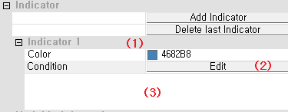

1. Click the “Add Indicator” button to add the desired number of indicators.

2. To change the color of an indicator, use the color dialog box that appears when the indicator is selected.

3. Click the “(2)” button to open the formula editor and enter the formula for the indicator.

4. Use “(3)” to review the entered formula. To modify it, click the edit button in “(2)”

Node Properties

|  |  |  |  |  |
| --- | --- | --- | --- | --- |
| Property group | **Property Name** | **Description** | **Misc.** | **Note** |
| Selection options | Create Table | Select 'No' to generate a single output table during execution. Select 'Yes' to generate a new output table for each run. | Optional (Default Value: No) | Yes, No |
| Indicator | Add Indicator | Add a color indicator to distinguish a specific row from other rows. | button |  |
| Delete Last Indicator | Delete a last indicator among the added indicators. | button |  |
| Variable Information | Variable Information | Show the name and type of the variable which shows in a table. |  |  |

### 3.5.8 Separate File

|  |  |
| --- | --- |
|  | **Separate File** is a node which separates data to save according to the purpose of a user. |

When the large amounts of data are processed, **Separate File** is used to separate and process them. Separated Save Node can process efficiently data when the number of records is less than 30 million.

Usage

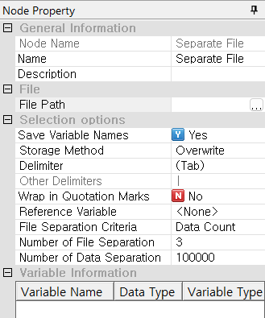

* Specify the name and path of the file to save through the field of File Path.
* Select whether to save a variable name through the option of ‘Save Variable Names’.
* Select whether to overwrite an existing file or show an error message through the option of ‘Storage Method’ in case a file name is same with the name of the existing file
* Set a delimiter by using the option of ‘Delimiter’ and ‘Other Delimiters’ and set a separation criteria and details by setting file separation criteria, a criteria variable setting, the number of file separations, and the number of data separations.

Node Properties

|  |  |  |  |  |
| --- | --- | --- | --- | --- |
| **Property group** | Property Name | Description | Misc. | Note |
| **File** | File Path | Specify the name and path of a file to save. | Required |  |
| **Selection options** | Save Variable Names | Specify whether to save a variable name. | Optional (Default: Yes) | Yes, No |
| Storage Method | Select 'overwrite' in the 'Storage Method' will discard existing data and write new data. If an identical file exists, the data will not be saved, and an error will occur. | Optional (Default: Overwrite) | Overwrite, Error if a file exists |
| Delimiter | Select the type of delimiter. Supported delimiters are tab, space, bar, comma, semicolon, and colon. To use a different delimiter, select the 'Other' option. | Required | (tab) (Space) (|) (,) (;) (:) (Other) |
| Other Delimiter | Set other delimiters in case the property of a delimiter is (Other). |  |  |
| Wrap in Quotation Marks | Choose whether to wrap a string in quotation marks on a file. | Optional  (Default: No) | Yes, No |
| Reference Variable | Select the variable which is criteria of a file separation. Once the Reference Variable option is defined, refer to <Separated storage method when a reference variable is set> below. | Required | None |
| File Separation Criteria | Specify the criteria for separating a file. Options include the number of data entries, the number of files, or the category of the reference variable. | Required | Data Count, Number of Files, Reference Variable by Category |
| Number of File Separation | Select this option if file separation is based on the number of files. | Conditionally Required |  |
| Number of Data Separation | Select this option if file separation criteria is based on the number of data entries. | Conditionally Required |  |
| **Variable Information** | Variable Information | Show the name and type of the variable which is displayed in a table. |  |  |
| <Separated storage method when a reference variable is set>   * If file separation criteria is based on the number of data entries.   For example, the option for the number of data entries to separate takes precedence over a reference variable. If the separation number is set to 10 and the reference variable is set to 'A', data are initially separated based on 10 entries. The 10th and 11th values of variable 'A' are then compared:  A. If the values are identical, they are combined to form a set of 11 data entries.  B. If the values differ, the 10 data entries are saved separately.  After saving, the next group of 10 data entries is separated and processed in the same manner. This process continues, dividing a large data file into multiple smaller files.   * If file separation criteria is based on the number of files.   When setting the number of files, the data separation number must be internally defined to divide the entire dataset. The dataset is divided based on the specified number of files.  Example: If 100 rows of data are separated into 6 files, the separation number is 17. | | | | |

## 3.6 Model Evaluation Node

The Model Evaluation Nodes are for comparing and evaluating model performances.

**ECMiner™** provides the following **Model Evaluation Nodes**.

* [ROC Chart](#_3.6.1_ROC_Chart)

Draws the ROC curves of each model.

* [Model Evaluation](#_3.6.2_Model_Evaluation)

Generates a report to compare each model.

* [Profit Chart](#_3.6.3_Profit_Chart_1)

Draws a profit chart for each model.

### 3.6.1 ROC Chart

|  |  |
| --- | --- |
|  | **ROC Chart** draws ROC curves of each model. The specificity and the sensitivity of the classification models are used to create the ROC curves. |

|  |  |  |  |
| --- | --- | --- | --- |
|  | | True Class | |
| Positive | Negative |
| Predicted Class | Positive | True Positive (TP) | False Positive (FP) |
| Negative | False Negative (FN) | True Negative (TN) |

* Sensitivity (true positive rate) refers to the probability of correctly classifying the true classes.

Sensitivity = TP / TP + FN

* Specificity (true negative rate) refers to the probability of correctly classifying ‘negative’.

Specificity = TN / TN + FP

The ROC curve is drawn by plotting sensitivity against 1 - specificity, as the classification threshold (cutoff) is increased from 0 to 1.

Applications

* Among the current classification models, only LDA, QDA, and Logistic Regression can be connected with the ROC Chart.

Usage - Diagram Example

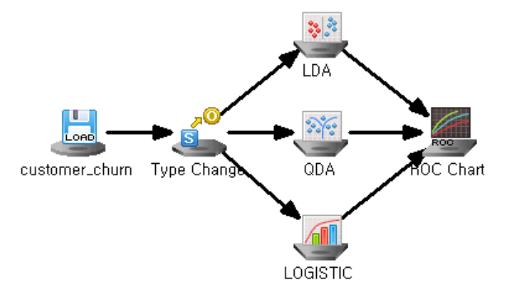

Node Properties

|  |  |  |  |  |
| --- | --- | --- | --- | --- |
| Property group | **Property Name** | **Description** | **Misc.** | **Note** |
| Selection options | Target Grade | Enter the number of target grade. | Required | Natural Number |
| Number of Classification Criteria | Enter the number of classification thresholds for the ROC curve. | Required |  |

Results

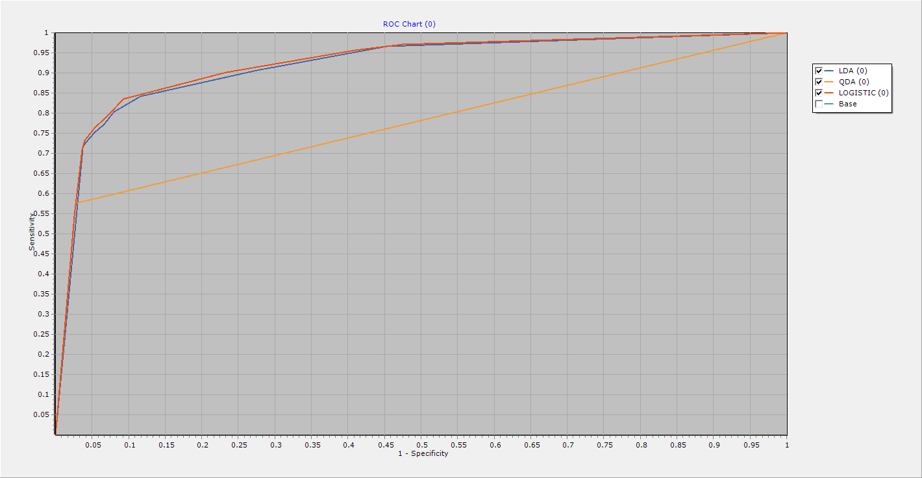

The ROC curve shows the performance of the generated model.

In the above case, we can see that the QDA model has the lowest sensitivity at a certain specificity. This means that this model has the highest misclassification rate at that specificity, making it the worst of the three models.

If your model's ROC curve is exactly diagonal, this indicates that your modeling has no effect at all. This is because specificity and sensitivity are the same for all classification criteria, so the frequency of diagonal elements in the misclassification matrix is ​​the same as the frequency of off-diagonal elements.

### 3.6.2 Model Evaluation Node

|  |  |
| --- | --- |
|  | **Model Evaluation Node** is to evaluate the performance of various model techniques based on prediction and classification accuracy. |

Usage - Diagram Example

* Clustering Tasks

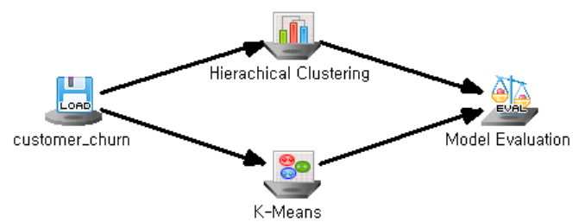

* Classification Tasks

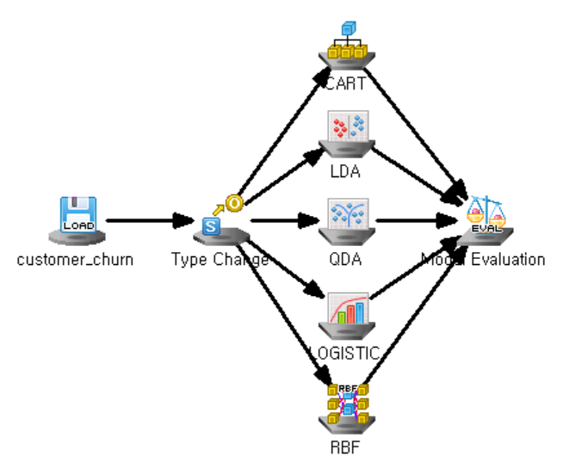

* Regression Tasks

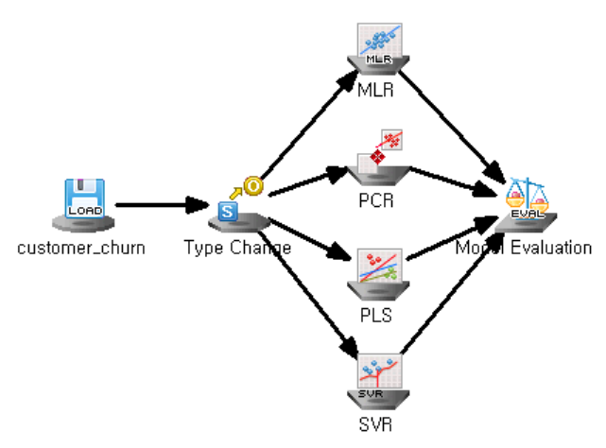

Results

* Clustering task

Clustering result are listed for each model.

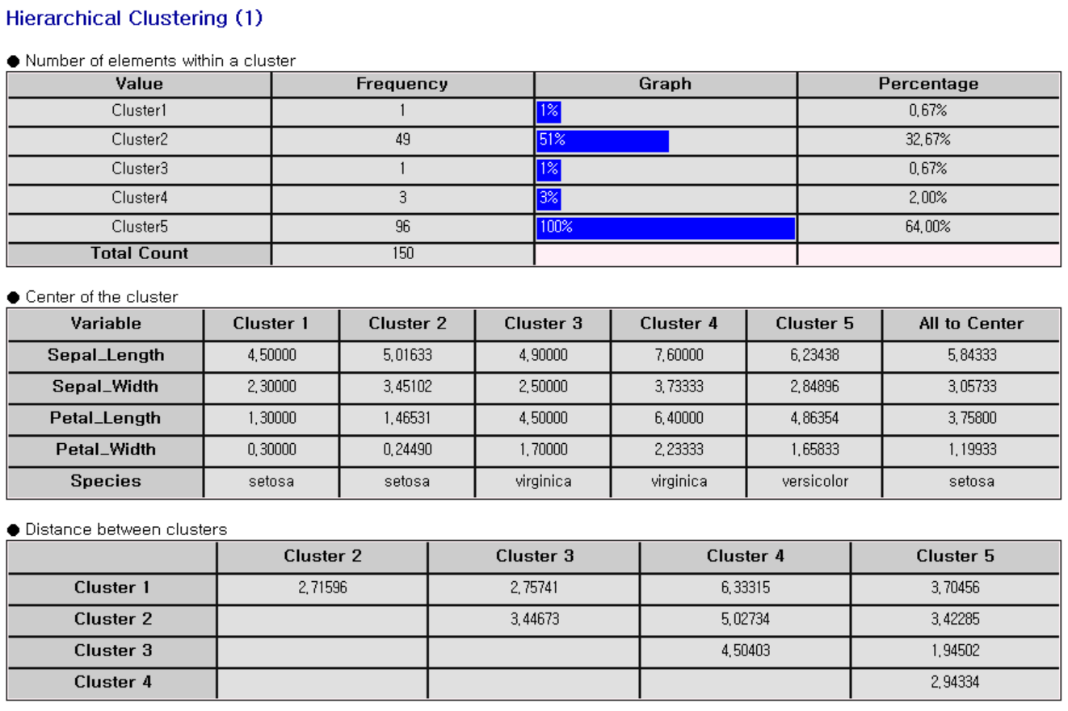

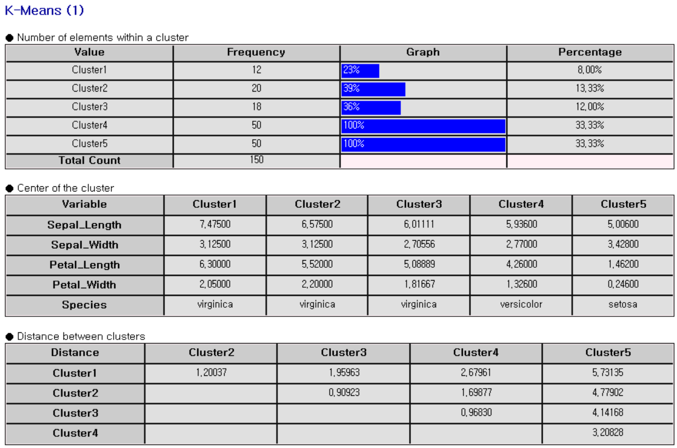

* Classification Tasks

The confusion matrix table, misclassification count and rate are listed for each model.

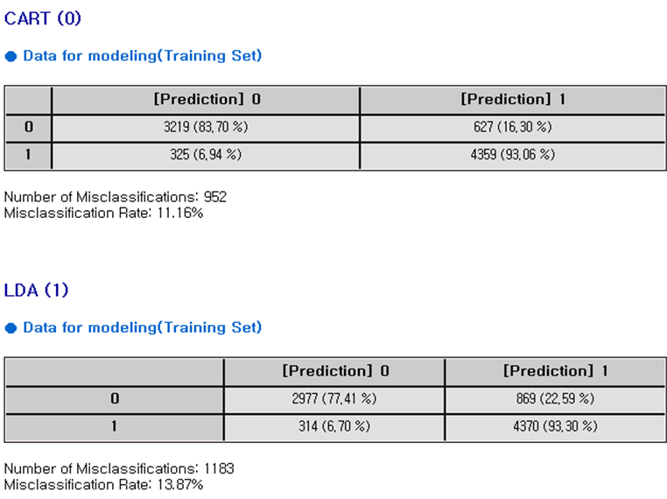

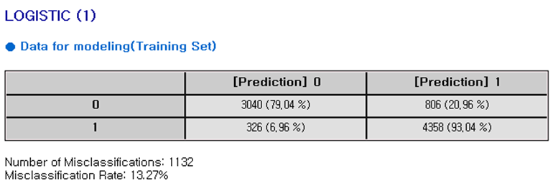

* Regression Tasks

As shown below, the ANOVA table and standard error information are listed for each model.

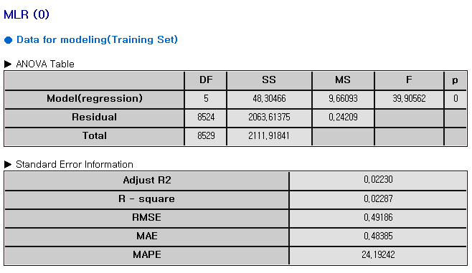

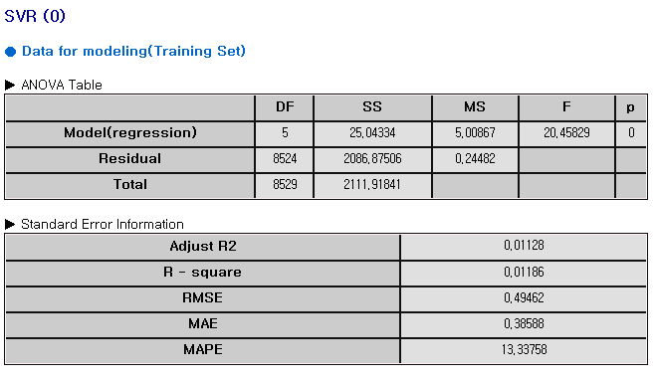

### 3.6.3 Profit Chart Node

|  |  |
| --- | --- |
|  | **Profit Chart** is to evaluate classification models using posterior probability values. **Profit Chart** performs model evaluation through four values: Captured Response, Response, Lift, and Gain. |

Considerations

* Among the current classification models, only LDA, QDA, Logistic, CART, and Random Forest Model Nodes can be connected with Profit Chart Node.

Usage - Diagram Example

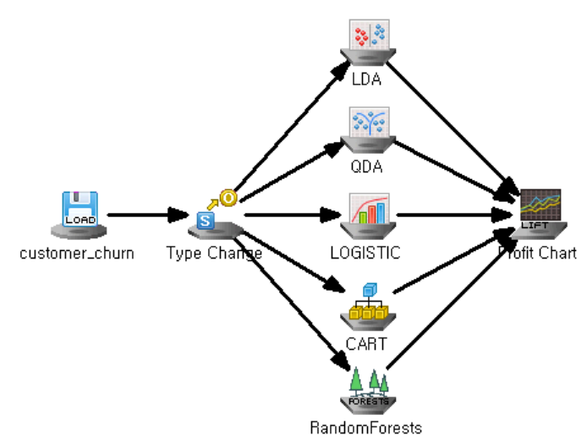

Node Properties

|  |  |  |  |  |
| --- | --- | --- | --- | --- |
| Property group | **Property Name** | **Description** | **Misc.** | **Note** |
| Selection options | Target Grade | Enter the number of target grade. | Required | Natural Number |
| Grade Ratio | Set the percentage of the total data for each grade through the Grade Ratio. | Required |  |
| Accumulated | Select whether or not to show the captured response cumulatively through the Accumulated option | Required | Yes or No |

Results

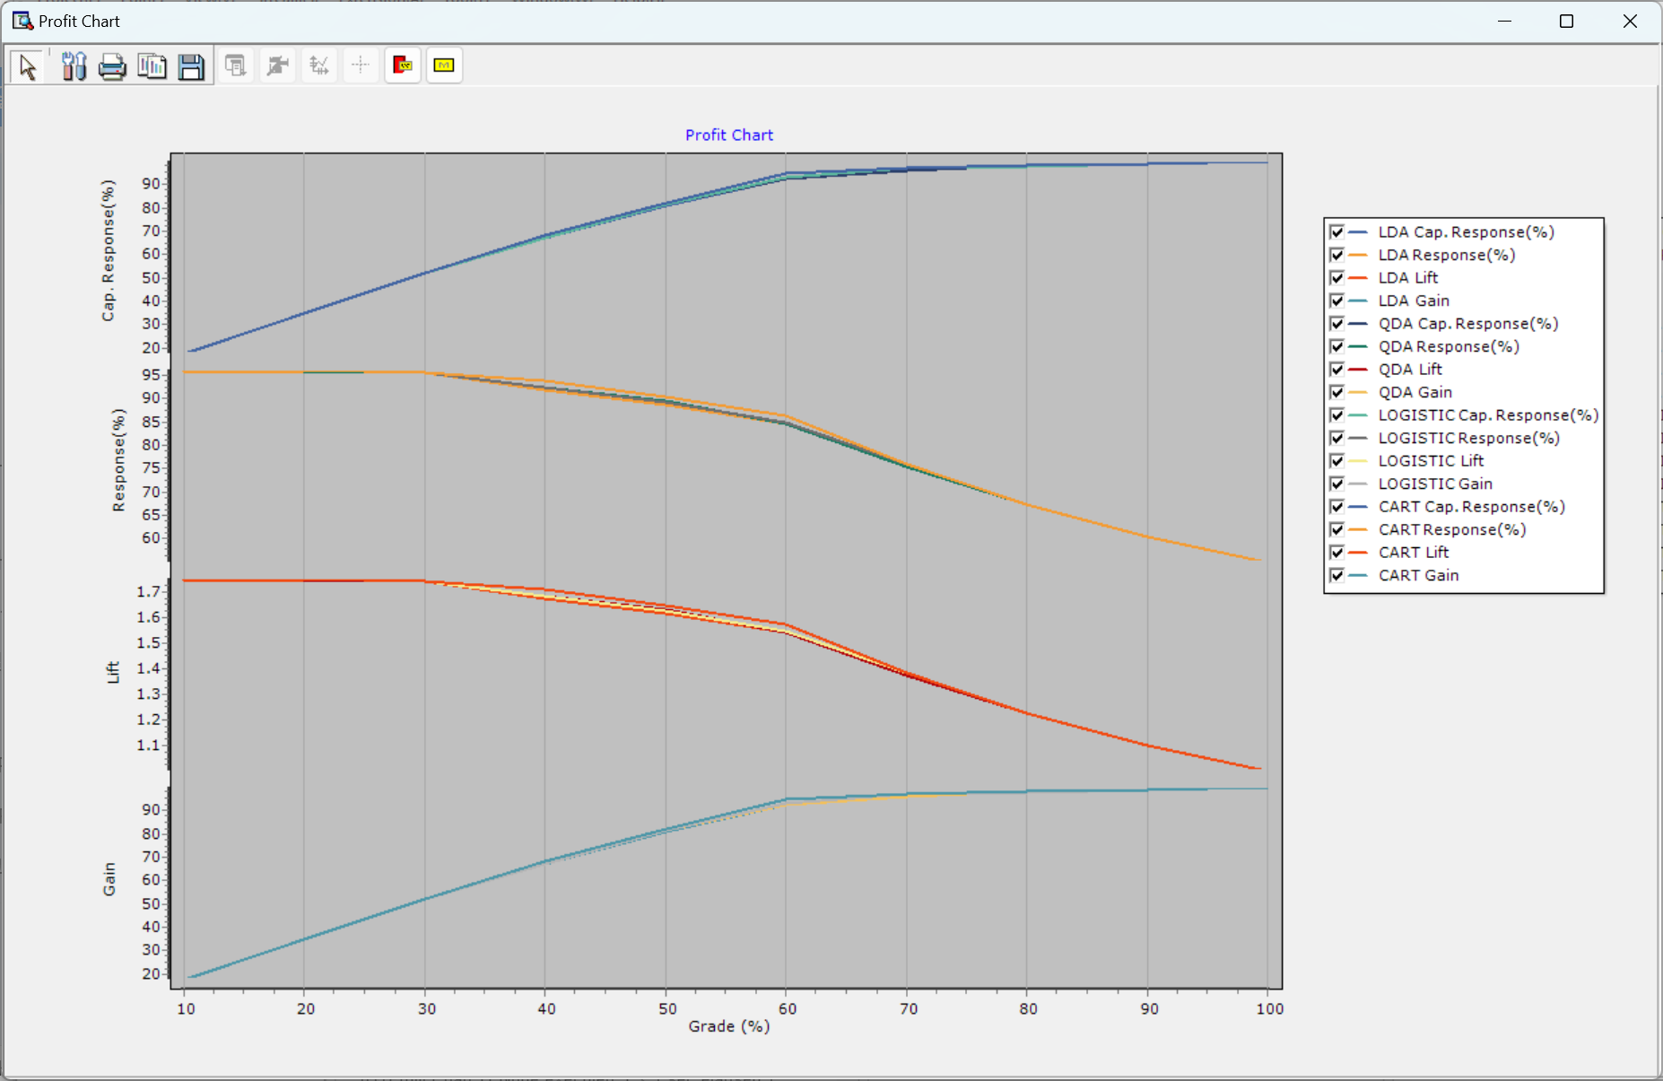

* **Captured Response**: the proportion of positive outcomes successfully identified within a specific targeted group.
* **Response**: the overall rate of positive outcomes in the entire dataset.
* **Lift**: a measure of how much better the targeted response rate is compared to random selection.
* **Gain**: the cumulative percentage of positive outcomes captured by targeting a specific percentage of the dataset.